Game Design Document

Fill up the following document

**By – Preshtha Bajaj**

1. Write the title of your project.

Ans. – Marry Escape Story

1. What is the goal of the game?

Ans. – The goal of the game is to escape from the haunted house.

1. Write a brief story of your game.

Ans. – The story of my game revolves around the escape of the little girl, named Marry, from a haunted house. She can do so by answering the questions asked to her at regular intervals. Answering these questions correctly will make her earn points which lead to her escape.

1. Which are the playing characters of this game?

* Playing characters are the ones who respond to the user based on the input from the user.
* Cars, monkeys, dinos, wizards, etc., are the playing characters in the game.

|  |  |  |
| --- | --- | --- |
| **Number** | **Character Name** | **What can this character do?** |
| 1 | Marry | Move around and answer the questions. |

1. Which are the Non-Playing Characters of this game?

* Non-Playing characters are the ones that don't have an action or behavior when the user interacts with the game.
* Hurdles, stones, bananas, coins, etc., are non-playing characters in the game.

|  |  |  |
| --- | --- | --- |
| **Number** | **Character Name** | **What can this character do?** |
| 1 | Ghost | Ask questions |

Draw your imagination of this game. What does this game look like?

* Draw the game either on your computer or on paper.
* Add images of the game scenes to show each of the playing and non-playing characters at least once.

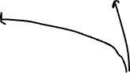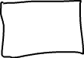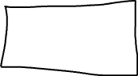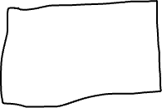

How do you plan to make your game engaging?

Ans. – Escape Story will make the player more engaging.