That's a smart approach. Using a Hikvision DVR as the central hub for the cameras over coaxial cable (or structured cabling) means the network only needs to reach one device — the DVR — rather than every camera individually. This solves your 200m field problem neatly.

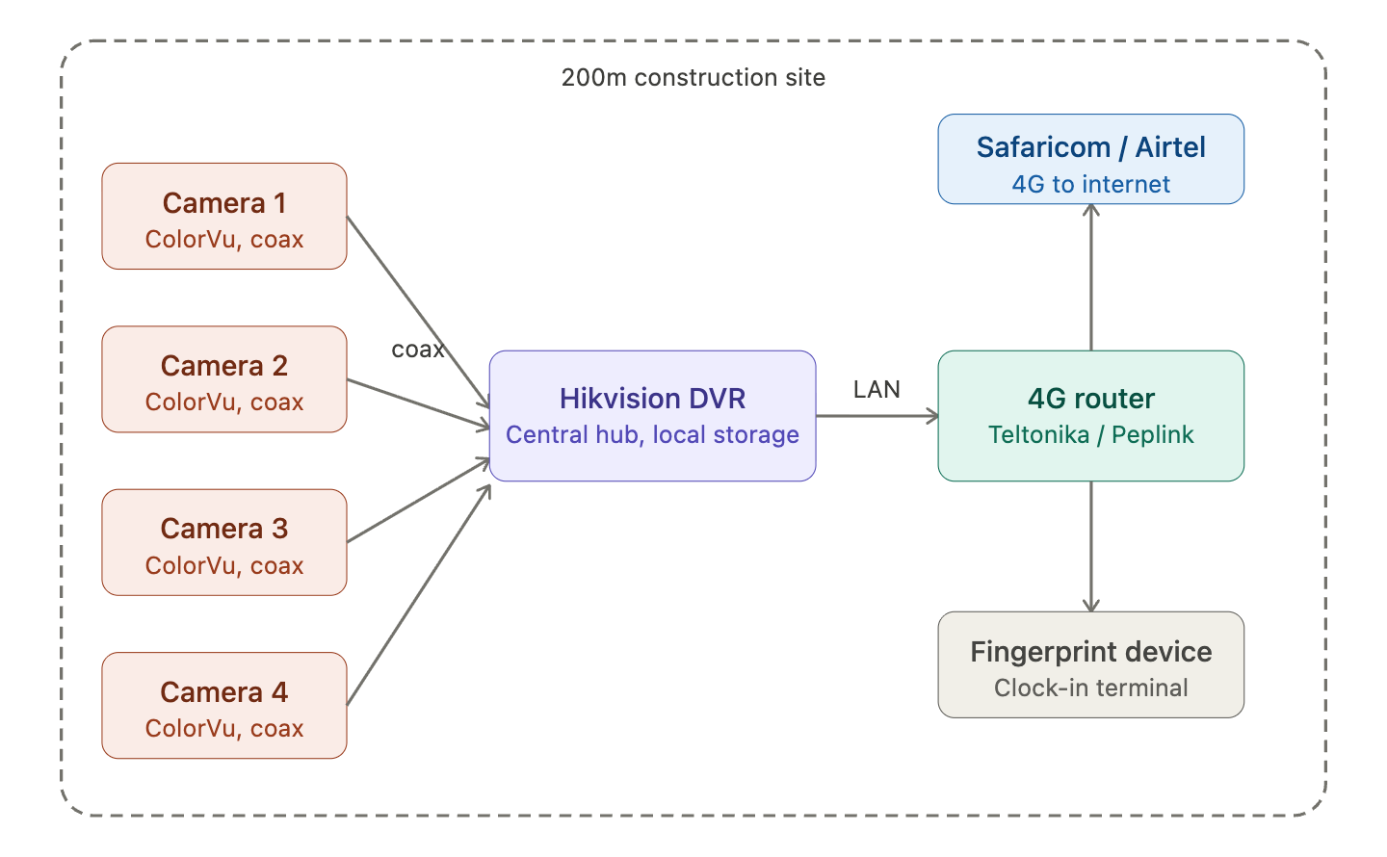
The coaxial cable advantage
Hikvision's ColorVu cameras typically use HD-TVI or AHD over RG59 coaxial cable. Coax can run up to 300–500m without signal degradation (with the right cable gauge and a balun), so your 200m field is well within range. You only need a single network point — the DVR — rather than running Ethernet to each camera location. Ethernet maxes out at 100m without a switch or repeater, so coax is actually the better choice here.
What the DVR provides
The DVR handles local recording (HDD storage on-site), camera management, and exports a single LAN port to the network. All your cameras talk coax to the DVR; the DVR then talks IP to the router. Hikvision DVRs also run Hik-Connect, which means you can view live footage and recordings remotely from your phone once the router gives it internet access.
Cabling consideration at 200m
For the coax run, use RG59 (standard) for up to ~300m, or upgrade to RG6 if you're pushing near 500m or want better image quality over distance. You'll need a power supply at or near the cameras — either run a separate power cable alongside the coax, or use a video/power combo cable (common on Kenyan CCTV supply shops).
One thing to confirm before buying — make sure the DVR model you choose is compatible with ColorVu cameras specifically. Hikvision's ColorVu line works on their own HD-TVI DVRs, but you want to check the DVR supports "full-colour" or ColorVu explicitly rather than just generic TVI cameras.

