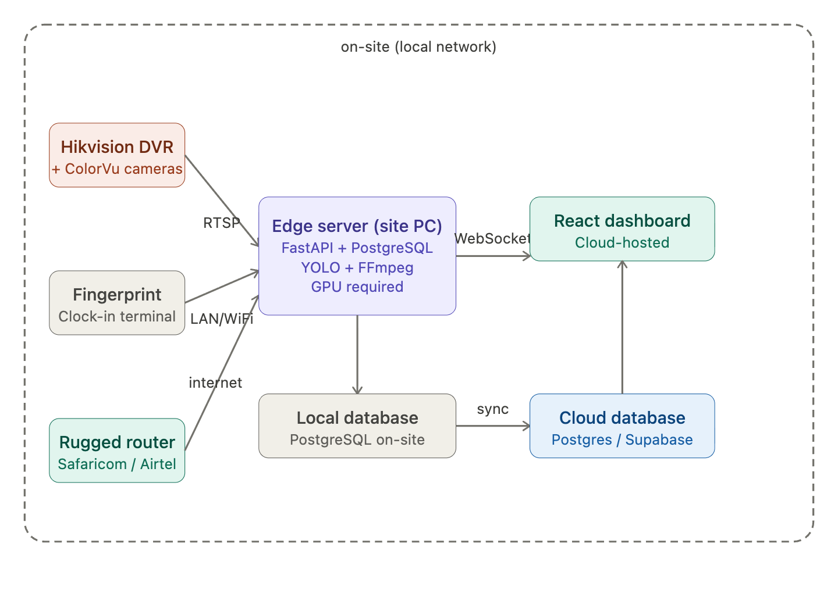
In a strictly WiFi-centric architecture, your local network acts as the "nervous system" of the construction site, and the Local Site PC serves as the "brain." This setup ensures that your AI video analytics, biometrics, and dashboard remain operational even if external internet is slow or intermittent.
1. The Local Site PC (Edge Server)
Instead of sending gigabytes of raw video to the cloud, you process everything on-site.
- Role: This PC hosts your FastAPI backend, your PostgreSQL database, and the YOLO/AI models.
- Specs: You need a machine with a dedicated GPU (e.g., an NVIDIA RTX series) to handle real-time video feeds from multiple cameras simultaneously.
- Function: It "pulls" data from the cameras and fingerprint devices over WiFi, runs the AI logic (tracking machinery, detecting PPE), and only sends small text-based updates to your cloud-hosted React dashboard.
2. Local Network Infrastructure
To cover a large construction site with WiFi, you need more than a standard home router:
- Central Router/Switch: Connects to your internet source (for remote access) and manages local traffic.
- Outdoor Access Points (APs): Use industrial-grade mesh WiFi units (e.g., Ubiquiti UniFi or TP-Link Omada) mounted high on poles or cranes to provide site-wide coverage.
- Static IPs: Every device (Cameras, Fingerprint Terminal, Site PC) must be assigned a fixed IP address (e.g., 192.168.1.50) so they never "disappear" from your FastAPI scripts.
3. Monitoring Signal Strength in React
You can monitor the status of your site's "vital signs" directly on your dashboard.
- Device Status: Your FastAPI backend periodically "pings" each device's IP. If a camera doesn't respond, the dashboard displays a red "Offline" badge.
- Signal Strength: For the Site PC itself, you can use the Web Network Information API to detect connection quality, or have your backend report the signal dBm levels of the mesh APs.
4. Why this local setup is superior
- Zero Latency: Your AI Project Advisor can analyze a video frame and check a fingerprint log in milliseconds because the data never leaves the local network.
- Data Savings: You aren't paying for massive data uploads; you only use the internet when a manager checks the dashboard from off-site.
- Security: By keeping the video processing local, sensitive site footage stays within your private network.
Setting up a robust local area network (LAN) is the foundation for connecting your on-site devices securely and efficiently:

Cloud Deployment | Edge Deployment (Mac Mini M2/M4)
BandwidthHigh Stress: Must stream raw video 24/7. | Low Stress: Only sends alerts/metadata.
Latency:2–5 seconds (Network dependent) | 200ms: Real-time safety alerts.
Cost: High monthly GPU & egress fees | One-time hardware cost.
Reliability:Fails if ISP goes down. | Autonomous: Still processes if offline.

