Here's a comparison of the four options for construction site connectivity:
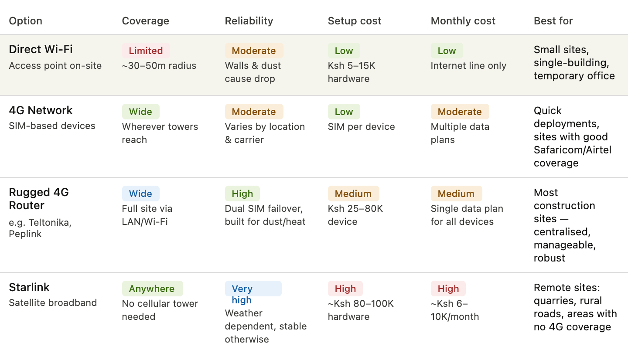 Here's a breakdown of each option in the context of your use case (cameras, biometric clock-in, etc.):
Direct Wi-Fi is the cheapest to set up but essentially requires a stable internet line coming into the site already — you're just distributing it locally. It struggles with range on large or open sites, and dust/interference on construction sites degrades signal. Not ideal as a primary solution on its own.
Raw 4G (SIM per device) is simple to deploy — just put a SIM in each camera or fingerprint device. But managing multiple plans gets expensive and messy, and if one device has poor signal, you can't easily reroute it. Also, not all devices support SIM cards directly.
Rugged cellular router (recommended for most sites) — devices like Teltonika RUT series or Peplink are purpose-built for harsh environments. You plug in one or two SIMs, and all your site devices (cameras, biometric terminal, etc.) connect over LAN or local Wi-Fi through a single managed gateway. Dual-SIM failover means if Safaricom drops, it auto-switches to Airtel. This is the sweet spot for most Kenyan construction sites.
Starlink is the go-to when you're outside cellular coverage — think remote road construction, quarries, or upcountry sites. Speeds are excellent (50–200 Mbps), but the dish costs and monthly fees are high. Heavy rain can briefly affect signal. Worth it where there's no alternative.

The router does NOT boost bandwidth. It's purely a traffic manager and distributor. You still get whatever Safaricom or Airtel delivers to the SIM at that location.
Here's what it actually does vs. what the network gives you:
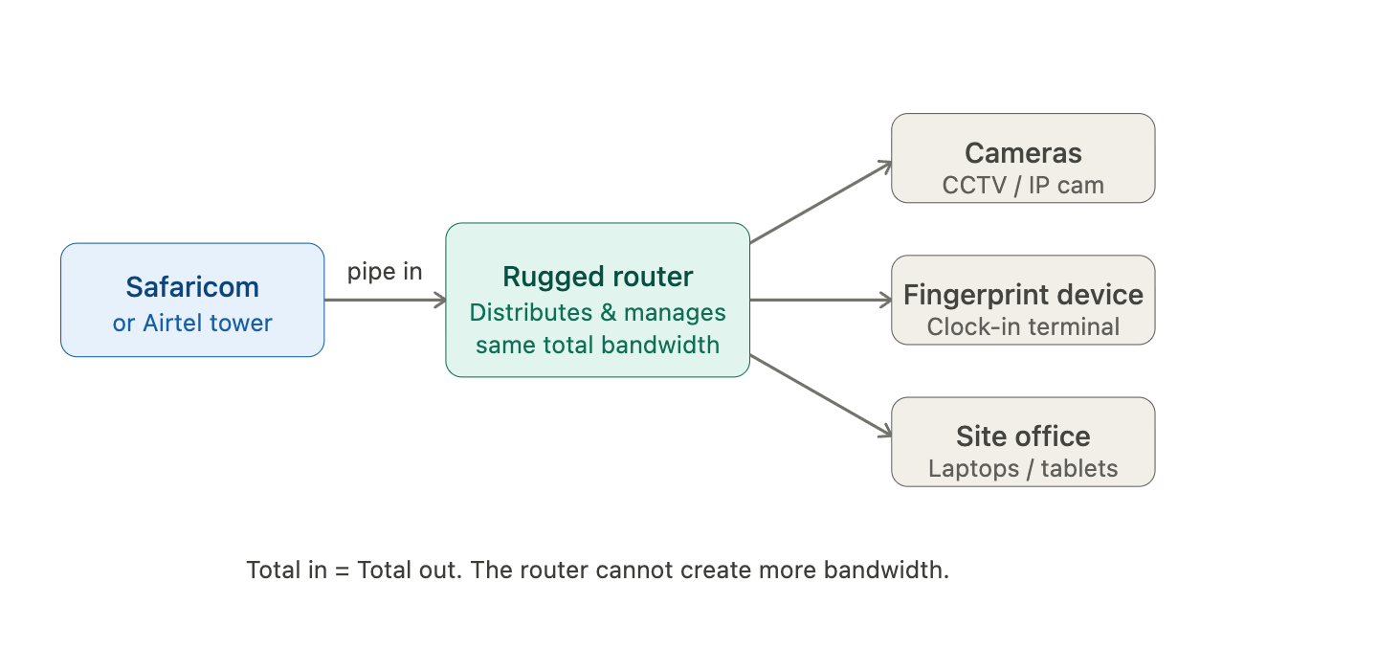 What the router actually adds:
It gives you one shared connection for all devices instead of a SIM per device, failover between Safaricom and Airtel automatically, better signal reception (external antenna support), and traffic prioritisation — so your fingerprint device doesn't get starved when cameras are streaming.
Realistic 4G speeds in Nairobi (what you actually get at the SIM):
Carrier | Typical download | Typical upload | Real-world at a site
Safaricom 4G | 20–50 Mbps | 8–20 Mbps | 10–30 Mbps (congestion varies)
Airtel 4G | 10–30 Mbps | 5–15 Mbps | 5–20 Mbps
Dual SIM combined | Still just one active at a time | — | Unless using load-balancing mode
One important nuance on dual SIM: most rugged routers use dual SIM for failover (one active, one standby), not bonding. A few premium models like Peplink do true bandwidth bonding where both SIMs run simultaneously and their speeds combine — but that requires a paid Peplink InControl subscription and is a more advanced setup.
Is 10–30 Mbps enough for your use case?
For IP cameras, a typical 1080p feed uses about 1–4 Mbps each. So if you have 4 cameras + a fingerprint device + office browsing, you're looking at roughly 10–15 Mbps needed. A good Safaricom 4G line through a rugged router should handle that comfortably — as long as you're in a strong coverage area.

