PLAYBACK TAB
A Playback Tab is where your system transitions from a "live monitor" to a "management tool." For an actual construction project, this is non-negotiable for two reasons: Dispute Resolution (e.g., "Was the cement delivered at 10 AM?") and Incident Investigation (e.g., "Why did the safety alarm trigger at 2 AM?").
Given your 20Mbps bottleneck and Mac Mini setup, here is how you should architect the playback.

1. The Storage Strategy: "Edge First"
Do not try to upload 24/7 video to the cloud on 20Mbps. You will run out of bandwidth instantly. Instead, use a Tiered Storage approach:
- Primary Storage (Mac Mini): Configure MediaMTX to record the RTSP streams directly to the Mac Mini’s internal SSD or an attached 4TB External Drive.
Tip: Record in 10-minute segments. This makes it easier for the React app to "seek" through the video without loading a massive 24-hour file.
- Event-Based Cloud Upload: Only upload "clips" to the cloud (like AWS S3 or Supabase Storage) when your YOLO model or Fingerprint scanner detects an anomaly.
Example: YOLO detects a person without a helmet → Mac Mini trims a 30-second MP4 → Uploads to Cloud → React Dashboard shows a "Notification" with a playback link.

2. The Playback Data Flow
To make this work in a React tab, you need a way to browse the files on the Mac Mini from a remote location.
- Recording: MediaMTX config record: yes saves streams as .mp4 or .mkv.
- API Layer: Your Python backend (running on the Mac Mini) scans the "recordings" folder and provides a list of files via a JSON API (e.g., GET /api/recordings?date=2026-04-06).
- Streaming the File: When the Site Manager clicks a file in the Playback Tab, the Mac Mini serves that file.
  - Pro Move: Use HLS (HTTP Live Streaming) for playback. It allows the manager to jump to any part of the 10-minute clip without waiting for the whole file to download.

3. React Frontend Implementation
Your Playback Tab should consist of three main components:
- A Calendar Picker: To select the day.
- An Event Timeline: A visual bar showing "Red" marks where YOLO detected a violation or the Fingerprint scanner was used.
- The Video Player: Using video.js, pointed at the Mac Mini's file server.

4. Handling the 20Mbps ISP for Remote Playback
If the manager is off-site, watching a 1080p recorded video will consume ~4-6Mbps of your 20Mbps upload speed.
- The "Proxy" Solution: Use the Mac Mini to transcode the playback video on the fly. If the manager is on a mobile device, the Mac Mini can downscale the 1080p recording to 480p before sending it out, saving bandwidth.
- MediaMTX API: MediaMTX has a built-in API that can tell you which files are available. You don't even need to write a complex file-scanner in Python; you can just query MediaMTX.

Suggested "Playback" Features for Investors
Since you mentioned investors, give them a "Daily Highlight" button.
- Use a script on the Mac Mini to take 1 frame every minute and stitch them into a 60-second Time-Lapse of the day's progress.
- Investors love seeing a building "rise from the ground" in high speed. It’s a much more powerful selling tool than just raw 24/7 footage.

How playback works with your architecture
You have two independent recordings happening:
The NVR records full-resolution video continuously to its HDD — this is your raw footage archive. Simultaneously, PostgreSQL on the Mac Mini stores every detection event with a timestamp, camera ID, bounding box coordinates, confidence score, and event type. These two stores are already in sync by timestamp, so playback is just a matter of replaying both together.

Three layers your playback tab needs to serve:

The three components you need to build:
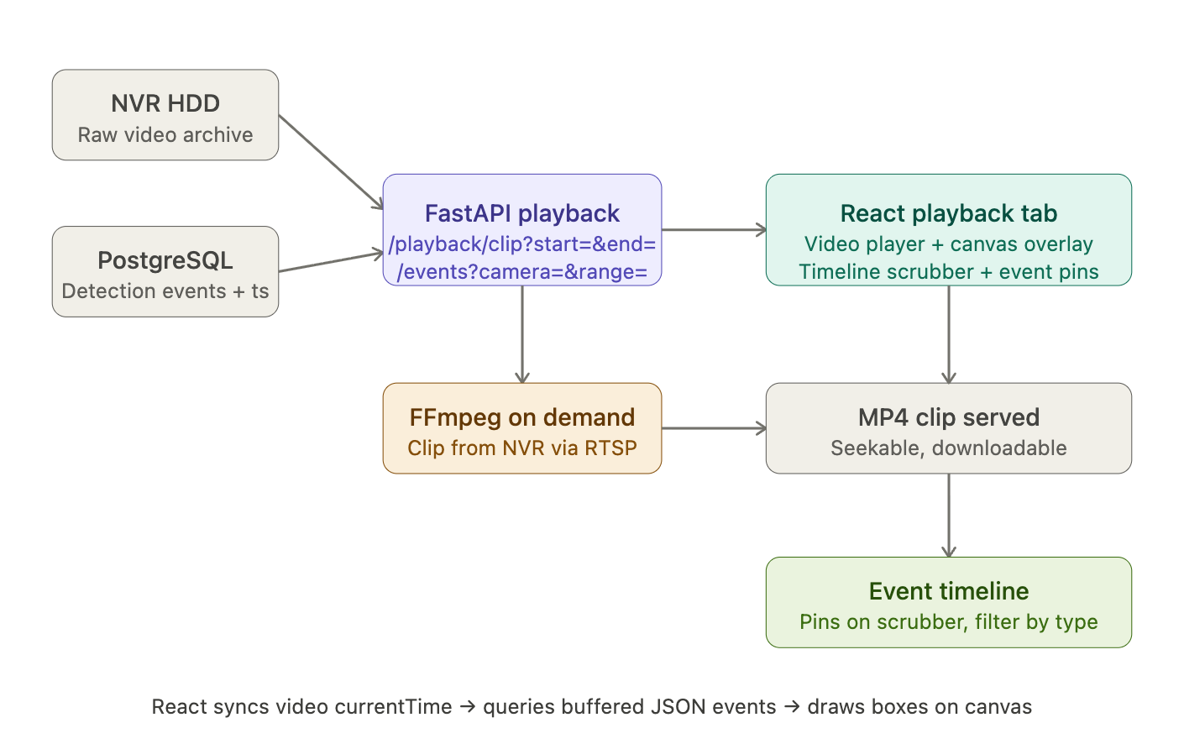
1. Video clip retrieval — Your FastAPI exposes an endpoint like GET /playback/clip?camera=1&start=2025-04-06T08:30:00&end=2025-04-06T08:35:00. This triggers FFmpeg to reach back into the NVR via RTSP and extract that time window as an MP4 file, which gets served to the React player. Hikvision NVRs support RTSP playback URLs with time parameters — it looks like rtsp://nvr-ip/Streaming/tracks/101?starttime=20250406T083000Z&endtime=20250406T083500Z. FFmpeg reads this and outputs a seekable MP4.
2. Synced detection overlay — A companion endpoint GET /events?camera=1&start=...&end=... returns all PostgreSQL detection rows for that time window as JSON. React loads this alongside the video and does the same timestamp-sync technique we discussed — as the user scrubs through the video, the canvas draws whichever detections correspond to currentTime. In playback this is actually easier than live because you have all the data upfront — no buffering needed, just a simple array lookup.
3. The event timeline scrubber — This is what makes playback genuinely useful. Instead of a plain progress bar, you render coloured pins above the scrubber — red for PPE violations, orange for unauthorised zone entry, blue for machinery events. The user clicks a pin and the video jumps to that exact moment. This is entirely a React/CSS feature built from your PostgreSQL event data — no video processing involved.
The feature that makes this production-grade: incident export
When a supervisor finds an incident in playback, they should be able to click "Export Report" which generates a PDF containing the video timestamp, camera ID, detection type, confidence score, a screenshot of the frame, and the bounding box annotation. This is a FastAPI endpoint that assembles the data from PostgreSQL and serves a PDF. Takes about a day to build and is extremely valuable for site safety documentation and legal protection.
One practical constraint to plan for
On-demand clip extraction from the NVR via RTSP is slightly slow — FFmpeg needs a few seconds to seek to the right position and start streaming. For clips under 10 minutes this is fine. For longer review sessions, consider having the Mac Mini also save a local copy of detection-adjacent clips (say, 30 seconds before and after each AI event) to its own SSD at the time of detection. Then playback for flagged events is instant — you're reading a local file, not re-fetching from the NVR.

MediaMTX isn't just a "bridge" for live video; it has a built-in Recorder and a Playback Server. It acts as both the librarian (recording) and the clerk (retrieving).
Here is the step-by-step breakdown of how the Mac Mini, the HDD, and MediaMTX work together to handle retrieval.

1. The Storage Stage (Writing to HDD)
You don't need to write a separate script to save files. You simply tell MediaMTX where the HDD is "mounted" on your Mac Mini (e.g., /Volumes/ConstructionHDD/recordings).
In your mediamtx.yml configuration:
YAML
paths:
cam1_processed:
record: yes
recordPath: /Volumes/ConstructionHDD/recordings/%path/%Y-%m-%d_%H-%M-%S
recordFormat: fmp4 # Fragmented MP4 is best for web playback
- %path: Creates a sub-folder for each camera.
- %Y-%m-%d: Names files by date and time automatically.

2. The Retrieval Stage (Finding the Files)
MediaMTX keeps an internal index of every file it has recorded. It exposes this index through its API.
When your React Dashboard wants to show the playback list, it sends a request to the Mac Mini:
- The Request: GET http://[MAC_MINI_IP]:9997/v3/recordings/list
- The Response: MediaMTX returns a JSON list of every recorded clip, including the start time, duration, and the "Path" (e.g., cam1_processed).

3. The Playback Stage (Bringing the Video Back)
This is the "Magic" part. You don't have to manually fetch a file from the HDD. MediaMTX treats recordings just like live streams.
When a user clicks a recording in your React app:
- React asks for a specific timestamp (e.g., "Show me Cam 1 from 10:00 AM yesterday").
- MediaMTX looks at its recordPath on the HDD, finds the correct .mp4 file, and "re-broadcasts" it.
- It serves it via HLS or WebRTC, so the site manager sees a video player with a seek bar, just like YouTube.

Summary of the Workflow
Component | Responsibility
HDD | The physical bucket where the .mp4 files sit.
MediaMTX (Recorder) | Watches the live stream and writes it to the HDD in small chunks.
MediaMTX (API) | Answers the question: "What files do you have for Tuesday at 2 PM?"
MediaMTX (Playback) | Reads the file from the HDD and streams it to the browser on demand.

Why this is perfect for your 20Mbps Site
- No Uploading: The video only leaves the site when someone actually clicks "Play" in the dashboard.
- HDD vs. SD Card: By using a high-capacity HDD on the Mac Mini, you can keep months of high-res footage, which is much more reliable than the tiny SD cards inside the cameras.
- Seekable Playback: Because it uses Fragmented MP4 (fmp4), the manager can jump to the middle of a 1-hour recording instantly without downloading the whole file.

