FINAL YEAR PROJECT · PROGRESS DOCUMENTATION
System Architecture — Current and Proposed
How the inherited Akela platform is built today, and exactly where my two new educational modules will plug into it
Item | Detail
Project | Extending the Akela database-education platform with Relational Algebra and Vector Database learning modules
Document | 01 — System Architecture: Current (inherited) and Proposed
Prepared by | Sanjana Yalamanchili
Supervisor | [Supervisor name]
Date / version | 25 September 2026 · v1.0 (for the Week-2 progress review)
Codebase baseline | Inherited repository FYP-Project-Version-1, branch main, commit b917118 (the last commit before my work)
Companion documents | 02 Design — Relational Algebra · 03 Design — Vector Database Labs · 04 Timeline, Risks & Open Questions

Document ID: FYP-ARCH-01

Contents

If the table of contents appears empty, right-click it in Word and choose “Update Field”.

1. Purpose, scope and how to read this document
This document has two jobs. First, it records my understanding of the inherited Akela platform — a production system (ntuakela.net) used to teach SQL and database design — so that my supervisor can see that I have studied the codebase in depth before changing it. Second, it describes the proposed architecture after my Final Year Project (FYP) adds two new educational topics: Relational Algebra (RA) and Vector Databases.
Contribution boundary — what is inherited and what is mine
Everything described in Sections 2–6 already existed when I received the project. My FYP contributions are the new and modified components described in Section 7 onwards, marked in orange (Relational Algebra) and green (Vector Database) throughout all diagrams.
To make this boundary verifiable, the inherited state is pinned at commit b917118. I will tag it baseline-inherited, so git diff baseline-inherited..main will show only my work for the rest of the project.

1.1 Sources used
- Direct reading of the source code in backend/app (FastAPI) and frontend/src (Next.js). File and line references in this document point to the baseline commit.
- HANDOFF.md (the previous maintainers’ ~2,000-line technical brief) and README.md.
- The git history: 422 commits from February 2026 to September 2026 by three previous contributors.
- Hands-on use of the application running locally against SQLite (README Quick Start). Screenshots are attached separately as evidence.

1.2 Conventions
Colour / style in figures | Meaning
Grey-blue box | Inherited component, used unchanged
Dashed outline | Inherited file I will modify (small, additive changes)
Orange box | New component for the Relational Algebra module (or shared infrastructure I build first)
Green box | New component for the Vector Database module
Yellow box | Storage (databases and database files)
Purple box | External third-party service

2. What Akela is
Akela is a web platform for teaching and practising SQL and database design, built for a university database course. Staff write practice questions, hands-on labs, entity-relationship (ER) diagram exercises and timed assessments. Students solve them in the browser. They get grading straight away, a streaming AI tutor ("Bagheera"), and a learning-analytics dashboard (behind a feature flag). There are three flat user roles: student, staff and admin (backend/app/models/user.py).

2.1 Feature inventory (inherited)
Table 1. Inherited features and where they live in the code
Area | Student can… | Staff can… | Main code
SQL Questions | Write read-only SQL against a per-question SQLite DB; get instant correct/incorrect + AI query review; see a query-structure diagram | Author, bulk-import (LeetCode bank), publish/unpublish questions | endpoints/questions.py, endpoints/execute.py, core/query_executor.py, core/answer_validator.py
SQL Labs | Run any SQL (incl. INSERT/UPDATE/DDL) in a private copy of a lab database; submit task answers | Author labs + tasks, start/stop labs, review student histories, lab analytics | endpoints/labs.py, utils/lab_db_manager.py, core/lab_query_executor.py
Graph Labs | Run Cypher queries against a private graph database | Author graph labs with Cypher seed scripts | utils/graph_db_manager.py, core/graph_query_executor.py (library: graphqlite)
ER Diagrams | Draw ER diagrams in embedded draw.io; receive rubric-based LLM grading and a Socratic tutor | Author questions and rubrics, override grades, submit on a student’s behalf | endpoints/er_diagram.py, services/erd_tutor/, services/erd_rubric/, components/DrawioBoard.tsx
Assessments | Take timed, optionally password-protected assessments made of any of the above | Build, clone, publish, schedule per class group, reset attempts, view analytics | endpoints/assessments.py, endpoints/student_assessments.py, services/assessment_*.py
AI tutor (Bagheera) | Streaming chat while working; optional adaptive mode driven by concept mastery | — | endpoints/chatbot.py, services/tutor_chat/, services/sql_tutor_*.py
Learning Analytics Dashboard (LAD) | Per-concept mastery map, SOLO-taxonomy level, anonymised peer benchmark | Tag questions with concepts | endpoints/lad.py, services/learner_profiling.py, services/solo_classifier.py
Admin | — | Users & whitelist, login activity, live presence, cohort analytics, research CSV export | endpoints/users.py, login_activity.py, research_export.py, *_analytics.py
Auth | Email/password, Google SSO, Microsoft Entra ID SSO | Same | endpoints/auth.py, core/security.py

3. Technology stack
Table 2. Technology stack
Layer | Technology | Notes relevant to my FYP
Frontend framework | Next.js 16 (App Router), React 19, TypeScript | New pages go under frontend/src/app/student/* and app/admin/*
UI | Mantine 8, Tabler icons, custom CSS modules | Operator palette and new panels use Mantine components
Editor | Monaco (@monaco-editor/react) | Supports custom languages — I will register an relalg language for RA syntax highlighting
Data fetching | TanStack Query + axios, one *.service.ts per backend area | New ra.service.ts; vector calls extend lab.service.ts
Graph layout | dagre + custom SVG (used by the SQL QueryGraph diagram) | Re-used for the RA expression-tree view — no new dependency
Backend | FastAPI, synchronous endpoints in a threadpool, Pydantic v2 | New/changed endpoints follow the same explicit response_model style
ORM / DB | SQLAlchemy 2.0; PostgreSQL in production, SQLite locally | Schema changes need a run_*.py migration and an inline ALTER in main.py
Student query engines | SQLite (sqlite3), graphqlite (Cypher on SQLite), sqlglot (MySQL→SQLite fallback) | RA compiles to SQLite SQL; vectors use the sqlite-vec SQLite extension
AI | OpenAI / Azure OpenAI, LangGraph + LangChain (ERD engines) | Tutor prompts get RA- and vector-specific variants; no new LLM infrastructure
Auth | JWT (python-jose, bcrypt), Google & Microsoft SSO | Unchanged
Hosting / CI | Frontend on Azure Static Web Apps; backend on Azure App Service (NTU-Akela-Backend, Python 3.11, Ubuntu build) via two GitHub Actions workflows | sqlite-vec must be installable on this Linux runtime (see risk R1 in Document 04)
Tests | pytest (backend); ESLint only on the frontend | I add unit tests for all new deterministic code

4. Current architecture (inherited)
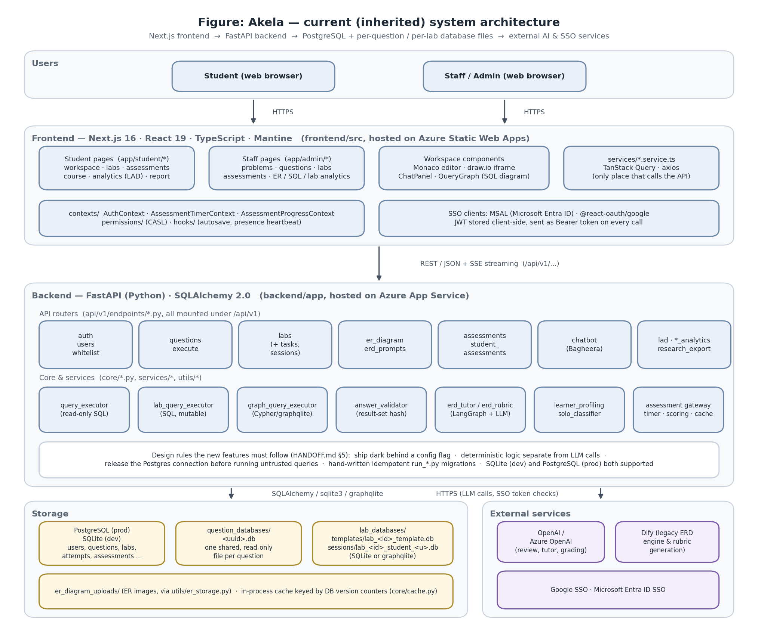
Figure 1. Current (inherited) system architecture — layers, main modules, storage and external services

4.1 Frontend layer
The frontend is a Next.js App Router application. Routes are split by role: students use app/student/* and staff use app/admin/*. ER-diagram pages live under the shared app/er-diagram/*. All server communication goes through src/services/*.service.ts, which wrap axios calls in TanStack Query hooks, so components never call the API directly. Three React contexts hold cross-page state: AuthContext (JWT and user), AssessmentTimerContext and AssessmentProgressContext.
Table 3. Frontend routes that matter for the extension
Route (frontend/src/app/…) | Purpose | Relevance to my FYP
student/workspace/[id] | Solve one SQL question (editor, results, tutor, diagram tabs) | Modified: switches to the RA editor when the question is an RA question
student/labs/[id]/workspace | Lab workspace (SQL or Graph) | Modified: renders the vector variant + scatter plot
student/assessments/[id]/items/[itemId]/{sql-question, sql-lab, graph-lab, er-question} | One page per assessment item type | RA re-uses sql-question; new vector-lab page
admin/problems | Unified bank of all problem types with filters | Modified: RA and Vector badges and filters
admin/questions/new, admin/questions/[id] | Question authoring (QuestionForm.tsx) | Modified: “Query language: SQL / Relational Algebra” toggle
admin/labs/wizard?type=… | Lab authoring wizard (LabForm.tsx, LabWizardShell.tsx) | Modified: type=vector option
admin/assessments/* | Assessment builder (AssessmentForm.tsx) | Modified: can add vector labs
student/analytics | Learning Analytics Dashboard | New RA and vector concepts appear automatically once seeded

4.2 Backend layer
backend/app/main.py builds the FastAPI app, installs middleware (CORS, a received_at timestamp used for fair assessment-time crediting), runs start-up DDL for SQLite, and mounts 21 routers under /api/v1. Business logic is split into three places: core/ (query execution, grading, security, cache), services/ (grading engines, analytics, tutors) and utils/ (database-file provisioning and storage).
Table 4. Backend routers
Router module | Responsibility | Touched by my FYP?
questions.py | CRUD for SQL questions; computes the reference-answer hash when a question is created or edited | Yes — RA reference answers are translated before hashing
execute.py | Grades one student submission for a question (3-phase handler, see §5.1) | Yes — one extra translate step for RA questions
labs.py (2,192 lines) | Labs, tasks, sessions, lab execution, task validation/submission | Yes — dispatch moves to an engine registry; vector becomes a lab type
chatbot.py | Bagheera chat, query review, counter-examples, worked examples, lab chat | Yes — RA/vector prompt variants
assessments.py, student_assessments.py | Assessment authoring, publishing, sessions, scoring | Yes — new vector_lab item type
er_diagram.py, erd_prompts.py, er_analytics.py | ER exercises, rubrics, analytics | No
auth.py, users.py, whitelist.py, login_activity.py | Identity and access | No
lad.py, sql_analytics.py, lab_analytics.py, research_export.py, student_report.py | Analytics and reporting | Minor — new type labels/counters

Table 5. Core and service modules
Core / service module | What it does
core/query_executor.py | Runs a student’s SQL against a question DB. Allows only read-only statements: the leading keyword must be SELECT/WITH/EXPLAIN/VALUES, and a word-boundary blacklist blocks DROP, INSERT, ATTACH, etc. Uses a thread plus a SQLite progress-handler deadline (core/query_deadline.py) so runaway queries really stop.
core/sql_dialect.py | Best-effort MySQL→SQLite rewrite using sqlglot, tried only if the original query fails
core/answer_validator.py | Normalises a result set (numbers→float, whitespace collapsed, rows sorted unless order-sensitive) and SHA-256-hashes it; compares with the stored correct_answer_hash
core/advanced_sql_grader.py | 3-stage grading for trigger/DML questions using an in-memory clone and hidden test/check scripts
core/lab_query_executor.py / core/graph_query_executor.py | Execute SQL / Cypher against a student’s private lab DB copy; identical result shape so the lab machinery doesn’t care which engine ran
utils/lab_db_manager.py / utils/graph_db_manager.py | Create lab templates, copy them per student, reset, delete
services/erd_tutor/, services/erd_rubric/ | LangGraph engines for ER grading and tutoring (selectable against legacy Dify via ERD_TUTOR_ENGINE)
services/learner_profiling.py, services/solo_classifier.py, services/concept_taxonomy_seed.py | Deterministic concept-mastery updates; LLM SOLO classification; the hand-written SQL concept taxonomy (27 concepts)
services/assessment_*.py | Timing gateway, timers, scoring, cloning on publish, reset
core/cache.py | In-process cache invalidated by version counters stored in the DB

4.3 Data and storage
The application database (PostgreSQL in production, SQLite locally) stores users, content metadata, attempts, sessions, assessments and analytics. Student queries never run against the application database. They run against separate SQLite files:
- question_databases/<uuid>.db — one shared file per SQL question. Sharing is safe only because the question executor is read-only.
- lab_databases/templates/lab_<id>_template.db — one template per lab, which students never touch.
- lab_databases/sessions/lab_<id>_student_<user>.db — one private copy per student per lab, because lab queries may change data.
- er_diagram_uploads/ — uploaded ER images, reached through utils/er_storage.py.

4.4 External services
- OpenAI / Azure OpenAI — query review, the tutor, ERD grading and SOLO classification. The Azure resource only supports the unified v1 API surface (HANDOFF §6.3).
- Dify — the legacy ERD engine, still required for ER rubric generation.
- Google and Microsoft Entra ID — single sign-on.

4.5 Deployment
Two independent GitHub Actions workflows deploy the system. azure-static-web-apps-*.yml deploys the frontend to Azure Static Web Apps using its Next.js hybrid-rendering support. main_fyp-sql-learning.yml builds the backend on Ubuntu with Python 3.11 and deploys it to the Azure App Service NTU-Akela-Backend. No CI step applies database migrations: run_*.py scripts are run by hand before a deploy that needs them.

5. Key runtime flows (inherited)

5.1 Grading an SQL question
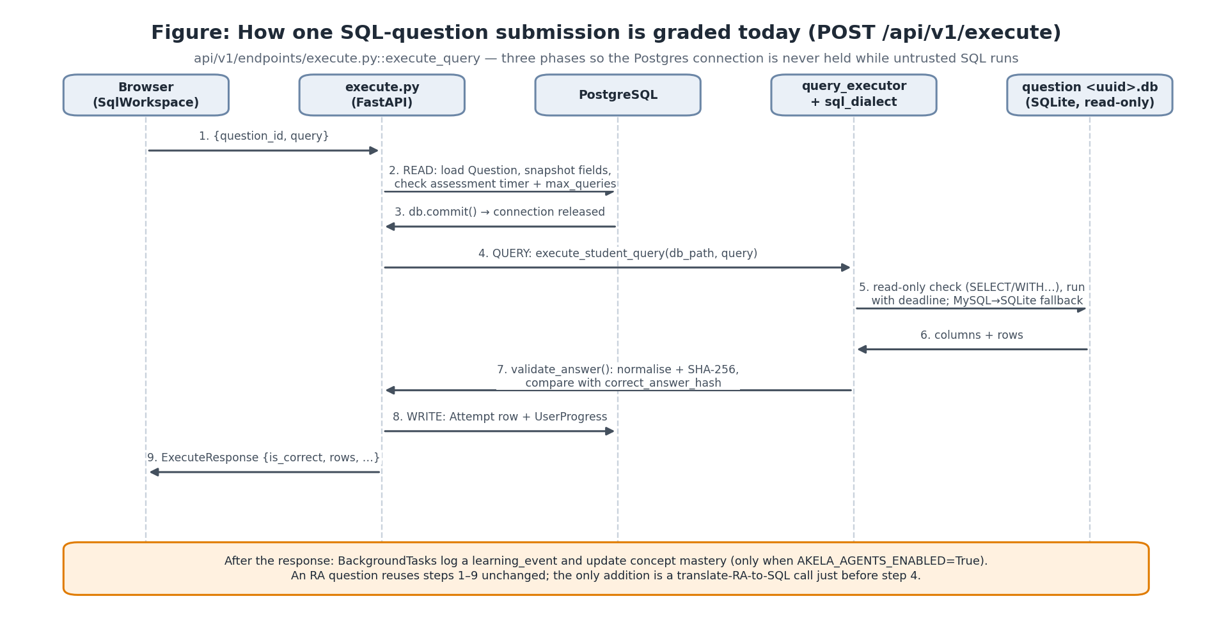
Figure 2. Sequence of POST /api/v1/execute — the flow the RA module re-uses
execute.py::execute_query runs in three phases. The read phase loads the question, copies every needed field into local variables, enforces the assessment timer and the per-item max_queries cap, then commits so the PostgreSQL connection returns to the pool. The query phase runs the untrusted SQL against the SQLite file with no PostgreSQL connection held. It then hashes the result and compares it with the stored hash. The write phase records an Attempt and updates UserProgress. A finally block credits the query’s wall-clock time back to the student’s assessment deadline. Learning-analytics telemetry runs afterwards as BackgroundTasks.
Why this matters for Relational Algebra
Because grading compares a hash of the result, it doesn’t care how the result was produced. If I translate an RA expression into an equivalent SQL query, the whole pipeline — the read-only executor, hashing, attempts, progress, assessment timers, max-query caps and telemetry — works for RA without being rewritten.

5.2 Labs: template plus per-student copy
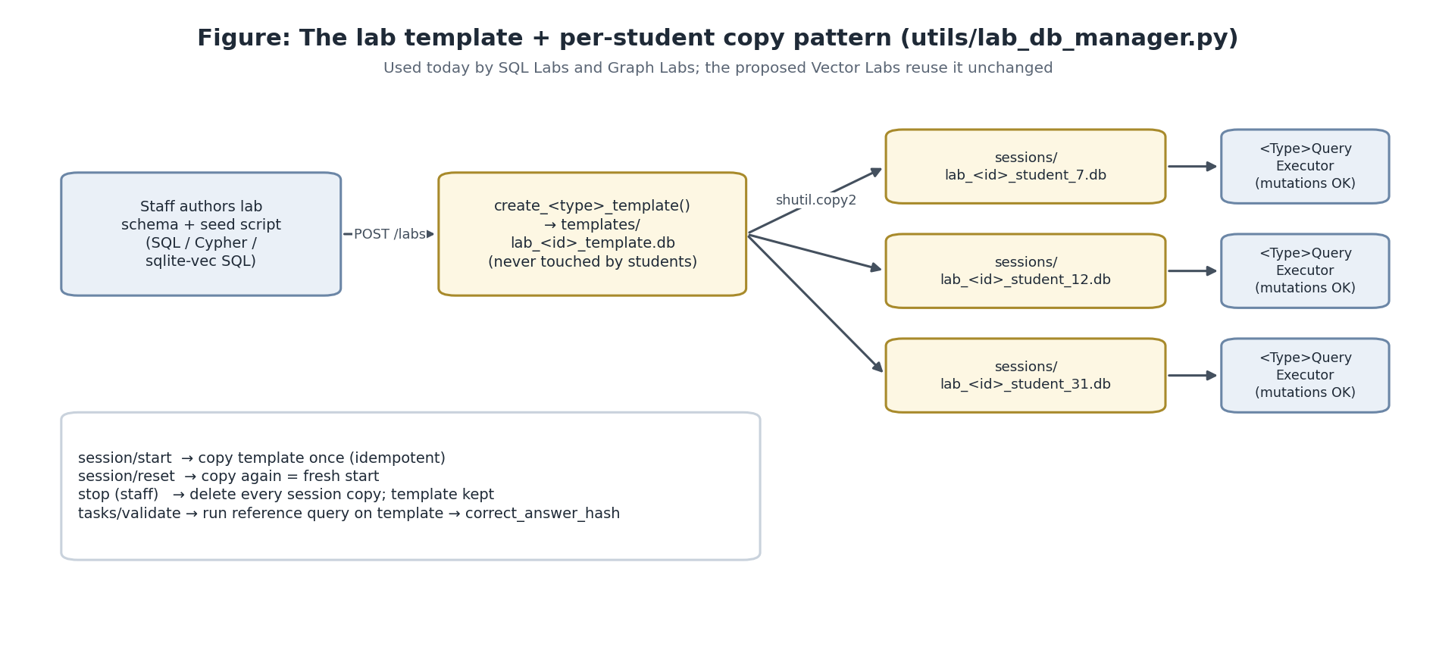
Figure 3. The lab template / session pattern used by SQL and Graph Labs (and, in future, Vector Labs)
Labs allow data changes, so each student gets a private copy of a template database. POST /labs builds the template. POST /labs/{id}/session/start copies it once (calling it again is safe). POST /labs/{id}/session/reset copies it again, and staff stop deletes every copy. Queries run through POST /labs/session/{id}/execute, which picks LabQueryExecutor or GraphQueryExecutor based on lab.lab_type. Task grading is split: staff validate a task’s reference query on the template to produce correct_answer_hash, and POST /labs/tasks/submit hashes the result set the client reports.
Known limitation I inherit (HANDOFF §11)
POST /labs/tasks/submit trusts the columns/results sent by the browser instead of re-running the query on the server. This is acceptable for practice labs. Before vector labs are used in graded assessments, I will re-execute on the server for vector tasks (Document 03, §8.4).

5.3 ER diagrams (context only)
ER exercises have no student database. The student’s draw.io XML (or an image) goes to the grading engine selected by ERD_TUTOR_ENGINE. The LangGraph engine turns the diagram into a canonical form, an LLM judges each rubric check, and a fixed formula computes the score. My FYP does not change this subsystem, but its structure (an LLM for judgement, deterministic scoring) is the model I follow for any AI help I add.

5.4 Assessments
An assessment is a list of AssessmentItem rows with item_type ∈ {sql_question, er_question, sql_lab, graph_lab} and an item_id. On publish, each item is cloned (services/assessment_clone.py). The clone carries owner_assessment_id, which gives each assessment its own attempt history. Execution endpoints recognise a clone by this field and enforce timers. Scoring uses each student’s best attempt, weighted per item.

5.5 AI tutor and learning analytics
Bagheera streams chat responses with the question/lab context injected into the prompt. When AKELA_AGENTS_ENABLED is on, every submission writes a learning_event, and learner_profiling.py moves the student’s mastery (0–1) for each concept tagged on that question by a fixed amount. SQL_TUTOR_ADAPTIVE switches the tutor to scaffolding that depends on mastery. Concepts come from a hand-written list with prerequisite links (concept_taxonomy_seed.py).

6. Design principles I must respect
HANDOFF §5 records deliberate design decisions. My extension follows them, so it looks like the existing code rather than a bolt-on:
Table 6. Inherited design principles and how the extension follows them
Principle (HANDOFF ref.) | What it means | How my design applies it
Ship dark behind flags (§5.1) | New features are merged to main behind env-var flags that default to off | RA_QUESTIONS_ENABLED and VECTOR_LABS_ENABLED, both default False
Deterministic logic separate from LLM logic (§5.2) | Anything that can be computed exactly is plain Python and unit-testable; LLM calls sit behind a narrow interface with a fallback | The RA translator and vector grading are 100% deterministic; the LLM is used only for tutoring
No queue infrastructure (§5.3) | Use FastAPI BackgroundTasks; no Celery/Redis | Nothing new needs background work; PCA for the scatter plot is computed on request (small data)
Release the DB connection before untrusted work (§6.7) | Read → commit → run → write | RA translation and vector queries run in the existing query phase
One codebase for SQLite and PostgreSQL (§5.7) | ORM code must work on both | Only new nullable/defaulted columns; no dialect-specific SQL in the application DB
Hand-written idempotent migrations (§5.8, §8) | run_*.py scripts plus an inline ALTER in main.py for SQLite | run_add_query_language_question_migration.py; lab_type='vector' needs no schema change (String(10))
Flat roles + ownership (§5.9) | No general ACL system | Unchanged: staff author, students solve
Extend labs via a template builder and executor pair (§6.2) | “If you’re adding a third lab flavor, follow this same shape” | create_vector_template + VectorQueryExecutor

7. Proposed architecture
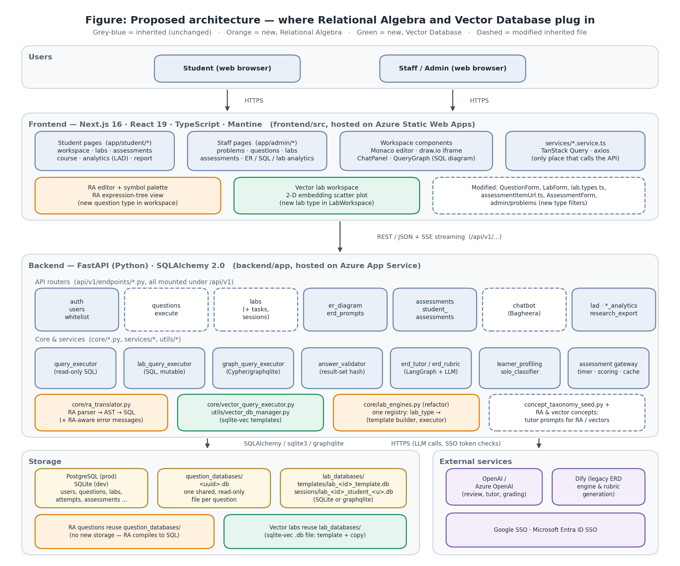
Figure 4. Proposed architecture — new components (orange/green) and modified inherited files (dashed)
The central idea is to reuse as much as possible and add as little as needed. Relational Algebra becomes a new kind of Question, because RA is read-only and graded by its result, exactly like SQL questions. Vector Databases become a new kind of Lab, because students need their own database to insert and search vectors in, exactly like SQL and Graph labs.

7.1 Why these two integration points (options considered)
Table 7. Integration options considered
Option | Pros | Cons | Decision
RA as a Question variant (query_language='ra') | Re-uses read-only executor, hashing, attempts, progress, max-query caps, assessments (sql_question item type) and SQL analytics; smallest change | Must translate RA to SQL faithfully (set semantics, naming) | Chosen
RA as a Lab type | Re-uses lab machinery | Labs exist for changing data; RA is read-only, so a per-student copy is wasted work; task-submit trusts the client | Rejected
RA as a standalone module (own tables and pages) | Full freedom | Would duplicate grading, assessments and analytics; much larger and harder to maintain | Rejected
Vector DB as a Lab type (lab_type='vector') | Students create and change vector tables; the handoff says to extend labs this way; per-student isolation for free | Needs the sqlite-vec extension on the server | Chosen
Vector DB as a Question variant | Simpler grading | Read-only only; can’t teach inserting, indexing or updating embeddings | Rejected (read-only tasks can still be lab tasks)
Vector DB on a shared server (pgvector, Chroma) | Industry-realistic | Breaks per-student isolation; more infrastructure; conflicts with §5.3 | Rejected for the platform (covered in teaching material)

7.2 Component inventory
Table 8. New and modified components
Component | Status | Layer | Module | Purpose
backend/app/core/ra/ (parser, AST, checker, SQL generator, errors) | New | Backend core | RA | Translate RA text to SQLite SQL plus a JSON tree and RA-level error messages
backend/app/core/ra/grammar.lark | New | Backend core | RA | Formal grammar of the supported RA dialect (Unicode and ASCII)
POST /api/v1/ra/parse | New endpoint | API | RA | Live preview: returns the tree / errors without grading or logging
Question.query_language | New column | Data model | RA | 'sql' (default) or 'ra'
questions.py, execute.py | Modified | API | RA | Translate before hashing (authoring) and before executing (students)
core/lab_engines.py | New (refactor) | Backend core | Shared | One registry: lab_type → (template builder, executor, schema info)
utils/vector_db_manager.py | New | Backend utils | Vector | Build vector lab templates with sqlite-vec loaded
core/vector_query_executor.py | New | Backend core | Vector | Run student SQL with vector functions; normalise float output
GET /labs/session/{id}/vector-projection | New endpoint | API | Vector | 2-D PCA coordinates for the scatter plot
AssessmentItem.item_type='vector_lab' | New value | Data model | Vector | Vector labs inside assessments
concept_taxonomy_seed.py | Modified | Services | Both | Add RA and vector concepts plus prerequisite links
sql_tutor_prompts.py, chatbot.py | Modified | Services/API | Both | Prompt variants and schema context for RA and vectors
RaEditor, OperatorPalette, RaTreeView | New | Frontend | RA | Student RA workspace
VectorPlot, vector option in LabForm | New / modified | Frontend | Vector | Student and staff UI for vector labs
config.py | Modified | Config | Both | RA_QUESTIONS_ENABLED, VECTOR_LABS_ENABLED, RA_MAX_EXPR_CHARS, VECTOR_MAX_ROWS…

7.3 Foundational refactor: a lab-engine registry
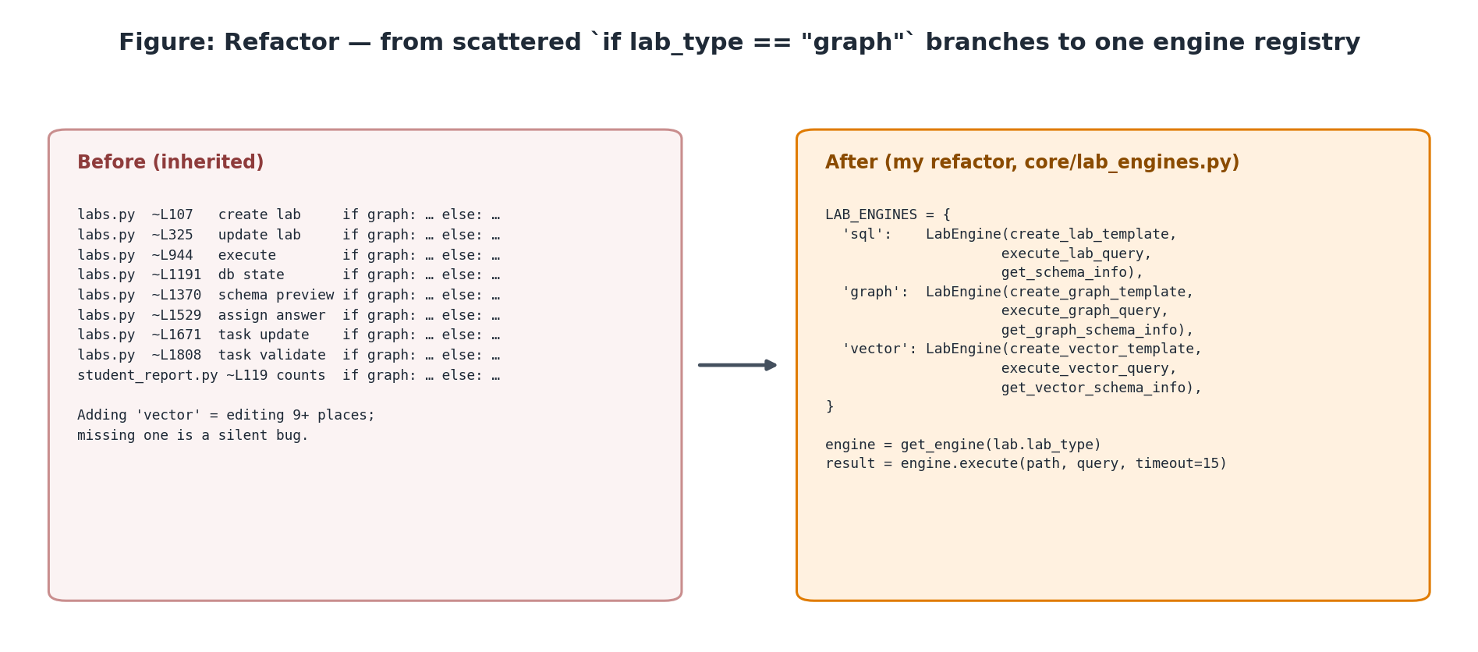
Figure 5. Replacing scattered lab-type branches with one registry before adding a third lab type
Today, labs.py checks if lab.lab_type == "graph" in about eight places (create, update, execute, database state, schema preview, task assign, task update, task validate), and student_report.py checks it again. Adding vector by copying that pattern would mean editing nine or more places, and missing one would be a silent bug. So the first engineering step is a small refactor: a LabEngine dataclass and a LAB_ENGINES dictionary in core/lab_engines.py, with regression tests confirming that SQL and Graph labs behave exactly as before. Adding the vector engine is then a single registry entry.

7.4 Data-model changes
Table 9. Schema changes (all additive)
Table.column | Change | Migration | Backward compatible?
questions.query_language | New String(10), NOT NULL, default 'sql' | run_add_query_language_question_migration.py + inline ALTER in main.py | Yes — every existing row becomes 'sql'
labs.lab_type | New allowed value 'vector' | None (column is already String(10)) | Yes
assessment_items.item_type | New allowed value 'vector_lab' | None (String(30)) | Yes
sql_concepts, sql_concept_prerequisites | New rows (RA and vector concepts) | Re-run the idempotent seed_taxonomy | Yes
labs.vector_config (optional) | New nullable Text (JSON: which table/columns hold vectors, labels and query vectors, for the plot) | run_add_lab_vector_config_migration.py + inline ALTER | Yes — NULL for SQL/Graph labs
lab_tasks (optional) | grading_mode ('exact' | 'id_set' | 'id_ranked') | run_add_lab_task_grading_mode_migration.py | Yes — default 'exact' keeps current behaviour

7.5 API changes
Table 10. API surface changes
Endpoint | Change | Notes
POST /api/v1/questions, PUT /questions/{id} | Accept query_language; RA reference answers are translated before hashing | Request schema gains an optional field
POST /api/v1/execute | If the question is RA: translate, then run as today | ExecuteResponse gains optional ra_tree, generated_sql, ra_error
POST /api/v1/ra/parse | New — returns {ok, tree, output_schema, errors[]} | No grading, no Attempt row; rate-limited by input size
POST /api/v1/labs (lab_type='vector') | Template built by create_vector_template | Only allowed when VECTOR_LABS_ENABLED
POST /labs/session/{id}/execute | Dispatch through the registry | Vector results come back with floats rounded
GET /labs/session/{id}/vector-projection | New | Returns [{id, label, x, y}] + explained variance
POST /labs/tasks/submit | For vector tasks: re-run on the server before hashing | Closes the inherited trust gap for this lab type
POST /chatbot/send, /query-review, /lab-chat | RA- and vector-aware context | Same streaming protocol

7.6 Assessment integration
RA needs no new assessment item type. An RA question is still a Question row, so it goes into an assessment as sql_question. The existing …/items/[itemId]/sql-question page reads question.query_language and shows the RA editor. Timers, max-query caps, cloning and scoring work unchanged.
Vector labs follow the graph_lab precedent and get a new vector_lab item type. A code search found where graph_lab is referenced, and each of those places needs a matching entry:
- Backend: models/assessment_item.py, schemas/assessment.py, endpoints/assessments.py, endpoints/labs.py, endpoints/student_report.py, services/assessment_clone.py, assessment_reset.py, assessment_scoring.py (7 references), assessment_timer.py.
- Frontend: types/assessment.types.ts, utils/assessmentItemUrl.ts, components/admin/AssessmentForm.tsx, StudentReportDrawer.tsx, app/admin/assessments/[id]/students/page.tsx, app/student/assessments/[id]/overview/page.tsx, and a new route …/items/[itemId]/vector-lab/page.tsx.

7.7 Cross-cutting concerns
Table 11. Non-functional design
Concern | Approach
Security — RA | The translator only ever emits SELECT/WITH. Identifiers are checked against the schema and quoted; literals are escaped. The generated SQL still goes through the inherited read-only executor (two layers of defence). Input length and nesting depth are capped to stop parser denial of service.
Security — vectors | The extension is loaded by server code, and enable_load_extension(False) is called straight afterwards, so student SQL can never call load_extension(). Row count, dimension and seed-script size are capped. The inherited 15 s deadline applies.
Performance | RA translation is pure CPU and takes milliseconds. Teaching-sized vector tables (≤ 5,000 rows, ≤ 384 dimensions) are fast with exact k-NN, and vec0 k-NN is available for larger sets.
Portability | Local SQLite and production PostgreSQL both work (only additive columns). sqlite-vec ships wheels for macOS, Linux and Windows; a pure-Python fallback covers environments that can’t load extensions (Document 03 §6).
Observability | Re-use learning_event telemetry. New event payload fields: language='ra', ra_error_code, operators_used, lab_type='vector'.
Feature flags | Both modules invisible until their flag is on; the frontend reads flags from the existing app_settings endpoint.
Accessibility | RA operators can be typed in ASCII (e.g. \select_{…}) as well as clicked; palette buttons have aria-labels; the tree and scatter plot have text equivalents (tables).

8. Requirements traceability
Table 12. Traceability from requirements (Documents 02/03) to components
Requirement (summary) | Satisfied by
FR-RA-01 Staff can author an RA question with an RA reference answer | QuestionForm toggle, questions.py, core/ra
FR-RA-02 Students write RA using symbols or ASCII and get graded | RaEditor, OperatorPalette, execute.py, core/ra
FR-RA-03 Students see their expression as a tree | /ra/parse, RaTreeView
FR-RA-04 Errors are explained in RA terms | core/ra/errors.py
FR-RA-05 RA questions work inside assessments | Existing sql_question item type + RA-aware item page
FR-VEC-01 Staff can author a vector lab with seed vectors and tasks | LabForm vector option, vector_db_manager, registry
FR-VEC-02 Students run similarity queries in a private DB | VectorQueryExecutor, lab sessions
FR-VEC-03 Results are graded deterministically | Float normalisation, grading_mode, server-side re-execution
FR-VEC-04 Students can see embeddings visually | vector-projection endpoint, VectorPlot
FR-VEC-05 Vector labs work inside assessments | vector_lab item type
FR-X-01 Tutor understands both topics | Prompt variants, schema context
FR-X-02 LAD tracks mastery of new concepts | Taxonomy additions, concept tagging

9. Repository hygiene and evidence of contribution
- Baseline tag. git tag baseline-inherited b917118 marks the hand-over point. Every later diff against this tag is my work.
- Branches. Short-lived feature branches (feat/ra-parser, feat/lab-engine-registry, feat/vector-labs…) merged to main behind feature flags, following the inherited ship-dark practice.
- Prototypes. Proof-of-concept scripts live in a top-level prototypes/ folder, outside the application, so they are clearly separate.
- Design documents. The inherited .gitignore excludes docs/ (HANDOFF §11). I will keep my documents in a committed folder (e.g. fyp-docs/) so they are version-controlled.
- Tests. Every new deterministic module ships with pytest tests under backend/tests/ (translator golden tests, registry regression tests, vector grading tests).
- Changelog. A running FYP_CHANGELOG.md lists each change, the related requirement ID and the date. It becomes raw material for the final report.

Appendix A. Glossary
Term | Meaning
Akela / Bagheera | Platform name / AI tutor persona (Jungle Book references; cosmetic)
RA | Relational Algebra: the formal query language of the relational model (σ, π, ⋈, ∪, −, ÷ …)
AST | Abstract syntax tree: the parsed, typed structure of an expression
Embedding | A fixed-length numeric vector representing an item (text, image …) so that similar items are close together
k-NN / ANN | k nearest neighbours (exact) / approximate nearest neighbours (index-based, e.g. HNSW)
sqlite-vec | An open-source SQLite extension adding vector types, distance functions and the vec0 k-NN virtual table
Template / session DB | Lab database built once by staff / private copy per student
LAD | Learning Analytics Dashboard
SOLO | Structure of the Observed Learning Outcome — taxonomy of response complexity
Ship dark | Merge a feature to main behind a disabled flag; enable later

Appendix B. Key inherited files (quick reference)
backend/app/main.py app assembly, router wiring, SQLite start-up ALTERs
backend/app/config.py all env-driven settings and feature flags
backend/app/api/v1/endpoints/execute.py SQL question grading (3-phase)
backend/app/api/v1/endpoints/questions.py question CRUD + reference hash
backend/app/api/v1/endpoints/labs.py labs, sessions, tasks, lab execution
backend/app/core/query_executor.py read-only SQL executor
backend/app/core/answer_validator.py result normalisation + SHA-256
backend/app/core/graph_query_executor.py Cypher executor (template for new engines)
backend/app/utils/lab_db_manager.py template/session file management
backend/app/services/concept_taxonomy_seed.py SQL concept list + prerequisites
frontend/src/components/workspace/* SQL and lab workspaces, QueryGraph
frontend/src/components/admin/* QuestionForm, LabForm, AssessmentForm
frontend/src/services/*.service.ts API client layer
HANDOFF.md previous maintainers' technical brief

