FINAL YEAR PROJECT · PROGRESS DOCUMENTATION
Design Document — Relational Algebra Module
Letting students write, visualise and get graded on relational-algebra queries inside Akela, reusing the platform’s SQL grading pipeline
Item | Detail
Project | Extending the Akela database-education platform with Relational Algebra and Vector Database learning modules
Document | 02 — Design Document: Relational Algebra module
Prepared by | Sanjana Yalamanchili
Supervisor | [Supervisor name]
Date / version | 25 September 2026 · v1.0 (for the Week-2 progress review)
Status | Design proposal: open for supervisor feedback. No production code written yet.
Depends on | Document 01 (architecture), §7

Document ID: FYP-DES-RA-02

Contents

If the table of contents appears empty, right-click it in Word and choose “Update Field”.

1. Introduction

1.1 Background and motivation
Relational algebra (RA) is the formal query language of the relational model introduced by Codd (1970). It is taught in almost every introductory database course before or alongside SQL, because it explains what a query means: every SQL query corresponds to an expression built from a small set of operators (selection σ, projection π, join ⋈, set operations, rename ρ, division ÷).
Students commonly struggle with RA for three reasons: (1) they practise it on paper, so nothing tells them straight away whether an expression is correct; (2) they find it hard to picture how nested operators build the result; and (3) they struggle to connect RA to the SQL they write. Stand-alone RA tools exist — notably RelaX (a web RA calculator from the University of Innsbruck) and radb (a Python RA interpreter from Duke University) — but they are separate from course platforms. They do not grade against staff answers, track mastery, work inside assessments, or give access to a tutor.
Akela already has all of that infrastructure for SQL. This module adds RA to it, so RA practice gets the same grading, tutor, analytics and assessment support as SQL practice.

1.2 Goals
- Staff can author RA questions (with an RA reference answer) using the same workflow as SQL questions.
- Students can write RA using Unicode symbols (clickable palette) or plain ASCII, and receive instant, deterministic grading.
- Students can see their expression as an operator tree and, when stuck, inspect the generated SQL.
- Errors are explained in RA terms (unknown attribute, union-incompatible inputs …), not as raw SQLite messages.
- RA questions work everywhere SQL questions work: question bank, assessments, timers, analytics, Learning Analytics Dashboard (LAD), and the Bagheera tutor.

1.3 Non-goals
- Tuple or domain relational calculus (possible future work).
- Query optimisation teaching (e.g. equivalence-rule rewriting). The tree view could support this later, but it is out of scope.
- Bag (multiset) algebra as the default. The module uses set semantics, as most textbooks do. Bag semantics could become a per-question option later.
- Replacing SQL questions. RA is an additional question language.

2. Stakeholders and user stories
ID | As a… | I want to… | So that…
US-1 | Student | type an RA expression and press Run | I immediately know if it is correct
US-2 | Student | click σ, π, ⋈ … instead of hunting for symbols | notation isn’t a barrier
US-3 | Student | see my expression as a tree | I understand how operators nest
US-4 | Student | get errors that name the wrong attribute or operator | I can fix my own mistakes
US-5 | Student | optionally see the equivalent SQL | I connect RA to SQL
US-6 | Student | ask Bagheera for a hint on my RA | I get unstuck without being given the answer
US-7 | Staff | author an RA question with the familiar question form | I don’t learn a new tool
US-8 | Staff | write the reference answer in RA | grading matches the lecture notation
US-9 | Staff | include RA questions in timed assessments | RA can be examined on the platform
US-10 | Staff / researcher | see which operators and errors students struggle with | I can adapt teaching

3. Requirements

3.1 Functional requirements
Table 1. Functional requirements (MoSCoW)
ID | Requirement | Priority
FR-RA-01 | A question has a query_language of sql (default) or ra; staff choose it in the question form | Must
FR-RA-02 | Supported operators: σ, π, ρ, ×, ⋈ (natural), ⋈θ (theta), ∪, ∩, −, ÷, and assignment (←) | Must
FR-RA-03 | Each operator has a Unicode form and an ASCII form; both parse to the same tree | Must
FR-RA-04 | Student submissions are graded by result equivalence with the reference answer | Must
FR-RA-05 | Syntax and semantic errors are reported with line/column and an RA-level explanation | Must
FR-RA-06 | A clickable operator palette inserts operator templates into the editor | Must
FR-RA-07 | A live tree view shows the parsed expression and each node’s output schema | Should
FR-RA-08 | Clicking a tree node shows that sub-expression’s intermediate relation | Should
FR-RA-09 | A “Show SQL” tab shows the generated SQL (can be hidden per question or in assessments) | Should
FR-RA-10 | Extended operators: grouping/aggregation γ, outer joins (⟕ ⟖ ⟗), semi-join (⋉) | Could
FR-RA-11 | Autocomplete of relation and attribute names from the question schema | Could
FR-RA-12 | RA questions can be added to assessments and respect timers and max-query caps | Must
FR-RA-13 | The tutor and AI query review understand RA submissions | Should
FR-RA-14 | RA concepts appear in the LAD and mastery updates on each RA submission | Should

3.2 Non-functional requirements
Table 2. Non-functional requirements
ID | Requirement | Target / measure
NFR-RA-01 Correctness | Translation preserves RA set semantics | 100% pass on the golden test suite + equivalence tests (§10)
NFR-RA-02 Performance | Parse + check + translate time | < 50 ms for expressions up to 2,000 characters
NFR-RA-03 Security | No student input can cause a write or escape the question DB | Output is SELECT/WITH only and passes the read-only executor
NFR-RA-04 Robustness | Hostile input cannot exhaust the server | Max 5,000 characters, max nesting depth 64, parser timeout
NFR-RA-05 Compatibility | No change to behaviour of existing SQL questions | All existing tests pass; flag off = identical behaviour
NFR-RA-06 Usability | Usable by first-year students | System Usability Scale (SUS) ≥ 68 in the pilot
NFR-RA-07 Maintainability | The grammar is the single source of truth | One .lark file; no duplicate parser in the frontend

4. The RA language supported

4.1 Operators
Table 3. Supported operators
Operator | Unicode form | ASCII form | Meaning | SQL shape it becomes
Selection | σ[age > 20](Student) | \select_{age > 20} Student | Keep tuples satisfying a condition | SELECT DISTINCT * FROM (…) WHERE cond
Projection | π[name, age](Student) | \project_{name, age} Student | Keep listed attributes; remove duplicates | SELECT DISTINCT name, age FROM (…)
Rename | ρ[S](Student) · ρ[S(id, n, a)](Student) | \rename_{S} Student | Rename relation and/or attributes | Column aliases / new qualifier
Cartesian product | Student × Course | Student \cross Course | All pairs of tuples | … CROSS JOIN …
Natural join | Student ⋈ Enrolled | Student \join Enrolled | Join on all common attribute names | JOIN … ON l.a = r.a … with common attributes kept once
Theta join | Student ⋈[Student.sid = E.sid] E | Student \join_{…} E | Product + selection | JOIN … ON cond
Union | R ∪ S | R \union S | Tuples in either | UNION
Intersection | R ∩ S | R \intersect S | Tuples in both | INTERSECT
Difference | R − S (also -) | R \diff S | Tuples in R not in S | EXCEPT
Division | R ÷ S | R \divide S | R-tuples related to all S-tuples | Double NOT EXISTS
Assignment | T ← expr; | T := expr; | Name an intermediate result | Common table expression (WITH T AS …)
Grouping (Could) | γ[major; COUNT(sid) → n](Student) | \group_{major; count(sid) -> n} Student | Aggregate per group | GROUP BY

Conditions support =, ≠ (<>, !=), <, ≤ (<=), >, ≥ (>=), the logical connectives ∧ (and), ∨ (or), ¬ (not), parentheses, numeric literals and single-quoted string literals. Attributes can be qualified (Student.sid) or bare (sid).
Notation decision to confirm with the supervisor
I use square brackets for operator parameters (σ[cond](R)) because the grammar is then unambiguous and easy to explain in error messages. Some textbooks and RelaX write σ cond (R) with a subscript and no brackets. If the course’s lecture notes use a particular style, the parser can accept it as another form of the same syntax (open question O-RA-1).

4.2 Grammar (Lark EBNF, draft)
// backend/app/core/ra/grammar.lark (draft v0.1)
start : (assignment ";")* expr ";"?
assignment : NAME ("←" | ":=") expr

?expr : setexpr
?setexpr : setexpr UNION joinexpr -> union
| setexpr INTERSECT joinexpr -> intersect
| setexpr MINUS joinexpr -> difference
| joinexpr
?joinexpr : joinexpr JOIN param? unary -> join // natural or theta
| joinexpr CROSS unary -> product
| joinexpr DIVIDE unary -> division
| unary
?unary : SELECT param unary -> select
| PROJECT param unary -> project
| RENAME param unary -> rename
| GROUP param unary -> group
| atom
?atom : NAME -> relation
| "(" expr ")"

param : "[" condition_or_list "]" | "_{" condition_or_list "}"
UNION : "∪" | "\\union"
INTERSECT : "∩" | "\\intersect"
MINUS : "−" | "-" | "\\diff"
JOIN : "⋈" | "\\join"
CROSS : "×" | "\\cross"
DIVIDE : "÷" | "\\divide"
SELECT : "σ" | "\\select"
PROJECT : "π" | "\\project"
RENAME : "ρ" | "\\rename"
GROUP : "γ" | "\\group"
// condition grammar: or_expr / and_expr / not_expr / comparison / literal …
Listing 1. Draft grammar. Unary operators bind tightest, then join/product/division, then set operations; binary operators are left-associative.

4.3 Semantics and naming rules
Table 4. Semantic decisions
Rule | Decision | Why
D-RA-1 Set semantics | Every operator removes duplicates (SELECT DISTINCT, UNION not UNION ALL) | Matches the textbook definition of a relation as a set
D-RA-2 Schema of a base relation | Taken from the question’s SQLite file (PRAGMA table_info) | Staff keep authoring schemas in SQL as today
D-RA-3 Natural join | Joins on all common attribute names; common attributes appear once; if no common attributes it equals × | Textbook definition
D-RA-4 Product with clashing names | Clashing attributes become qualified (Student.sid, Enrolled.sid) | Allows later σ/π to refer to either
D-RA-5 Output column names | Bare attribute name when unique in the result, otherwise the qualified name | Deterministic names are required because the grader hashes column names
D-RA-6 Union compatibility | ∪, ∩, − require equal arity; result takes the left operand’s attribute names; type mismatch → warning | Textbook rule; SQLite is loosely typed
D-RA-7 Division | R(A∪B) ÷ S(B) requires attrs(S) ⊂ attrs(R); result schema is A | Textbook definition
D-RA-8 Row order | RA results are unordered; RA questions are always order-insensitive | Relations are sets
D-RA-9 NULLs | Supported by SQLite but discouraged; authoring shows a warning if seed data contains NULLs | Classical RA has no NULLs; avoids 3-valued-logic surprises

5. Architecture and component design
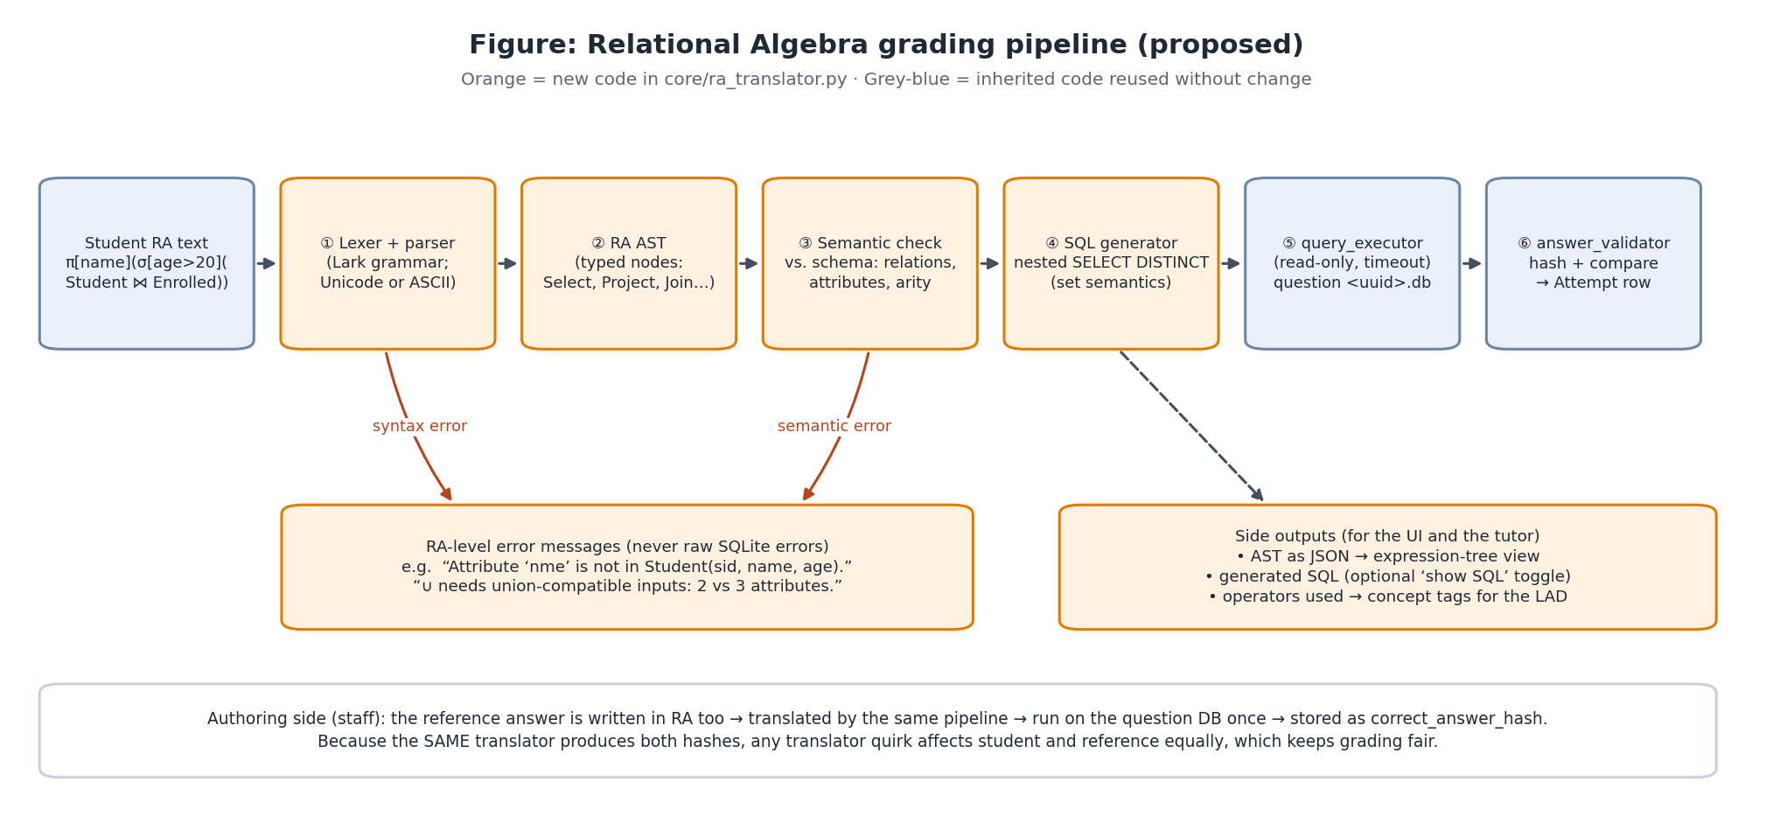
Figure 1. RA grading pipeline — new stages ①–④, inherited stages ⑤–⑥

5.1 Module layout
backend/app/core/ra/
├── __init__.py translate(expr, schema) -> TranslationResult (public API)
├── grammar.lark the grammar (Listing 1)
├── parser.py Lark LALR parser + transformer -> AST
├── ast.py dataclasses: Relation, Select, Project, Rename, Product,
│ Join, Union, Intersect, Difference, Division, Group, Assign
├── schema.py Schema/Attribute types; introspection of a question DB
├── checker.py semantic analysis: resolves names, computes output schemas
├── sql_gen.py AST -> SQLite SQL (nested subqueries, deterministic aliases)
└── errors.py RAError(code, message, line, col, hint)

5.2 Public interface
@dataclass
class TranslationResult:
sql: str # SELECT/WITH only
tree: dict # JSON tree for the frontend (node type, params, output schema)
output_attributes: list[str]
operators_used: set[str] # e.g. {"select", "natural_join", "project"} -> concept tagging
warnings: list[RAError]

def translate(expr: str, schema: Schema) -> TranslationResult # raises RAError

5.3 Semantic checker
The checker walks the tree from the leaves up and computes each node’s output schema (an ordered list of attributes, each with an optional qualifier and a SQLite type). It checks:
- Every relation exists in the question DB (RA002 unknown relation) or was assigned earlier.
- Every attribute in a condition or projection list resolves to exactly one attribute (RA003 unknown attribute, RA004 ambiguous attribute), with a “did you mean …?” hint from difflib.get_close_matches.
- Set operations have equal arity (RA005); division schemas satisfy D-RA-7 (RA006); rename lists have the right length (RA007).
- Comparisons between obviously incompatible types (TEXT vs INTEGER) produce a warning (RA008), not an error.
- Size limits (RA009): expression length, nesting depth, number of assignments.
The base-relation schema is read once per question database with PRAGMA table_info and cached in memory, keyed by the file path and modification time (question DBs are never changed by students).

5.4 SQL generation
Generation is a recursive, bottom-up translation. Each node becomes a sub-query with a deterministic alias (t1, t2, …) whose output columns are named exactly by the node’s output attribute names. Nesting sub-queries keeps the translation compositional and easy to prove correct. SQLite’s query planner flattens most of them, so performance is not a concern at teaching data sizes.
RA: π[name]( σ[age > 20]( Student ⋈ Enrolled ) )

SQL (generated, formatted):
SELECT DISTINCT t3."name"
FROM (
SELECT DISTINCT t2.*
FROM (
SELECT DISTINCT t0."sid", t0."name", t0."age", t1."cid", t1."grade"
FROM (SELECT * FROM "Student") AS t0
JOIN (SELECT * FROM "Enrolled") AS t1 ON t0."sid" = t1."sid"
) AS t2
WHERE t2."age" > 20
) AS t3;
Listing 2. Example translation: selection over a natural join, then projection
RA: π[sid, cid](Enrolled) ÷ π[cid](σ[dept = 'CS'](Course))
-- students enrolled in every CS course

SQL (generated, simplified aliases):
SELECT DISTINCT r."sid"
FROM (SELECT DISTINCT "sid", "cid" FROM "Enrolled") AS r
WHERE NOT EXISTS (
SELECT 1 FROM (SELECT DISTINCT "cid" FROM "Course" WHERE "dept" = 'CS') AS s
WHERE NOT EXISTS (
SELECT 1 FROM (SELECT DISTINCT "sid", "cid" FROM "Enrolled") AS r2
WHERE r2."sid" = r."sid" AND r2."cid" = s."cid"));
Listing 3. Division becomes a double NOT EXISTS
RA: CS ← σ[major = 'CS'](Student);
Math ← σ[major = 'Math'](Student);
π[name](CS) ∪ π[name](Math)

SQL:
WITH "CS" AS (SELECT DISTINCT * FROM "Student" WHERE "major" = 'CS'),
"Math" AS (SELECT DISTINCT * FROM "Student" WHERE "major" = 'Math')
SELECT "name" FROM (SELECT DISTINCT "name" FROM "CS")
UNION
SELECT "name" FROM (SELECT DISTINCT "name" FROM "Math");
Listing 4. Assignment becomes a CTE; union keeps set semantics

5.5 Error model
Table 5. Error catalogue (draft)
Code | Stage | Example message shown to the student
RA001 | Parse | Line 1, col 14: expected a relation or “(” after “⋈”, found “]”.
RA002 | Check | Relation “Students” does not exist. Available: Student, Course, Enrolled. Did you mean “Student”?
RA003 | Check | Attribute “nme” is not in σ’s input (sid, name, age). Did you mean “name”?
RA004 | Check | “sid” is ambiguous after ×: use Student.sid or Enrolled.sid.
RA005 | Check | ∪ needs union-compatible inputs: left has 2 attributes (sid, name), right has 3.
RA006 | Check | ÷ requires the divisor’s attributes (cid) to be a subset of the dividend’s (sid, name).
RA007 | Check | ρ lists 2 new names but the relation has 3 attributes.
RA008 | Check (warning) | Comparing TEXT attribute “name” with number 20 — is that intended?
RA009 | Limits | Expression is too deeply nested (max 64 levels).
RA100 | Execution | The query took too long (possible huge Cartesian product — did you mean ⋈?).

Errors carry line and col, so the Monaco editor can underline the exact place (monaco.editor.setModelMarkers). Error codes are logged in telemetry, which gives new research data: which RA misconceptions are most common.

6. Integration with the inherited platform

6.1 Data model and migration
# backend/app/models/question.py (addition)
# 'sql' (default) or 'ra'. When 'ra', correct_answer_query holds the RA
# reference expression and student submissions are RA text.
query_language = Column(String(10), nullable=False, default="sql")

Migration: backend/run_add_query_language_question_migration.py (idempotent ALTER TABLE questions ADD COLUMN query_language VARCHAR(10) NOT NULL DEFAULT 'sql', wrapped in try/except like the ~30 existing scripts), a reference copy under backend/migrations/, and the matching inline ALTER in main.py for existing local SQLite databases (HANDOFF §8).

6.2 Authoring flow (questions.py)
- Staff choose Relational Algebra in QuestionForm.tsx. The schema and seed data stay in SQL (they define the relations), and the reference-answer field becomes an RA editor.
- create_question builds the SQLite file as today (create_sqlite_from_sql).
- New: if query_language == 'ra', call translate(reference, schema_of(db)). On RAError, delete the new DB file and return HTTP 422 with the RA error, like the existing advanced-SQL error handling.
- Run the generated SQL with the existing execute_query_on_database, require ≥ 1 row (_require_answer_rows), hash with generate_hash(..., order_sensitive=False) and store it as correct_answer_hash.
- order_sensitive and advanced_sql_testing are forced off for RA questions.

6.3 Student flow (execute.py)
Only the query phase changes. After the read phase has copied the question’s fields into locals (including the new q_language) and released the PostgreSQL connection:
if q_language == "ra":
try:
tr = translate(execute_request.query, get_schema(db_path)) # pure CPU, no DB
result = execute_student_query(db_path, tr.sql) # inherited read-only executor
ra_tree, generated_sql = tr.tree, tr.sql
except RAError as e:
result = ra_error_result(e) # success=False, error_message=e.message
ra_error = e.to_dict()
else:
result = execute_student_query(db_path, execute_request.query) # unchanged
# ... validate_answer(), Attempt, UserProgress, timers, telemetry: all unchanged
Listing 5. Sketch of the only change to execute.py (the Attempt row stores the student’s RA text)

6.4 New endpoint: live parse preview
POST /api/v1/ra/parse {question_id, expression} → {ok, tree, output_schema, errors[]}. The frontend calls it about 400 ms after the student stops typing, to update the tree view and error markers. It never grades and never writes an Attempt, so exploring doesn’t count against max-query caps. Parsing happens on the backend so there is one grammar only (NFR-RA-07). A second TypeScript parser would eventually drift out of sync.

6.5 Frontend
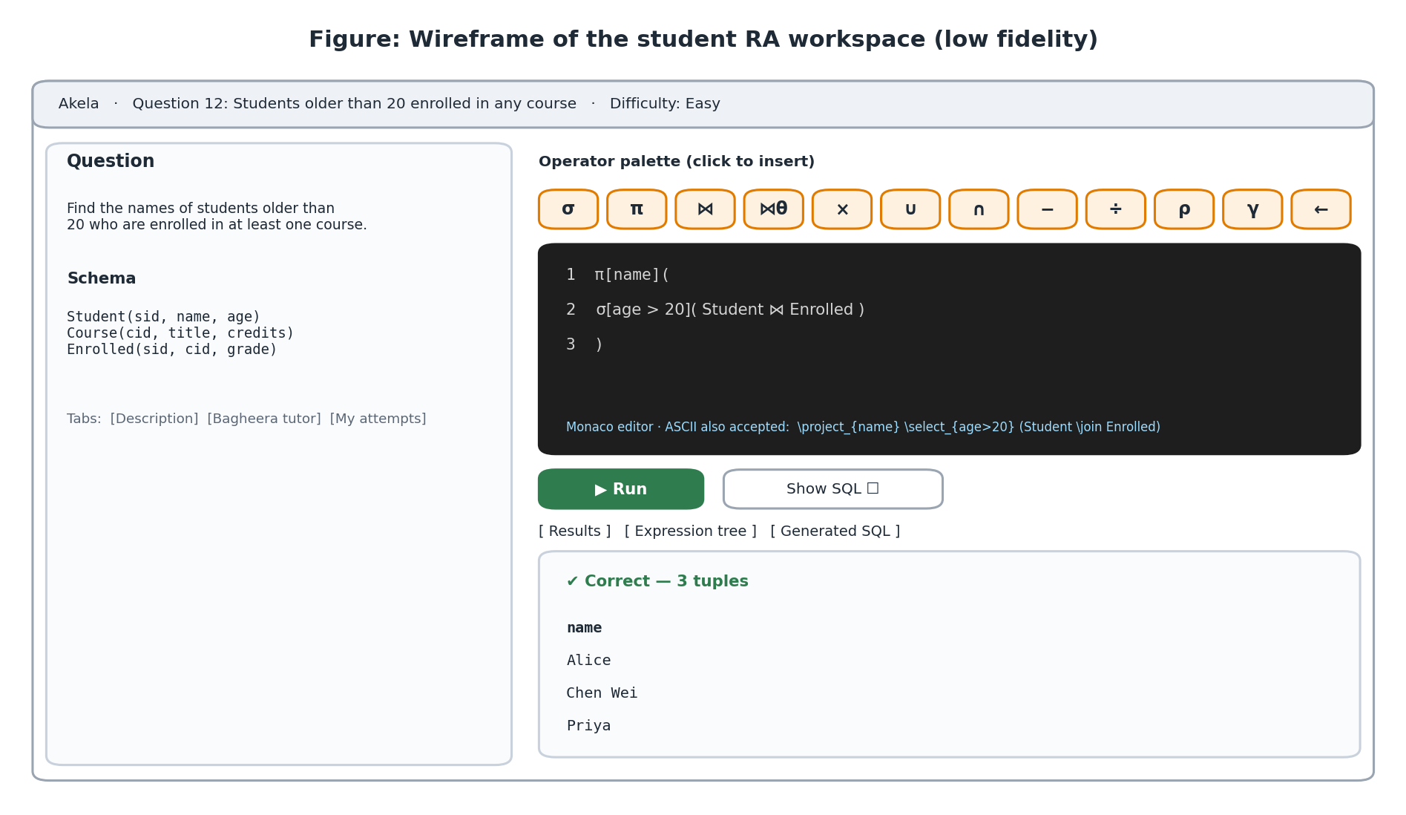
Figure 2. Low-fidelity wireframe of the student RA workspace
Table 6. Frontend components
Component | Responsibility | Builds on
RaEditor.tsx | Monaco with a custom relalg language (Monarch tokenizer for highlighting), error markers, ASCII shortcuts (e.g. typing \sel + Tab inserts σ[]()) | Existing EditorPanel.tsx
OperatorPalette.tsx | Buttons for each operator; inserts a template at the cursor; tooltips with meaning + example; aria-labels | Mantine Button/Tooltip
RaTreeView.tsx | Draws the tree returned by /ra/parse; node hover shows output schema; (Should) click shows intermediate result | dagre + SVG, as in QueryGraph.tsx
Generated-SQL tab | Read-only Monaco showing generated_sql; hidden when the question/assessment disables it | Existing tab layout
QuestionForm.tsx (modified) | Language toggle; RA reference editor; live translate preview | Existing form
Workspace & assessment sql-question pages (modified) | Choose SQL or RA workspace from question.query_language | Existing pages
admin/problems (modified) | “RA” badge and filter | Existing list
ra.service.ts (new) | useRaParse() hook (debounced) | TanStack Query pattern

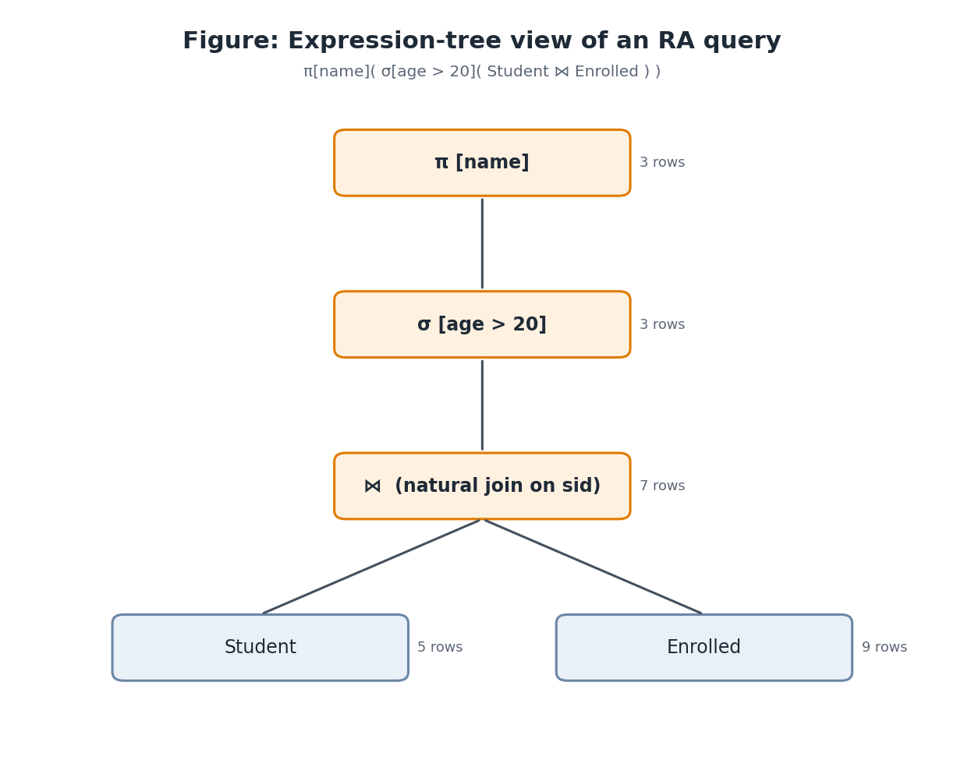
Figure 3. Expression-tree view (row counts appear after Run)

6.6 AI tutor
- Add an RA-specific system-prompt section in services/sql_tutor_prompts.py: the tutor receives the question, schema, student RA text, the parse tree and any RA error code. It must give hints about operators and never reveal the full reference expression (the same rule as the existing SQL tutor).
- AI query review (/chatbot/query-review) gets the student’s RA and the generated SQL, so it can explain why a result is wrong (e.g. “you projected before joining, so sid is no longer available”).
- Deterministic hints come first, following HANDOFF §5.2: for common error codes (RA003/RA005) the fixed message is enough and no LLM call is made.

6.7 Learning analytics (LAD)
Table 7. New concepts added to concept_taxonomy_seed.py (category relational_algebra)
Concept slug | Display name | Prerequisites
ra_selection | RA: selection σ | —
ra_projection | RA: projection π | —
ra_rename | RA: rename ρ | ra_projection
ra_product | RA: Cartesian product × | —
ra_natural_join | RA: natural join ⋈ | ra_product, ra_selection
ra_theta_join | RA: theta join | ra_natural_join
ra_set_operations | RA: ∪ ∩ − | ra_projection
ra_division | RA: division ÷ | ra_set_operations, ra_natural_join
ra_composition | RA: composing & assignment | ra_selection, ra_projection
ra_aggregation | RA: grouping γ (if implemented) | ra_projection

Questions can be tagged automatically from operators_used, which staff can edit. Cross-links to SQL concepts (e.g. inner_join → ra_natural_join) let the LAD show how RA and SQL mastery relate, which the evaluation can also study.

6.8 Assessments, analytics and feature flag
- Assessments: RA questions are ordinary sql_question items, so cloning, timers, max_queries, hide-correctness and scoring work unchanged.
- Staff SQL analytics: add a language filter plus two RA-specific panels — most common RA error codes and operator usage.
- Feature flag RA_QUESTIONS_ENABLED (default False): hides the language toggle and rejects query_language='ra' when off.

7. Grading design and edge cases
Table 8. Grading edge cases
Case | Handling
Duplicates | Both student and reference translations use DISTINCT → set comparison, as RA requires
Column names | The inherited validator hashes rows as {column: value} dicts with sorted keys, so column order does not matter but names do. D-RA-5 makes names deterministic. Pedagogically, the result schema is part of the answer (a relation is its schema plus its tuples)
Equivalent but different expressions | Graded correct, because only results are compared (e.g. pushing σ below ⋈)
Accidentally-correct answers | Staff should design seed data with distinguishing rows (a checklist in the authoring guide). Optional: a second hidden dataset for grading (future work)
Numeric formatting | Inherited: numbers normalised to float before hashing
Empty reference result | Rejected at authoring time (inherited _require_answer_rows)
Huge products | Inherited 5 s deadline + progress handler; RA100 message suggests using a join
NULLs in data | Allowed, but the authoring form warns (D-RA-9)

Fairness property
The same translator produces both the reference hash and the student’s result. If the translator has a quirk (for example in naming), it affects both sides equally. So correctness depends on whether the two expressions are semantically equivalent, not on details of the SQL text.

8. Security analysis
Table 9. Threats and mitigations
Threat | Mitigation
SQL injection through identifiers | Identifiers must match the introspected schema (allowlist) and are always double-quoted; quotes inside identifiers are rejected
SQL injection through literals | String literals are parsed by the grammar and re-emitted with standard SQL escaping (' → ''); the generator never concatenates raw input
Writing to the shared question DB | The generator only emits SELECT/WITH, and the inherited QueryExecutor rejects anything that is not read-only (two layers)
Denial of service via parser | Length and depth limits, LALR parser (linear time), no backtracking regexes
Denial of service via query | Inherited deadline and progress-handler cancellation
Answer leakage | Tutor prompt forbids revealing the reference; the generated-SQL tab only shows the student’s own translation

9. Alternatives considered
Table 10. Implementation alternatives
Alternative | Assessment | Decision
Use radb (Duke) as a library | Mature, and it also compiles RA to SQL. But its syntax and error messages are fixed, it is built around its own command-line/database workflow, it would need a licence check, and extending it (tree JSON, error codes, positions) means forking it | Study it as a reference; don’t depend on it
Parse RA in the browser (TypeScript) | Fast feedback, but two grammars to maintain and the backend must re-parse anyway for grading | Rejected (NFR-RA-07)
Interpret RA directly in Python (e.g. pandas) | No SQL generation needed, but it creates a second execution engine whose results must match SQLite exactly (types, NULLs), and it bypasses the hardened executor | Rejected
Hand-written recursive-descent parser | No dependency, but more code and weaker error reporting than Lark | Fallback only
Lark grammar + own checker/generator | Small dependency (pure Python), grammar is readable documentation, precise error positions, full control of messages | Chosen

10. Testing strategy
Table 11. Test plan
Level | What | How
Unit — parser | Every operator in both notations; precedence; associativity; error positions | Golden files: tests/ra/cases/*.ra → expected tree JSON
Unit — checker | Each RA0xx error fires on a minimal example and not on valid input | Parametrised pytest
Equivalence | Translated RA returns the same hash as a hand-written SQL query on a sample university DB | ≈ 60 (RA, SQL) pairs covering all operators
Property-based | Random well-typed RA trees always translate to SQL that runs without error; algebraic laws hold (e.g. σ distributes over ∪; R ⋈ S ≡ S ⋈ R up to column order) | hypothesis strategies over a small schema
Integration | /execute with RA question: correct, incorrect, parse error, timeout; Attempt/UserProgress rows written | FastAPI TestClient on SQLite, as the existing suite does
Regression | All existing tests pass with the flag on and off | CI run
Frontend | Palette insertion, markers, tree rendering, SQL tab hidden in assessments | Manual test script + ESLint; screenshots recorded as evidence

11. Evaluation plan
The evaluation answers three research questions. All data collection with students needs ethics approval and course-coordinator consent (open question O-X-2 in Document 04).
Table 12. Evaluation design
Research question | Measure | Instrument
RQ1 Does practising RA on Akela improve students’ RA ability? | Pre-/post-test score gain | 10-item RA quiz before and after a 2-week practice window
RQ2 Do RA-level error messages help students fix mistakes? | Attempts-to-correct after an error; share of errors resolved within 3 attempts | Telemetry (ra_error_code, attempts)
RQ3 Is the RA workspace usable? | SUS score; qualitative comments | SUS questionnaire + 3 open questions

12. Question bank plan
A shared university schema — Student(sid, name, age, major), Course(cid, title, dept, credits), Enrolled(sid, cid, grade), Lecturer(lid, name, dept), Teaches(lid, cid) — makes questions comparable and the seed data easy to design so that wrong answers give visibly different results. The bank will have about 20 questions; examples:
Table 13. Sample questions
# | Question (student-facing) | Key operators | Difficulty
1 | Names of all Computer Science majors | σ, π | Easy
2 | Titles of courses with more than 3 credits | σ, π | Easy
3 | Names of students enrolled in ‘Databases’ | ⋈, σ, π | Easy
4 | Pairs of students with the same major | ρ, ⋈θ, π | Medium
5 | Students not enrolled in any course | −, π | Medium
6 | Courses taken by both Alice and Bob | ∩, σ, ⋈ | Medium
7 | Lecturers who teach in a department other than their own | ⋈, σ | Medium
8 | Students enrolled in every CS course | ÷ | Hard
9 | Students with the highest age (without aggregation) | ρ, ×, σ, − | Hard
10 | Students who took courses from every lecturer in their major’s department | ÷, ⋈, ← | Hard

13. Implementation plan and deliverables
Table 14. RA work plan (aligned with the Gantt chart in Document 04)
Weeks | Work | Deliverable / evidence
W3–W4 | Lab-engine registry refactor (shared foundation) + regression tests | PR + green tests
W3–W5 | Grammar, parser, AST, golden tests | core/ra/parser.py, 100+ parser tests
W5–W7 | Checker, SQL generator, error catalogue, equivalence + property tests | translate() passing all tests
W7–W8 | Model column, migration, questions.py + execute.py integration, /ra/parse | API demo via Swagger
W8–W10 | RaEditor, palette, tree view, SQL tab, QuestionForm toggle | End-to-end demo video
W10–W11 | Question bank (≈ 20), tutor prompts, LAD concepts | Milestone M1: RA feature complete

14. RA-specific risks and open questions
Table 15. Risks and open questions (full register in Document 04)
ID | Risk / question | Mitigation / what I need
R-RA-1 | Notation mismatch with the lecture notes confuses students | Confirm notation (O-RA-1); the grammar can accept aliases
R-RA-2 | Subtle translation bugs give wrong grades | Equivalence + property tests; same-translator fairness; pilot with staff before students
R-RA-3 | Column-name strictness frustrates students (e.g. after ρ) | Clear message on mismatch (“your result has columns (n) but expected (name)”); possible per-question ignore_column_names option
O-RA-1 | Which RA notation does the course use (brackets vs subscripts; ⋈ with or without condition)? | Supervisor / course coordinator
O-RA-2 | Should extended operators (γ, outer joins) be in scope? | Supervisor
O-RA-3 | Should the “Show SQL” tab be available during assessments? | Supervisor
O-RA-4 | Set or bag semantics by default? | Proposed: set (D-RA-1)

References
- Codd, E. F. (1970). A relational model of data for large shared data banks. Communications of the ACM, 13(6), 377–387.
- Silberschatz, A., Korth, H. F., & Sudarshan, S. Database System Concepts (7th ed.). McGraw-Hill — chapter on the relational algebra.
- Elmasri, R., & Navathe, S. B. Fundamentals of Database Systems (7th ed.). Pearson — relational algebra and calculus.
- Garcia-Molina, H., Ullman, J. D., & Widom, J. Database Systems: The Complete Book (2nd ed.). Pearson — set vs bag algebra.
- RelaX — relational algebra calculator (University of Innsbruck), https://dbis-uibk.github.io/relax/ — reviewed as related work.
- radb — relational algebra interpreter (Duke University), https://github.com/junyang/radb — reviewed as related work.
- Lark parsing toolkit for Python, https://github.com/lark-parser/lark.
- Brooke, J. (1996). SUS: A “quick and dirty” usability scale. In Usability Evaluation in Industry. Taylor & Francis.

