FINAL YEAR PROJECT · PROGRESS DOCUMENTATION
Design Document — Vector Database Labs
Hands-on labs where students store embeddings, run similarity search and understand how modern vector databases work, built on Akela’s existing lab infrastructure
Item | Detail
Project | Extending the Akela database-education platform with Relational Algebra and Vector Database learning modules
Document | 03 — Design Document: Vector Database Labs
Prepared by | Sanjana Yalamanchili
Supervisor | [Supervisor name]
Date / version | 25 September 2026 · v1.0 (for the Week-2 progress review)
Status | Design proposal: open for supervisor feedback. Technology choice to be confirmed by a spike in Week 15 (earlier if possible).
Depends on | Document 01 (architecture) §7.3 lab-engine registry

Document ID: FYP-DES-VEC-03

Contents

If the table of contents appears empty, right-click it in Word and choose “Update Field”.

1. Introduction

1.1 Background and motivation
Vector databases store high-dimensional embeddings — numeric vectors produced by machine-learning models so that similar items (texts, images, products) sit close together — and answer nearest-neighbour queries quickly. They power semantic search, recommendation, and retrieval-augmented generation (RAG), where an LLM is given the most relevant documents retrieved by vector search (Lewis et al., 2020).
The ecosystem has grown quickly: dedicated systems (Pinecone, Milvus, Weaviate, Qdrant, Chroma) and vector extensions to established databases (pgvector for PostgreSQL, sqlite-vec for SQLite). Most introductory database courses still stop at relational and, at best, graph/NoSQL models. Akela already teaches SQL and graph (Cypher) databases through hands-on labs. This module adds the third major data model now common in industry.

1.2 Learning objectives for students
- Explain what an embedding is and why similar items have nearby vectors.
- Compute and compare distance/similarity measures: Euclidean (L2), cosine, dot product; explain when cosine ignores magnitude.
- Write exact k-nearest-neighbour (k-NN) queries in SQL with vector functions.
- Combine similarity with ordinary filters (hybrid search, e.g. nearest Malaysian dishes).
- Use a vector index (vec0 virtual table) and explain exact vs approximate nearest-neighbour (ANN) search conceptually (HNSW, IVF; recall vs latency).
- Describe the retrieval step of a RAG pipeline and run it on a small document collection.

1.3 Goals and non-goals
Goals | Non-goals
A new lab type vector that works like SQL and Graph labs (authoring, sessions, tasks, analytics, assessments) | Training or fine-tuning embedding models
Students query with SQL + vector functions, building on SQL they already know | Teaching a vendor-specific API (Pinecone, Milvus)
Deterministic, fair grading despite floating-point arithmetic | Production-scale ANN benchmarking
A visual 2-D view of the embedding space | Live LLM generation inside graded tasks

2. User stories and requirements
ID | As a… | I want to… | So that…
US-V1 | Student | run similarity queries on my own copy of a vector DB | I can experiment, including inserting my own vectors, without affecting others
US-V2 | Student | see the vectors and my query as points on a plot | “nearest neighbour” becomes visual
US-V3 | Student | compare L2 and cosine results side by side | I understand when the metric matters
US-V4 | Student | get graded on tasks immediately | I know whether I understood
US-V5 | Student | ask Bagheera about vector concepts in the context of my lab | I get help at the right moment
US-V6 | Staff | author a vector lab from a template (toy vectors or pre-computed embeddings) | creating content is quick
US-V7 | Staff | include vector labs in assessments | the topic can be examined

2.1 Functional requirements
Table 1. Functional requirements (MoSCoW)
ID | Requirement | Priority
FR-VEC-01 | lab_type='vector' can be chosen in the lab wizard; the template is built with vector support loaded | Must
FR-VEC-02 | Students run SQL including vector functions (vec_distance_l2, vec_distance_cosine, vec_length …) against their private copy | Must
FR-VEC-03 | vec0 virtual tables with MATCH … AND k = n k-NN queries are supported | Should
FR-VEC-04 | Vector outputs are displayed readably (no raw BLOBs) and floats are normalised for grading | Must
FR-VEC-05 | Task grading modes: exact result, id-set (top-k membership), id-ranked (top-k order) | Must
FR-VEC-06 | The server re-runs vector task submissions instead of trusting the client’s result set | Must
FR-VEC-07 | An authoring check warns about near-ties at the k-th position | Should
FR-VEC-08 | A 2-D PCA scatter plot shows stored vectors, the query and the top-k results | Should
FR-VEC-09 | Vector labs can be added to assessments (vector_lab item type) | Must
FR-VEC-10 | The tutor receives vector-table metadata (dimensions, metric) in lab chat | Should
FR-VEC-11 | Vector concepts appear in the LAD | Should
FR-VEC-12 | Demo-only “embed my own text” box using the existing OpenAI configuration (never graded) | Could

2.2 Non-functional requirements
Table 2. Non-functional requirements
ID | Requirement | Target
NFR-VEC-01 Determinism | Identical grading on macOS (dev) and Linux (Azure) | Same hashes on both for the whole test suite
NFR-VEC-02 Performance | Query latency on teaching-sized data | < 200 ms for 5,000 vectors × 384 dims (exact k-NN)
NFR-VEC-03 Isolation | No cross-student interference | Inherited template + per-student copy
NFR-VEC-04 Security | Students cannot load extensions or reach the file system | enable_load_extension(False) after loading; keyword guard
NFR-VEC-05 Resource limits | Bounded storage and CPU | ≤ 5,000 vectors, ≤ 384 dims, seed ≤ 5 MB, 15 s deadline (inherited)
NFR-VEC-06 Compatibility | SQL/Graph labs unaffected | Registry regression tests pass; flag off = identical behaviour

3. Technology evaluation
The deciding constraint comes from the inherited architecture: each student must get a private, disposable copy of the lab database (HANDOFF §6.2). A single-file, embedded engine fits this perfectly. A server-based vector database would need per-student namespaces, clean-up logic and new infrastructure, which goes against the platform’s “no new infrastructure until needed” principle (§5.3).
Table 3. Vector engine options
Option | Fits template + copy? | Query language | Deployment on Azure App Service | ANN index | Verdict
sqlite-vec (SQLite extension, MIT/Apache-2.0) | Yes — just a .db file | SQL + vector functions; vec0 k-NN table | pip wheel; needs Python’s sqlite3 to allow extension loading | Exact k-NN today; ANN on its roadmap | Primary choice
Python UDFs registered on sqlite3 (create_function) | Yes | SQL + the same function names | Always works (no extension) | No (brute force only) | Fallback
ChromaDB (embedded) | Partly — a directory per student | Python API, not SQL | Heavy dependencies | HNSW | Rejected
pgvector (PostgreSQL) | No — shared server; would need a schema per student | SQL | Requires the extension on the managed Postgres | HNSW, IVFFlat | Rejected for labs; covered in teaching material
FAISS / LanceDB / Qdrant local | Partly | Python API / own DSL | Native builds | Yes | Rejected (not SQL; heavier)

Finding from Week 2 — extension loading is a real risk
On my development Mac, the python.org build of Python 3.13 has no sqlite3.Connection.enable_load_extension method (checked with hasattr(sqlite3.connect(':memory:'), 'enable_load_extension') → False). It was compiled without loadable-extension support, so sqlite-vec cannot be loaded there as-is.
Production runs Python 3.11 on Linux (Azure App Service, see .github/workflows/main_fyp-sql-learning.yml). Whether that build allows extension loading must be tested early. Three independent ways out: (1) a Python build that supports it (e.g. Homebrew or pyenv locally); (2) the apsw or pysqlite3 driver for vector labs only; (3) the pure-Python UDF fallback, which supports every Level-1 task (§5).
This is logged as risk R1 in Document 04. The Week-15 spike is designed to settle it.

4. Architecture and component design
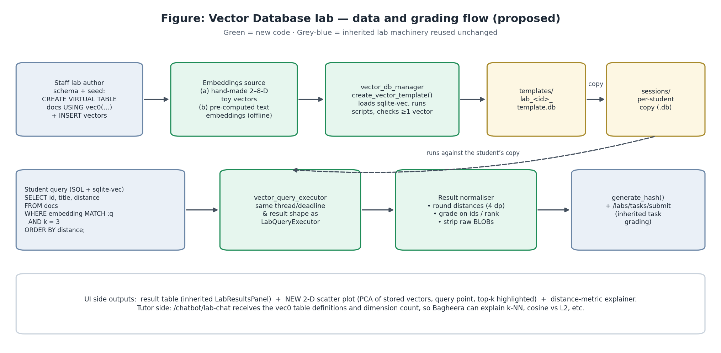
Figure 1. Vector lab data and grading flow — new components in green

4.1 Prerequisite: the lab-engine registry
As described in Document 01 §7.3, I first replace the if lab_type == "graph" branches in labs.py with a registry. The vector engine is then one entry:
# backend/app/core/lab_engines.py
@dataclass(frozen=True)
class LabEngine:
create_template: Callable[[int, str, str], str] # (lab_id, schema, seed) -> path
execute: Callable[[str, str, int], dict] # (db_path, query, timeout) -> result dict
schema_info: Callable[[str], dict] # for previews + tutor context
editor_language: str # 'sql' | 'cypher'

LAB_ENGINES = {
"sql": LabEngine(create_lab_template, execute_lab_query, get_schema_info, "sql"),
"graph": LabEngine(create_graph_template, execute_graph_query, get_graph_schema_info, "cypher"),
"vector": LabEngine(create_vector_template, execute_vector_query, get_vector_schema_info, "sql"),
}

def get_engine(lab_type: str) -> LabEngine:
if lab_type == "vector" and not settings.VECTOR_LABS_ENABLED:
raise HTTPException(404, "Vector labs are not enabled")
return LAB_ENGINES[lab_type]
Listing 1. Engine registry (sketch)

4.2 vector_db_manager.py
def open_vector_connection(path: str) -> sqlite3.Connection:
conn = sqlite3.connect(path)
if HAVE_SQLITE_VEC:
conn.enable_load_extension(True)
sqlite_vec.load(conn) # adds vec_* functions and vec0
conn.enable_load_extension(False) # students can never load anything
else:
register_python_vector_udfs(conn) # fallback: same function names
return conn

def create_vector_template(lab_id, schema_sql, seed_sql) -> str:
path = get_lab_template_path(lab_id) # inherited helper, same folder layout
# remove old template, executescript(schema_sql); executescript(seed_sql)
# validate: at least one vector column/table with >= 1 row, dims <= 384,
# rows <= 5000, all vectors in a column have equal dimension
# run near-tie check for every task reference query (FR-VEC-07)
return path
Listing 2. Template creation (sketch). Session copy, reset and stop are inherited unchanged.

4.3 VectorQueryExecutor
This is a copy of LabQueryExecutor’s structure (thread, attach_deadline, same result dict), with three differences:
- Connections are opened with open_vector_connection (extension or fallback loaded).
- A keyword guard rejects load_extension and ATTACH as defence in depth.
- Result normalisation before returning: BLOB vectors are converted to readable previews such as [0.10, 0.30, 0.90, 0.60] (dim 4); floats are rounded to 4 decimal places; -0.0 is changed to 0.0.
Why −0.0 matters (found while preparing this document)
In the sample lab below, the cosine distance between the query and the dish “Achar” is exactly 0. Floating-point arithmetic can produce it as -0.0. The inherited answer_validator serialises rows with json.dumps, which writes -0.0 and 0.0 differently, so two correct answers could hash differently. The vector normaliser therefore changes -0.0 to 0.0 before hashing. This is exactly the kind of cross-platform detail the tests in §9 check.

4.4 Grading design
Table 4. Task grading modes (new optional lab_tasks.grading_mode column)
Grading mode | What is compared | Typical task
exact (default, inherited behaviour) | All returned columns and rows after normalisation | “Return name and L2 distance of the 3 nearest dishes”
id_set | Only the first column, as a set (order ignored) | “Which 5 documents would be retrieved?”
id_ranked | Only the first column, in order | “Rank the 3 nearest dishes”

Server-side re-execution. For vector tasks, POST /labs/tasks/submit re-runs submitted_query on the student’s session DB and hashes the server’s own result. This closes, for this lab type, the inherited gap where the client-reported result set is trusted (HANDOFF §11). Near-tie guard. When staff validate a task, the reference query is run with k+1 results. If the k-th and (k+1)-th distances differ by less than 10⁻³, the form warns that tiny floating-point differences could change the answer, and suggests changing the data or k.

4.5 Embedding strategy
Table 5. Where vectors come from
Tier | Source | Dimensions | Use
1 — Toy vectors | Hand-authored, each dimension has a human meaning (e.g. sweet, salty, spicy, sour) | 2–8 | First lab: builds intuition; distances can be checked by hand
2 — Pre-computed real embeddings | Generated offline by staff with an embedding model (e.g. an OpenAI embedding model with reduced dimensions, or a sentence-transformers model), pasted into the seed script | 64–384 | Semantic search / mini-RAG lab on course descriptions or FAQ snippets
3 — Live embedding (demo) | POST /labs/session/{id}/embed using the existing AI_* settings | Model-dependent | Ungraded “try your own sentence” box; behind a separate flag

Query vectors are stored in the seed data (a queries(name, embedding) table), so graded tasks never depend on a live API call. They are reproducible, free and work offline.

4.6 Visualisation: the embedding plot
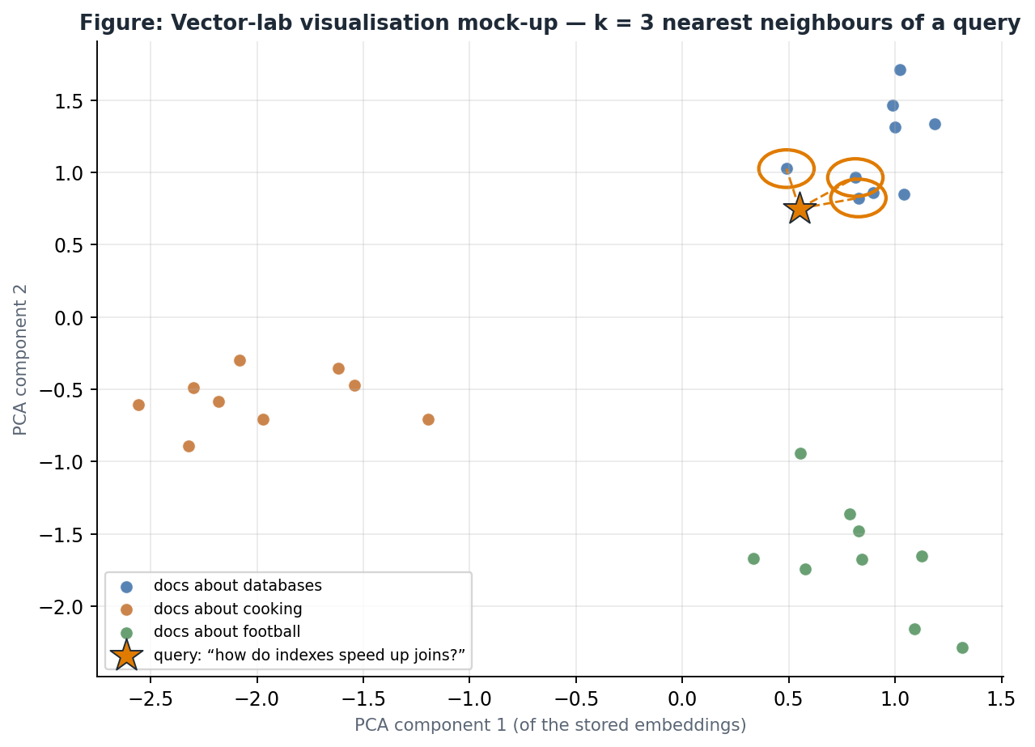
Figure 2. Mock-up of the vector-lab plot: PCA projection of stored vectors, the query (star) and its k = 3 nearest neighbours
- GET /labs/session/{id}/vector-projection reads the vectors named in the lab’s vector_config and computes a 2-D PCA with numpy (already installed as a pandas dependency). It returns {points:[{id,label,x,y}], query:{x,y}, explained_variance}.
- The frontend VectorPlot.tsx draws plain SVG, with no new charting dependency (the frontend currently has none). It highlights the ids in the latest result table and connects them to the query.
- A caption states the explained variance (e.g. “this 2-D view keeps 78% of the variation”). This is an honest reminder that the projection distorts distances, which is itself a learning point.
- For accessibility, the plot has a table alternative listing each point’s coordinates and distance.

4.7 Other integration points
Table 6. Integration changes
Area | Change
Data model | labs.lab_type='vector' (no migration); optional labs.vector_config JSON text (table, id/label/vector columns, queries table); optional lab_tasks.grading_mode
Lab wizard (LabForm.tsx) | type=vector option with two starter templates (toy food vectors; document search); seed-size and dimension validation; editor language sql
Workspace (LabWorkspace.tsx) | Plot tab when lab_type='vector'; vector preview rendering in results
Assessments | New vector_lab item type; the touch-points are listed in Document 01 §7.6 (≈ 16 files, mirroring graph_lab); new page …/items/[itemId]/vector-lab
Tutor (/chatbot/lab-chat) | Schema context adds vector columns, dimensions and metric; prompt section on vector concepts (metrics, k-NN, hybrid search, ANN trade-offs)
LAD | New category vector_search (see §6)
Analytics | Lab analytics work per task automatically; add a lab-type filter
Feature flag | VECTOR_LABS_ENABLED (default False)
Dependencies | sqlite-vec added to backend/requirements.txt (pinned version)

5. Sample lab: “Hawker flavour space”
This is the first lab students would meet. Four interpretable dimensions — [sweet, salty, spicy, sour] — make every distance checkable by hand. The expected outputs below were computed while preparing this document (numpy, rounded to 4 decimal places).

5.1 Schema and seed
CREATE TABLE foods (
id INTEGER PRIMARY KEY,
name TEXT NOT NULL,
cuisine TEXT NOT NULL,
embedding TEXT NOT NULL -- JSON array: [sweet, salty, spicy, sour]
);
INSERT INTO foods VALUES
(1,'Mango sticky rice','Thai', '[0.90,0.20,0.00,0.10]'),
(2,'Tom yum soup', 'Thai', '[0.10,0.40,0.80,0.70]'),
(3,'Laksa', 'Malaysian', '[0.20,0.50,0.70,0.30]'),
(4,'Kaya toast', 'Singaporean', '[0.80,0.30,0.00,0.00]'),
(5,'Salted egg chips', 'Singaporean', '[0.10,0.90,0.20,0.00]'),
(6,'Mala hotpot', 'Chinese', '[0.10,0.60,0.95,0.20]'),
(7,'Chendol', 'Malaysian', '[0.95,0.10,0.00,0.00]'),
(8,'Sambal stingray', 'Malaysian', '[0.10,0.60,0.80,0.30]'),
(9,'Achar', 'Malaysian', '[0.05,0.15,0.45,0.30]');

CREATE TABLE queries (name TEXT PRIMARY KEY, embedding TEXT NOT NULL);
INSERT INTO queries VALUES
('craving_spicy_sour', '[0.10,0.30,0.90,0.60]'),
('dessert', '[1.00,0.10,0.00,0.00]');

-- Level 2: an indexed copy for k-NN with vec0 (sqlite-vec only)
CREATE VIRTUAL TABLE foods_vec USING vec0(embedding float[4]);
INSERT INTO foods_vec(rowid, embedding) SELECT id, embedding FROM foods;
Listing 3. Seed script (Achar is deliberately exactly half of the spicy-sour query vector)

5.2 Tasks
Table 7. Tasks with verified expected outputs
# | Task | Reference query (abridged) | Expected result
1 | How many dimensions does each embedding have? | SELECT DISTINCT vec_length(embedding) FROM foods; | 4
2 | 3 dishes nearest to craving_spicy_sour by L2 | SELECT f.name, ROUND(vec_distance_l2(f.embedding, q.embedding),4) AS d FROM foods f, queries q WHERE q.name='craving_spicy_sour' ORDER BY d LIMIT 3; | Tom yum 0.1732 · Laksa 0.4243 · Sambal stingray 0.4359
3 | Same, by cosine distance. What changed and why? | as above with vec_distance_cosine | Achar 0.0 · Tom yum 0.0116 · Laksa 0.0677 — Achar jumps from 5th to 1st: cosine ignores intensity (magnitude)
4 | Hybrid search: 2 Malaysian dishes nearest to dessert (L2) | … WHERE q.name='dessert' AND f.cuisine='Malaysian' … | Chendol 0.05 · Achar 1.0943
5 | Use the vec0 index for the 3 nearest to dessert | SELECT rowid, distance FROM foods_vec WHERE embedding MATCH (SELECT embedding FROM queries WHERE name='dessert') AND k = 3 ORDER BY distance; | ids 7, 1, 4 (Chendol, Mango sticky rice, Kaya toast) — mode id_ranked
6 | Insert a dish of your own and find its 3 nearest neighbours | student-defined | Graded by mode exact on a staff-defined dish (shows why labs need per-student copies)

A second lab (Tier 2) will apply the same ideas to about 200 short course descriptions with pre-computed embeddings. Its final task is the retrieval half of RAG: “return the 3 passages you would give an LLM to answer Which courses cover indexing?”.

6. Learning analytics concepts
Table 8. New concepts (category vector_search) — prerequisites link to existing SQL concepts
Concept slug | Display name | Prerequisites
vec_embeddings | Embeddings & dimensions | —
vec_distance_metrics | Distance metrics (L2, cosine, dot) | vec_embeddings
vec_knn_exact | Exact k-NN queries | vec_distance_metrics, order_by, limit
vec_hybrid_search | Hybrid search (filter + similarity) | vec_knn_exact, where_clause
vec_index_ann | Vector indexes & ANN | vec_knn_exact
vec_rag_retrieval | Retrieval for RAG | vec_hybrid_search

7. Security analysis
Table 9. Threats and mitigations
Threat | Mitigation
Student calls load_extension() to load arbitrary native code | Extension loading disabled on the connection right after sqlite-vec is loaded; keyword guard as a second layer
ATTACH another file to read other students’ data | Keyword guard; the inherited lab executor pattern already runs each student on their own file
Huge vectors or row counts exhaust memory | Authoring limits (NFR-VEC-05); an insert trigger in the template can cap rows per table
CPU exhaustion (e.g. cross join of vectors) | Inherited 15 s deadline with progress-handler cancellation
Cost/abuse of the live embedding demo | Separate flag, per-user rate limit, never used for grading
Answer leakage through the plot | The plot shows neighbours only for the student’s own last query

8. Testing strategy
Table 10. Test plan
Level | What | How
Registry regression | SQL and Graph labs behave identically after the refactor | Existing lab flows exercised through TestClient before and after
Template builder | Valid/invalid seeds; dimension mismatch; limits; near-tie warning | pytest with small seeds
Executor | Vector functions, vec0 k-NN, BLOB preview, rounding, −0.0, keyword guard, timeout | pytest; parametrised over sqlite-vec and the UDF fallback
Cross-platform determinism | The same task hashes on macOS (dev) and Linux (CI/Azure) | CI job prints hashes; compared with committed golden values
Fallback parity | UDF fallback returns identical normalised results to sqlite-vec for Level-1 tasks | Differential test on random vectors
Grading | exact / id_set / id_ranked; server-side re-execution; client tampering rejected | TestClient with forged request bodies
Frontend | Plot rendering, highlighting, table alternative, wizard validation | Manual test script + screenshots

9. Evaluation plan
Table 11. Evaluation design (subject to ethics approval)
Research question | Measure | Instrument
RQ4 Do vector labs improve understanding of similarity search? | Pre/post concept-quiz gain (metrics, k-NN, hybrid, ANN) | 8-item quiz
RQ5 Does the 2-D plot help? | Task success and time with vs without the plot (if cohort size allows); self-reported usefulness | Telemetry + Likert items
RQ6 Is the lab usable and motivating? | SUS; perceived relevance to industry | Questionnaire

10. Implementation plan
Table 12. Vector work plan (aligned with Document 04)
Weeks | Work | Deliverable
W3–W4 | Lab-engine registry (shared with RA work) | Refactor PR + regression tests
W15 (earlier if time allows) | Spike: sqlite-vec on dev machine and on an Azure staging slot; decide primary engine or fallback | Spike report (1 page) + decision
W15–W17 | vector_db_manager, VectorQueryExecutor, registry entry, limits, keyword guard | Unit tests green
W17–W18 | Normalisation, grading modes, server-side re-execution, near-tie guard | Grading tests green
W18–W20 | Wizard option, workspace plot, projection endpoint, assessment item type | End-to-end demo
W20–W21 | Author 2–3 labs (≈ 12 tasks), tutor prompts, LAD concepts | Milestone M2: Vector feature complete

11. Vector-specific risks and open questions
Table 13. Risks and open questions (full register in Document 04)
ID | Risk / question | Mitigation / what I need
R-V-1 | Extension loading unavailable on Azure’s Python build | Early spike; apsw/pysqlite3; UDF fallback supports Level-1 tasks
R-V-2 | sqlite-vec is pre-1.0; syntax may change | Pin the version; wrap in vector_db_manager; tests catch changes on upgrade
R-V-3 | Float differences between CPUs change rankings | Rounding, −0.0 fix, near-tie guard, id-based grading modes
R-V-4 | Students lack ML background | Tier-1 interpretable vectors first; concept primer page; tutor prompts
O-V-1 | Is vector search in scope for the course syllabus, or an optional enrichment module? | Supervisor / course coordinator
O-V-2 | May staff use an OpenAI API key to pre-compute embeddings for Tier-2 labs? | Supervisor (cost, policy)
O-V-3 | Should the live-embedding demo be offered at all? | Supervisor

References
- Lewis, P., et al. (2020). Retrieval-augmented generation for knowledge-intensive NLP tasks. Advances in Neural Information Processing Systems 33.
- Malkov, Y. A., & Yashunin, D. A. (2020). Efficient and robust approximate nearest neighbor search using Hierarchical Navigable Small World graphs. IEEE TPAMI, 42(4), 824–836.
- Johnson, J., Douze, M., & Jégou, H. (2021). Billion-scale similarity search with GPUs. IEEE Transactions on Big Data, 7(3), 535–547.
- Mikolov, T., et al. (2013). Efficient estimation of word representations in vector space. arXiv:1301.3781.
- Reimers, N., & Gurevych, I. (2019). Sentence-BERT: Sentence embeddings using Siamese BERT-networks. EMNLP-IJCNLP 2019.
- sqlite-vec — vector search SQLite extension, https://github.com/asg017/sqlite-vec.
- pgvector — open-source vector similarity search for PostgreSQL, https://github.com/pgvector/pgvector.
- Brooke, J. (1996). SUS: A “quick and dirty” usability scale.

