FINAL YEAR PROJECT · PROGRESS DOCUMENTATION
Timeline, Risks and Open Questions
The plan for the rest of the project, what could go wrong and how I will handle it, and the decisions I need from my supervisor
Item | Detail
Project | Extending the Akela database-education platform with Relational Algebra and Vector Database learning modules
Document | 04 — Project Timeline, Risk Register and Open Questions
Prepared by | Sanjana Yalamanchili
Supervisor | [Supervisor name]
Date / version | 25 September 2026 · v1.0 (for the Week-2 progress review)
Planning horizon | 30 weeks: Monday 14 Sep 2026 (Week 1) → Sunday 11 Apr 2027 (Week 30)

Document ID: FYP-PLAN-04

Contents

If the table of contents appears empty, right-click it in Word and choose “Update Field”.

1. Purpose and planning assumptions
This document turns the two designs (Documents 02 and 03) into a dated plan with milestones and measurable exit criteria. It lists the project risks with their mitigations and gathers the questions only my supervisor or the course team can answer. It is a living document: I will update it after every supervisor meeting.
Table 1. Planning assumptions (to confirm at this meeting)
# | Assumption | If it is wrong…
A1 | Week 1 started Monday 14 Sep 2026; final submission is around the end of Week 30 (≈ 9–11 Apr 2027) | Shift all dates; the order of phases stays the same
A2 | Weeks 11–14 (23 Nov – 20 Dec 2026) are an exam period with reduced FYP time | Pull the vector spike earlier (see §3.3)
A3 | About 15–20 hours per week of FYP work during semester, more during the vacation | Cut “Could” requirements first (§3.4)
A4 | I can run the full stack locally; staging/production access is granted by Week 15 | Demonstrate locally; production pilot becomes optional
A5 | A student pilot for evaluation can run in Weeks 23–26 with ethics approval | Evaluate with staff/peer testers and a think-aloud study instead

2. Progress to date (Weeks 1–2)
The first two weeks were for understanding the inherited system and designing the extension before changing any production code. This is deliberate: the codebase is large (the backend endpoint modules alone are about 11,500 lines, and labs.py is 2,192 lines) and runs in production, so changing it before understanding it would be risky.
Table 2. Weeks 1–2 work and evidence
Activity | Output / evidence | Status
Read HANDOFF.md, README.md and the core backend/frontend code paths | Document 01 §2–6 (architecture of the inherited system, with file references) | ✔ Done
Traced the SQL-question grading flow end to end | Figure: SQL question sequence (Doc 01 §5.1) | ✔ Done
Traced the lab template/session pattern and how Graph Labs extend it | Figure: lab pattern (Doc 01 §5.2); found 9 lab-type branch points → registry refactor proposal | ✔ Done
Identified integration points and options for both features | Doc 01 §7 (options table, component inventory, data-model and API changes) | ✔ Done
Relational Algebra design | Document 02 (language spec, grammar, translation scheme, error catalogue, tests, evaluation) | ✔ Done
Vector Database design | Document 03 (technology evaluation, grading design, sample lab with verified expected outputs) | ✔ Done
Early technical risk check | Found that the dev machine’s Python cannot load SQLite extensions (Doc 03 §3); found the −0.0 hashing edge case (Doc 03 §4.3) | ✔ Done
Plan, risks, open questions | This document | ✔ Done
Run the full stack locally and capture screenshots of each existing feature (student + staff) | Screenshot pack / short screen recording | ☐ Complete before the meeting
Tag the inherited baseline: git tag baseline-inherited b917118 | Tag visible in the repository | ☐ Complete before the meeting

3. Timeline
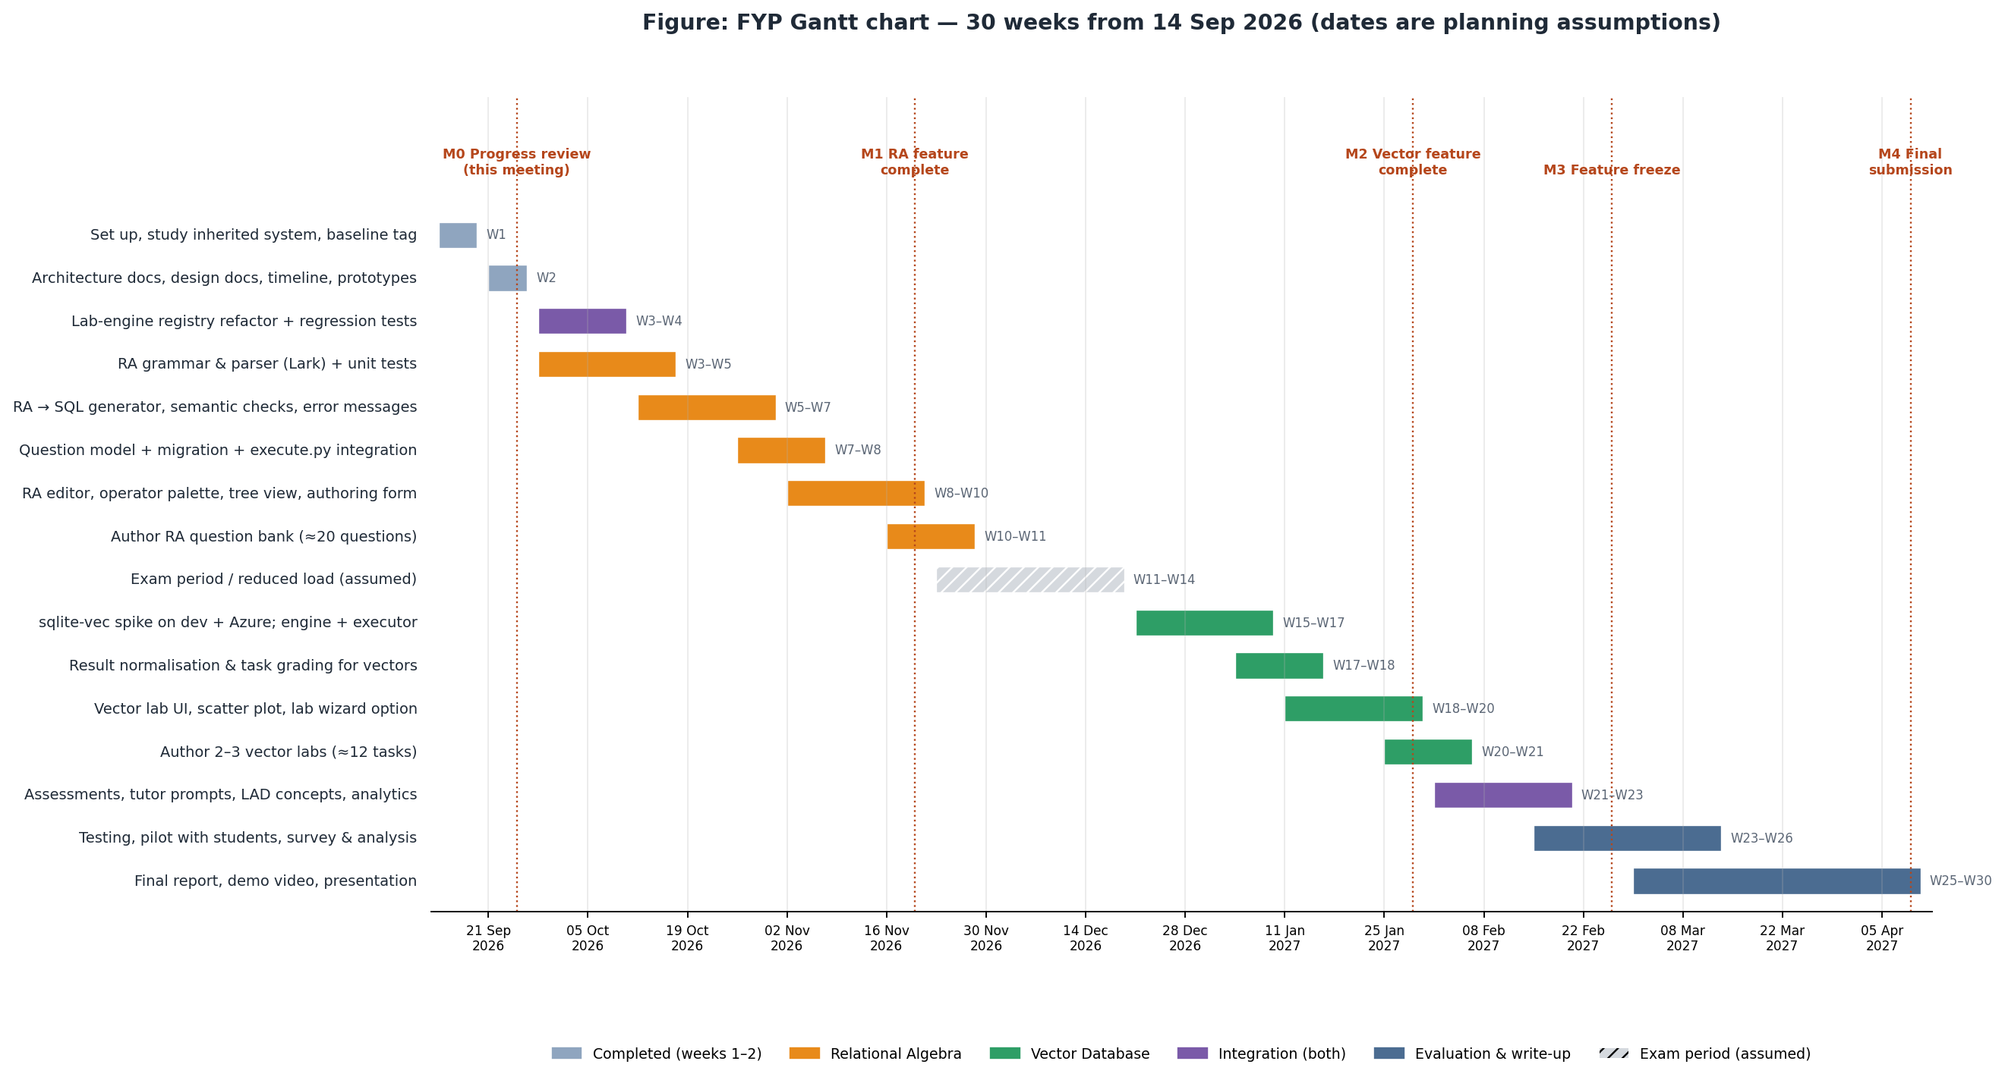
Figure 1. Gantt chart for the 30-week project (dates follow assumptions A1–A2)

3.1 Phase-by-phase plan
Table 3. Detailed plan
Phase | Weeks (dates) | Main tasks | Exit criteria
P0 Onboarding & design | W1–W2 (14–27 Sep 2026) | Study codebase; architecture and design documents; plan | Documents 01–04 reviewed by supervisor
P1 Foundations | W3–W5 (28 Sep–18 Oct) | Lab-engine registry refactor + regression tests; RA grammar, parser, AST, golden tests | Refactor merged with all existing behaviour unchanged; parser handles every operator in both notations
P2 RA backend | W5–W8 (12 Oct–8 Nov) | Checker, SQL generator, error catalogue; equivalence + property tests; query_language column + migration; questions.py/execute.py integration; /ra/parse | RA questions can be created and graded through the API; all RA tests green
P3 RA frontend + content | W8–W11 (2 Nov–29 Nov) | RaEditor, palette, tree view, SQL tab, QuestionForm toggle; ≈ 20 questions; tutor prompts; LAD concepts | M1: end-to-end RA demo in the browser
— Exam period | W11–W14 (23 Nov–20 Dec) | Reduced load: bug fixes, documentation, literature review for the report | Interim notes written
P4 Vector backend | W15–W18 (21 Dec–17 Jan 2027) | sqlite-vec spike (dev + Azure staging); vector_db_manager, VectorQueryExecutor; normalisation; grading modes; server-side re-execution; near-tie guard | Vector labs can be created and graded through the API on the target runtime
P5 Vector frontend + content | W18–W21 (11 Jan–7 Feb) | Wizard option, workspace plot + projection endpoint, vector_lab assessment item; 2–3 labs (≈ 12 tasks) | M2: end-to-end vector-lab demo
P6 Integration | W21–W23 (1 Feb–21 Feb) | Assessments for both, tutor context, LAD concepts, analytics filters, feature-flag rollout on staging | M3 (W24): feature freeze; both flags can be enabled on staging
P7 Evaluation | W23–W26 (15 Feb–14 Mar) | Pilot with students (or fallback study); pre/post quizzes; SUS; telemetry analysis | Evaluation data collected and analysed
P8 Write-up | W25–W30 (1 Mar–11 Apr) | Final report, demo video, presentation; handoff notes for the next maintainer | M4: final submission

3.2 Milestones
Table 4. Milestones
Milestone | Target date | What I will demonstrate
M0 Progress review | Fri 25 Sep 2026 (W2) | Documents 01–04; inherited system running locally; design walkthrough
M1 RA feature complete | Fri 20 Nov 2026 (W10) | Staff creates an RA question; student solves it with the palette; tree view; RA errors; the question inside an assessment
M2 Vector feature complete | Fri 29 Jan 2027 (W20) | Staff creates the “Hawker flavour space” lab; student completes its tasks; plot; grading modes
M3 Feature freeze | Fri 26 Feb 2027 (W24) | Both features behind flags on staging; test report
M4 Final submission | ≈ Fri 9 Apr 2027 (W30) | Report, video, presentation, code tagged fyp-final

3.3 Schedule buffers and re-planning rules
- The vector spike can move earlier (e.g. to Week 6, as a half-day task) so R1 is settled before the exam period. I recommend doing this.
- Each phase ends with its exit criteria. If a phase overruns by more than one week, I cut scope from that module’s “Could” list rather than delaying the next module.
- Weeks 11–14 act as a buffer for RA overruns.
- Evaluation (P7) can start with RA alone if the vector module is late, so the report always has an evaluated contribution.

3.4 Scope ladder (what gets cut first)
Table 5. Scope ladder
Order to cut | Item | Module
1 | Live-embedding demo box (FR-VEC-12) | Vector
2 | Extended RA operators γ, outer joins (FR-RA-10) | RA
3 | Autocomplete (FR-RA-11) | RA
4 | Click-to-inspect intermediate results (FR-RA-08) | RA
5 | Tier-2 real-embedding lab (keep the Tier-1 lab) | Vector
6 | vec0 index tasks — keep scalar-function tasks (fallback-compatible) | Vector
Never cut | Correct grading, security guards, tests, feature flags, Tier-1 vector lab, core RA operators | Both

3.5 Working rhythm
- Supervisor meetings every two weeks (proposed), each with a short demo and an update of this document.
- Weekly log (FYP_CHANGELOG.md): what I did, the related requirement IDs, decisions and blockers. It is the raw material for the final report.
- Definition of done for any feature: code + tests + behind a flag + short documentation entry + screenshot/video evidence.

4. Risk register
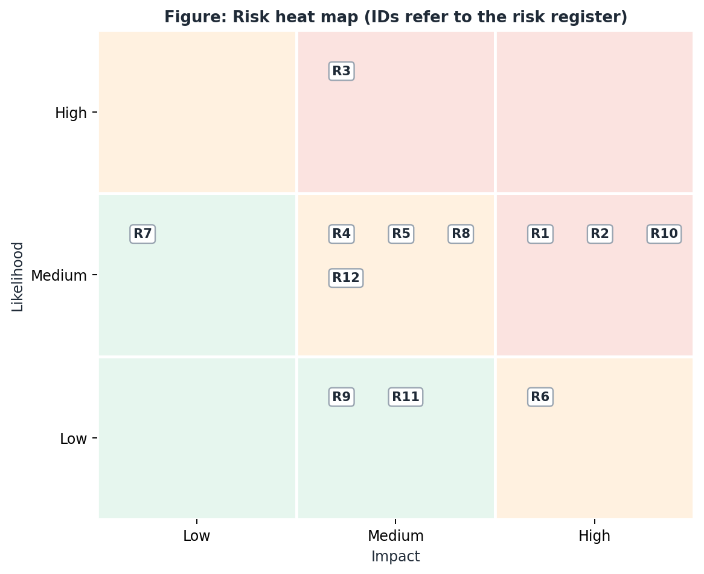
Figure 2. Risk heat map
Table 6. Risk register (L = likelihood, I = impact; H/M/L)
ID | Risk | L | I | Mitigation (reduce likelihood) | Contingency (if it happens) | Early warning
R1 | sqlite-vec cannot be loaded on the production Python (extension loading disabled) | M | H | Early spike on Azure staging; test apsw/pysqlite3 | Pure-Python UDF fallback (Level-1 tasks); drop vec0 tasks | Spike fails on staging
R2 | Two features are too much scope for one student | M | H | MoSCoW priorities, scope ladder, shared foundations first | Cut from the scope ladder; evaluate RA fully, vector partially | Phase overruns > 1 week
R3 | Unfamiliar, large inherited codebase slows development | H | M | Documented study (Doc 01); refactor with regression tests first; follow house patterns | Ask supervisor for access to previous maintainers | Simple changes taking > 2 days
R4 | RA translation bugs produce wrong grades | M | M | Equivalence + property-based tests; same translator for reference and student | Hide-correctness mode during the pilot; manual regrade | Test failures; student reports
R5 | Floating-point differences make vector grading unstable | M | M | Rounding, −0.0 fix, near-tie guard, id-based modes, cross-platform CI | Switch affected tasks to id_set mode | Hash mismatch between macOS and Linux
R6 | My changes break existing production features | L | H | Feature flags default off; additive migrations; regression tests; staging first | Turn flag off; revert the PR | Errors in staging logs
R7 | RA notation or topics differ from the course syllabus | M | L | Confirm notation (O-1); grammar accepts aliases | Add the course notation as another form of the syntax | Supervisor feedback
R8 | Ethics approval or student access for the evaluation is delayed | M | M | Apply early (by W8); design the study now | Staff/peer usability study + think-aloud | No approval by W20
R9 | No access to staging/production (Azure, secrets) | L | M | Request access at this meeting | Evaluate on a local or university-hosted instance | No access by W15
R10 | Exams and other coursework reduce available time | M | H | Plan the exam period as a buffer; front-load RA | Use the scope ladder | Weekly hours below plan for 2 weeks
R11 | LLM API cost or availability affects tutor features | L | M | Deterministic hints first; LLM only for tutoring | Tutor features become optional | API errors / budget alerts
R12 | Missing inherited artefacts: docs/ and the ERD test suite are gitignored; no frontend tests | M | M | Don’t rely on them; write my own tests for touched code | Ask the previous maintainers for the files | Unexpected behaviour in untested code

5. Open questions for my supervisor
Each question has my proposed default, so the project can go ahead even if an answer takes time, and the week by which I need the answer.
Table 7. Open questions
ID | Question | Why it matters | My proposed default | Needed by
O-1 | Which relational-algebra notation does the course use (bracket or subscript style; symbols)? | Grammar and student familiarity | Accept both brackets and ASCII; add the course style as another form of the syntax | W3
O-2 | Should extended operators (γ aggregation, outer joins, semi-join) be in scope? | Scope | “Could” priority — only if time allows | W5
O-3 | Set or bag semantics for RA? | Grading correctness | Set semantics (textbook) | W5
O-4 | Should students see the generated SQL during assessments? | Assessment integrity | Hidden in assessments, visible in practice | W8
O-5 | Is vector search part of the syllabus, or an enrichment module? | Depth and tone of content | Enrichment module, 2–3 labs | W12
O-6 | May I use an OpenAI API key to pre-compute embeddings for a Tier-2 lab? | Cost and policy | Yes, offline and one-off, cost < US$1 | W15
O-7 | Can I get access to a staging slot on Azure App Service (for the sqlite-vec spike)? | Risk R1, R9 | Request now; test locally until then | W6 (ideally)
O-8 | Is ethics approval required for the student pilot, and who is the approving body? | Evaluation (R8) | Assume yes; submit by W8 | W6
O-9 | Can the pilot run with the current course cohort, and when? | Evaluation timing | Weeks 23–26 | W12
O-10 | May I contact the previous maintainers for the gitignored files (docs/, ERD tests)? | Risk R12 | Yes, via the supervisor | W4
O-11 | Should the new features eventually be deployed to production (ntuakela.net), or only demonstrated on staging? | Deployment work and risk | Staging for the FYP; production at the course team’s discretion | W20
O-12 | How will the FYP be assessed (report weighting, demo, code quality)? | Where to invest effort | Follow the school’s FYP guidelines | W4

The three decisions I most need at this meeting
- O-1 — the RA notation, because the parser is next on the plan.
- O-7 — staging access, because it settles the biggest technical risk (R1) early.
- O-8 — whether ethics approval is needed, because it has the longest lead time.

6. Plan for the next two weeks (W3–W4)
Table 8. Next-two-weeks plan
# | Task | Output
1 | Tag the baseline; set up FYP_CHANGELOG.md and a committed fyp-docs/ folder | Tag + files in the repository
2 | Write regression tests for the current lab flows (SQL and Graph) | Passing test suite that pins current behaviour
3 | Implement core/lab_engines.py and switch labs.py + student_report.py to it | Refactor PR; all regression tests still green
4 | Write the Lark grammar and parser for σ, π, ρ, ×, ⋈, ∪, ∩, − (both notations) | core/ra/parser.py + golden tests
5 | Quick sqlite-vec check on any Linux Python 3.11 environment (e.g. Docker) | Half-page note that reduces or confirms R1
6 | Draft the ethics application (if required) | Draft for supervisor review

Appendix A. Suggested 15-minute agenda for the progress meeting
- (3 min) Demo of the inherited system running locally: one SQL question, one lab, one ER exercise, the admin problem bank.
- (3 min) Architecture — Document 01, current vs proposed figures; the contribution boundary.
- (3 min) RA design — pipeline figure, one example translation, error messages, wireframe.
- (3 min) Vector design — why a lab type, sqlite-vec plus fallback, the sample lab and the two findings (extension loading, −0.0).
- (3 min) Plan and decisions — Gantt chart, top risks, the three decisions needed (O-1, O-7, O-8).

