Задание №1
#include <iostream>
using namespace std;
int main() {
long long a, b;
char op;
if (cin >> a >> op >> b) {
switch (op) {
case '+':
cout << a + b << "\n";
break;
case '-':
cout << a - b << "\n";
break;
case '*':
cout << a * b << "\n";
break;
case '/':
if (b != 0) {
cout << a / b << "\n";
}
break;
default:
break;
}
}
return 0;
}
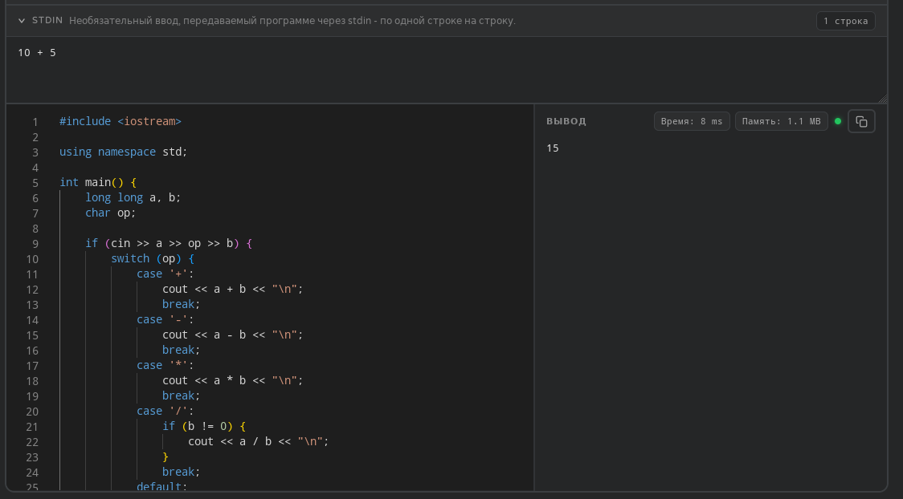

Задание №2
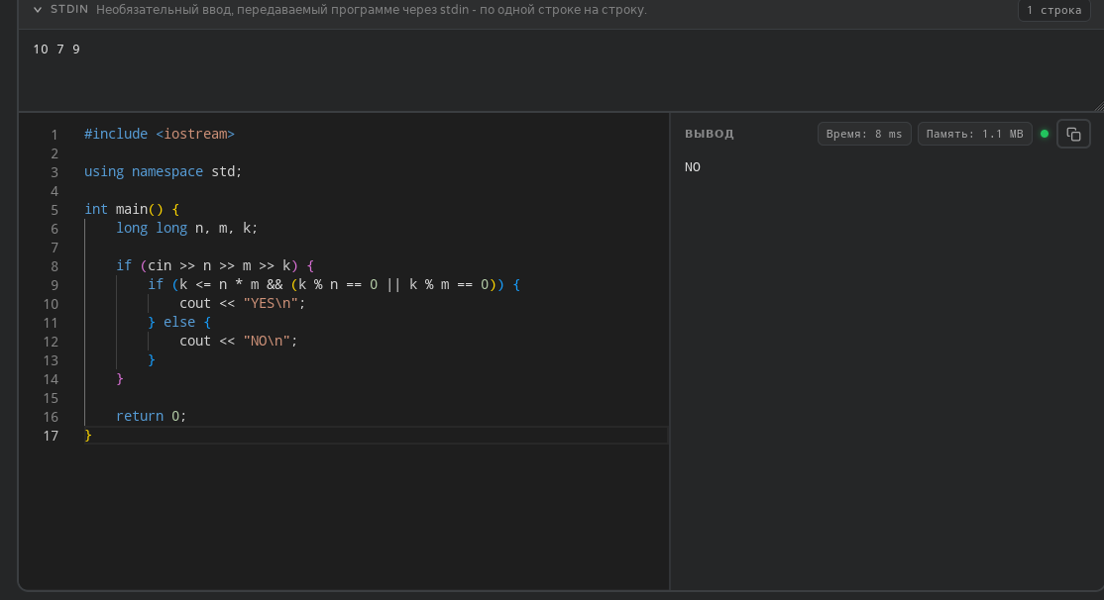
#include <iostream>
using namespace std;
int main() {
long long n, m, k;
if (cin >> n >> m >> k) {
if (k <= n * m && (k % n == 0 || k % m == 0)) {
cout << "YES\n";
} else {
cout << "NO\n";
}
}
return 0;
}

Задание №3
#include <iostream>
#include <string>
using namespace std;
int main() {
int x;
if (cin >> x) {
const int values[] = {1000, 900, 500, 400, 100, 90, 50, 40, 10, 9, 5, 4, 1};
const string numerals[] = {"M", "CM", "D", "CD", "C", "XC", "L", "XL", "X", "IX", "V", "IV", "I"};
string result = "";
for (int i = 0; i < 13; ++i) {
while (x >= values[i]) {
result += numerals[i];
x -= values[i];
}
}
cout << result << "\n";
}
return 0;
}
