Read me → Module d'actualités for Prestashop (prestanews).

1-Installation

Go to module tab and click on load module.
Choose files .zip and click on load module, then look for the modue and click on install.

By FTP :
Connect to your server FTP using a software (ex:filezila)
Unzip the .zip file, and drag the folder in your /modules folder.
Go to prestashop, in tab module, look for the module and click install.

2 - Configuration.
  - In the configuration you can choose the number of news to display on columns.

2a) – Ajouter une actualités

You can see that when the module is installed, a tab in the administration menu is generated, it must simply click on the submenu "all news»
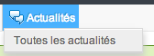
Once you click on "All News"
You see the list of events and you can simply adding clicking
on the button "Add" in the navigation bar.

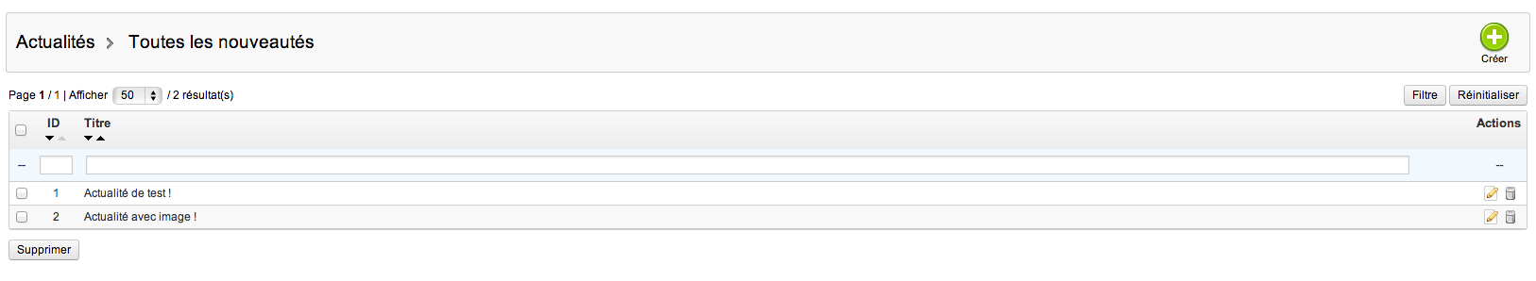
En cas de problèmes :
Do not hesitate to contact us in case of problems.
contact@web-batier.com

Thanks to choose our module.

