Remotely Controlled Switch
  - An affordable a versatile home automation solution.
By: Chris Voelker

Preface
The goal of this project is to create a remotely controlled bank of electrical switches, for the purpose of controlling several electrical loads remotely through the use of a frontend system, such as a Twilio SMS messaging service or an http webpage. The functionality of this device would be similar to that of a Zigbee & Matter Shelly 1 Smart Relay™ but with more than one relay, so that it could be used to control multiple electrical loads located in the same area. At a component cost of $82.37 per unit ($48.37 if a Raspberry Pi Pico was used instead), this device provides a cost-effective framework for programming hobbyists to design their own frontend software on top of. Because this system is built from an Arduino and Pi platform, electrical components, such as sensors and receivers (like Bluetooth or infrared) can be easily added to it, expanding its capabilities.

Hardware Used
  - The components used for this project are as follows:

Bill of Materials
Component Name | Component Cost | Functionality
Elegoo 8 channel 250 VAC/30 VDC 10 Amp relay bank: | $8.99 | Controls external electrical loads.
Elegoo Arduino Uno R3 w/ USB cable: | $16.99 | Receive data from sensors and Pi.  Preforms hardware level control.  Actuates Relays to control loads.
Arduino 5v breadboard power supply: | $2.99 | Provides an external 5VDC power supply for the end user
Photoresistor | $0.95 | Senses light intensity and sends out an analog signal. An example of how the device could be used with other components to automate lighting.
DHT 22 | $5.00 | Sense humidity and temperature. An example of how the device could be used with other components to automate air conditioning.
Mini Breadboard | $3.95 | A receptacle for end users to prototype and add components.
Jumper wires | $3.50 | Connects components together.
Pi 3 model B+ | $40 | Receives and sends information from the web to Arduino, runs user’s frontend software. Connects to Arduino via serial cable.

The relays will be actuated by the Arduino when it receives a relay code from the PI in its serial buffer or when a defined input pin is triggered. The Arduino will then set the requested relay pins to either a low or high state to actuate the relay coil(s). There is a prototyping board with an external 5-volt breadboard power supply included in the framework. Here is the full schematic:
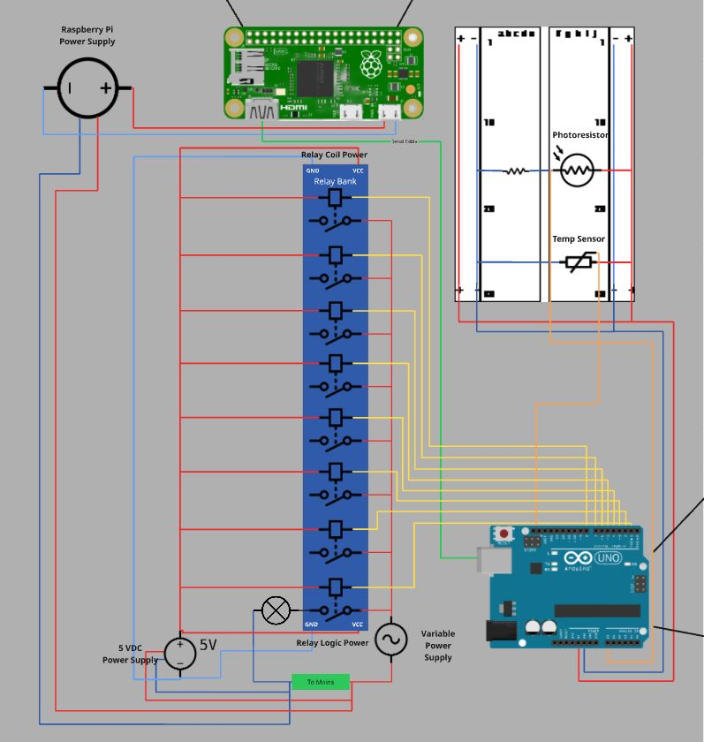

Setup
The device will need to be wired according to the schematic. Gather the necessary components listed. Use Platform IO to flash the Arduino Program onto the Arduino. Connect your Pi to the internet. Load the python file onto the PI. Install the necessary python modules with PIP. Depending on the OS you load onto your Pi, you may need to create a python virtual environment to successfully install the packages and run the program. Make sure to specify serial port in the SERIAL_PORT variable, device ID in the DEVICDE_ID variable, and device key in the DEVICE_KEY variable. Configure your Azure IoT Hub, Analytics stream, and SQL database. Make sure the table Schema matches the one used by this program.

External Data Flow Outline
The PI will be responsible for being the interface between the Arduino (and subsequently the hardware) and the Internet, or for that matter any other external network. Python will be used as the programming language for this part of the project. It will primarily communicate using MQTT messaging, however in future versions of this project a flask server could be implemented for sending and receiving http requests. Communication between the Internet, the Pi, and the Arduino is event driven. For the purposes of this project the event that will send requests to the Arduino will be commands sent from the terminal, but any other form of incoming request could be used.
When the Arduino receives a request from the PI over its serial communication channel, it will preform the specified actuation, then send an acknowledgement message back. That acknowledgement message will be decoded into a relay coil number and Boolean state, and then be dumped into a JSON object along with the device ID, the current date and time, and a description of the load that the relay is controlling. This JSON object will then be sent via MQTT to an MQTT topic channel in a Microsoft Azure IOT hub. From there the data will flow into a Stream Analytics Job that will write the information to an Azure SQL database. The following schema will be used:

CREATE TABLE borgMemory (
RowID INT PRIMARY KEY AUTO_INCREMENT,
DeviceID NVARCHAR(MAX) NOTNULL,
RecordTime DATETIME NOTNULL,
RelayUpdated NVARCHAR(MAX) NOTNULL,
StateChangedTo BIT NOTNULL,
ConnectionDescription NVARCHAR(MAX) NOTNULL
);

- RowID is an auto generated unique primary key the new row.
- DeviceID is the name of the IOT device associated with the primary key used for authentication in the Azure Hub. This is of type NVARCHAR and is a required field.
- RecordTime is the time that the request was sent out by the Pi. This is of type DATETIME and is a required field.
- RelayUpdated is the Coil number of the Relay that’s state was updated. This is of type NVARCHAR and is a required field.
- StateChangedTo is the state that the relay’s coil was changed to. This is a Boolean value of type BIT and is a required field.
- ConnectionDescription is a description of the load that is connected to the relay that was actuated. This is of type NVARCHAR and is a required field.

Component Usage
- Arduino R3: This is the primary hardware controller for the project. This is responsible for receiving a relay code from the Pi, decoding it, and updating the specified relay pin to the specified state (On or Off).
- Raspberry Pi: This is the device’s main interface to outside communication networks. The Pi is responsible for running serial communications to the Arduino, sending out JSON data via MQTT requests to Azure, and any other user facing software applications.
- Sensors
  - Photoresistor: This is a resistor that changes its resistance depending on the level of light that it is exposed to. The Arduino reads this as an analog signal. This is used to give an example of the device’s applications
  - DHT 22 Temperature Humidity Sensor: This is a digital device that sends a signal to the Arduino which is translated into temperature and humidity. This is used to give an example of the device’s applications
- 8 Channel Relay Module: this is the device that will actuate the connected loads. It is controlled by 8 of the Arduino’s Digital Pins.
- MQTT: This is the protocol used to send JSON objects from the python program to the Azure IoT Hub.
- Azure IoT Hub: This is the Azure cloud-based resource that the MQTT data will flow into.
- Stream Analytics: This service will process the data from the Hub into SQL commands that can be executed on the Azure SQL database.
- SQL Database: this is the endpoint for the data leaving the device via MQTT. This will store the Device Name, the time of the event, the relay that was updated by the event, the state the relay was updated to (On/Off), And a description of the load that is connected to the relay that was updated.

Software Plan
  - Described below are the primary software components to be used in this project:
- Arduino logic:
  - Include statements section: Brings necessary libraries into the program. DHT pin and type are also defined here.
  - Pin definitions section: Meaningful Variables that store the pin numbers. DHT instance is also created in this section.
  - void setup(): This function is responsible for beginning the serail connection and DHT read, as well as initializing the pins. All eight of the relay pins must also be written to the HIGH state in the setup function. This is done because the relay is sourcing, and power must flow into it in order to disable it.
  - void updateRelay(): This function takes in two parameters: char relayNum and char relayState. It uses a switch case which takes relayNum as the expression. relayNum is a char of the relay number. When it finds a matching case it preforms a digital write to the corresponding relay pin, using the relayState parameter to determine the pin state.
  - void loop(): there are two sections of logic in this function. The first section checks the serial buffer to see if there are any available bytes. If yes, the byte is read and assigned to a variable called command with the type string. The string is trimmed to remove escape sequence and any other unnecessary trailing characters. An IF statement checks if command has a length of 2 characters. If so, he string is split into two segments. The first segment is assigned to the variable relayNum, and the second segment is assigned to relayState. updateRelay() is invoked with the two aforementioned variables passed in as parameters. An acknowledgement message that the operation was successful is then printed to the serial port. If the first IF statement found that command.length() did not equal 2 the IF statement would default to an ELSE statement that printed an error message to the serial port.
- Python gateway script
  - generate_sas_token(): Generates the necessary Shared Access Signature (SAS) token for authenticating the device with the Azure IoT Hub.
  - Create_MQTT_Client(): Initializes and connects an MQTT client to the Azure IoT Hub endpoint. The token that was generated by generate_sas_token() is utilized by this function as part of the authentication process.
  - sendPayload(): Connects to and manages the MQTT client loop to send a data payload to the Azure IoT Hub. It defines the MQTT topic, converts the input dictionary to a JSON object, and publishes the payload. Prints payload to the console and message of success or failure.
  - send_Serial_Data(): Sends a two-character command (relay number and toggle state) to the Arduino via the serial port. It first validates that the input parameters (relay_number_char and relay_state_char) are strings before encoding and writing to serial.
  - recieve_Serial_Data(): Checks if there are any bytes waiting in serial buffer. If yes it reads an incoming line of data from the serial buffer (from the Arduino) and decodes it into a usable UTF-8 string.
  - Querry_Usr(): Presents a menu in the terminal to prompt the user to select a relay number (1-6) and a relay state (0 for Off, 1 for On). It then validates the user's input to ensure the selection is a valid coil number and state and returns the choices as two strings.
  - generatePayLoad(): takes in the string from recieve_Serial_Data() and processes it by splitting it into two pieces of data (relayNumber and relay State). Retrieves the current date and time with the datetime.now() function. Returns a dictionary that is structured as follows:
{'Device_ID': DEVICE_ID, 'DateTime': current_time, 'relay': relayNumber, 'state_changed_to': relayState, 'description': description}

- MQTT publishing logic: I will be reusing most of the logic from the last project.
- Cloud integration steps: Azure IOT Hub and Stream analytics and Azure SQL database will be used in this project.
- How you will structure and organize your code: the code will be structured as functions that are called in a main loop

Documentation and Project Outline
  - Much of the work of outlining the project has already been done in this document. The rest is explained below:
- README structure: this will be a markdown file bundled with the program, very standard. Most of required information is already covered in this document and can be pasted into the ReadMe.
- Wiring diagram or wiring photos: This will be illustrated in a Miro Board. I will attach screenshots of it in the ReadMe.
- Bill of Materials: This has been outlined in this document.
- Architecture and data flow diagrams: This will be illustrated in a Miro Board.
- What you will demonstrate during your final presentation: The Miro Board and the prototype.
- What areas you predict may be challenging: The Azure Services component.

Risks, Challenges, or Questions
I have had significant difficulties with the Azure side of the project. I wish the class had gone more into depth about using Azure, as I do not really understand how to use it.

Known Issues
The Azure component does not work at all. Zero information is digested by the database. I am not entirely sure if it is related to my Azure configurations, my data schema, or my MQTT scripting. Fixing this problem would be priority number one for future attempts at this project. The next improvement I would make would be adding a flask framework into my python project.

Reflections
What went well:
The local side of the project, like the hardware and software, was in my opinion executed well (with the exception of getting the program to run on the Pi). The serial communication was reliable, and the device did actuate the coils as intended.
What did not go well:
I think the initial scope of this project was too grand for the timeframe that was given. If I were to do it again, I would have scaled back my plans and managed my time better. The Azure Side of the project was a total disaster, and despite my best efforts I was unable to achieve any success with it. I am really not a fan of using Azure.

