Name: Abdulla S Alnaimi Mark _____________________/50

## Brief introduction __/3

I will be responsible over the level design and all of it sub features. Where loading levels components, mainly the main hero character, and other sub components such as coins, enemy level blocks and floors. Which all will be controlled and affecting the game levels throughout the game for example, the main character will affect the background and level rendering, by how the user manipulates the character. Also sub components will be controlled to suit the level the user is experiencing, by changing in look or attribute according to level reached.

## Use case diagram with scenario __14

### Use Case Diagrams

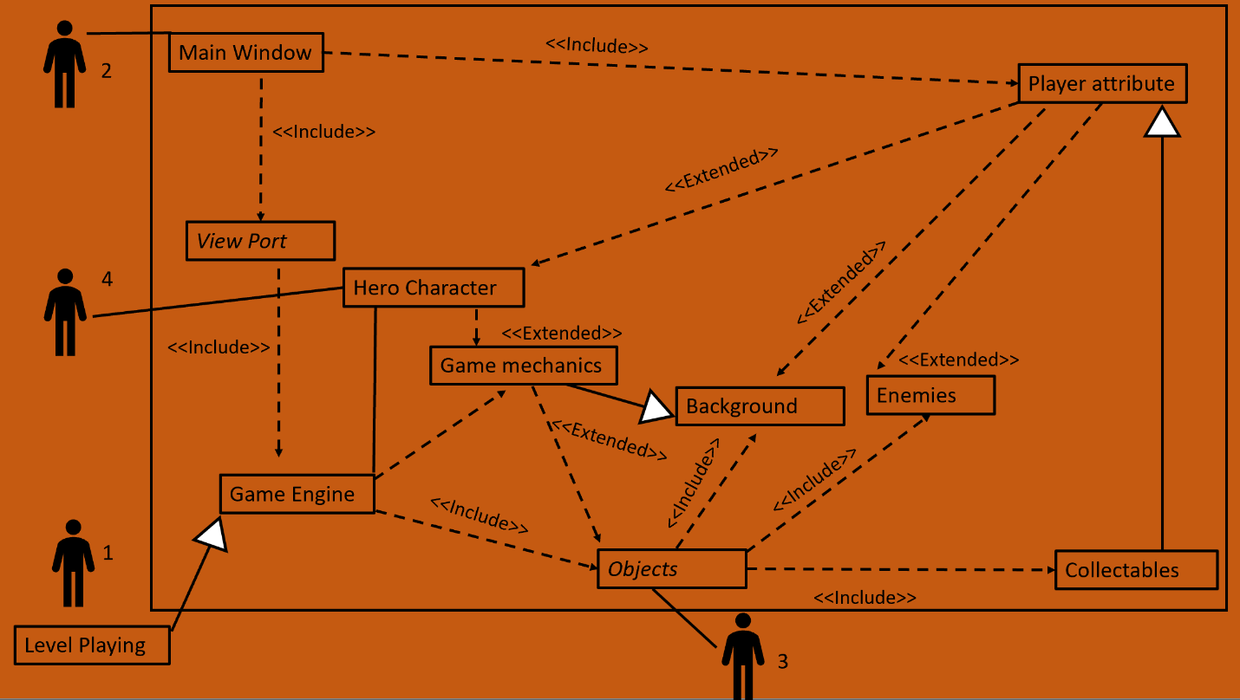

### Scenarios

**Name:** Level Playing {Abdulla Alnaimi}

**Summary:** This discuss the case should be considered regarding levels of the game.

**Preconditions:** Player attribute and objects as well as the Hero character.

**Basic sequence:**

**Step 1:** Background and enemy are chosen after setting attributes.

**Step 2:** collectables are objects as well as enemies and background.

**Step 3:** Engine Reflects level and object into the view

**Step 4:** Calculate and show result.

**Exceptions:**

**Step 1:** Game mechanic changes with saved attribute, with the level the user chooses.

**Step 2:** Enemies change in form and attribute with different levels.

**Step3:** Background changes as the level changes and get affected by hero character attribute such as speed.

**Post conditions:** Player attribute is created.

**Priority:** 1

**ID:** 01

**Name:** 2 -> Main Window {Baoying Loe}

**Summary:** This is where player creates a file and the attribute is generated.

**Preconditions:** none.

**Basic sequence:**

**Step 1:** Force user to not play until file is created.

**Step 2:** set the attribute ready before each level is started.

**Exceptions:**

**Step 1:** As background or level finish attribute is updated.

**Post conditions:** collectables are counted after level completion.

**Priority:** 1

**ID:** 02

**Name:** 3 -> Objects {Isaac Riggs}

**Summary:** This is where object characteristics and functions as well as method is set, where it extends other objects such as the floor, bricks, enemies and collectables.

**Preconditions:** Player attribute and hero character.

**Basic sequence:**

**Step 1:** form regarding the given attribute or needed specification.

**Exceptions:**

**Step 1:** player attribute and level.

**Post conditions:** destroy objects as the leave the scene of the player.

**Priority:** 1

**ID:** 03

**Name:** 4 -> hero character {Preston Stephens}.

**Summary:** This is where the hero character property is initialized.

**Preconditions:** Player attribute.

**Basic sequence:**

**Step 1:** Set life, look of spirit and score

**Exceptions:**

**Step 1:** game mechanic is to be affected by extended player attribute from main window.

**Post conditions:** can interact with other objects.

**Priority:** 1

**ID:** 04

## Data Flow diagram(s) from Level 0 to process description for your feature _______14

### Data Flow Diagrams

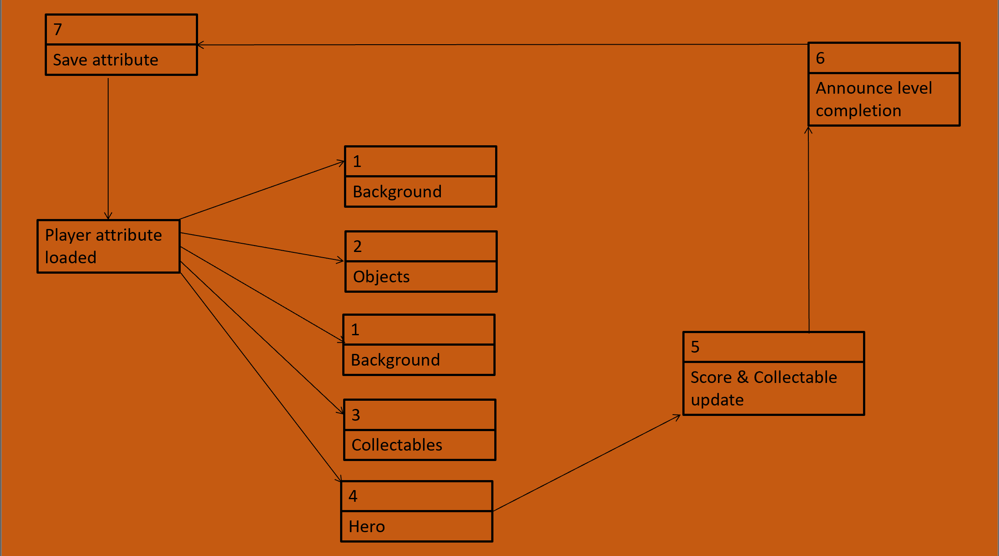

### Process Descriptions

WHILE :As the player attribute is loaded to the engine. The corresponding Background, Objects -enemies and floors-, collectables and hero options are set. Hero can collect items and update score, then hero will finish the level announcing completion. Then finally the player attribute is updated for the next levels. Going through the cycle with updated set of options related again to player attribute. END WHILE

## Acceptance Tests ________9

* Testing load and log in player functionality insuring safe player attribute first.
* Testing game object interaction and reaction.
* Testing the corresponding update to level design.
* Testing Level Functionality of rendering enemies and graphics.
* Testing fluidity and destruction of object outside the frame or when called for.

## Timeline _________/10

I will have to start working immediately, and I will be setting some goals for my group, as well as delivering. In more precise I’m in the critical path. However, my expectation is that I will not have any work by the end of the project. Where My time will solely be aimed to get the game running and rendering levels and game component. Therefore levels layout and enemies placement.

### Work items

|  |  |  |
| --- | --- | --- |
| Task | Duration | Predecessor Task(s) |
| 1. Allowing scripts | 3 w | Game must be made |
| 2. Creating win script | 1 w | Game must be made |
| 3. Create lose script | 1 w | Game must be made |
| 4. Update enemy count | 1 w | Game must be made |
| 5. Test system | 2 w | 1,2,3, and 4 |

### Pert Digram

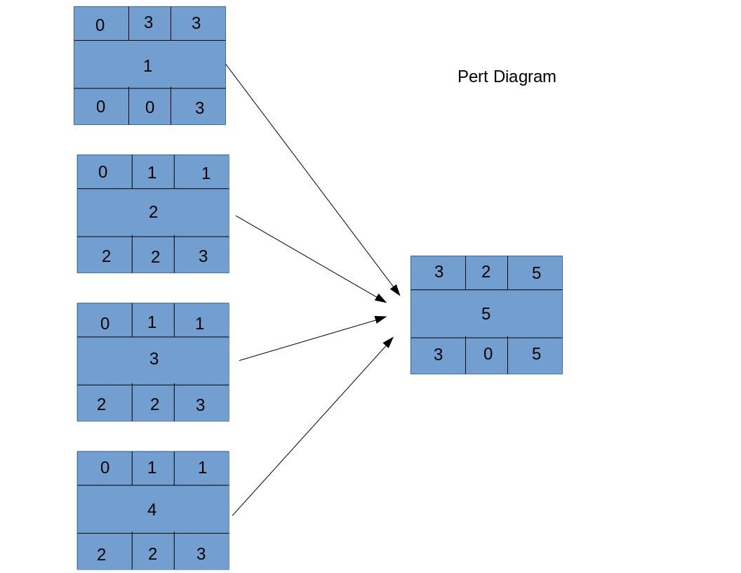

### Gantt timeline

