Developer’s Manual

# Environment

Qt Version: Qt Creator 4.8.0-beta1 (4.7.82) Base on Qt 5.11.2 (MSVC 2015, 32 bit)

Got to [www.qt.io/download](http://www.qt.io/download) and select the ‘Go open source’ option. From there run the installer.

# Code Overview

## Context Diagram

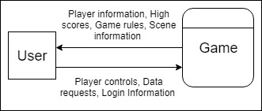

## Preston Class Diagram

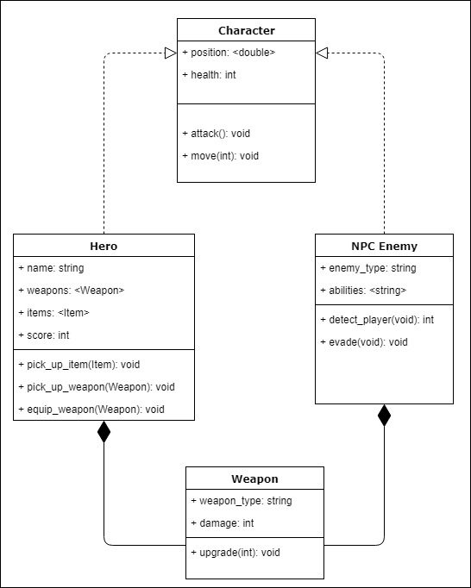

## Karb Class Diagram

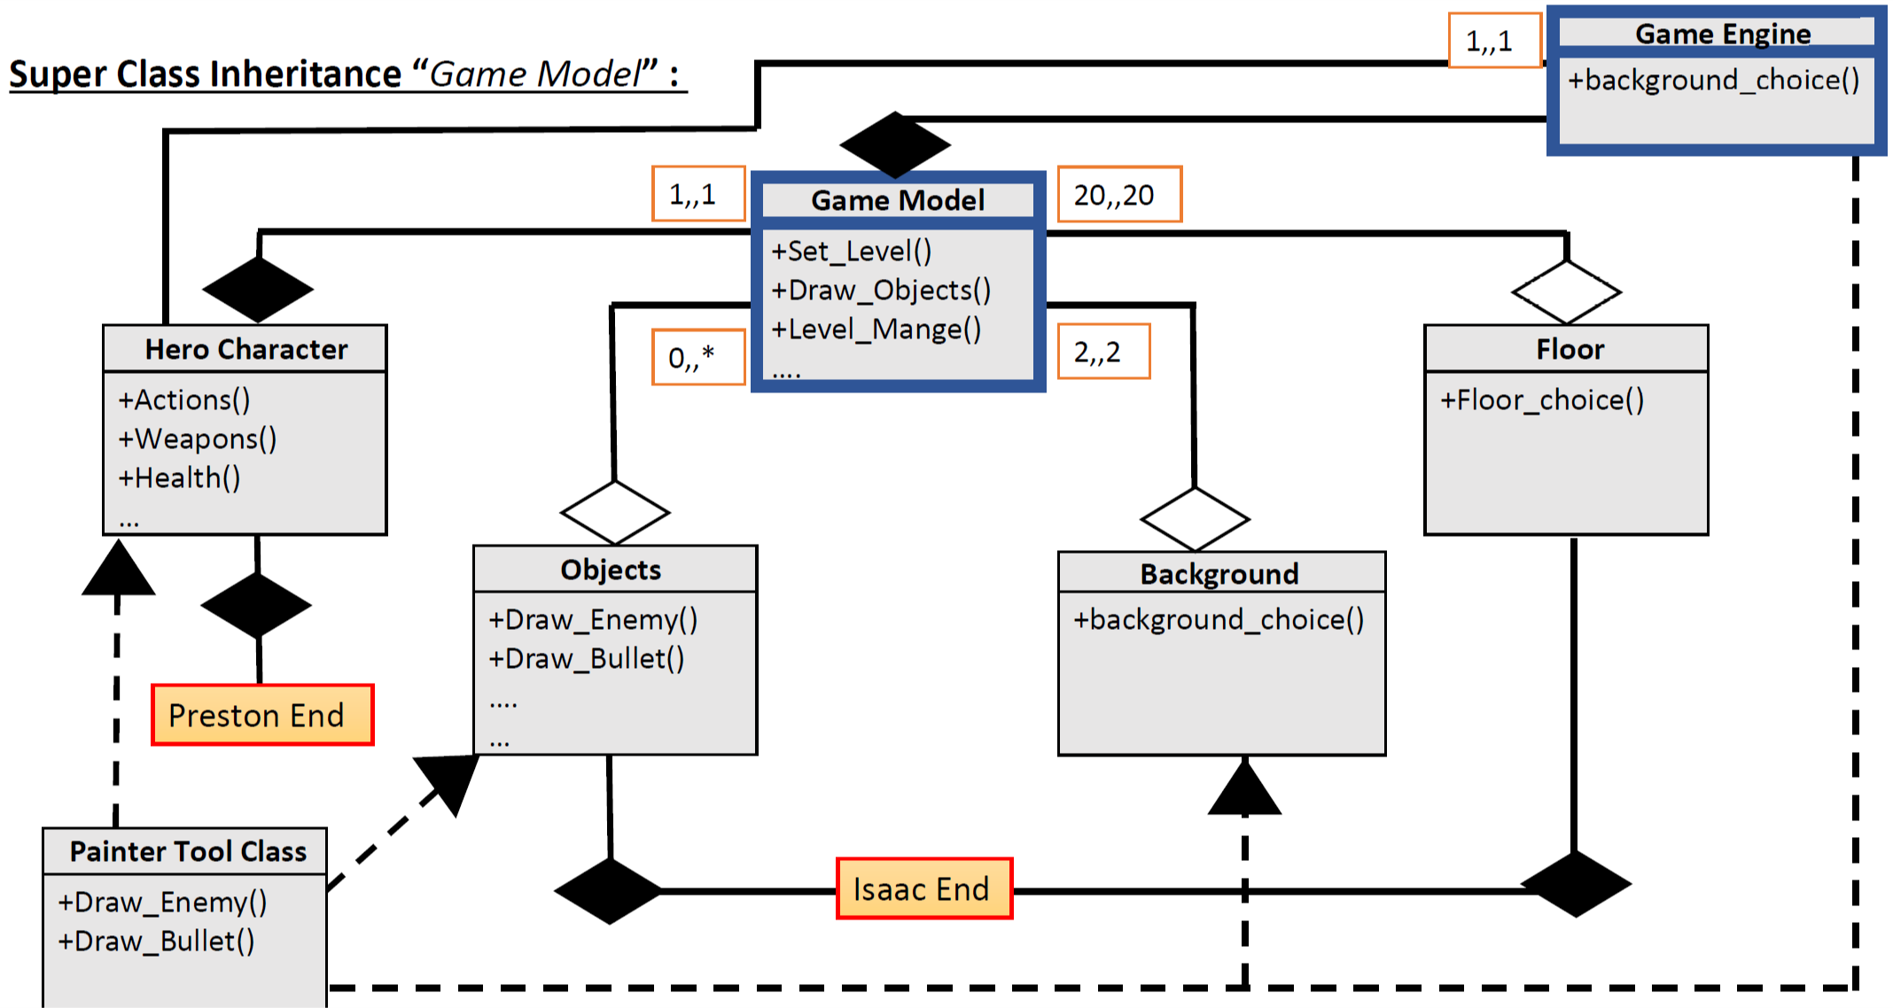

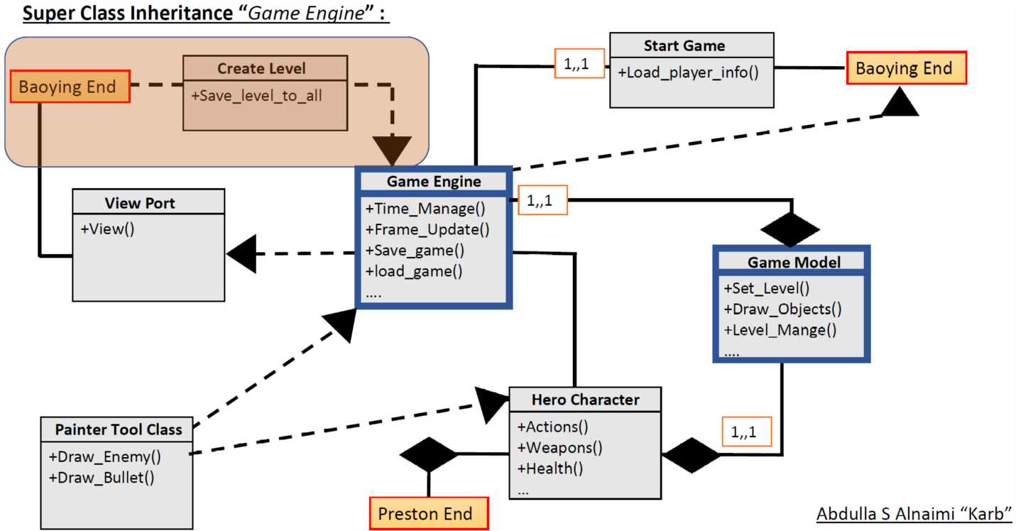

## Dustin Class Diagram

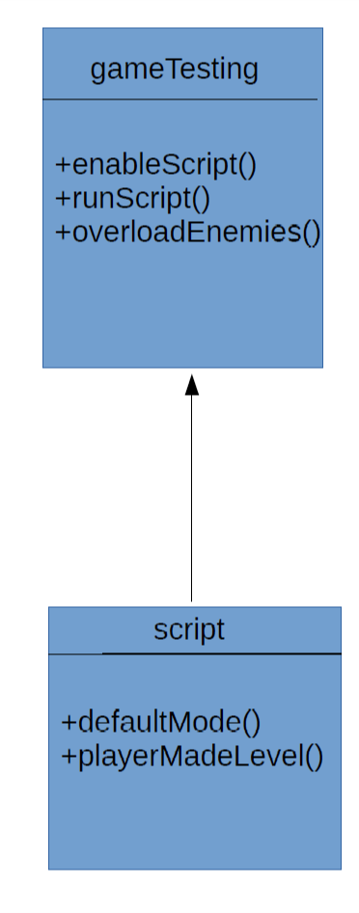

## Baoying Class Diagram

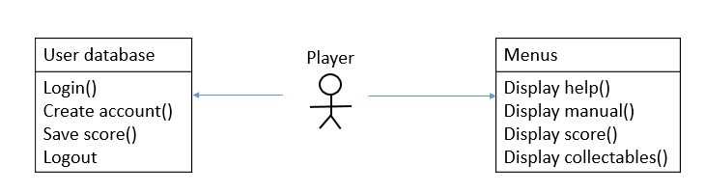

## Riggs Class Diagram

