Name Isaac Riggs Mark _____________________/50

[**Instructions**: Remove everything that is not a heading below and fill in with your own diagrams, etc.]

## Brief introduction __/3

My feature will be implementing the weapons, projectiles, and collectables. Weapons will a part of the collectables class and upon collecting a collectable, a Boolean value will be set in order to give the player the attribute. Collectables will also contain coins that affect the player’s overall score. Each coin collected will add 1 to a counter variable. Projectiles will vary upon the weapon collected by the player. Weapons will be water attack (Melee), Fire Attack (Long Range), and Earth Wall (Shield).

## Use case diagram with scenario __14

### Use Case Diagrams

Player

<< Extend >>

Pick up Collectable

Add Ability

<< Extend >>

Iterate coin count

Collectable Location

Collectable type

Player

Fire

Projectile

Projectile

Range

Collision Handling

Weapon Type

<< include >>

Projectile type

### Scenarios

**Name:** Pick Up Collectable

**Summary:** The player collides with a collectable and either gains an ability or the score is Increased.

**Actors:** Player.

**Preconditions:** Game has been started.

**Basic sequence:**

**Step 1:** Check if location contains collectable.

**Step 2:** Check if coin or weapon.

**Step 3:** If coin, then increase score. If weapon, then add ability.

**Step 4:** Display new score or ability.

**Exceptions:** No exceptions needed.

**Post conditions:** New score or ability displayed.

**Priority:** 1

**ID:** 05

**Name:** Fire Projectile

**Summary:** Fires a projectile based on player input.

**Actors:** Player.

**Preconditions:** Weapon collectable picked up.

**Basic sequence:**

**Step 1:** Accept user input.

**Step 2:** If player input matches a fire key, then fire projectile.

**Step 3:** Delete projectile after certain distance or it hits an enemy.

**Exceptions:**

**Step 1:** Input not a fire key: keep taking input.

**Step 2:** Attempt at firing projectile not picked up yet: use Boolean variables.

**Post conditions:** Enemy destroyed or projectile deletes itself after certain distance.

**Priority:** 3

**ID:** 0311

## Data Flow diagram(s) from Level 0 to process description for your feature _______14

### Data Flow Diagrams

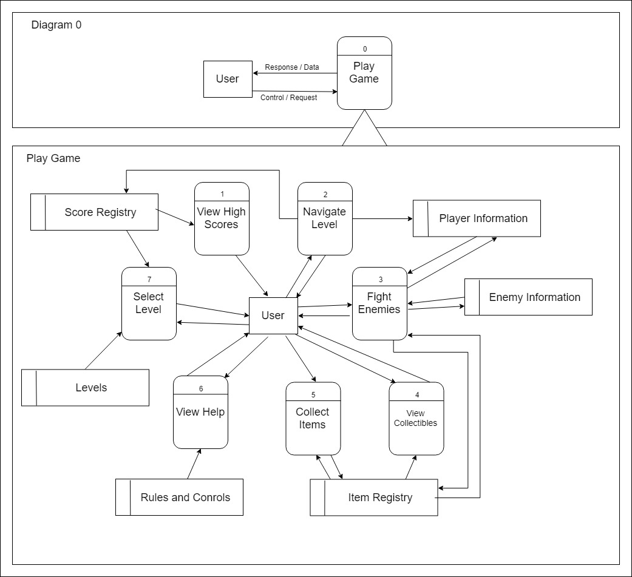

Collect Items

Location

1.1

Get Item

Item Registry

Item

User

Coin

New Score

Score Registry

1.3

Update Score

Ability

1.2

Check Item

Attack

Item Registry

Attack

Get Projectile

1.1

Fight Enemies

Projectile Type

Enemy Information

Player Information

Enemy

User

Remove Enemy

Lower Health

1.5

1.4

1.2

Update Enemy

Update Player

Fire Projectile

Projectile

Enemy Hit

Player Hit

1.3

Detect Collision

### Process Descriptions

Get Item: While not equal to item, keep looping end while

Check Item: Check if item is ability or coin. If coin then update score, else add user ability

Update Score: Increments coin count up.

Get Projectile: If player attack, then check if player has attack. If enemy attack, then check what type of attack enemy has.

Fire Projectile: While projectile range is not equal to its maximum range, keep the projectile in motion.

Detect Collision: If enemy projectile hit player, then return player hit. If player projectile hit enemy, then return enemy hit.

Update Player: If Player hit, then lower health.

Update Enemy: If enemy hit, then delete enemy.

## Acceptance Tests ________9

* Testing the collect items by running through a large amount of coins and abilities.
* Testing projectile acceptance and collision detection by running through multiple scenarios

## Timeline _________/10

### Work items

|  |  |  |
| --- | --- | --- |
| Task | Duration (PWks) | Predecessor Task(s) |
| 1. Collect Items | 2 | - |
| 2. Projectile Animation | 1 | 1 |
| 3. Hit Detection | 2 | 1,2 |
| 4. Update Player/Enemy | 1 | 1 |

### Pert diagram

|  |  |  |
| --- | --- | --- |
| 2 | 1 | 3 |
| 2 | | |
| 2 | 0 | 3 |

|  |  |  |
| --- | --- | --- |
| 0 | 2 | 2 |
| 1 | | |
| 0 | 0 | 2 |

|  |  |  |
| --- | --- | --- |
| 3 | 2 | 5 |
| 4 | | |
| 3 | 0 |  |

|  |  |  |
| --- | --- | --- |
| 2 | 1 | 3 |
| 3 | | |
| 2 | 0 | 3 |

### Gantt timeline

|  |  |  |  |  |  |
| --- | --- | --- | --- | --- | --- |
| 1 |  |  |  |  |  |
| 2 |  |  |  |  |  |
| 3 |  |  |  |  |  |
| 4 |  |  |  |  |  |
|  | 1 | 2 | 3 | 4 | 5 |