HW 4 & 5

Preston Phillips

November 8, 2016

## Results

Table 1: Percentage of drivers testing positive by drug type, sex and year group

|  |  |  |  |  |  |  |
| --- | --- | --- | --- | --- | --- | --- |
| Drug type | F 1999-2002 | F 2003-2006 | F 2007-2010 | M 1999-2002 | M 2003-2006 | M 2007-2010 |
| Alcohol | 27.5 | 25.1 | 27.5 | 43.5 | 43.3 | 43.6 |
| Cannabinoid | 2.7 | 6.2 | 7.8 | 6.6 | 11.6 | 13.8 |
| Depressant | 4.7 | 4.4 | 6.0 | 2.1 | 2.9 | 3.6 |
| Narcotic | 4.9 | 5.4 | 8.1 | 2.5 | 3.6 | 4.6 |
| Other | 6.4 | 7.4 | 8.2 | 4.4 | 4.8 | 4.5 |
| Stimulant | 9.9 | 12.5 | 11.0 | 14.0 | 15.9 | 12.0 |

Figure 1: Prevalence of nonalcohol drugs in fatally injured drivers by year and age

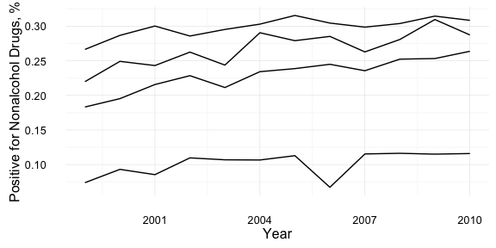 Figure 2: Prevalence of nonalcohol drugs in fatally injured drivers by year and drug type 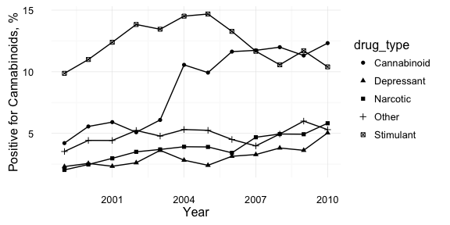

Figure 3: Prevalence of cannabinoid drugs in fatally injured drivers by year and age group

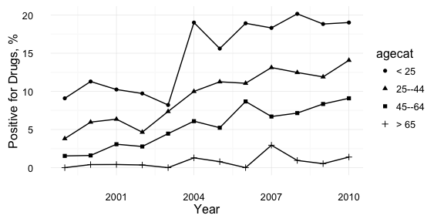

Prevalence of drugs in fatally injured drivers for 1999 and 2010 by drug type

|  |  |  |
| --- | --- | --- |
| Drug Type | 1999 | 2000 |
| Alcohol | 37.5% (35.5%, 39.6%) | 38.5% (36.6%, 40.5%) |
| Cannabinoid | 4.2% (3.4%, 5%) | 5.6% (4.6%, 6.5%) |
| Depressant | 2.3% (1.7%, 2.9%) | 2.6% (1.9%, 3.2%) |
| Narcotic | 2% (1.4%, 2.6%) | 2.5% (1.8%, 3.1%) |
| Other | 3.5% (2.8%, 4.3%) | 4.4% (3.6%, 5.3%) |
| Stimulant | 9.9% (8.6%, 11.1%) | 11% (9.7%, 12.3%) |

Statistics for testing for trend in prevalence of drugs over study years by drug type using Cochran-Armitage trend test

|  |  |  |
| --- | --- | --- |
| drug | Z | p.value |
| Alcohol | 1.22 | 0.22 |
| Nonalcohol | 12.32 | 0.00 |
| Narcotic | 7.86 | 0.00 |
| Depressant | 5.19 | 0.00 |
| Stimulant | 1.62 | 0.11 |
| Cannabinoid | 16.01 | 0.00 |
| Other | 1.95 | 0.05 |

Statistics for testing for trend in prevalence of drugs over study years by drug type using Wald test of logistic regression coefficient for “year”

|  |  |  |
| --- | --- | --- |
| drug | Z | p.value |
| Alcohol | 1.2 | 0.22 |
| Nonalcohol | 12.3 | 0.00 |
| Narcotic | 7.8 | 0.00 |
| Depressant | 5.2 | 0.00 |
| Stimulant | -1.6 | 0.11 |
| Cannabinoid | 15.9 | 0.00 |
| Other | 2.0 | 0.05 |