Joel Petracci
Gavin Gallino
ECE 478 Project

PeopleBot

The goal of the project was to develop software for the Pioneer 2 robot to enable collision avoidance in a room with either fixed or moving obstacles. The second goal of the project was to develop a new pair of arms for the robot and design software to command the controller to move the servos. The robots purpose is as a receptionist or other information dispersing agent.
A head for the robot has been previously developed and not included in this project.

PeopleBot Arms:
The arms of the robot needed to be reconstructed. The originals where held together with glue and tape and used plastic for the arms. The goal for redesigning them was to make them durable and also serviceable. The arms also have an one more axis of movement which is rotating the wrist. Below is an overview of the build process and the results.
The primary challenge of the arm is making it strong but light at the same time. Many materials are either light or strong but not both. This is why I chose aluminum to construct the arm from. It is a very strong metal that is soft enough to machine with simple tools. The weight is also a factor that makes it a great material with only about 2600 kg/m3 compared to 7900 kg/m3 for steel. Aluminum in the dimensions used for this project can be found at most home improvement stores such as Home Depot or Lowes. This makes it very easy for anyone to build the arm at a reasonable cost. A parts list and aproximate cost will be listed later in the report. Build instructions can also be provided.
The servos used on the arm are standard Hitec servos for the elbow/wrist and high power Hitec servos for the shoulder joint. The servos are powered via a 6volt sealed lead acid battery. Any battery that meets the voltage specs of the servos could be used but a rechargeable cell with enough amp-hours for the desired runtime would be recommended. To control the servos the ASC16 controller is used. This controller connects to a computer via the RS232 serial port or optionally at TTL levels for microcontrollers. The controller required a RS232 to TTL voltage converter which consisted of a MAX232 chip and 4 capacitors. The power for the voltage converter is sourced from the controller. The manual for the ASC16 controller describes this common circuit in more detail.

The controller accepts commands as binary numerical values sent over the serial connection. It has a 128 command buffer so you can issue many commands at a time. Various parameters can be set for the servos such as accelration and speed. There are also other commands for using multiple controllers in parallel or for accessing the data input/output ports. The software that ships with the controller has an interpreter that translates servo commands in a mnemonics form into the binary form. For this project I wrote a Python module that does this same task allowing anyone on any operating system to send commands to the controller in an easy to read form. It also provides a programming interface to the controller so that other code can directly issue commands. The Python module does rely on the PySerial module for the serial port IO.

Parts list:
Part Description | Cost | Use
3/4in x 3ft  Square Aluminum Tubing | $8.17 | Cut into 4 pieces for two arms.
3/4in x 1/8in x 3ft  Flat Aluminum Plate | $3.38 | Elbow Servo braket
7in x 18in 22gauge  Aluminum Seet | $7.98 | Servo brakets
1/2in x 1in x 3ft  Poplar (or any fine graned material) | $1.10 | Servo connection blocks
#8-32 x 2in  bolts |  | Bracket connections
#6 x 1/2in |  | Servo block connections
zip-ties |  | Wire management
Large servos |  | Shoulder joint
Sandard servos |  | Elbow and wrist joints

Total cost is aproximately <$30 not including the servos.

Tools used:
#8-32 tap for bolts
Drill/bits
Metal cutting saw
Screw driver
Tin snips
Hammer

Arm Pictures:
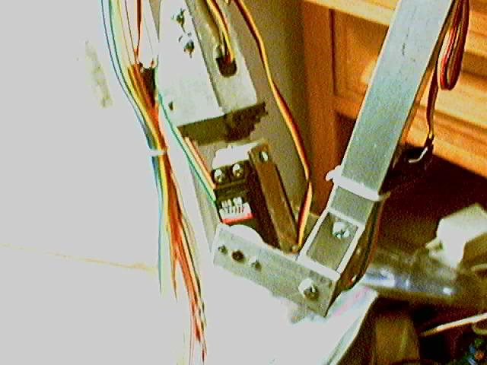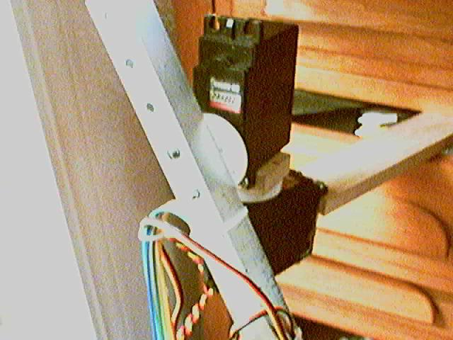
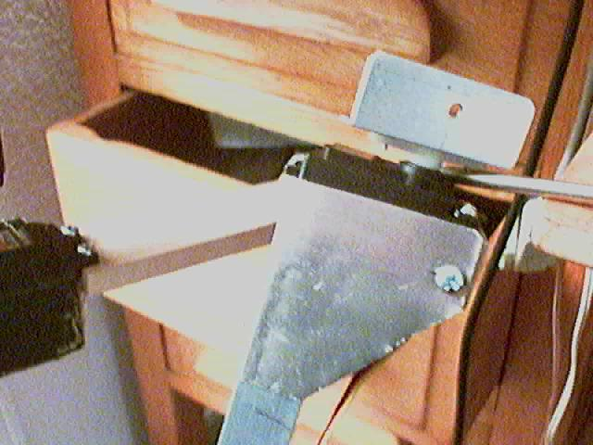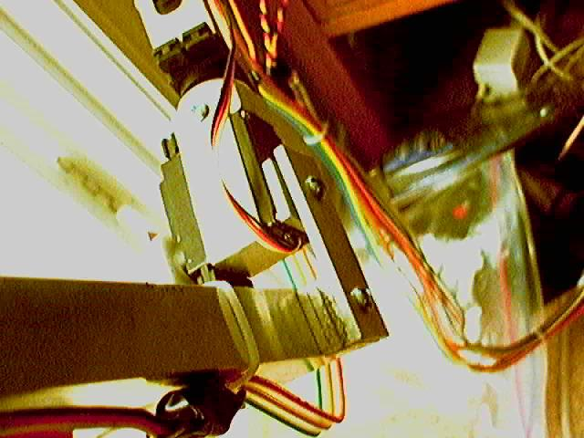

Collision Avoidance Software:

In order to run programs that will communicate to the PeopleBot robot you must first download the software from the manufactures website at http://robots.mobilerobots.com. the software is called Aria and allows communication between the client and the robot. The robot OS will act as a server and the users computer acts a client sending commands to the robot.

There is also a simulator provided that allows users to run programs for the robot without actually using the robot. The simulator allows testing of the sensors and the movement of the robot. You need to load maps into the simulator and the robot will run through the maps running the program. For this project the office map was used during tests. The office map provides different rooms for the robot and some smaller obstacles that may represent tables.

The software for this project is written in python using the Aria python module. Python allows quick changes to the program without having to recompile the software every time. It also allows easy access to graphics libraries that are used to display sensor data to the user. The library used in this project is the pygame module for python. It allows access to commands for drawing windows and also keyboard commands.

The peoplebot software has three modes of operation. There is the wander mode which is the default mode the robot is in when started. This mode enables the robot to move around a room avoiding obstacles. The second mode is manual mode. This mode is entered into by pressing one of the arrow keys. Which ever arrow is pressed the robot will begin to move in that direction. The space bar is used to stop the robots movement. Wander mode is entered into by pressing the escape key. The third mode is the tracking mode. This mode is used to track movement around the robot. Pressing the escape key will exit out of this mode and return to wander mode.

In the wander mode the robot will avoid obstacles in front of it. This is done by polling the sensors and checking the minimum distances to the obstacles around it. If an obstacle is detected the robot will determine which way is best and then turn until the obstacle is no longer in front of the robot. The choice in which way to turn is determined by comparing each directions closeness to obstacles and then choosing which side is less. Below is a piece of code from the program that determines which direction to turn:
for i in range(len(left_sensors)) :
if left_sensors[i] > right_sensors[i] :
direction -= 1
else:
direction += 1

If direction is negative then the robot will choose to turn left. Otherwise the robot will turn right. Below is the code for detecting obstacles:

if sensors[2] < FRONT_RR or sensors[1] < FRONT_MR or sensors[0] <
FRONT_CR or sensors[-1] < FRONT_CL or sensors[-2] <
FRONT_CM or sensors[-3] < FRONT_LL :
return 1
else:
return 0

Tracking is done when the robot is stationary. The software takes two snapshots of the sensors at different intervals and then subtracts the two snapshots. It then checks if there is a difference. If there is then there was movement and the robot will turn towards the movement.

import pygame, random, os, sys, signal

#import the path to the AriaPy module
sys.path.append('/usr/local/Aria/python')

from AriaPy import *
from pygame.locals import *

Aria.init()
pygame.init()

# Constant Declaration
FRONT_RR = 500
FRONT_MR = 600
FRONT_CR = 750
FRONT_CL = 750
FRONT_CM = 600
FRONT_LL = 500

# Class instances declaration
robot = ArRobot()
conn = ArSimpleConnector(sys.argv)
sonar = ArSonarDevice()
bumper = ArBumpers()
time = ArTime()

# Global variables
robot_position = [270,0,0] # angle, x, y
obstacle = 0
direction = 0

robot.addRangeDevice(sonar)
robot.addRangeDevice(bumper)

# connect to simulator or the robot
if (not conn.connectRobot(robot)):
print "Could not connect to robot, exiting"
sys.exit(1)

# run the robot in its own thread
robot.runAsync(0)

robot.comInt(ArCommands.ENABLE, 1)

# draw main window to display information
screen = pygame.display.set_mode((250,250))

def readSensors():

# variable to hold the sensor data
sensors = range(18)

for i in range(18):
sensors[i] = sonar.currentReadingPolar( (i*20) , ((i*20)+20) )

# correct for blind spots at angles 60-80,100-120 and 240-260,280-300,
sensors[3] = sensors[4]
sensors[5] = sensors[4]
sensors[14] = sensors[13]
sensors[12] = sensors[13]
return sensors

def readBumpSensors():

# variable to hold the sensor data
bump_sensors = range(18)

for i in range(18):
bump_sensors[i] = bumper.currentReadingPolar( (i*20) , ((i*20)+20) )

return bump_sensors

def drawSensorData(sensors,):
#draw the sensor data
for i in range( len(sensors) ):
# draw each rect( , color , (left, top, width, height) ,thickness
pygame.draw.rect(screen, (0, 0, 255), Rect(i*10, 0, 10, (sensors[i]/25) ), 0)

def averageSensors(sensors):
avg_sensors = range( len(sensors) )

for i in range( len(sensors) ):
if i == len(sensors)-1 :
end = 0
else:
end = i+1

avg_sensors[i] = (sensors[i-1] + sensors[i] + sensors[end]) / 3

return avg_sensors

def obstacleInPath(sensors):

if sensors[2] < FRONT_RR or sensors[1] < FRONT_MR or sensors[0] < FRONT_CR or sensors[-1] < FRONT_CL or sensors[-2] < FRONT_CM or sensors[-3] < FRONT_LL :
return 1
else:
return 0

def bumperCheck(sensors):
for x in sensors:
if x < 1000 :
robot.lock()
robot.setVel2(-300,-300)
robot.unlock()
print "bumper"

def moveRobot(sensors):
global obstacle
global direction

movement = (0,0)

# move forward until obstacle at min distance
if obstacleInPath(sensors) :

if obstacle == 0:
# check for best direction
direction = determineDirection(sensors)

#obstacle found keep turning until obstacle is no longer present
obstacle = 1

# turn
if direction > 0 :
# turn right
turn_right()
else:
# turn left
turn_left()

else:
# move forward
move_forward()

obstacle = 0

return movement

def turn_left():
robot.lock()
robot.setVel2(100,-100)
robot.unlock()

def turn_right():
robot.lock()
robot.setVel2(-100,100)
robot.unlock()

def move_forward():
robot.lock()
robot.setVel2(300,300)
robot.unlock()

def move_back():
robot.lock()
robot.setVel2(-300,-300)
robot.unlock()

def move_stop():
robot.lock()
robot.setVel2(0,0)
robot.unlock()

def determineDirection(sensors):
direction = 0

# create arrays of each side
left_sensors = sensors[0: (len(sensors)/2) ]
right_sensors = sensors[(len(sensors)/2) : len(sensors)]
right_sensors.reverse()

for i in range(len(left_sensors)) :
if left_sensors[i] > right_sensors[i] :
direction -= 1
else:
direction += 1

return direction

def New_SIGSEGV(*args):
# exit program
print "exit"
Aria.exit()
sys.exit(1)

signal.signal(signal.SIGSEGV, New_SIGSEGV)

def track():
sensors1 = range(18)
sensors2 = range(18)
sens_diff = range(18)
angle = 0
tracking = 1

print "entering tracking mode"

while tracking:

move_stop()

for event in pygame.event.get():
if event.type == QUIT:
Aria.exit()
sys.exit(1)
elif event.type == KEYDOWN:
if event.key == K_ESCAPE:
print "exiting tracking mode"
tracking = 0

# get the reading for the sonic sensors
sensors1 = readSensors()

for i in range(9999999):
i

sensors2 = readSensors()

for i in range(18):
sens_diff[i] = sensors1[i] - sensors2[i]

angle = sens_diff.index(max(sens_diff))

if angle > 0:
if angle > 8:
angle = -(360 - (angle * 20 + 10))
else:
angle = angle * 20 + 10
robot.setRotVel(angle)
time.setToNow();
while 1:
robot.lock()
if time.mSecSince() > 1000:
robot.unlock()
break
robot.unlock();

def main():
# variable to hold the data
sensors = range(18)
sensors_avg = range(18)
bump_sensors = range(18)
manual = 0

# main program loop
while 1:
# reset the time stamp
time.setToNow()
for event in pygame.event.get():
if event.type == QUIT:
Aria.exit()
sys.exit(1)
elif event.type == KEYDOWN:

if manual == 0:
print "exiting wander mode"
manual = 1

if event.key == K_LEFT:
turn_left()
if event.key == K_RIGHT:
turn_right()
if event.key == K_UP:
move_forward()
if event.key == K_DOWN:
move_back()
if event.key == K_SPACE:
move_stop()
if event.key == K_t:
track()
if event.key == K_ESCAPE:
print "entering wander mode"
manual = 0

if not manual: #enter wander mode
#clear the screen
pygame.draw.rect(screen, (0, 0, 0), Rect(0, 0, 250, 250), 0)

# get the reading for the sonic sensors
sensors = readSensors()

# get the reading for the bump sensors
bump_sensors = readBumpSensors()

# average the sensors
sensors_avg = averageSensors(sensors)

# display the sensor data
drawSensorData(sensors)

pygame.display.flip()

# move robot
moveRobot(sensors_avg)

#check for bumpers
bumperCheck(bump_sensors)

# end main program loop

Aria.exit()
sys.exit(1)

if __name__ == '__main__': main()

import serial

# name
# array: 0=none, 1=add to base
# extra bytes: 0=none, 1=8bit, 2=16bit
# base number code
cmd_set = {
"ac":(1,1,81),
"am":(0,0,250),
"at":(0,0,249),
"bt":(0,1,124),
"en":(0,1,121),
"f+":(0,0,251),
"f-":(0,0,252),
"fp":(1,2,21),
"iv":(0,1,112),
"la":(0,0,242),
"ld":(0,1,123),
"lm":(0,0,253),
"lp":(0,0,254),
"mk":(1,0,221),
"mr":(1,2,41),
"mv":(1,2,1),
"no":(0,0,0),
"nv":(0,1,113),
"op":(0,1,110),
"pg":(0,1,120),
"ra":(1,0,141),
"rd":(0,0,179),
"rp":(0,1,116),
"rs":(0,1,117),
"s+":(0,0,245),
"s-":(0,0,246),
"sa":(0,0,241),
"sp":(1,1,61),
"st":(1,0,151),
"sv":(0,1,122),
"tl":(0,1,119),
"tm":(1,0,181),
"tp":(1,0,201),
"tt":(0,1,111),
"wf":(0,0,243)
}

class ASC16:
def __init__(self, port=0,dummy=False):
self.serial_port = None
if not dummy:
self.serial_port = serial.Serial(port)
if not self.serial_port.isOpen():
print "Error opening serial port."
print "port =", port

def compile_motion_script(self, script):
script_binary = []
script_cmd = script.lower().split()
next_data = 0
for c in script_cmd:
if c.isspace():
continue
if next_data == 1:
if c.isdigit():
script_binary.append(int(c))
next_data = 0
continue
else:
print "value error,",c
elif next_data == 2:
if c.isdigit():
n = int(c)
script_binary.append(n >> 8)
script_binary.append(n & 0xff)
next_data = 0
continue
else:
print "value error,",c

a = c.rstrip("0123456789")
n = c.lstrip("abcdefghijklmnopqrstuvwxyz")
try:
i = int(n)
except ValueError:
i = None
if a in cmd_set:
if cmd_set[a][0] == 0:
if i != None:
print "command error,",c
return
else:
script_binary.append(cmd_set[a][2])
next_data = cmd_set[a][1]
elif cmd_set[a][0] == 1:
if i != None:
script_binary.append(cmd_set[a][2] + i - 1)
next_data = cmd_set[a][1]
else:
print "command error,",c
return
else:
print "command error,",c
return
return script_binary

def motion_script(self, script):
binary = self.compile_motion_script(script)
self.motion_script_binary(binary)

def motion_script_binary(self, script):
if self.serial_port:
for c in script:
if c > 255 or c < 0:
print "byte bound error,",c
return
else:
self.serial_port.write(chr(c))
else:
print script

