**Introduction**

Definitions

* *Function* – Takes one or more arguments and evaluates to a single number
* *Operator* – A mathematical function that has two arguments and is written in infix notation
* *Operand* – A numerical argument to an operator
* *Expression* – A syntactically correct string of numbers and operators
* *Result* – The evaluation of an expression
* *Field* – The text area that acts as a display for expressions

Purpose

The purpose of this document is to specify the requirements of the client-requested calculator. This document tries to state all necessary user and system requirements and will act as a guideline for system developers.

**System Requirements**

Properties

Compatible Platforms: Windows, OS X, Linux, Android

Language: Java SE 8

**User Requirements**

# Expressions

Memory

Up to 10 of the most recently evaluated expressions will be stored in persistent memory when the application is closed by the user.

Operators

All conventional operations are supported along with the modulus operator as well. Below is a table that specifies each operation's related symbol and precedence. For precedence, 1 is the “highest”, and 3 is the “lowest”. All operators are left-associative.

|  |  |  |
| --- | --- | --- |
| Operator | Symbol | Precedence |
| Exponentiate | ^ | 1 |
| Multiply | * | 2 |
| Divide | / | 2 |
| Modulo | % | 2 |
| Add | + | 3 |
| Subtract | - | 3 |

Output

Each result will be a double-precision floating-point number with up to 10 digits of precision.

# Interface

Design

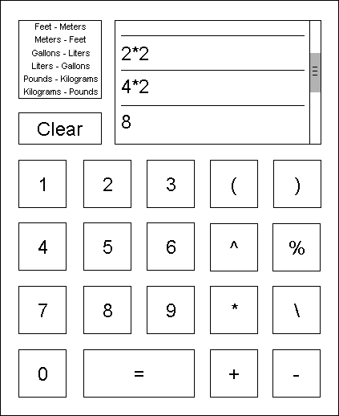

Functionality

* When one of the six conversion functions is clicked, it will take the current expression or result as an argument and output a converted number in the appropriate units.
* If the field is empty, all six conversion functions, “clear” and “=” will be disabled.
* If an operator is clicked after an expression is evaluated, the result of the previous evaluation will become an operand of that operator. If instead a number or either parentheses is entered, the result will not become a part of the new expression.