A Behavioral HDL Description of Forward AES-128 Encryption
Preston Pitzer, Nate Sawitzki [1]

Introduction
Advanced Encryption Standard (AES) is a substitution-permutation network private-key block cipher, designed as a successor to DES by John Daemen and Vincent Rijman [1]. The use of a substition-permutation network makes it highly efficient to implement in hardware, and the use of Galios Fields can be significantly simplified in hardware down to simple XOR operations. The x86 instruction set contains several instructions relating to AES encryption and decryption, including AESENC, which implements a single non-final round of AES encryption (final round is handled by AESENCLAST).
The AES cryptosystem relies on several submodules, each of which can be implemented (optionally) combinationally. The first of these is the SubBytes module, which reads byte(s) and returns a transformed byte (the input’s multipliative inverse on GF(8) through an affine transform). The second is ShiftRows, a byte-wise ciruclar left shift, the magnitude of the shift being dependent on the Row’s index. The third is MixColumns, which performes modular reduction on a column down to a 4th order polynomial with coefficients in GF(2), and then multiplies by a fixed polynomial. Practically, this corresponds to a multiplication of the input row by a fixed 4x4 matrix (in the 128 bit case). Finally, the round key (explained later) is bitwise XORd against the flattened matrix. The state controller handles construction of the data matrix and key from a 32-bit data line input, cycling through 10 rounds of the AESENC flow, and then returning the ciphertext through the 32-bit output line.

Module Descriptions

data_mat
The primary “data structure” for AES-128 is a 4x4 column major matrix of bytes, the individual bits of which represent coefficients of elements of GF(28). Because we have chosen to work with a 32 bit-bus length, this module should allow for reading and writing of an arbitrary row or column. To this end, the module has a 32-bit data in, 2 bits for index, 1 bit for row/column selection, 1 bit for read/write, and a write_enable. It has a single 32 bit output vector.

Key_expand
The key_expand module handles the generation of the round keys from the original cipher during the AES encryption scheme. In AES-128, the cipher key is 128 bits long, and from the cipher key, 11 round keys are generated (the first of which being the original cipher key). Each subsequent round key is generated by performing bit manipulations on the previous key. The manipulations in order are a circular left shift of one word (word = 32 bits), a bytewise sbox substitution fot the entire key, a xor operation with a round constant that varies between each round key, and finally extra xor operations with the previous key. Each of these operation are encapsulated as separate functions in my module and then are called upon during the key expansion stage as necessary.
The inputs to the key_expand module include the clock, reset, the cipher key (32 bits at a time), a start signal, and indexing variables to determine which portion of which round key to output (32 bits at a time). The outputs of the system are a done signal to signify all round keys are generated and the round key itself (in 32 bit segments). Following a start pulse, the key_expand module pulls in a quarter of the cipher key at a time, (32 bits) MSB first. Once it is done loading the cipher key, it generates each round key in 10 stages and then outputs a high done signal. Each round key takes 1 clock cycle to complete such that all of the sbox, round key, and shifting hardware can be reused during each round key generation (area prioritization).
Verification:
Using the testbench key_expand_tb, I verified my design using a cipher key I found in an online example that includes all of the correct round key ouptuts. I also tested various conditions with consecutive starts, holds, and restarts to ensure the design works robustly. Here is the output from my test next to the online round key outputs:

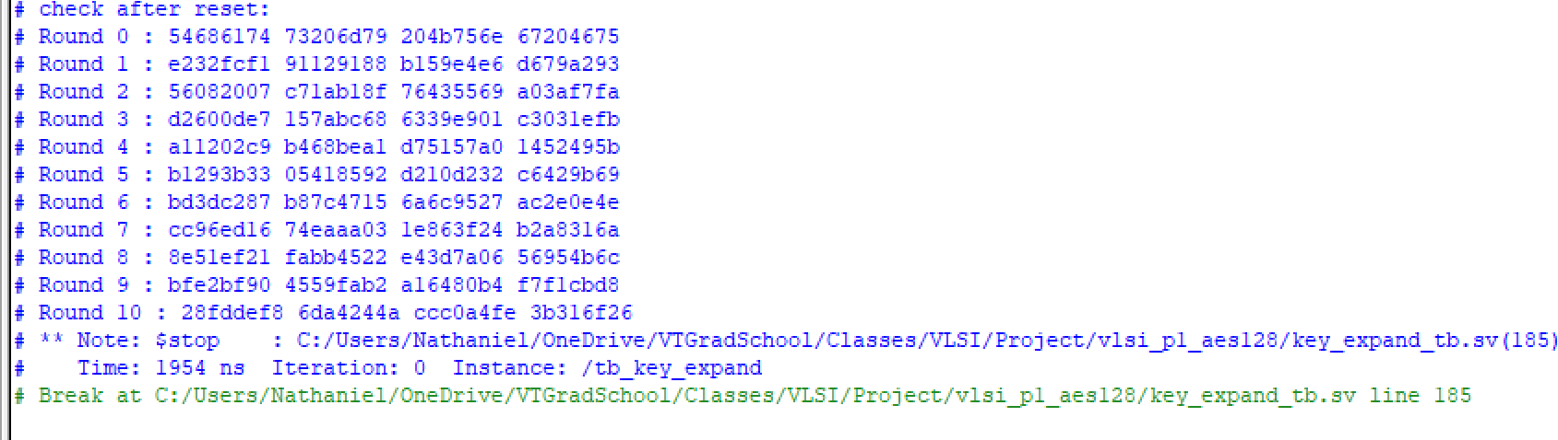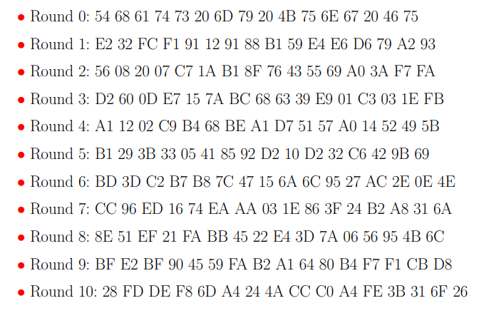
Figure 1: key_expand Output Figure 2: Valid Output

d

