Timetable editor

# Introduction

The timetable-function of Openrails offers a great option to define trains. The timetable is a simple csv-file (text-table), which defines the different trains. Since you have to take care of the correct data a macro for Microsoft Excel had been developed. Since not everyone has Excel, i have written this small editor.

# Userinterface

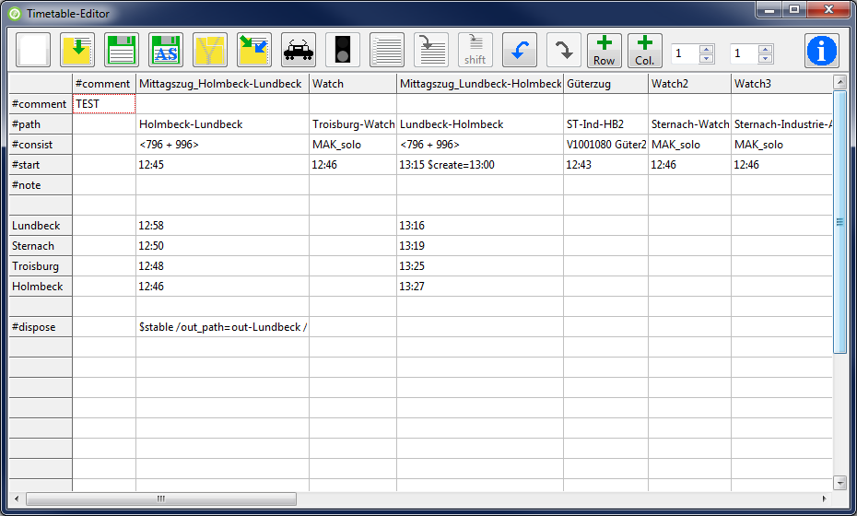

Symbols

|  |  |  |  |
| --- | --- | --- | --- |
|  | Create new timetable |  | Open timetable |
|  | Save timetable |  | Save timetable as |
|  | Create a zip-file with the timetable, the paths and consists |  | Import another timetable into the current one |
|  | Define train |  | Dispose action definition |
|  | Copy train (copy selected column) |  | Paste train (paste into selected column) |
| shift | Paste train and shift times (paste into selected column) |  | Undo |
|  | Redo | row | Add row above selected row |
| col | Add column left of the selected column |  | Infobutton |

The two spinedits are used to adjust the fixed rows (left spinedit) and fixed columns (right spinedit). Fixed lines are not editable.

The following is specific to Openrails timetables.

* In the corner of the first column-“#comment“ and the first row-“#comment“ Openrails expects the title of the timetable. The first column in the first row has to be empty. After the column-“#comment“ you define the different trains.
* #path: In this row the main paths for the train are entered.
* #consist: This row takes the consist of the train
* #start: Start time of the train.
* #note: Row for optinal commands
* #dispose: Row for the dispose-action. Defines what happens to the train, when it has arrived at the end of ist path.

Right clicking in one of the white cells of the table opens a menu, which lets you adjust the column width to the text in it and it lets you delete the current row or column.

# Creating a timetable

After the editor has started, you choose if you want to create a new timetable or if you want to open an existing one. By clicking “new” a dialog is shown which lets you choose the route-database-file (*.tdb) of the route you want the timetable to be created for. Apart from the track work defined in this file, there are the station names saved in it, which the editor needs to know, to be able to create the timetable.

The editor extracts the station names out of the route database and shows them in a list. With buttons you are able to move the entries up or down the list. Since it is a normal listbox, you are able to insert new rows or delete an entry. The list has to be saved, before going on. Before saving, the editor tests if the folder “Openrails“ exists inside the folder „Activities“ of the route. If the folder doesn’t exist it offers to create it. You should do that, because the editor searches its files there and Openrails will look there for the timetable. The station files are saved with the ending „.stations“ with the save-dialog.

If there are station files available the editor offers to choose one, ore create a new one.

The stations are added to the table and you can start defining the trains.

# Defining trains

To do this, click on the train-Icon, while you are in the column in which the train should be defined . Every train definition consists of four things. It has a name, a path, a consist and a start time. The name and start time have to be entered manually. The paths and consists are chosen from lists, so you don’t need to care to the correct spelling of the filename. The editor has loaded all available consists and paths which belong to installation of the chosen route. You are able to reload the files, for example if you created new paths or consists after having opened the editor.

To allow easier population of sidings, I would suggest the following way: Paths for sidings get a filename starting with “sid_”. This way they can be identified by the editor and you can choose if you want to see all paths, no sidings or just sidings. A similar way exists for consists. Here you can choose if you want to see all consists, only trains with engines or trains without engines.

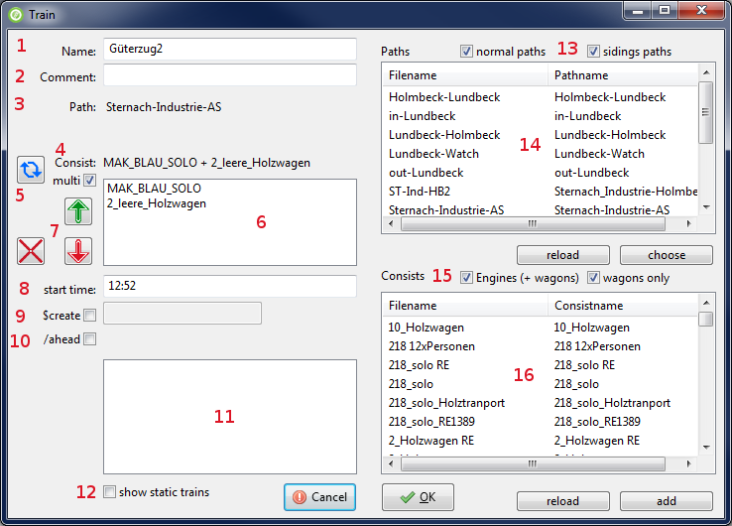

1. Name for the train-definition or $static for a static train
2. Comment to this train
3. Path for the train
4. Selected consist
5. Reverses the consist, or in multi-consist-mode it reverses the selected part of the consist
6. Only visible if the checkbox „multi” is selected. This way you can define a train which consists of two or more consist-files. The parts of this consists will be listed here
7. Move a part of the multi-consist up or down the list, delete a part of the consist
8. Start-time for the train
9. Allows entering a time at which the consist will be created
10. Allows defining, that this train will be placed ahead of another train, so that several trains can be placed on a siding in the right order
11. Lists the already defined trains, so you can pick the one, which this train should be placed ahead to.
12. Toggles if static trains ($static) should be visible in the list or not.
13. You can choose which paths should be visible in the list. If you select both checkboxes, you will see all paths. If only the left one is selected you will see all paths, whose filename doesn’t start with “sid_”. If only the right on is selected you will see only paths with the beginning “sid_”.
14. Path-List: Doubleclick or press choose to choose the selected path. Reload reloads the paths for this route
15. You can choose which consists should be visible in the list. If you select both checkboxes, you will see all consists. If only the left one is selected, you will see all consists, which contain an engine. If only the right one is selected, you will see all consists, which haven’t got an engine.
16. Consist-List: Doubleclick or press choose to choose the selected consist. Reload reloads the consists for this route.

# Time

The times for stops of the passenger trains are added in the table. You are able to define actions like waiting for another train or something like that. You find these infos inside the manual of the timetable function.

# Copying trains

You can copy a whole train (actually the whole column) and paste it into another column. There is a second paste-Button which allows to shift the times of the copied train, when pasting it. So it’s easy, to define trains which run the same path every hour, half an hour, or which interval is wanted.

# Import timetable

It is possible to import another timetable into the current one. But you have to be careful. If the two timetables have a different row count (because of empty rows, comments or…), there will be mismatches between them.

# Zip timetable

If you want to give your timetable to other persons, you can create a zip-file of the timetable. The zip-file will contain the timetable and all used paths and consists.

# Undo / Redo

The program has a simple Undo-Redo-Function. There are maximum 10 steps you can go back and forth.

# Dispose – or what happens to the train at the end of the path

The row whith „#dispose“ defines what happens to the train if it has reached the end of its path. Normally the train simply disappears. But you can define other things like forming another train or send the current train to a siding. Adding these functions is not easy, but there is a helper which you can open by clicking on the icon with the signal.

# Disclaimer

I can not guarantee that the programm runs without errors. So you use it at your own risk.

Lutz Döllermann, April 2015

Lutzs_de@yahoo.de