# EXP:01Developing a Neural Network Regression Model

## AIM

To develop a neural network regression model for the given dataset.

## THEORY

Explain the problem statement

## Neural Network Model

Include the neural network model diagram.

## DESIGN STEPS

### STEP 1:

Loading the dataset

### STEP 2:

Split the dataset into training and testing

### STEP 3:

Create MinMaxScalar objects ,fit the model and transform the data.

### STEP 4:

Build the Neural Network Model and compile the model.

### STEP 5:

Train the model with the training data.

### STEP 6:

Plot the performance plot

### STEP 7:

Evaluate the model with the testing data.

## PROGRAM

from google.colab import auth

import gspread

from google.auth import default

import pandas as pd

from sklearn.model_selection import train_test_split

from sklearn.preprocessing import MinMaxScaler

from tensorflow.keras.models import Sequential

from tensorflow.keras.layers import Dense

auth.authenticate_user()

creds, _ = default()

gc = gspread.authorize(creds)

worksheet = gc.open('data').sheet1

rows = worksheet.get_all_values()

df = pd.DataFrame(rows[1:], columns=rows[0])

df1 = df.astype({'input':'float'})

df1 = df.astype({'output':'float'})

df1.head()

x = df1[['input']].values

y = df1[['output']].values

x

y

x_train,x_test,y_train,y_test = train_test_split(x,y,test_size=0.33,random_state=33)

scaler = MinMaxScaler()

scaler.fit(x_train)

x_train1 = scaler.transform(x_train)

x_train1 = scaler.transform(x_train)

ai_brain = Sequential([

Dense(8,activation='relu'),

Dense(10,activation='relu'),

Dense(1)

])

ai_brain.compile(optimizer='rmsprop',loss = 'mse')

ai_brain.fit(x_train1,y_train,epochs=2000)

loss_df = pd.DataFrame(ai_brain.history.history)

loss_df.plot()

x_test1 = scaler.transform(x_test)

ai_brain.evaluate(x_test1,y_test)

x_n1 = [[4]]

x_n1_1 = scaler.transform(x_n1)

ai_brain.predict(x_n1_1)

## OUTPUT:

### SAMPLE DATA:

[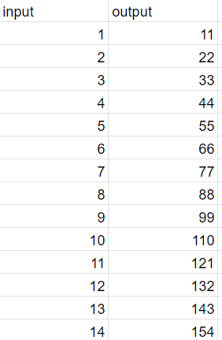](https://github.com/Prethiveerajan/basic-nn-model/blob/main/data.png)

### graph:

[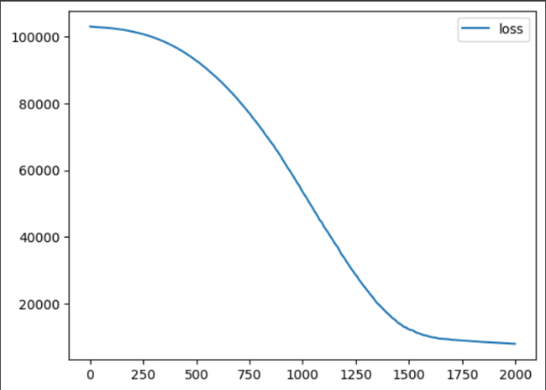](https://github.com/Prethiveerajan/basic-nn-model/blob/main/graph.png)

### Test Data Root Mean Squared Error:

[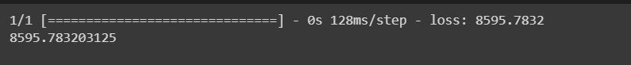](https://github.com/Prethiveerajan/basic-nn-model/blob/main/test.png)

### New Sample Data Prediction:

[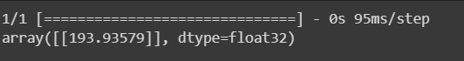](https://github.com/Prethiveerajan/basic-nn-model/blob/main/predict.png)

### Training Loss Vs Iteration Plot

Include your plot here

### Test Data Root Mean Squared Error

Find the test data root mean squared error

### New Sample Data Prediction

Include your sample input and output here

## RESULT

Thus a neural network regression model for the given dataset is written and executed successfully.