Lab 1

Prescott Massingill

**Possible Protocol 1 (PP1)**: roll once; if get 6 then conclude the dice is not fair; if roll any other number then conclude it is fair. Analyze PP1: if the dice were fair, what is the probability it would be judged to be unfair? Oppositely, if the dice were unfair, what is the probability that it would be judged to be fair?

1. The Probability that it will be judged as fair if the dice are fair is 1/6
2. The Probability that it will be judged as fair if they dice are unfair is equal to the population mean of getting a 6 on that dice

**PP2**: roll the dice 30 times. Group can specify a decision rule to judge that dice is fair or unfair. Consider the stats question: if fair dice are rolled 30 times, what is likely number of 6 resulting? How unusual is it, to get 1 more or less than that? How unusual is it, to get 2 more or less? 3? At least one member of the group should be able to do this with theory; at least one member of the group should be able to write a little program in R to simulate this. Analyze PP2 including the question: if the dice were fair, what is the chance it could be judged as unfair?

1. The number or 6’s that will be rolled within 95% of the time is between 2 and 9
2. If you roll a dice 30 times and you get in between 2 and 9 rolls you can be 95% confident that the mean of those dice are equal to the mean of a fair dice getting 6.

**PP3**: roll 100 times and specify decision rules. Some cases are easy: if every roll comes to 6 then might quickly conclude. But what about the edge cases? Is it fair to say that every conclusion has some level of confidence attached? Where do you set boundaries for decisions? Analyze PP3.

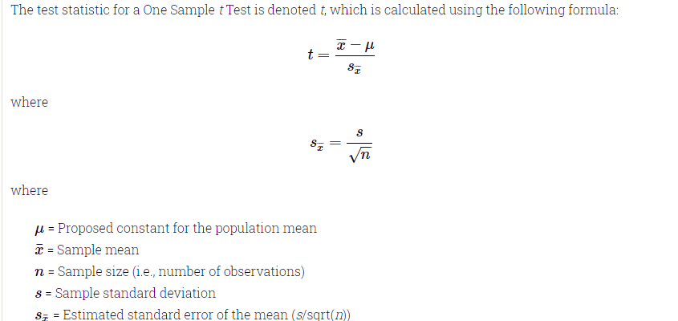

To properly use the methode of the T test above I will be evaluating the dice rolls through mean not based on number of 6’s rolled.

I used R to generate a roll of 100 dice and got the following information based on those rolls

Sample mean = 3.96

Sample Standard Deviation = 1.76

Sample size = 100

Population mean = 3.5

Using the formula above I calculated

t-value = 2.6124

using the t distribution chart will Degrees of freedom of 99 I got found that the confidence level that fell below the calculated t-value was 98%

So as the mean of the sample moves away from the population mean of a fair dice the lower the confidence level. Meaning that we can be less and less sure that the dice are fair.

**EP1:** Devise My Own Experiment!

The key to this is to find a balance between the number of throws of the dice and the confidence that the dice are fair. The higher the confidence the more throws and vice versa. Is there a nice middle before there is to much diminishing returns on the dice throw?

Quickly doing the math on a 99.5% confidence and 2% margin of error on the fairness of the dice I find I need 2741 throws of the dice. I got this using this formula

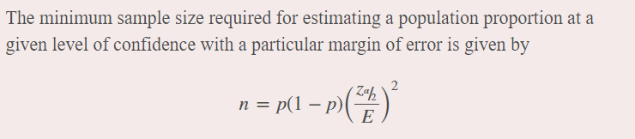

Flipping this equation around I can test different sample sizes and compare them to the confidence level achieved

i.e. using a sample of 1000 dice throws I only get 95.5% confidence

This shows how there is a lot of diminishing returns in increasing the sample size since going from a sample of 1000 to 2741 only gave an increase in confidence of 4%