PROG8171

Programming: SQA Techniques

# Assignment #1 – Defect Finding and Logging

1. Input is wrong when typing from Keyboard

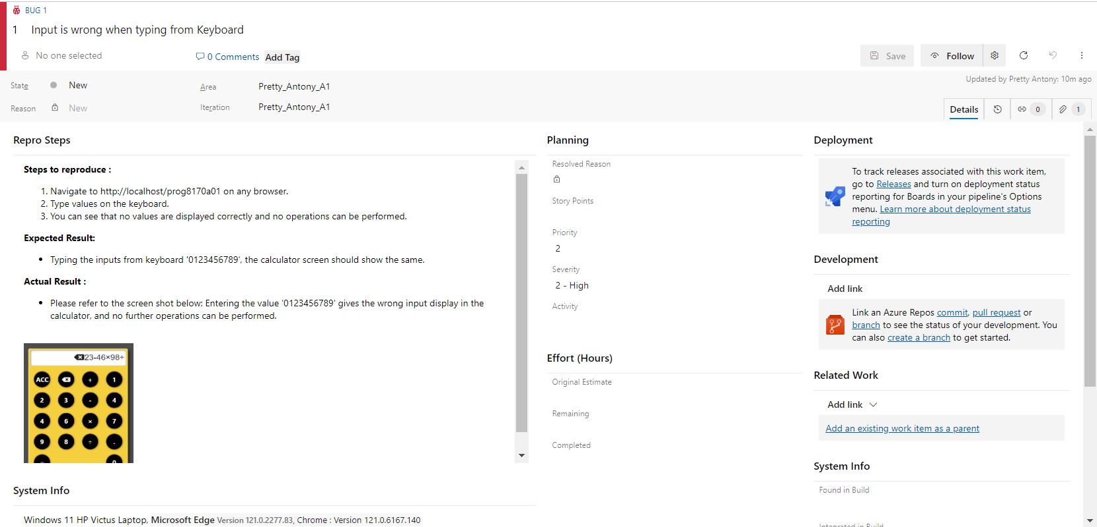

Fig 1.0 Screenshot from Azure DevOps

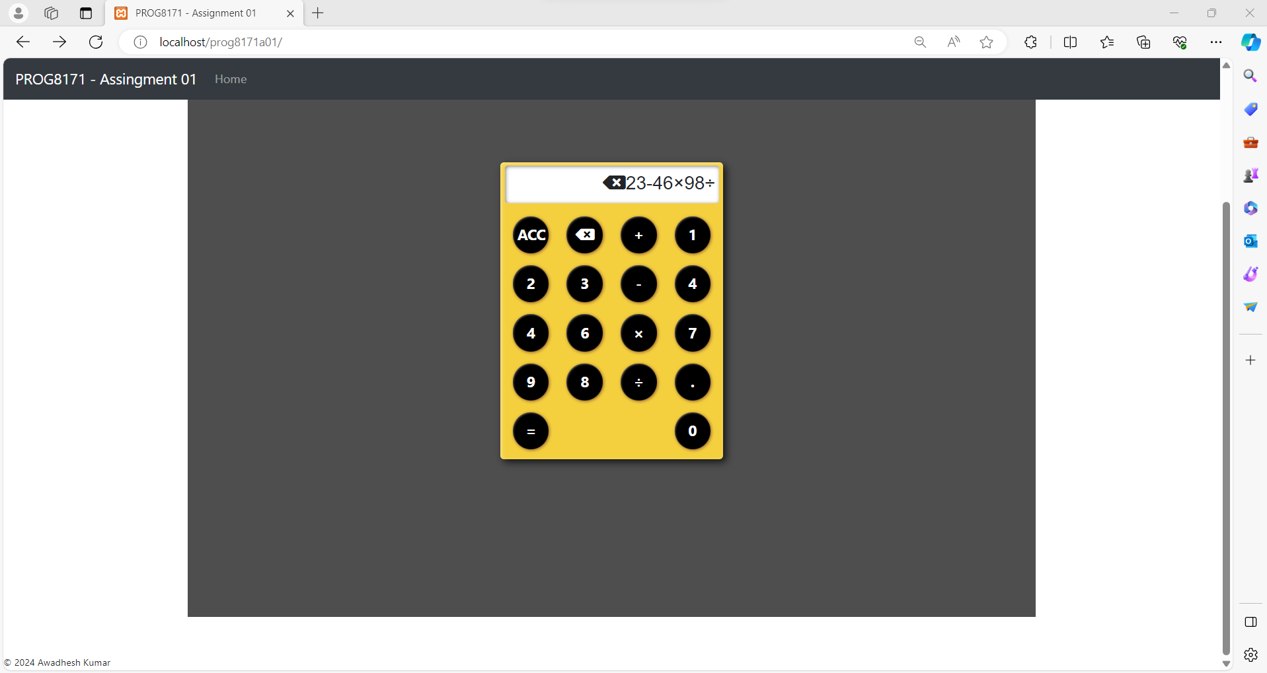

Fig 1.1 Screenshot from Browser

1. The result of the selected operation does not show eight decimal places

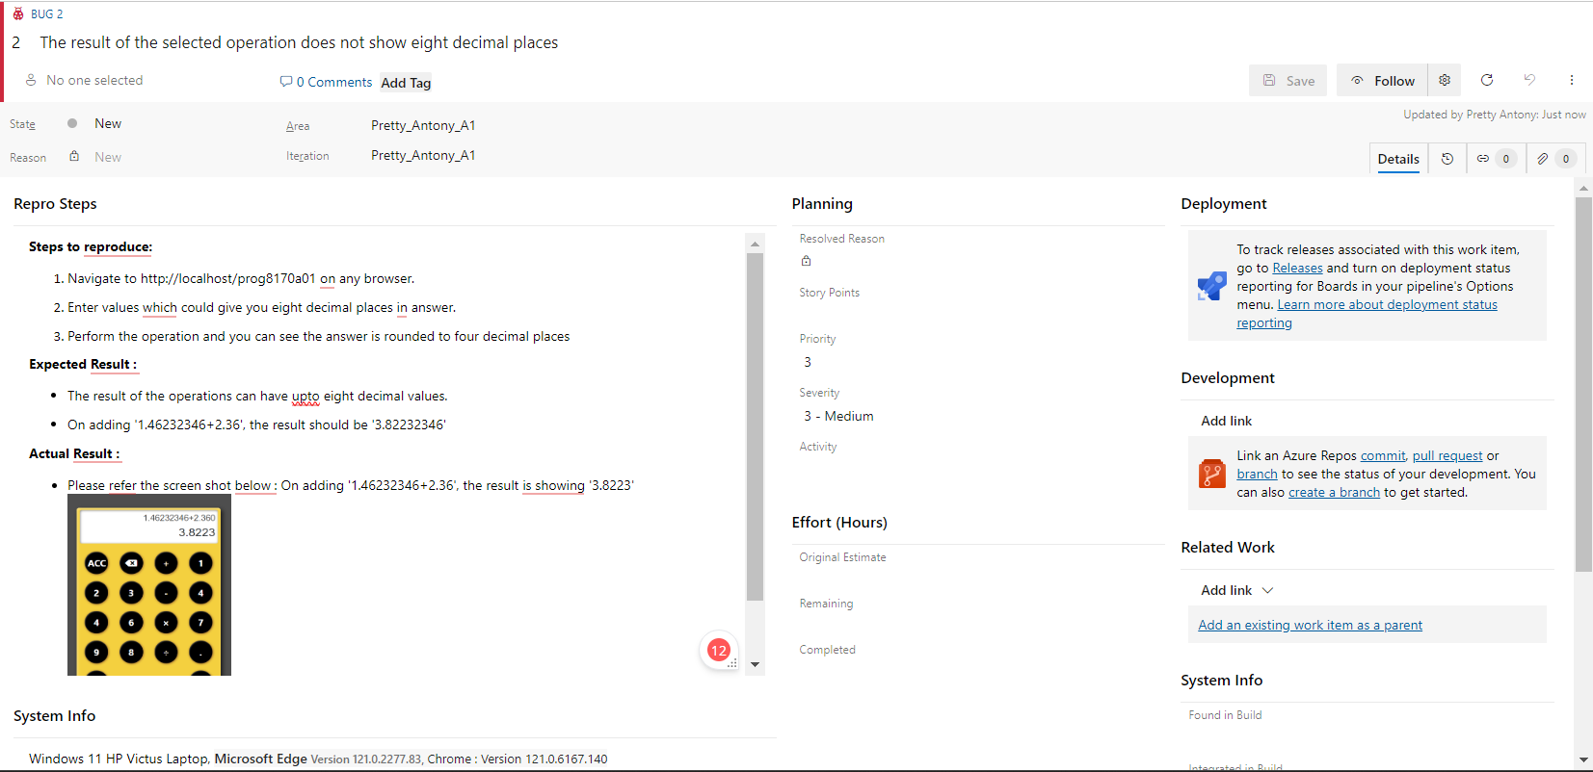

Fig 2.0 Screenshot from Azure DevOps

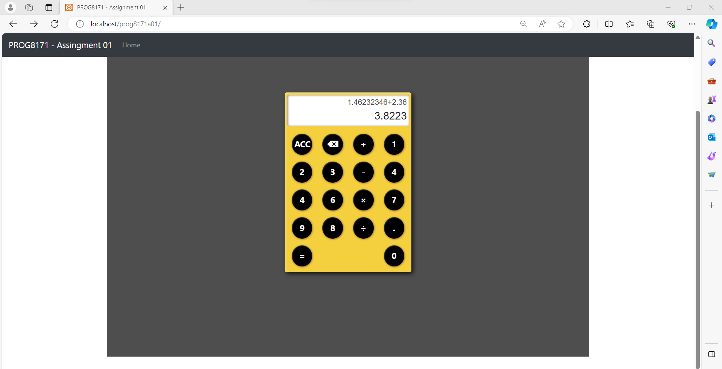

Fig 2.1 Screenshot from browser

1. The link to take the user back to the home page of this site is not loading

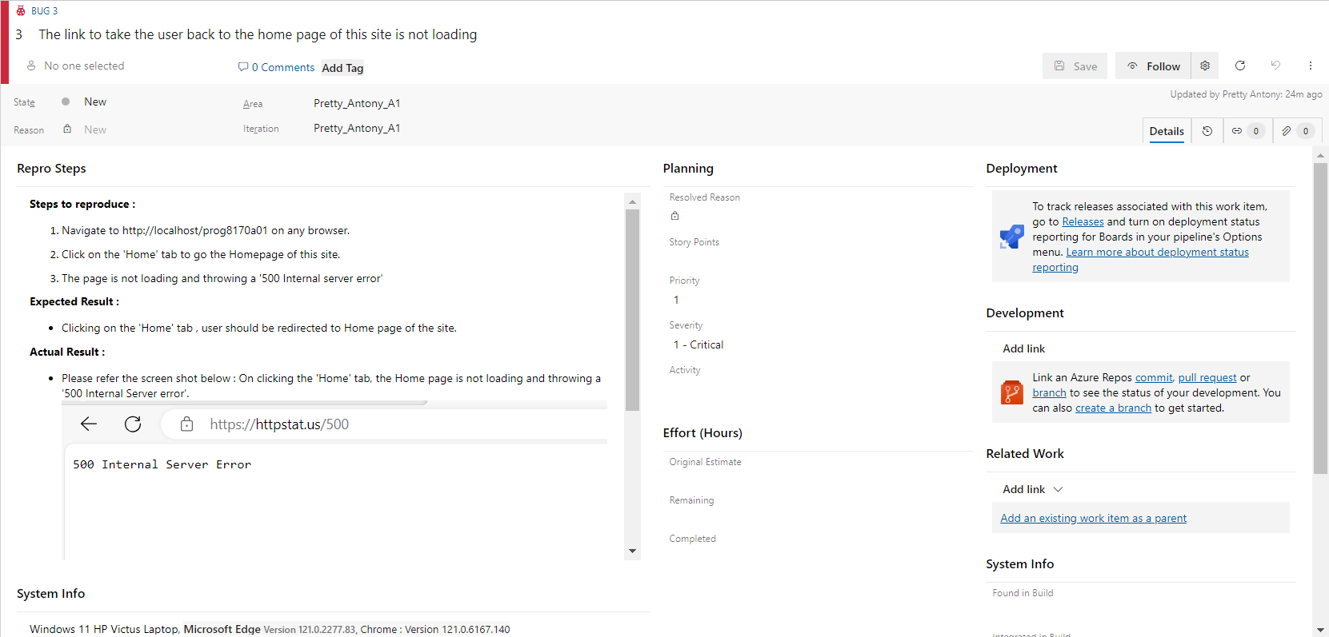

Fig 3.0 Screenshot from Azure DeveOps

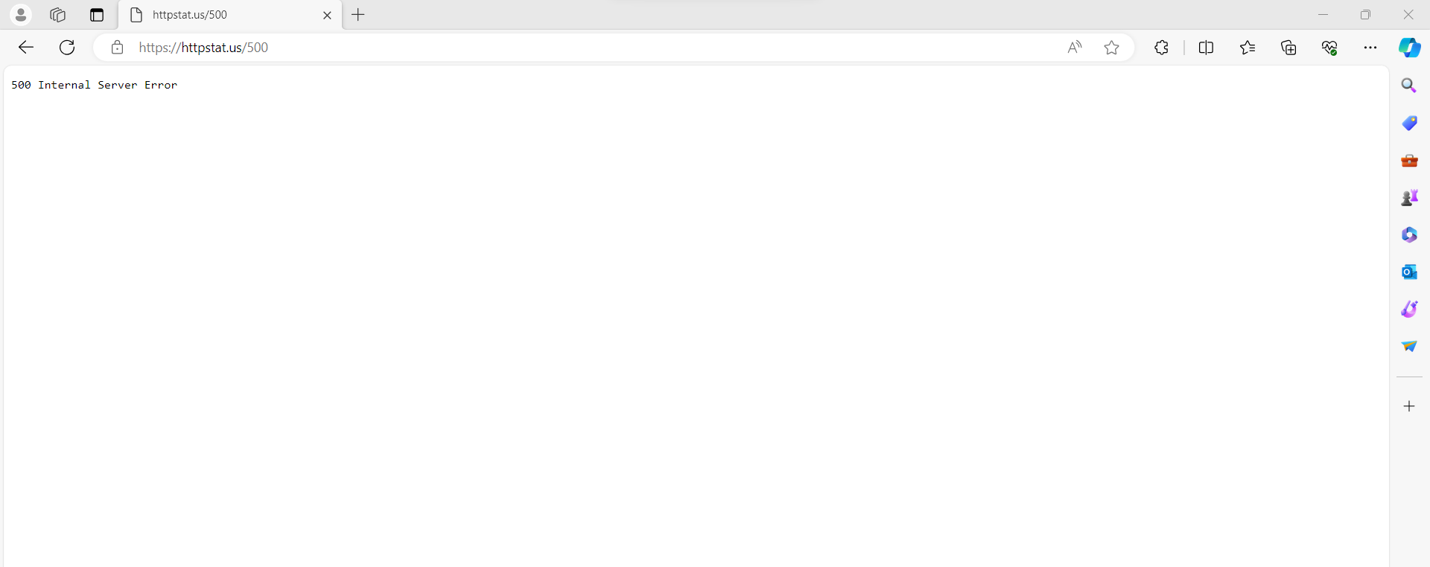

Fig 3.1 Screenshot from browser

1. Spelling Error in Calculator UI

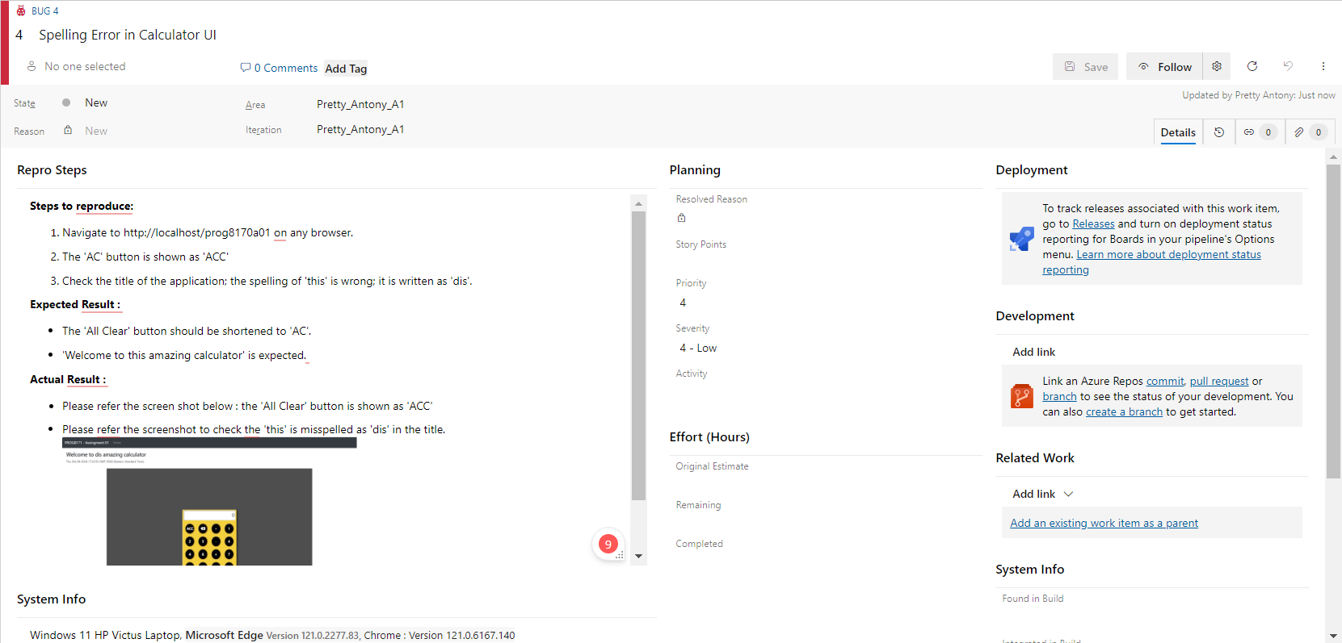

Fig 4.0 Screenshot from Azure DevOps

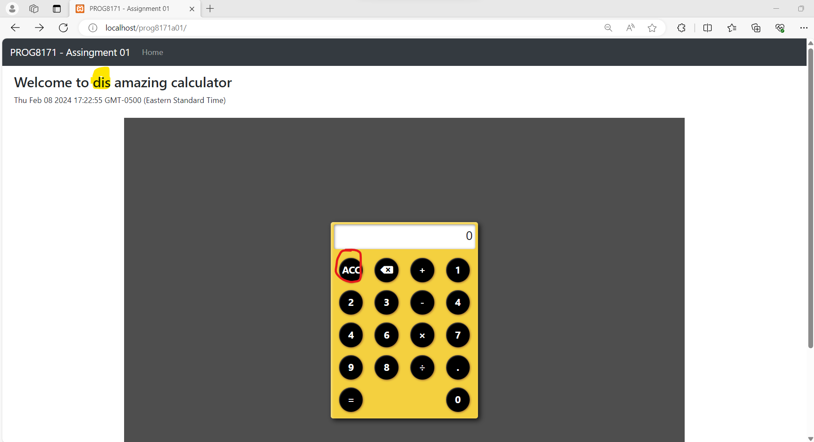

Fig 4.1 Screenshot from browser

1. Keypad display consistency

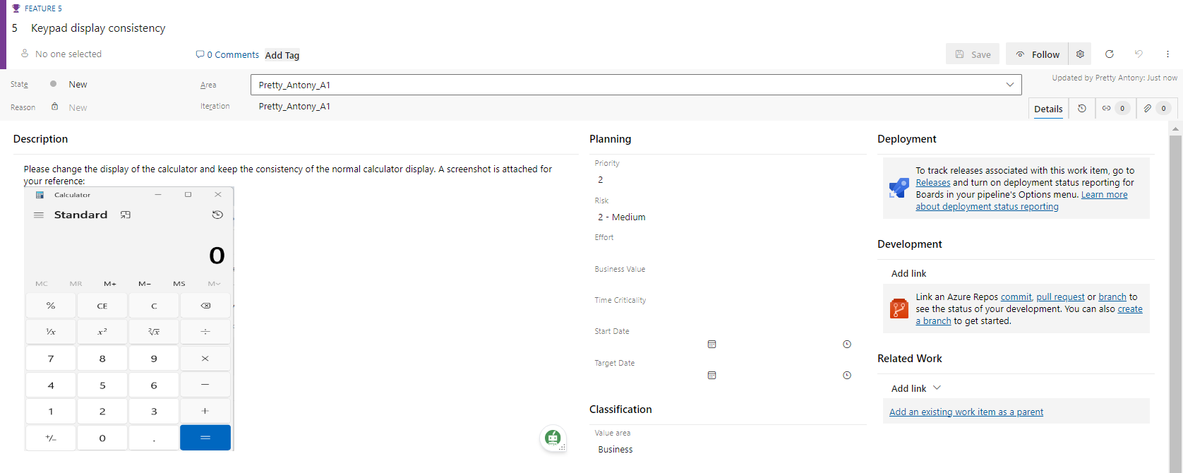

Fig 5.0 Screenshot from Azure DevOps

1. Duplicate buttons in Calculator UI

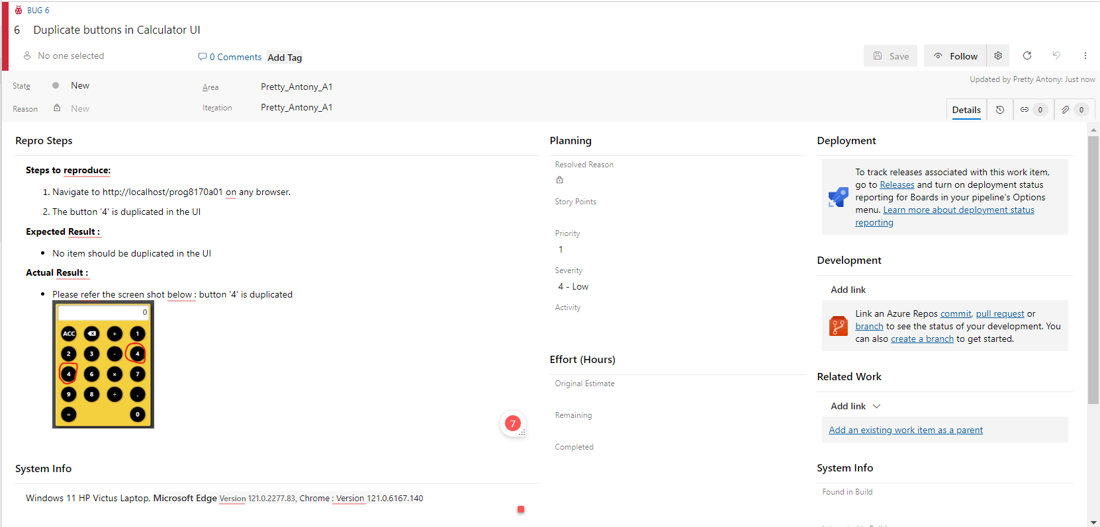

Fig 6.0 Screenshot from Azure DevOps

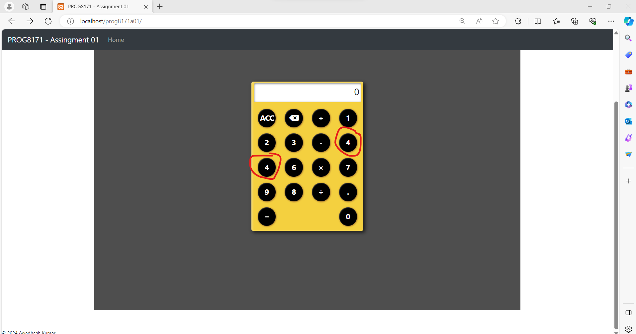

Fig 6.1 Screenshot from Browser

1. The number '5' is missing in the UI

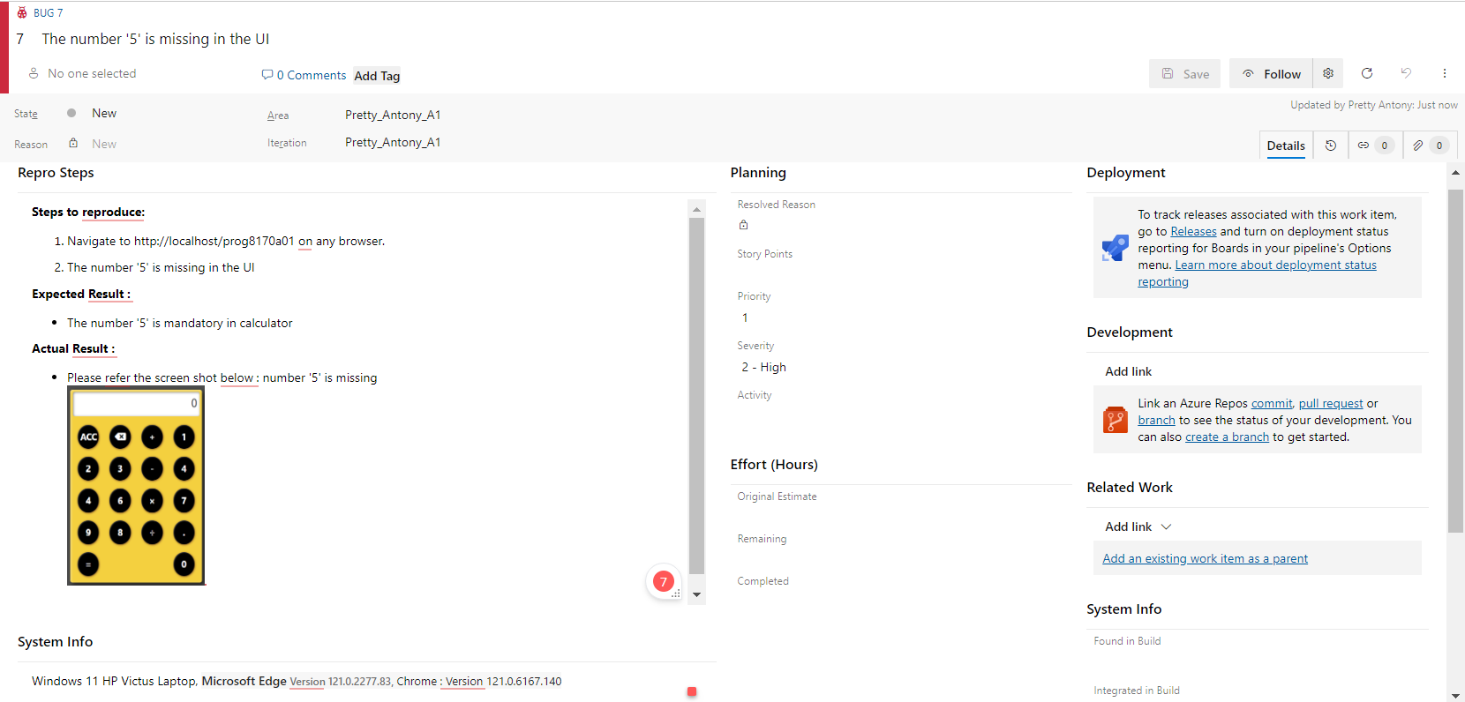

Fig 7.0 screenshot from Azure DevOps

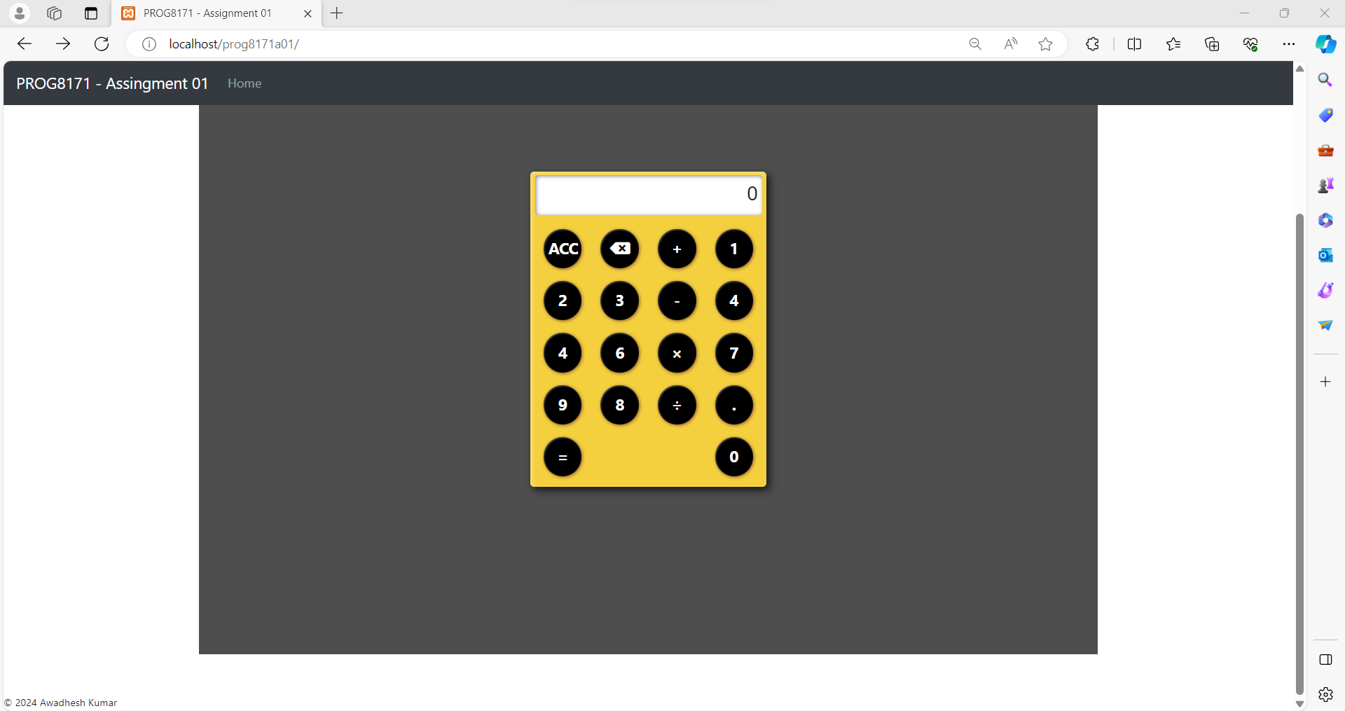

Fig 7.1 screenshot from browser

**Queries**

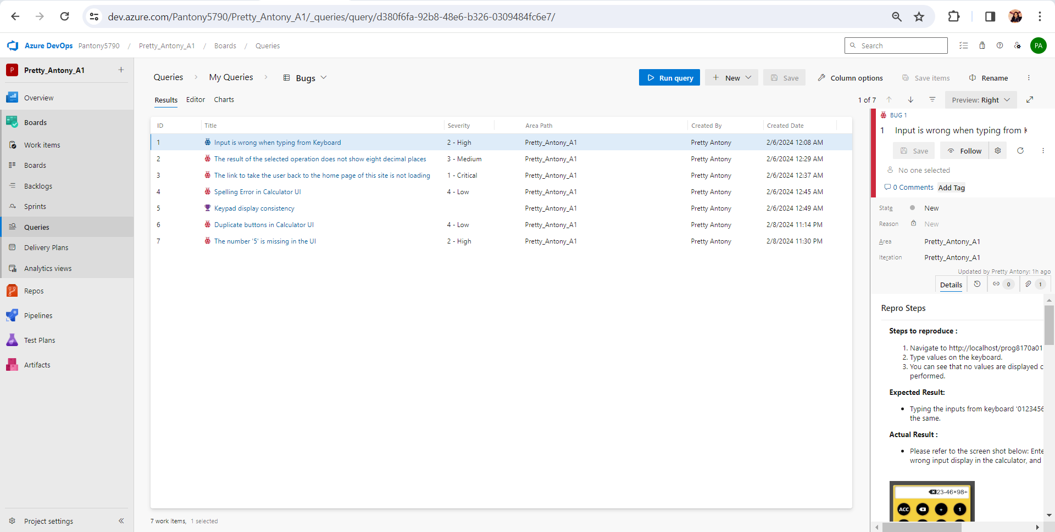

**A pie-chart of all the defects grouped by Severity**

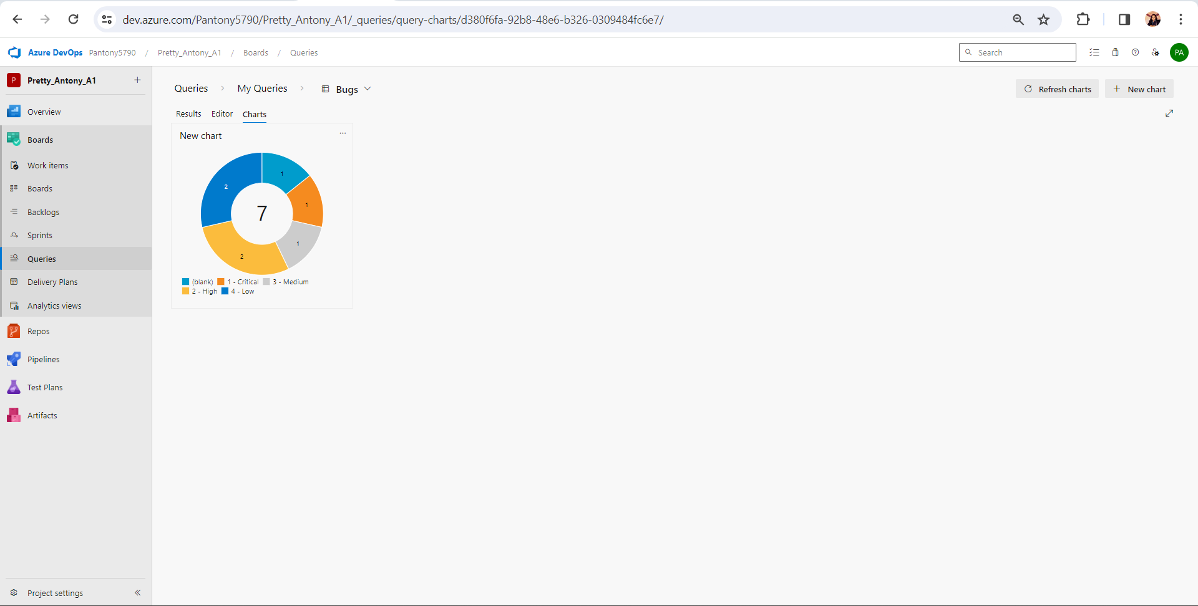

**Overview of the Application**After careful examination and testing, the application is found to be unfit for release. As for the logged bugs, there are more than 3 bugs with higher severity than the third level. The missing number bug and the duplicate button show that the developer is unfamiliar with the simple calculator UI and is confused with the arrangement of the buttons within; these types of inconsistency can confuse the user, leading to a bad user experience. So, as a software quality tester, I have added a new feature to arrange the application UI, which is similar to the standard calculator UI, which can make the user comfortable while using the application.

The discrepancies with the entry from the keypad and the application crash on clicking the ‘Home’ tab are high-priority bugs that should be resolved as soon as possible since those can prevent the user from further operations or steps. And, spelling mistakes can lead the user to a stage of confusion, so try to avoid those silly mistakes. I have only reported 6 bugs and a new feature, even though the pie chart, which is sorted by means of severity, shows that there are more high-priority bugs. Moreover, the basic functionality, like backspace, is not working in the application. The screenshots for the reported bugs are attached above in the document for your reference.   
  
 As a software quality tester, I recommend that the application not be released due to the incompetencies I have logged and analyzed.