**Restaurant Menu**

**By: Saed Alsafadi**

**ID: 201921369**

**Course: CIS 201 – Fundamentals of Web Design**

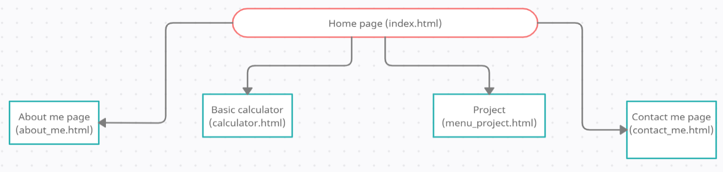

You can access every page at any time through the navigation bar, beside the main page.

1. Index page:

This page is the main page for this website which the user can review and access the other pages.

* It uses the main external CSS file as the other related webpages.

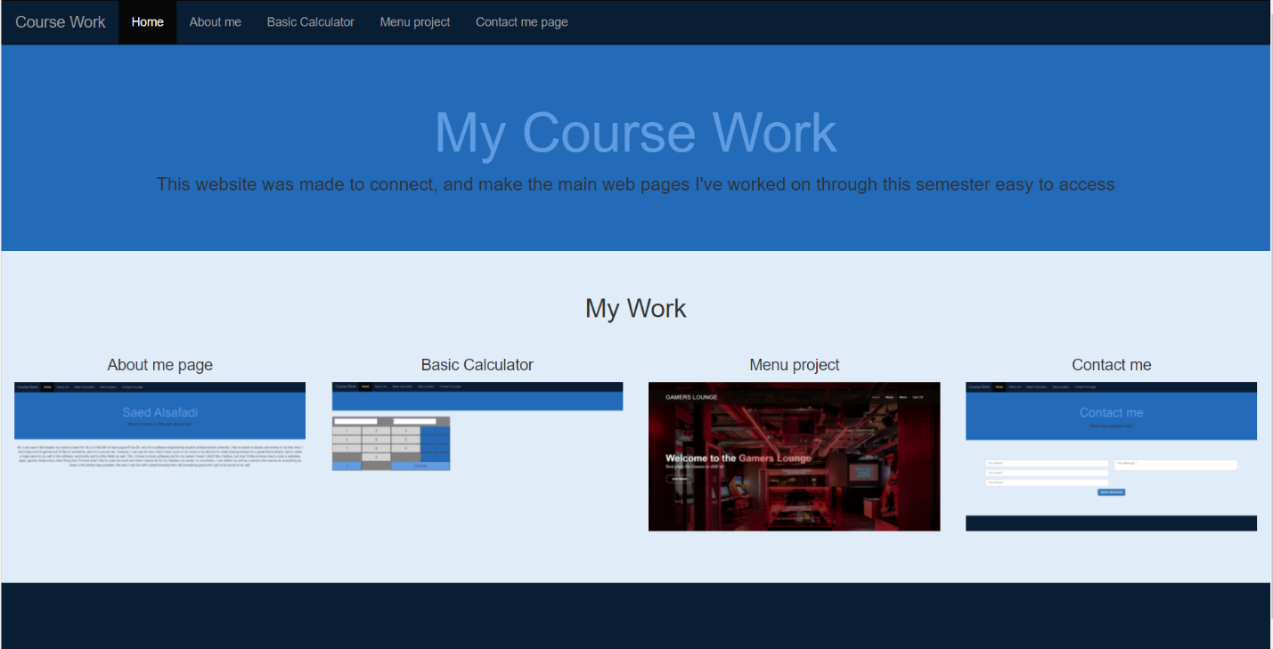

1. About me page:

This page includes a small paragraph talking about me to give the user the ability to know some info about me.

* It uses the main external CSS file as the other related webpages.
* course_work\assets\css

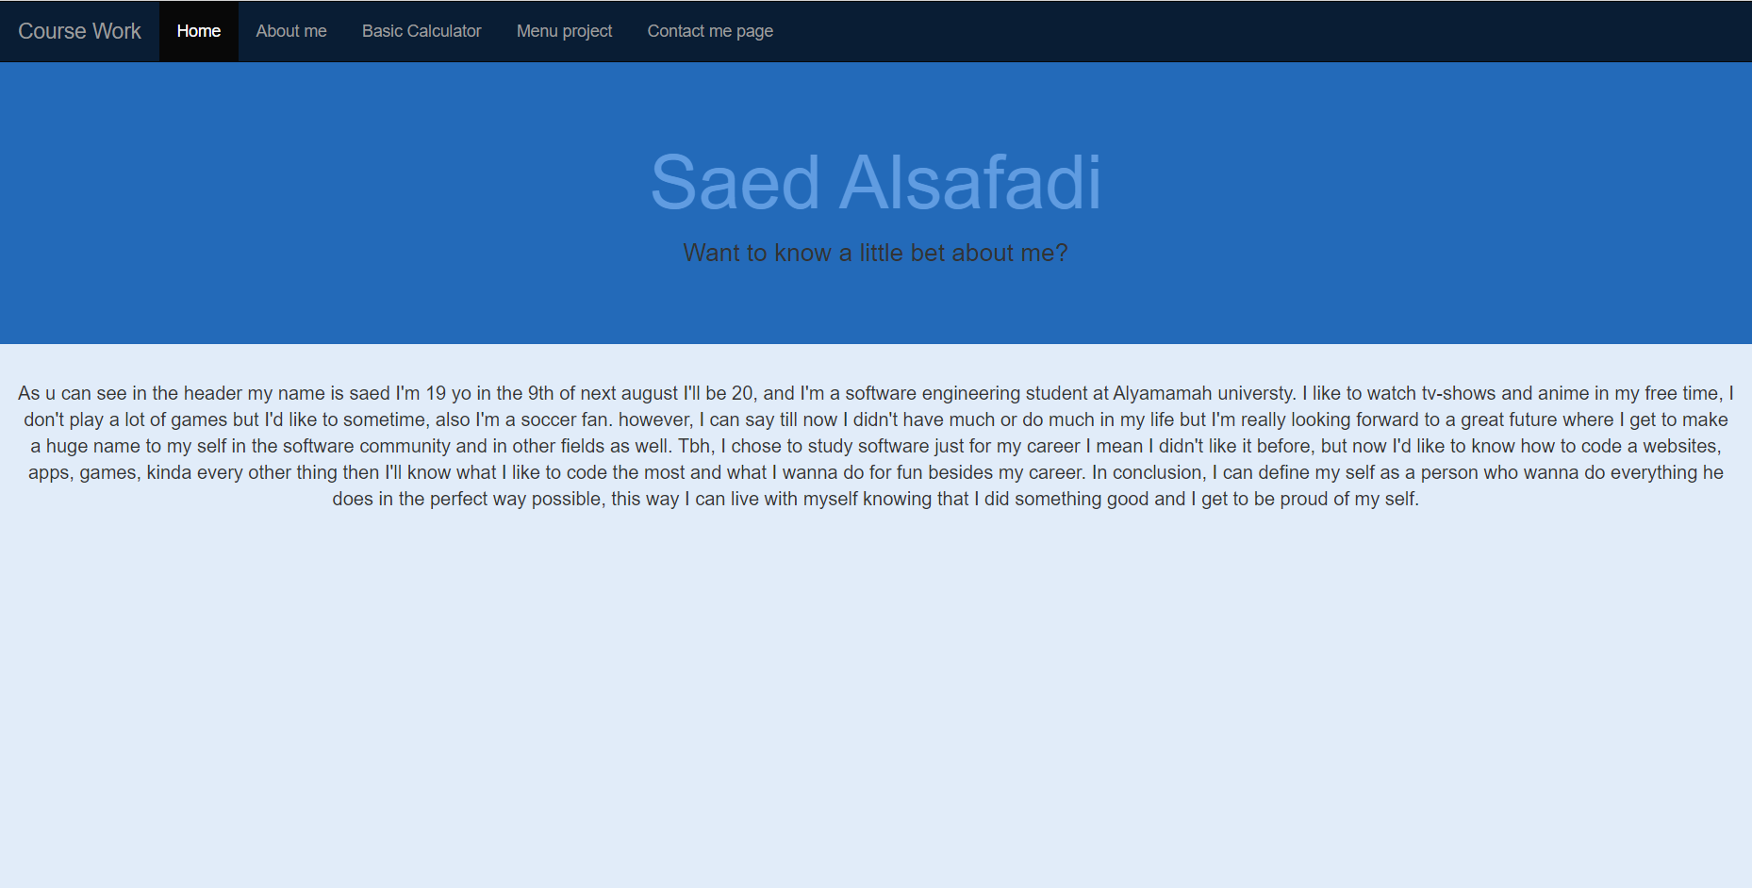

1. Basic calculator:

This page includes a basic calculator created be using some html and CSS and JavaScript.

* It uses the main external CSS file as the other related webpages.
* course_work\assets\css

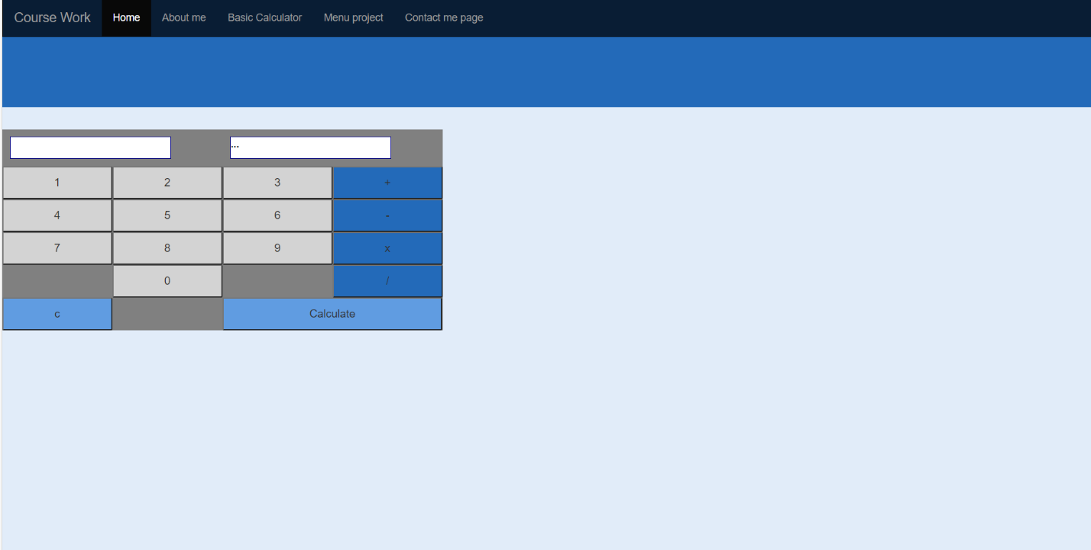

1. The menu project:

This is the main course project, which is a restaurant menu. It has a special theme and uses advanced html and CSS and JavaScript properties.

* It uses an external CSS and JavaScript files, and external vendor files.
* course_work\CIS_Project\assets\css
* course_work\CIS_Project\assets\js
* course_work\CIS_Project\assets\vendor\

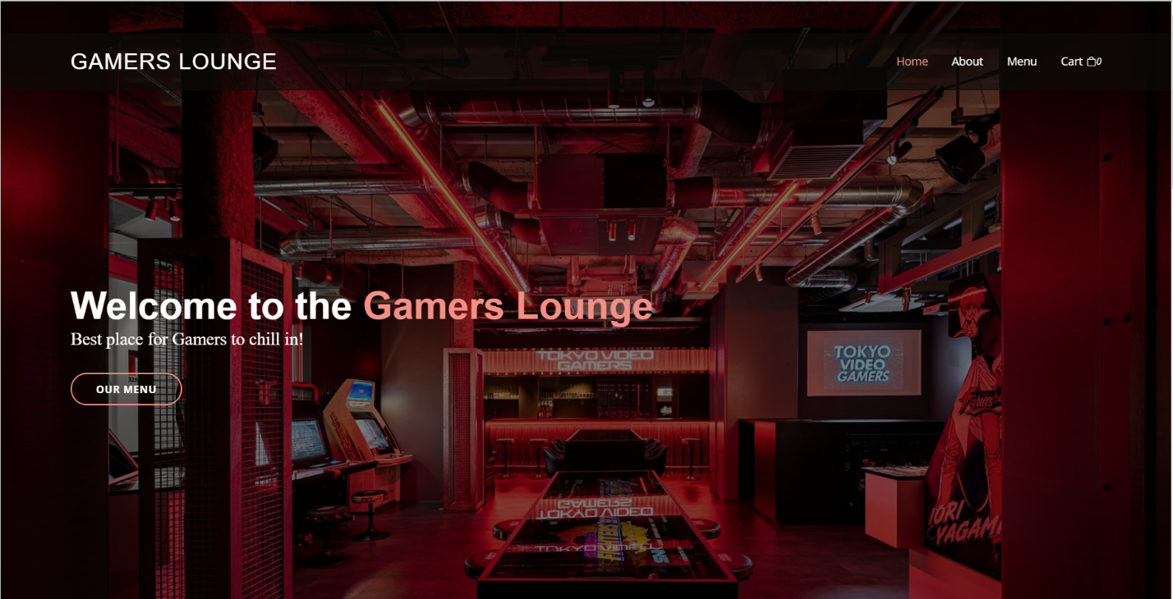

1. Contact me page:

This page was made to give the user the ability to contact me in easy way.

* It uses the main external CSS file as the other related webpages.
* course_work\assets\css

