**INTRODUCTION**

* Barrel shifter is a combinational logic circuit.
* It has M inputs and N outputs where M>N.
* It Shifts the set of bits from input sequence to produce outputs.
* The number of shifts is decided by the control\selection signal.
* Barrel shifter can perform N bit shift in single combinational function and rotate right operation.
* A barrel shifter is a digital circuit used in computer architecture and digital design to shift binary data by a specified number of positions, either left or right. It is called a "barrel" shifter because it resembles a barrel with rings that can be rotated.
* The key feature of a barrel shifter is its ability to perform shifts of multiple bits simultaneously in a single clock cycle. This efficiency is achieved through a parallel structure that allows for high-speed operations.

**WORKING**

* Input Data: The input to the barrel shifter is the binary data that needs to be shifted.
* Shift Amount: The shift amount determines how many positions the data will be shifted by. This is typically provided as control inputs to the barrel shifter.
* Control Logic: The control logic decodes the shift amount and generates control signals for the shifting operation.
* Shifting Operation:
* For a left shift, the input data is shifted to the left by the specified number of positions. Zeros are filled in from the right.
* For a right shift, the input data is shifted to the right by the specified number of positions. Zeros are filled in from the left.
* Output Data: The shifted data, along with any additional control signals indicating the shift operation, is provided as the output of the barrel shifter.
* Barrel shifters are commonly used in processor architectures for tasks such as multiplication, division, and bitwise operations where efficient shifting of binary data is required. Their parallel nature makes them particularly suitable for high-speed and complex arithmetic operations in digital systems.

**DESIGN TABLE IMPLEMENTATION**

* This design table is done according to the number of shifts it’s going to do.
* In my case, I have 3 selection or control lines s2, s1 and s0 where these three decide the number of right shifts it’s going to make.
* First the s2 the MSB is going to make 4bit shift to the right when it is HIGH and No shift when its LOW
* Here the next MSB is s1 which will have 2 bits shifted to right when its HIGH and no shift when its low.
* Whereas the s0 output will have 1 bit shifted to right when its HIGH and no shift when its low.
* Here by making the design of circuit diagram using this design table which is given below for your reference.

**8-BIT BARREL SHIFTER USING 2X1 MUX**

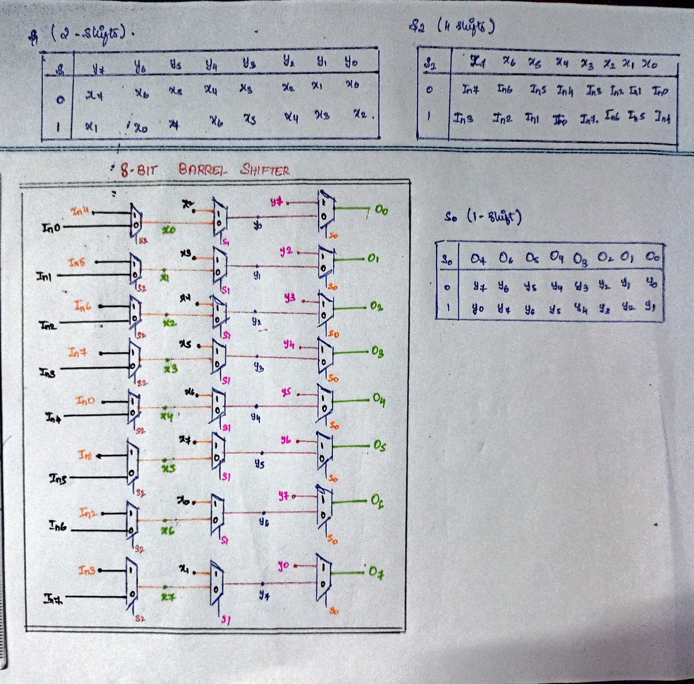

**PROGRAM**

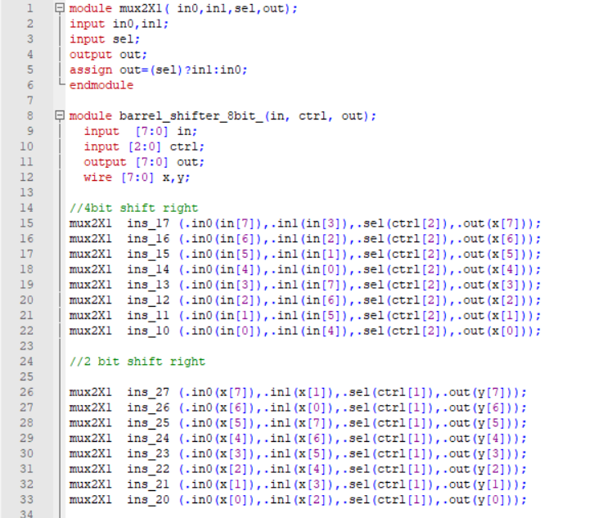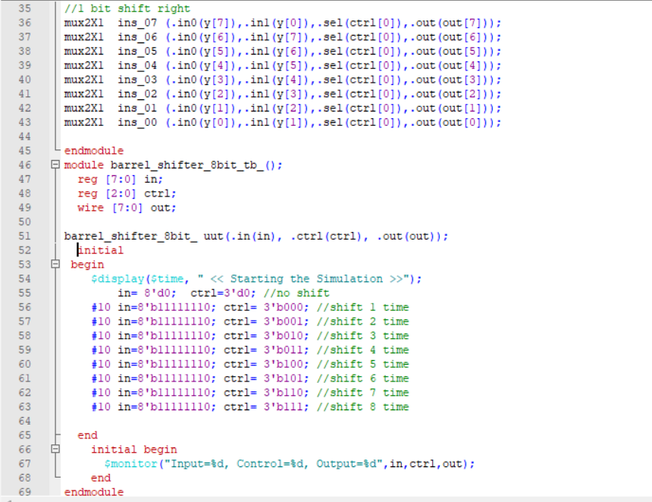

**OUTPUTS**

WITHOUT TESTBENCH:

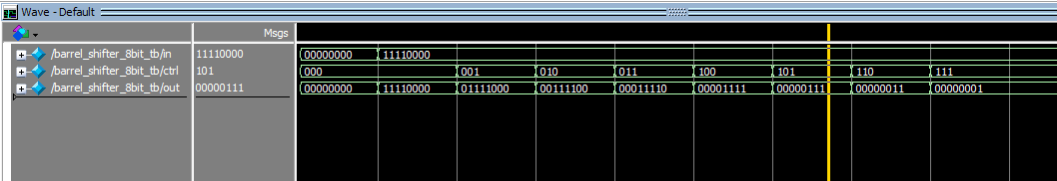

WITH TESTBENCH: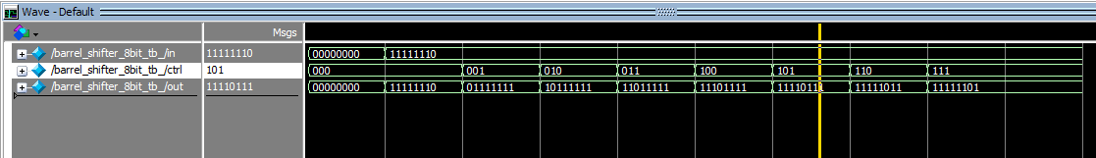

* Here the input given was 11111110 where the control signal becomes 1 this will perform 1bit right shift.
* When on second control signal it will be having 2-bit shift from the given input. Similarly for each selection line the bits are shifted right.
* When the third control signal i.e. s2 is High then it’s going to perform 4bit shift to the right.

**CONCLUSION**

A barrel shifter is a digital circuit that efficiently shifts binary numbers left or right based on a shift amount. Unlike conventional shifters, which shift by one position at a time, a barrel shifter can perform multiple shifts. It utilizes combinational logic to decode the shift amount and generate the shifted output in a single clock cycle, making it ideal for high-speed and complex arithmetic operations in digital systems such as processors and DSPs.