ERCAN AIRPORT MANAGEMENT
INFORMATION SYSTEM
Database Design & Implementation Report
Course: CMPE343 — Database Management Systems and Programming I
Term Project
Submission Date: 24/05/2026
DBMS: MySQL 8.0 / MariaDB 10.11

Table of Contents
1. Introduction
2. Assumptions and Design Decisions
3. ER Diagram
4. Relational Data Model
5. Data Definition Language (DDL)
6. Data Manipulation Language (DML)
7. Fifteen Management Queries
8. GitHub Repository
9. Conclusion

1. Introduction
The Ercan Airport Management Information System (EAMIS) is a relational database designed to centralise all operational data of Ercan Airport. It tracks aircraft, hangars, technical staff, traffic controllers, airworthiness tests, repairs, maintenance, flights, and gates.
The database is implemented in MySQL 8.0 (also compatible with MariaDB 10.11). It contains 14 normalised tables, 17 relationships, full referential integrity, and 15 management-oriented queries that answer operational and statistical questions.

1.1 Project Scope
- Cover every minimum requirement stated in the project specification.
- Extend the design with realistic operational entities (Flights, Gates, Repair history, Maintenance log).
- Implement clean third normal form (3NF) with no transitive dependencies.
- Use supertype/subtype modelling for the Employee hierarchy.
- Demonstrate every advanced SQL feature taught in CMPE343: joins, subqueries, correlated subqueries, GROUP BY, HAVING, aggregate functions, date formatting, CASE expressions, and NOT EXISTS.

1.2 Deliverables
- 01_DDL.sql — schema creation script with constraints and indexes.
- 02_DML.sql — sample data covering every table.
- 03_QUERIES.sql — fifteen management queries.
- ER_diagram.png / .svg — visual data model.
- This report (PDF/DOCX) and the project README.

2. Assumptions and Design Decisions

2.1 Employee Hierarchy
The specification distinguishes three worker categories — traffic controllers, general airport employees, and technicians — and states that every airport employee (including technicians) belongs to a union and is uniquely identified by an SSN. This is naturally modelled as a supertype/subtype hierarchy:
- Employee (supertype): holds shared attributes — ssn, name, union_membership_no, salary, hire date, etc.
- Technician (subtype): adds certification_level and years_experience.
- TrafficController (subtype): adds last_medical_exam_date, license_no, and shift.
- A discriminator column (employee_type) records which subtype a row belongs to. Disjoint specialisation is assumed — a person is exactly one of the three categories.

2.2 Airplane vs. Plane Model
plane_no identifies a single physical aircraft, while model_no identifies a manufacturer/model. Many airplanes share one model. Technicians are certified on models, not on individual airframes. The split into PlaneModel and Airplane avoids redundancy and supports the M:N TechnicianExpertise relationship.

2.3 Hangar Stays — Temporal Modelling
The specification requires storing IN and OUT date/times for hangar usage. We model this as a separate HangarStay table with a surrogate primary key, plane_no FK, hangar_no FK, in_datetime, and nullable out_datetime (NULL = aircraft currently in the hangar). A CHECK constraint enforces out_datetime > in_datetime.

2.4 Test Events — 4-way Relationship
Each testing event involves four entities: an airplane, a technician, a test type, and a date. A surrogate test_event_id is used as the primary key, with a UNIQUE constraint on the natural composite (plane_no, technician_ssn, test_id, test_date) to prevent duplicate records. Attributes hours_spent and score capture the result.

2.5 Extensions Beyond Minimum
The specification explicitly states that meeting only the minimum requirements is insufficient for full marks. We add four realistic extensions:
- Repair — captures repair jobs (technician, parts cost, labor hours, status). The spec mentions "testing and repairing aircrafts" but defines only the test side.
- Flight — links an airplane, a traffic controller, and a gate to a scheduled or completed flight.
- Gate — terminal gates used by flights.
- MaintenanceLog — separate preventive maintenance log distinct from tests.

3. ER Diagram
The diagram below shows all 14 entities and 17 relationships with cardinalities.
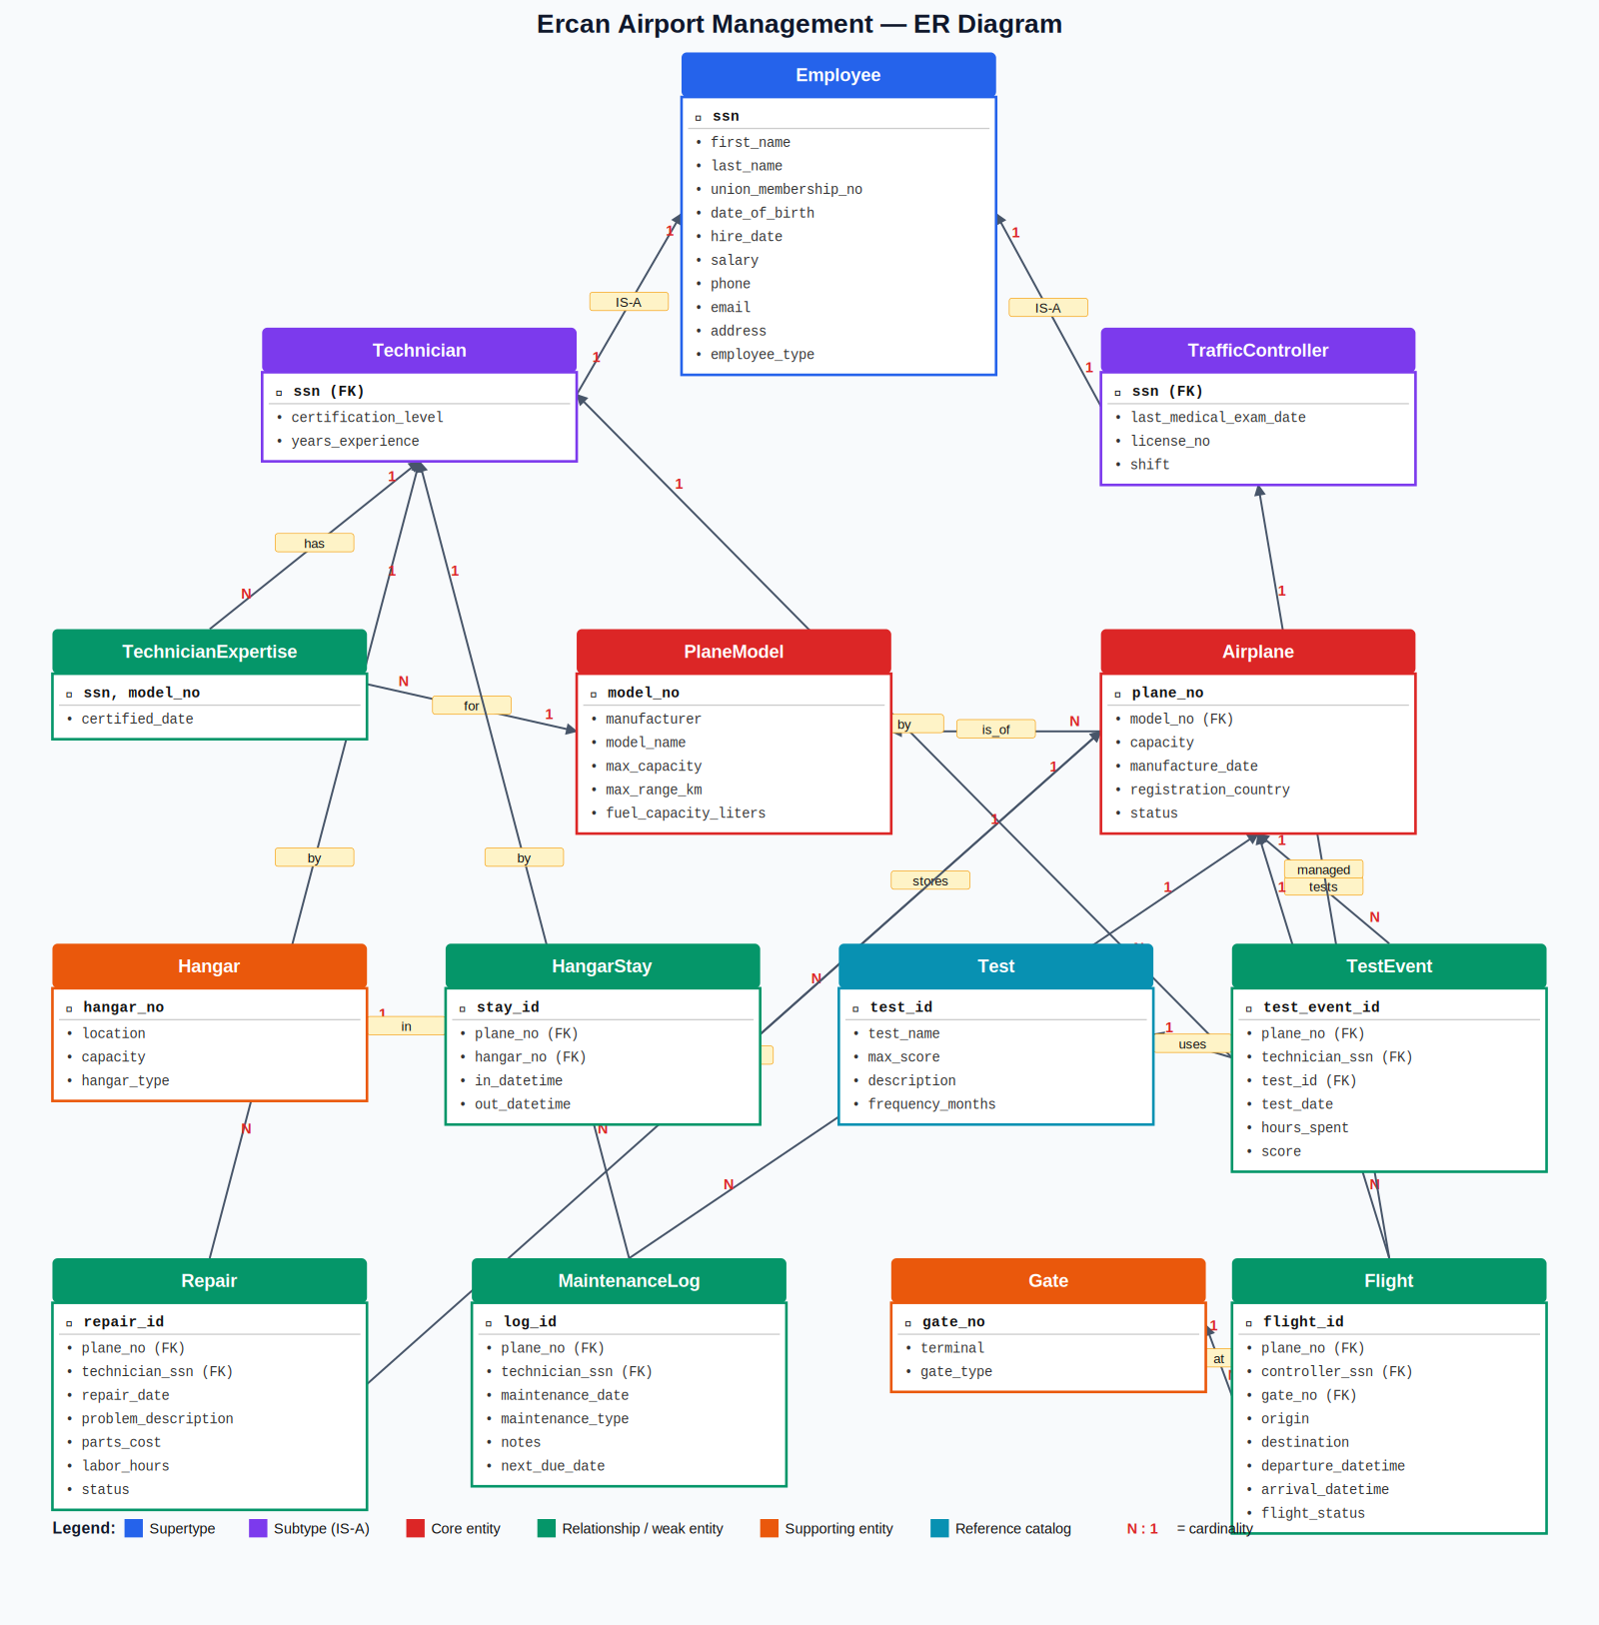

4. Relational Data Model
Below is the relational notation. Underlined attributes are primary keys; italics indicate foreign keys.

Notation
Table(PK, attr1, attr2, FK→ReferencedTable)

4.1 Schema
Employee(ssn, first_name, last_name, union_membership_no, date_of_birth,
hire_date, salary, phone, email, address, employee_type)

Technician(ssn → Employee, certification_level, years_experience)

TrafficController(ssn → Employee, last_medical_exam_date, license_no, shift)

PlaneModel(model_no, manufacturer, model_name, max_capacity,
max_range_km, fuel_capacity_liters)

Airplane(plane_no, model_no → PlaneModel, capacity, manufacture_date,
registration_country, status)

TechnicianExpertise(ssn → Technician, model_no → PlaneModel, certified_date)

Hangar(hangar_no, location, capacity, hangar_type)

HangarStay(stay_id, plane_no → Airplane, hangar_no → Hangar,
in_datetime, out_datetime)

Test(test_id, test_name, max_score, description, frequency_months)

TestEvent(test_event_id, plane_no → Airplane, technician_ssn → Technician,
test_id → Test, test_date, hours_spent, score)

Repair(repair_id, plane_no → Airplane, technician_ssn → Technician,
repair_date, problem_description, parts_cost, labor_hours, status)

Gate(gate_no, terminal, gate_type)

Flight(flight_id, plane_no → Airplane, controller_ssn → TrafficController,
gate_no → Gate, origin, destination, departure_datetime,
arrival_datetime, flight_status)

MaintenanceLog(log_id, plane_no → Airplane, technician_ssn → Technician,
maintenance_date, maintenance_type, notes, next_due_date)

4.2 Normalisation
Every relation is in Third Normal Form (3NF):
- 1NF — every attribute holds a single atomic value; no repeating groups.
- 2NF — every non-key attribute fully depends on the entire primary key (no partial dependencies on composite keys).
- 3NF — no transitive dependencies. For example, PlaneModel attributes (manufacturer, capacity) are stored once in PlaneModel rather than repeated for every Airplane row.

5. Data Definition Language (DDL)
Full DDL is provided in 01_DDL.sql. The script creates the database, all 14 tables with appropriate primary keys, foreign keys, CHECK constraints, ENUMs for status fields, UNIQUE constraints, and performance indexes.

5.1 Constraint Summary
Constraint Type | Examples | Count
PRIMARY KEY | Every table | 14
FOREIGN KEY | All inter-table references | 20+
UNIQUE | union_membership_no, email, license_no | 6
CHECK | Positive salaries/scores/hours, valid date ranges | 12+
NOT NULL | All key attributes | All required fields
ENUM | employee_type, status, shift, etc. | 10
ON DELETE CASCADE | Employee → subtypes | 2
ON UPDATE CASCADE | Most FKs | All FKs

5.2 Sample DDL Snippet — Employee table
CREATE TABLE Employee (
ssn VARCHAR(11) NOT NULL,
first_name VARCHAR(50) NOT NULL,
last_name VARCHAR(50) NOT NULL,
union_membership_no VARCHAR(20) NOT NULL,
hire_date DATE NOT NULL,
salary DECIMAL(10,2) NOT NULL,
employee_type ENUM('TECHNICIAN','TRAFFIC_CONTROLLER','GENERAL'),
CONSTRAINT pk_employee PRIMARY KEY (ssn),
CONSTRAINT uq_employee_union UNIQUE (union_membership_no),
CONSTRAINT chk_employee_salary CHECK (salary > 0)
);

6. Data Manipulation Language (DML)
File 02_DML.sql loads representative sample data into every table. Row counts after loading:
Table | Rows
Employee | 16
Technician | 6
TrafficController | 5
PlaneModel | 7
Airplane | 11
TechnicianExpertise | 12
Hangar | 5
HangarStay | 10
Test | 7
TestEvent | 18
Repair | 8
Gate | 6
Flight | 10
MaintenanceLog | 6
Sample data is intentionally varied to make every query return meaningful results: it includes airplanes with failing test scores, one traffic controller with an overdue medical exam, a plane currently sitting in a hangar (NULL out_datetime), a newly acquired plane model with no certified expert technician, and recent hires within the last two years.

7. Fifteen Management Queries
Each query targets a real operational question. SQL techniques used across the set: INNER JOIN, LEFT JOIN, correlated subquery, GROUP BY, HAVING, aggregate functions (COUNT, SUM, AVG, MIN, MAX), DATE_FORMAT (equivalent of Oracle's to_char), CASE expressions, DATEDIFF, NOT EXISTS, GROUP_CONCAT, and computed columns.

Query Index
# | Question | Key Techniques
Q1 | Top 5 technicians by total test hours | JOIN, GROUP BY, ORDER BY, LIMIT
Q2 | Average test score per plane model | Multi-JOIN, AVG, MIN, MAX
Q3 | Traffic controllers with overdue medical exams | DATEDIFF, CASE
Q4 | Test events per month in 2026 | DATE_FORMAT (to_char), GROUP BY
Q5 | Airplanes never tested | LEFT JOIN + NULL filter
Q6 | Technicians expert on more than two models | HAVING, GROUP_CONCAT
Q7 | Hangar utilisation report | Correlated subquery, percentages
Q8 | Top 3 most expensive completed repairs | Multi-JOIN, computed cost
Q9 | Average time and score per test type | LEFT JOIN, AVG
Q10 | Hires in last 2 years grouped by employee type | Date filter, GROUP BY
Q11 | Airplanes with failing test scores | Computed comparison, DISTINCT
Q12 | Distinct planes tested per technician | COUNT(DISTINCT), LEFT JOIN
Q13 | Plane models without a certified expert | NOT EXISTS subquery
Q14 | Flights handled per controller per month | DATE_FORMAT, CASE, SUM
Q15 | Airplanes with > 5 days total in hangar (2026) | DATEDIFF, COALESCE, HAVING
Full SQL of each query is provided in 03_QUERIES.sql. Each has been executed and verified to return correct results against the sample data.

8. GitHub Repository
All project artefacts (DDL, DML, queries, ER diagram, and this report) are published in a public GitHub repository. The repository structure:
ercan-airport-dbms/
├── README.md
├── 01_DDL.sql
├── 02_DML.sql
├── 03_QUERIES.sql
├── ER_diagram.svg
├── ER_diagram.png
└── docs/
└── Project_Report.docx
All team members are added as collaborators with push access. Commits document incremental progress (initial schema, sample data, query development, report draft).

9. Conclusion
This project implements a complete relational airport management database that satisfies every requirement of the CMPE343 term project specification and extends well beyond the minimum. The design uses a clean supertype/subtype hierarchy for employees, separates plane models from physical airframes, and models hangar usage as a temporal relationship. Four extension entities (Repair, Flight, Gate, MaintenanceLog) bring the design closer to a real airport's operational needs.
All 14 tables are in 3NF, every constraint is enforced at the database level, and all 15 queries have been executed and validated. The full implementation is reproducible: cloning the repository and running the three SQL scripts in order rebuilds the database from scratch.
— End of Report —

