DATED: APRIL 04, 2024

Dear Ongoing Living & Learning Inc. Community,

We are excited to share with you the latest updates and developments from our organization! As we strive to enhance the lives of adults with disabilities and their families, we are dedicated to providing accessible support and services tailored to meet the diverse needs of our community. Take a moment to explore the exciting initiatives and opportunities we have in store:

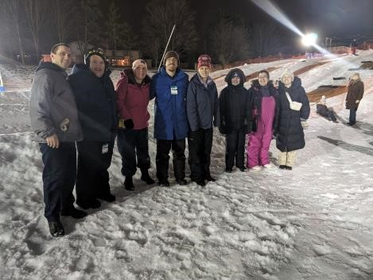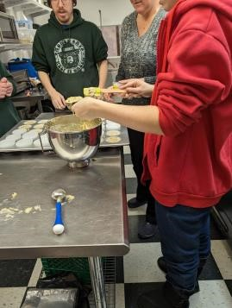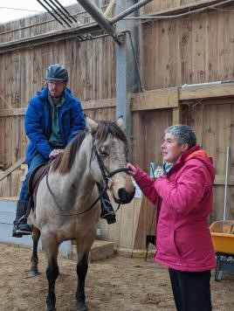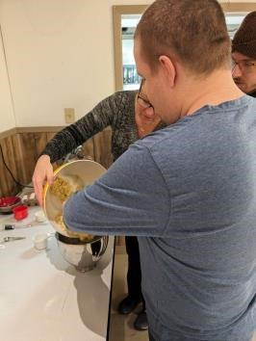

# Introducing our New Website: Enhancing Accessibility and Engagement

We are thrilled to announce the launch of our new website! Designed with accessibility in mind, our website serves as a comprehensive hub for information, resources, and support for individuals with disabilities, their families, and the wider community. Here are some key features:

* **Vital Information at Your Fingertips:** Access essential resources, program details, and support services easily from any device.
* **Improved Communication:** Stay informed about our offerings and events through our userfriendly platform.
* **Caregiver Support:** Connect with our caregiver support group and access valuable resources to navigate the journey of caregiving effectively.
* **Public Engagement:** Explore opportunities for community involvement, fundraising, and partnerships to support our mission of inclusivity and accessibility for all.

Visit our website at [Insert Website Link] to discover more!

# CHEER Programs: Empowering Individuals, Building Community

At Ongoing Living & Learning Inc., we are proud to offer a range of programs designed to empower individuals with disabilities and foster a sense of belonging. Here's a glimpse into what we have to offer:

* **CHEER Group:** Our social, recreation, leisure, and friendship program provides a supportive environment for young adults with intellectual disabilities. Through engaging activities and community integration, we promote independence and social inclusion.
* **CHEER Works:** Our assisted employment program offers valuable job skills training and paid employment opportunities for community members with intellectual disabilities. Join our inclusive workplace and be part of a supportive team!
* **CHEER Connections:** Our caregiver support group offers a space for parents and caregivers to connect, share experiences, and access resources. Find solace, support, and valuable insights as we navigate the journey of caregiving together.

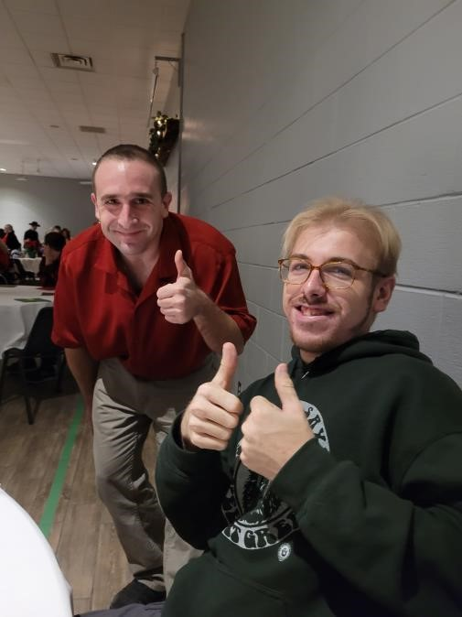**Get Involved!**

Interested in learning more about our programs or getting involved? Reach out to our fearless leader, Ivey Hartman, at ihartmancheer@gmail.com. You can also find us on Facebook at Family Connections Cheer for the latest updates and news.

We extend our heartfelt gratitude to our supportive community partners and donors who make our work possible. Together, we are creating a community of inclusion and support where everyone belongs.

Thank you for your continued support!

Warm regards,

Ongoing Living & Learning Inc.