ASSIGNMENT 1 — COMPLEX PROBLEM-SOLVING / MINI PROJECT
Design, Simulation and Material Transport Integration for an Automated Flexible Manufacturing Cell
Technical Design Document · Machine specification, feed drive and feedback selection, CNC part programming with collision verification, and AGV throughput analysis
Particulars | Details
Name of the student
Enrolment / Roll number
Class / Division
Subject | Automation in Manufacturing
PBL category | Complex Problem-Solving targeting relevant SDGs / Mini Project (Activity 1)
Target Course Outcomes | CO-2, CO-3, CO-4
Target SDGs | SDG 9 (Industry, Innovation and Infrastructure), SDG 12 (Responsible Consumption and Production)
Estimated workload | 15 hours
Accompanying files | gcode/turning_shaft.nc, gcode/milling_plate.nc, simulation/toolpath_simulator.py, simulation/simulation_verification.log, figures/cell_layout.py
Date of submission

1. Introduction and Problem Context
A precision automotive component supplier in Gujarat is converting a manual job-shop line into an Automated Flexible Manufacturing Cell (FMC). The objectives set by the plant are to reduce the component rejection rate, to shorten part cycle times and to hold a repeatable positioning accuracy of ±0.005 mm under continuous operation.
This document reports the design of that cell. It covers the selection and specification of the machine tools and their feed drives, the CNC part programs written for a representative turned and a representative milled component together with their simulation and collision verification, and the design and quantitative analysis of the automated material transport loop that links the cell to the raw-material store and the despatch dock.
Item | Detail
Target Course Outcomes | CO-2, CO-3, CO-4
Target SDGs | SDG 9 — Industry, Innovation and Infrastructure; SDG 12 — Responsible Consumption and Production
Required positioning accuracy | ± 0.005 mm (± 5 µm) per linear axis
Cell output (design basis) | 24 components per hour, two shifts per day
Deliverables covered here | Technical design document · G/M-code package · simulation evidence · cell layout diagram

How the SDG targets are met. SDG 9 is addressed directly by replacing a manual job shop with a networked, sensor-instrumented cell that raises process capability and makes the plant competitive in precision work. SDG 12 is addressed by the reduction in scrap that follows from closed-loop positioning and 100 % in-line inspection, by coolant recovery and chip briquetting in the swarf-management station, and by the AGV fleet being sized to the demand rather than over-provisioned — each avoided vehicle saves both its embodied energy and its running energy.
2. Machine Tool Specification and Motion Control Selection
2.1 Choice of machine tool configurations
The part family consists of rotationally symmetric shafts and prismatic cover plates, so two machine tools are required:
- TC-01 — a 2-axis CNC turning centre (X, Z). A slant-bed turning centre with a 12-station servo turret, a bar feeder and a sub-spindle. The slant bed gives better chip evacuation and a stiffer loop than a flat bed; the bar feeder allows unattended running, which is essential if the cell is to be loaded by a robot.
- MC-01 — a 3-axis CNC vertical machining centre (X, Y, Z). A 24-pocket armless automatic tool changer, provision for a 4th rotary axis, and a through-spindle coolant capability. A vertical configuration is chosen over a horizontal one on cost grounds, the part mix not justifying pallet-pool working.
2.2 Machine specification sheet
Parameter | TC-01 — CNC turning centre | MC-01 — 3-axis CNC VMC
Controlled axes | 2 (X, Z) + C-axis ready | 3 (X, Y, Z), 4th axis ready
Travel | X 210 mm · Z 560 mm | X 760 mm · Y 460 mm · Z 510 mm
Max. turning Ø / table | Ø 340 mm swing, Ø 65 mm bar | 900 × 460 mm table
Spindle | A2-6 nose, 15 kW, 4 500 rev/min | BT-40, 11 kW, 12 000 rev/min
Spindle bearings | Hybrid ceramic angular contact, DBB set | Hybrid ceramic angular contact, 4 × DBB set
Feed drive | C3 ground ball screw, double-nut preload, direct-coupled AC servo | Same, all three axes
Guideways | Hardened and ground box ways (Z) + roller LM guides (X) | Roller-type LM guides, preload class C1, all axes
Position feedback | Linear glass scale on both axes (full closed loop) | Linear glass scale on all three axes (full closed loop)
Rapid traverse | 24 / 30 m/min | 36 / 36 / 30 m/min
Positioning accuracy | ± 0.005 mm | ± 0.005 mm
Repeatability | ± 0.002 mm | ± 0.002 mm
Tool changer | 12-station servo turret, 0.15 s index | 24-pocket ATC, 1.3 s tool-to-tool
Control | Fanuc 0i-TF (or Siemens 828D) | Fanuc 0i-MF (or Siemens 828D)
Automation interface | Robot I/O, auto door, parts catcher | Robot I/O, auto door, chip conveyor
3. Feed Drive and Feedback Design for ± 0.005 mm
The ± 0.005 mm requirement is a system requirement: it cannot be met by specifying one good component. The approach taken is to identify every contributor to positioning error, to select a component for each so that its share is small, and then to combine the residuals into an error budget that demonstrates the target is met with margin.
3.1 Recirculating ball screw
Parameter | Selection | Justification
Nominal diameter | Ø 32 mm | Gives adequate buckling and critical-speed margin over the 760 mm X travel while keeping rotary inertia low enough for a 36 m/min rapid.
Lead (pitch) | 10 mm | 36 m/min rapid needs 3 600 rev/min; dm·n = 32 × 3 600 = 1.15 × 10⁵, comfortably inside the 1.6 × 10⁵ limit for a ground screw with forced lubrication. A finer 5 mm lead would halve the speed available.
Accuracy grade | JIS C3 (ISO 5), ± 8 µm per 300 mm | C3 is the normal grade for a machine required to hold single-digit micrometres. C5 would leave too little budget; C1/C2 is laboratory grade and not cost-justified.
Preload method | Double-nut (or offset-lead) preload at 7 % of Cₐ | Removes axial backlash completely, which is what otherwise dominates reversal error. 7 % is the standard compromise: enough to eliminate lost motion, low enough to avoid excessive heat and preload collapse.
Mounting | Fixed–fixed, double-row angular contact support bearings, axially pre-tensioned | Fixed–fixed mounting roughly doubles axial stiffness and, with pre-tension, absorbs the thermal growth of the screw instead of letting it displace the table.
Drive | Direct coupling to the AC servo through a bellows coupling | Eliminates the backlash and the torsional wind-up that a belt or gear reduction would introduce.

Resolution check. With a 10 mm lead and a 2²⁰ count/rev (1 048 576) absolute rotary encoder on the motor, one count corresponds to 10 / 1 048 576 = 0.0000095 mm. Command resolution is therefore nowhere near the limiting factor; the limit is the mechanical and metrological chain, which is why the position loop is closed on a linear scale rather than on this encoder.
3.2 Linear guideways — LM guides versus hardened and ground box ways
Criterion | Recirculating LM (rolling) guideways | Hardened and ground box (sliding) ways
Friction | µ ≈ 0.002–0.005; almost no difference between static and dynamic friction | µ ≈ 0.05–0.15, and static friction clearly exceeds dynamic
Stick–slip at low feed | Virtually absent — this is the decisive property for micrometre-level positioning | Present; causes a jerk at motion reversal and a following error at creep feeds
Positioning and reversal error | Very low; reversal error ≈ 1 µm with preload | Reversal error typically 3–10 µm
Damping | Low — rolling contact dissipates little energy | High — the oil film between large sliding areas damps chatter well
Load capacity and stiffness | High, and can be raised by preload class (C0 → C1 → C2) | Very high over the large contact area
Rapid traverse capability | Up to 100 m/min and beyond | Limited by friction and heat, typically < 20 m/min
Maintenance | Sealed, grease- or oil-lubricated blocks; replaceable | Requires way lubrication, way-wiper upkeep and periodic re-scraping
Cost | Moderate, bought-in | High labour content (hand scraping)

Selection — roller-type LM guideways, accuracy class P, preload class C1, are selected for all three axes of MC-01 and for the X axis of TC-01. Roller blocks are preferred over ball blocks because their line contact gives roughly twice the stiffness for the same envelope. The absence of stick-slip is what makes the ± 0.005 mm target reachable at the creep feeds used in finishing. The Z axis of TC-01 retains hardened and ground box ways, because that axis carries the heavy roughing loads where the damping of a sliding way suppresses chatter and protects insert life; its accuracy requirement is met by closing the loop on a linear scale.
3.3 High-speed spindle bearings
Selection: hybrid ceramic angular contact ball bearings — silicon nitride (Si₃N₄) balls running in steel rings — arranged as a four-bearing back-to-back (DBB / tandem) set, 15° contact angle at the front, light-to-medium preload, with oil-air lubrication.
Property of Si₃N₄ balls | Value relative to steel | Consequence for the spindle
Density | ≈ 40 % of steel (3.2 vs 7.8 g/cm³) | Centrifugal force and gyroscopic moment fall by ~60 %, so the contact angle stays stable and the speed limit rises
Modulus of elasticity | ≈ 1.5 × steel (310 vs 210 GPa) | Smaller contact deformation, hence higher radial and axial stiffness, which directly improves the accuracy held while cutting
Coefficient of thermal expansion | ≈ 25 % of steel | Less preload growth as the spindle warms, so less heat generation and far less risk of preload collapse
Hardness / wear | Harder, chemically inert, non-conductive | No micro-welding with the steel rings, better life under marginal lubrication, and immunity to electrical pitting from VFD shaft currents

Speed check. For the BT-40 spindle a 70 mm bore front bearing pair has a mean diameter dₘ ≈ 92.5 mm. At the 12 000 rev/min maximum, dₘ·n = 92.5 × 12 000 ≈ 1.11 × 10⁶ mm·rev/min. Grease lubrication would be marginal at this value; oil–air lubrication is therefore specified, under which hybrid ceramic angular contact bearings are rated to roughly 1.6 × 10⁶ and the selection carries a comfortable margin. A 15° contact angle is used at the front for speed and a 25° angle at the rear pair for axial stiffness during drilling.
3.4 Position feedback — rotary encoder versus linear glass scale
This is the single most important decision for the ± 0.005 mm target, because it decides which errors the control can see and correct.
Aspect | Optical rotary encoder on the screw (semi-closed loop) | Linear glass scale on the axis (full closed loop)
What it measures | The angle of the ball screw — table position is inferred from the lead | The actual position of the table, directly
Ball screw pitch error | Not seen; can only be reduced by stored pitch-error compensation | Seen and corrected automatically
Thermal growth of the screw | Not seen at all — a 2 °C rise over 500 mm gives ≈ 12 µm of uncorrected error | Seen and corrected, because the scale measures the table, not the screw
Backlash and axial play in the nut and support bearings | Not seen | Seen and corrected
Typical resolution | 0.0001 mm equivalent (easily achieved) | 0.0001 mm (0.1 µm), with grades to 0.00005 mm
Typical system accuracy achievable | ± 0.010 to ± 0.015 mm | ± 0.003 to ± 0.005 mm
Servo loop stability | Easier — the loop excludes the machine structure | Harder — structural compliance is inside the loop, so the drive must be tuned carefully
Relative cost | Low | Higher (scale, reader head, mounting and protection)

Selection — absolute linear glass scales with 0.1 µm resolution and ± 3 µm/m accuracy grade, sealed and purged with dry air, on every linear axis, with the motor-mounted rotary encoder retained for velocity feedback and commutation. A semi-closed loop simply cannot meet ± 0.005 mm in a cell running continuously, because thermal growth of the ball screw alone exceeds the whole error budget within the first hour of operation.
3.5 Error budget — demonstrating that ± 0.005 mm is met
Contributions are combined as the root sum of squares, which is appropriate because they are independent and random in sign. The budget is evaluated for a 500 mm axis position.
# | Error source | Raw magnitude | Mitigation applied | Residual, µm
1 | Ball screw lead error (C3 grade) | ± 8 µm / 300 mm | Laser-measured stored pitch-error compensation | ± 2.0
2 | Thermal growth of the ball screw | ≈ 12 µm at ΔT = 2 °C | Removed by closing the loop on the linear scale; fixed–fixed pre-tensioned mounting | ± 1.0
3 | Linear scale accuracy grade | ± 3 µm / m | Scale graduation accuracy over 500 mm | ± 1.5
4 | Reversal error (backlash + stick–slip) | 3–10 µm if unaddressed | Double-nut preloaded screw + preloaded roller LM guides + direct coupling | ± 1.0
5 | Structural and Abbe offset error | 2–4 µm | Scale mounted close to the work plane to minimise the Abbe arm | ± 1.5
6 | Measurement resolution / quantisation | 0.1 µm | Scale interpolation | ± 0.05
 | Root sum of squares |  | √(2.0² + 1.0² + 1.5² + 1.0² + 1.5² + 0.05²) | ± 3.24

Result — the predicted positioning accuracy is ± 3.24 µm against a requirement of ± 5 µm, a margin of about 35 %. The margin is deliberate: it absorbs foundation settlement, ambient temperature drift across a shift and the gradual wear of the preload, all of which erode the budget over the life of the machine. Acceptance should be verified on site by laser interferometry to ISO 230-2, and the pitch-error compensation tables re-measured annually.
4. CNC Part Programming and Simulation
4.1 Test components selected
 | Turned component — O0001 | Milled component — O0002
Description | Stepped transmission shaft | Cover plate
Material | Mild steel | Aluminium
Stock | Ø 50 × 100 mm bar | 160 × 100 × 20 mm plate
Features demanded by the brief | Facing · step turning · circular contour (chamfer) · threading | Circular pocketing · rectangular pocketing · drill canned cycle · cutter radius compensation · subprograms
Features actually programmed | Facing (G94) · two-step stock removal (G90) · 2 × 45° chamfer · 4 × 2 mm relief groove · M30 × 1.5 thread (G92) · G42 nose radius compensation | 63 mm face milling · 60 × 40 × 6 rectangular pocket · Ø 40 × 6 circular pocket · 4 × Ø 8 through holes (G83 peck) · G41 cutter radius compensation · two subprograms (O1001, O1002)
4.2 Turning program O0001 — structure
The program is written in the one-shot canned cycle format requested in the brief: G94 for facing, G90 for single- and multi-pass stock removal, and G92 for thread cutting. Constant surface speed (G96) is used for facing and turning so that the cutting speed stays correct as the diameter changes, and is switched back to direct rev/min (G97) for grooving and threading, where a constant spindle speed is required.
Op | Operation | Tool | Cycle / technique | Key blocks
10 | Facing, two passes | T0101 | G94 end-face cycle, G96 180 m/min | N70–N80
20 | Rough turning, 4 passes, 0.5 mm left on diameter | T0101 | G90 straight turning cycle, G96 200 m/min | N110–N140
30 | Finish profile including the 2 × 45° chamfer | T0202 | G42 nose radius compensation, G96 260 m/min | N210–N270
40 | Thread relief groove, 4 mm wide × 2 mm deep, 2 plunges | T0303 | G01 plunge with G04 dwell to clean the bottom | N310–N380
50 | M30 × 1.5 thread, 7 cutting passes + 1 spring pass | T0404 | G92 threading cycle, decreasing infeed | N440–N510

Thread infeed. The minor diameter is d₃ = d − 1.2268 P = 30 − 1.2268 × 1.5 = 28.16 mm. A decreasing infeed schedule (0.30, 0.22, 0.16, 0.10, 0.07, 0.04, 0.03 mm on radius) keeps the chip cross-section roughly constant, which protects the insert corner; a final spring pass at full depth removes the elastic deflection of the previous pass.
4.3 Milling program O0002 — structure
Op | Operation | Tool | Cycle / technique | Key blocks
10 | Face mill the top surface, 2 passes | T01 Ø63 | G01 passes at Z −0.5 | N40–N120
20 | Rectangular pocket roughing, 2 depth levels | T02 Ø12 | M98 P1001 L2 — subprogram repeated, G91 incremental step-down, spiral-out loops | N180
30 | Rectangular pocket finishing | T03 Ø10 | G41 cutter radius compensation with lead-in and lead-out | N260–N320
40 | Circular pocket roughing and finishing | T02 / T03 | Concentric G03 circles for roughing; G41 + full-circle G03 for finishing | N390–N540
50 | 4 × Ø8 through holes | T04 Ø8 | G83 peck drilling canned cycle, M98 P1002 supplies the hole pattern | N610–N630

Use of subprograms. O1001 contains one complete depth level of the rectangular pocket written in incremental Z, so calling it with M98 P1001 L2 machines the pocket in two 3 mm steps; changing the pocket depth needs only the repeat count to be edited. O1002 contains nothing but the four hole positions and is called while the G83 cycle is modal, so the canned cycle is executed at each position in turn — the idiomatic Fanuc way of handling repeated geometry.
4.4 Simulation and collision verification
Both programs were verified with a purpose-written G-code interpreter and material-removal simulator (simulation/toolpath_simulator.py). The simulator expands the subprogram calls, the lathe one-shot cycles and the milling canned cycles, applies G41/G42 cutter radius compensation, and then removes material from a model of the stock — a radius profile r(z) for turning and a height map z(x, y) for milling. Every rapid traverse is tested against the stock as it stands at that moment, so a rapid that would strike uncut material is detected rather than merely drawn.
Check | O0001 turning | O0002 milling
Elementary moves interpreted | 83 | 381
Rapid traverse into remaining material | none | none
Travel outside the machine envelope | none | none
Cutting move with the spindle stopped | none | none
Cutting move with no feed rate set | none | none
Tool change with compensation still active | none | none
Dimensional checks on the simulated part | profile matches the drawing | 11 of 11 passed
Verification result | PASS — collision free | PASS — collision free

Validity of the PASS result — a verifier that can only ever report PASS proves nothing, so the simulator also runs two deliberately faulty programs as a negative control: one that rapids straight into the uncut bar, and one that cuts with the spindle stopped, with no feed rate, and rapid-plunges into solid stock. The checker detects 1 and 3 faults respectively. The PASS results above are therefore meaningful. The full console output is reproduced in simulation/simulation_verification.log.

The two verified tool paths are shown below. In both figures the broken red lines are rapid traverses and the solid blue lines are cutting moves.
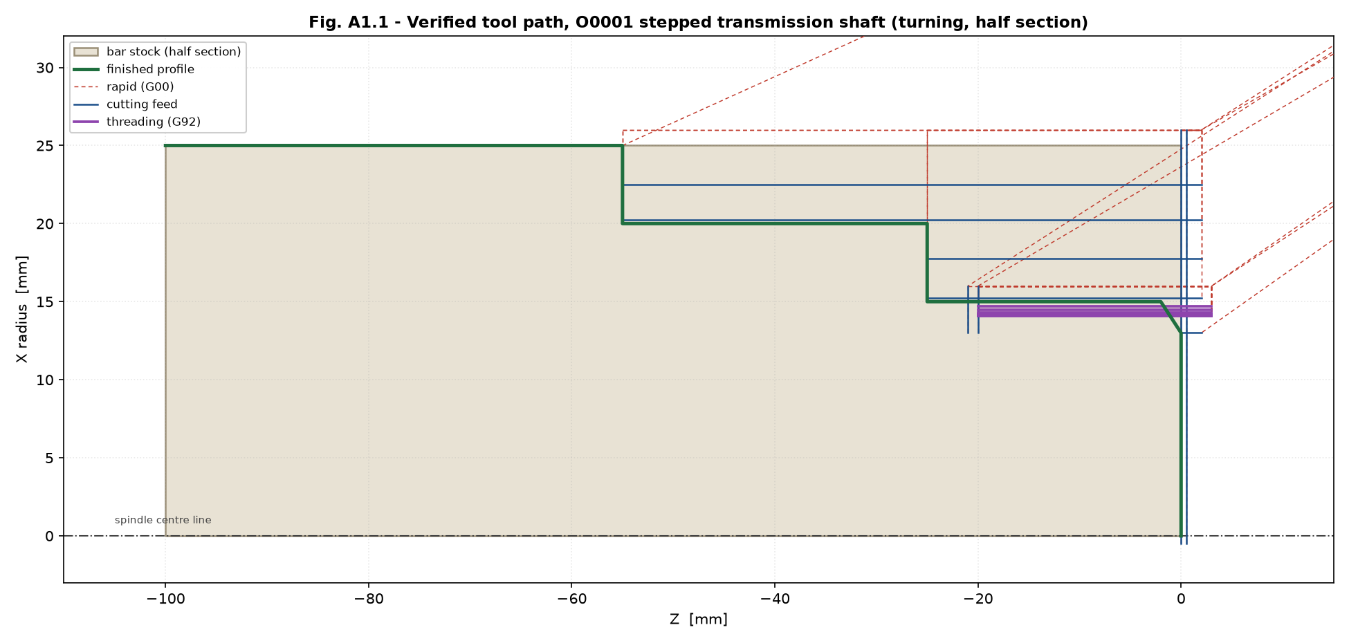
Fig. A1.1 — Verified tool path for O0001, shown as a half section through the bar. The green line is the finished profile.
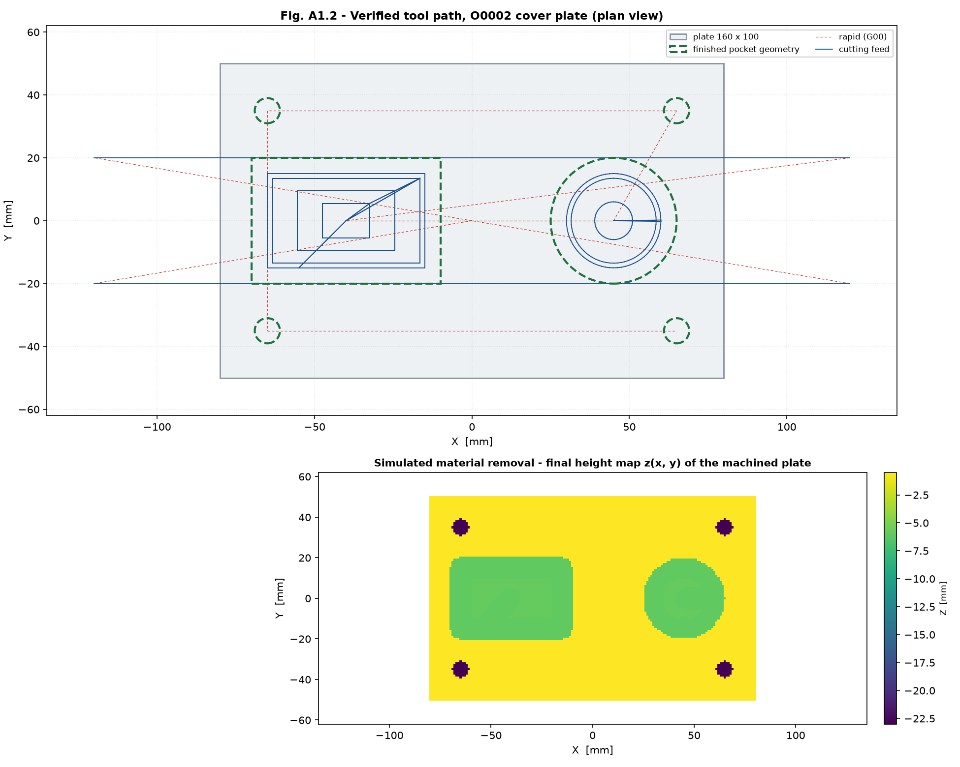
Fig. A1.2 — Verified tool path for O0002 (upper) and the simulated material-removal height map of the finished plate (lower).
The height map in the lower half of Fig. A1.2 is the direct output of the material-removal model. The eleven dimensional checks listed in the verification log probe the floor of each pocket, the faced top surface, an uncut corner, and points 2 mm inside and 2 mm outside every pocket wall. The wall probes are what prove that cutter radius compensation has actually been applied: without G41 the pockets would come out one cutter radius oversize and the "just outside the wall" probes would read −6 mm instead of −0.5 mm.
Stated honestly — these figures are the output of the verifier written for this assignment. They are not screenshots of CutViewer, LinuxCNC or FreeCAD. The simulator models the tool as a cylinder of the declared diameter and does not model the tool holder, the turret body, the fixture or machine kinematics, so it does not replace a final single-block dry run on the machine before the first part is cut.
5. Automated Material Transport Design and Analysis
5.1 Transport loop
A unidirectional AGV guide-path loop serves the cell, with an outbound (loaded) leg running past the front of every station and a return (empty) leg. Five pick-and-deposit stations are provided: P/D-1 at raw material staging, P/D-2 at the turning centre, P/D-3 at the machining centre, P/D-4 at wash and deburr, and P/D-5 at inspection and finished goods. Transfer between TC-01 and MC-01 is not done by AGV at all but by a six-axis robot on a 10.7 m linear rail, because that transfer happens every cycle and an AGV move would dominate the cell cycle time.
A roller conveyor was considered as the alternative. It was rejected because the part mix is high and the volume moderate: a conveyor fixes the route in steel, whereas the AGV loop can be re-sequenced in software when a new part family is introduced — which is the whole point of a *flexible* cell.
5.2 Transport system analysis
The delivery cycle time is
Tc = TL + Ld/Vc + TU + Le/Vc [min per delivery]

TL = loading time TU = unloading time
Ld = loaded distance Le = empty return distance
Vc = vehicle speed

Input | Symbol | Value | Basis
Loading time | TL | 0.60 min | Robot or roll-on transfer plus AGV docking and handshake
Unloading time | TU | 0.50 min | Roll-off transfer at the receiving station
Loaded travel distance | Ld | 140 m | 48 m from the central raw store + 28 m through the cell + 64 m to the despatch dock
Empty return distance | Le | 110 m | Direct return leg of the guide path
Vehicle speed | Vc | 50 m/min | Typical safe speed for a laser-guided AGV in a manned aisle
Delivery demand | Rf | 22 /h | 16 production moves (24 parts/h in pallets of 6, four moves per pallet) + 6 ancillary moves for tooling, empty pallets and swarf bins
Availability | A | 0.95 | Allows for opportunity battery charging and breakdowns
Traffic factor | Ft | 0.90 | Allows for blocking and queueing at the P/D stations

Calculation (performed by Assignment3_Coding/task3_4_agv_fleet_sizing.py, Test Case 1):
Tc = 0.60 + 140/50 + 0.50 + 110/50
= 0.60 + 2.80 + 0.50 + 2.20
= 6.10 min per delivery

Workload WL = Rf x Tc = 22 x 6.10 = 134.20 vehicle-min per hour
Available time AT = 60 x A x Ft = 60 x 0.95 x 0.90 = 51.30 min per vehicle per hour

Vehicles n = WL / AT = 134.20 / 51.30 = 2.616
-> 3 AGVs (rounded up)

Fleet utilisation = 2.616 / 3 = 87.2 %
Delivery rate the fleet can serve = 3 x 51.30/6.10 = 25.23 deliveries/h
Demand = 22.00 deliveries/h OK

Result | Value
Delivery cycle time, Tc | 6.10 min
Workload, WL | 134.20 vehicle-min per hour
Available time per vehicle, AT | 51.30 min per hour
Vehicles required (exact) | 2.616
Fleet size specified | 3 AGVs
Fleet utilisation | 87.2 %
Delivery capacity of the fleet | 25.23 deliveries/h against a demand of 22.00
Line throughput supported | 24 components per hour (≈ 384 per day on two shifts)

Sensitivity. The sizing was re-run across a demand sweep to confirm the fleet does not sit on a knife edge:
Demand, deliveries/h | 5 | 10 | 20 | 30 | 40 | 60 | 80
Vehicles (exact) | 0.60 | 1.19 | 2.38 | 3.57 | 4.76 | 7.14 | 9.51
AGVs required | 1 | 2 | 3 | 4 | 5 | 8 | 10

Three vehicles cover demand from roughly 15 to 25 deliveries per hour, so the design has headroom for a 14 % increase in output before a fourth vehicle is needed. Utilisation at 87.2 % is high but acceptable for a laser-guided fleet with opportunity charging; if the plant expects growth beyond 25 deliveries per hour the fourth vehicle should be ordered with the original three, because retrofitting guide-path capacity later is far more disruptive than buying a vehicle.
6. Cell Layout
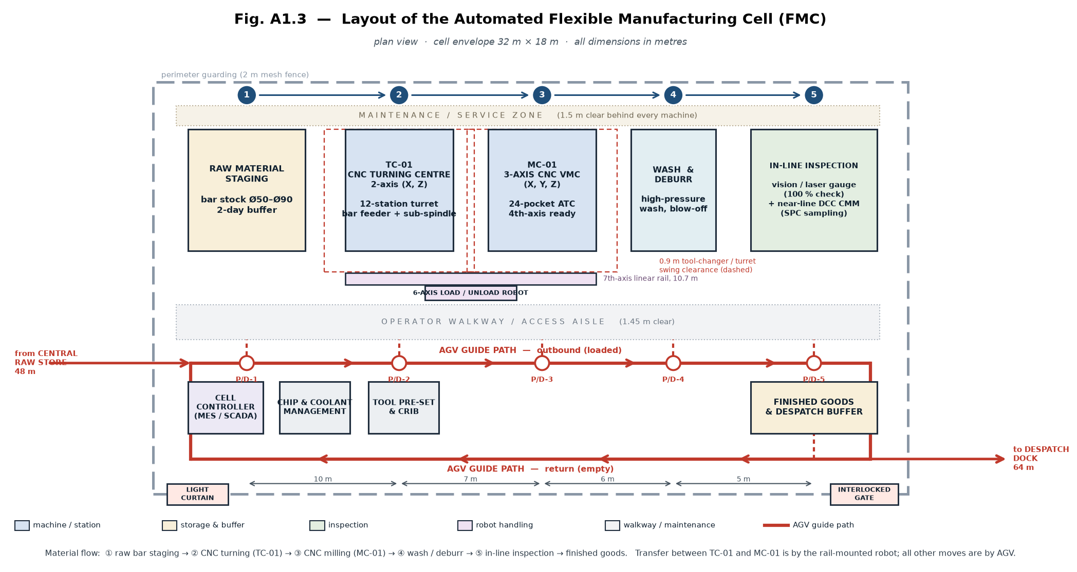
Fig. A1.3 — Plan layout of the Automated Flexible Manufacturing Cell, 32 m × 18 m envelope.
The layout is arranged as a straight-line flow so that the part never back-tracks:
- Machine positions. The five stations sit in one row along the top of the cell, in process order — raw staging, TC-01, MC-01, wash and deburr, inspection. This keeps the robot rail short and makes the AGV route a simple one-way loop.
- Automated material handling path. The AGV guide path runs as a closed loop below the stations, outbound (loaded) along the front of the machines and return (empty) along the bottom. Five P/D stations connect the loop to the stations. The loop extends outside the cell to the central raw store (48 m) and the despatch dock (64 m).
- Tool changer clearance. A 0.9 m clear envelope is maintained around TC-01 and MC-01 (shown dashed) for turret indexing and ATC arm swing. Nothing — not the robot rail, not the walkway — is allowed to intrude into it.
- Operator and maintenance zones. A 1.45 m operator walkway separates the machine line from the AGV path, so that an operator never has to stand on the guide path. A 1.5 m maintenance strip runs behind every machine for access to the electrical cabinet, the way lubrication and the coolant tank.
- Safety. The cell is enclosed by 2 m mesh guarding with one interlocked access gate and a light curtain at the operator entry point. The AGV loop crosses the guarding line through the two openings only.
- Ancillary stations. The cell controller (MES/SCADA), chip and coolant management, and the tool pre-setting crib are placed inside the loop where they are reachable from the walkway without crossing the AGV path.
7. Conclusions
- A two-machine flexible cell — a 2-axis CNC turning centre and a 3-axis CNC vertical machining centre — meets the part family, linked by a rail-mounted six-axis robot for the machine-to-machine transfer and by a three-vehicle AGV loop for everything else.
- The ± 0.005 mm positioning requirement is met by a system design: a Ø32 × 10 mm C3 ground ball screw with double-nut preload and fixed–fixed pre-tensioned mounting, preloaded roller LM guideways, hybrid ceramic angular contact spindle bearings with oil–air lubrication, and — decisively — absolute linear glass scales closing the position loop on every axis. The error budget predicts ± 3.24 µm against the ± 5 µm requirement, a 35 % margin.
- A semi-closed loop using only a rotary encoder on the screw was shown to be inadequate: thermal growth of the ball screw alone, about 12 µm for a 2 °C rise, exceeds the entire error budget and is invisible to a rotary encoder.
- Both part programs were written in the canned-cycle formats required by the brief and were verified by material-removal simulation. Both are collision free, and all eleven dimensional checks on the simulated milled plate pass. The verifier was itself validated against deliberately faulty programs.
- The transport analysis gives a delivery cycle time of 6.10 min and a required fleet of 3 AGVs at 87.2 % utilisation, supporting 24 components per hour with headroom to about 25 deliveries per hour.
- Recommended next steps before the cell is commissioned: verify positioning accuracy on site by laser interferometry to ISO 230-2 and load the measured pitch-error compensation tables; run both programs in single block with the tool holders fitted; and re-measure the AGV route distances on the finished floor, since Ld and Le drive the fleet size directly.

