Mid-Semester Examination — Performance Analysis
B.E. Semester 5 · Robotics & Automation · September 2026 Mid-Sem (each paper out of 30)
1. Overview
This report analyses the September 2026 mid-semester results of the Robotics & Automation (Sem-5) class across five subjects, each marked out of 30. It focuses on six students — Jenil (self), Krushna, Navya, Hardh, Prashant and Nikhil — and places each of them against the class average, the subject toppers and the overall class spread.
The five subjects analysed are:
Subject | Code | Students | Class Avg /30 | Highest | Pass %
Modelling & Simulation (MS) | BE05041031 | 45 | 20.7 | 27 | 97.6
Automated Manufacturing (AM) | — | 80 | 17.0 | 26 | 90.7
Microprocessor & Microcontroller (MPMC) | BE05041011 | 80 | 16.0 | 28 | 93.3
Machine Vision (MV) | BE05041051 | 80 | 15.9 | 29 | 86.8
Fuzzy Logic & Genetic Prog. (FLGP) | — | 37 | 21.6 | 29 | 94.3

(Pass mark taken as 40% = 12 / 30. FLGP is an elective taken by a subset of the class.)
2. Subject Difficulty (whole class)
Looking at the class average of each paper shows how hard the paper was for everyone — a low average means a tough paper, not just a weak student.
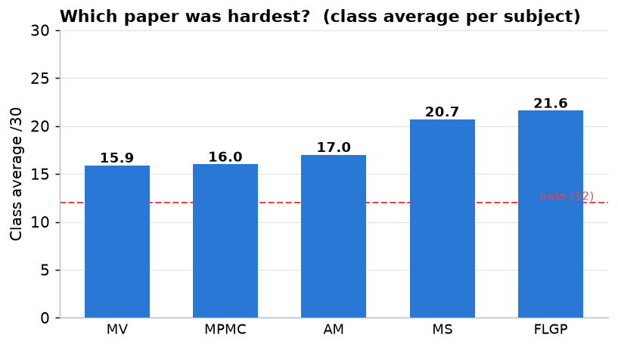
Chart 1: Class average mark per subject. MV and MPMC were the toughest papers; MS and FLGP were the most scoring.
- MV (15.9) and MPMC (16.0) were the hardest papers — the class average barely cleared half marks, and MV also had the most fails (pass rate only 86.8%).
- MS (20.7) and FLGP (21.6) were the most scoring papers, with averages around 70% and very high pass rates.
- So a modest MV score has to be read against a tough paper, while a modest MS/FLGP score stands out more, because most of the class scored well there.
3. Focus Group — Overall Standing
Adding up each student’s marks across the subjects they appeared for gives their overall percentage. (Prashant, Nikhil and Krushna did not appear in all five subjects, so their total is out of fewer papers.)
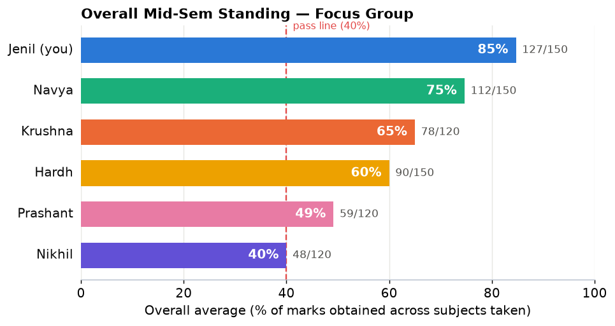
Chart 2: Overall average (% of marks obtained) for the six focus students.
Student | Subjects Taken | Total | Average /30 | Overall % | Group Rank
Jenil (self) | 5 | 127 / 150 | 25.4 | 84.7 % | 1
Navya | 5 | 112 / 150 | 22.4 | 74.7 % | 2
Krushna | 4 | 78 / 120 | 19.5 | 65.0 % | 3
Hardh | 5 | 90 / 150 | 18.0 | 60.0 % | 4
Prashant | 4 | 59 / 120 | 14.8 | 49.2 % | 5
Nikhil | 4 | 48 / 120 | 12.0 | 40.0 % | 6

Headline: Jenil leads the group clearly at 84.7%, followed by Navya at 74.7%. Prashant and Nikhil are near the pass line and need the most support.
4. Marks Matrix (student × subject)
The table and heat-map below show every mark side by side (darker = higher). The "—" marks subjects a student did not take.
Student | MS | AM | MPMC | MV | FLGP
Jenil (self) | 23 | 26 ★ | 28 ★ | 25 | 25
Navya | 26 | 23 | 17 | 19 | 27
Krushna | 25 | 21 | 20 | 12 | —
Hardh | 23 | 17 | 18 | 12 | 20
Prashant | — | 12 | 16 | 15 | 16
Nikhil | — | 16 | 12 | 12 | 8
Class average | 20.7 | 17.0 | 16.0 | 15.9 | 21.6

(★ = class topper in that subject.)
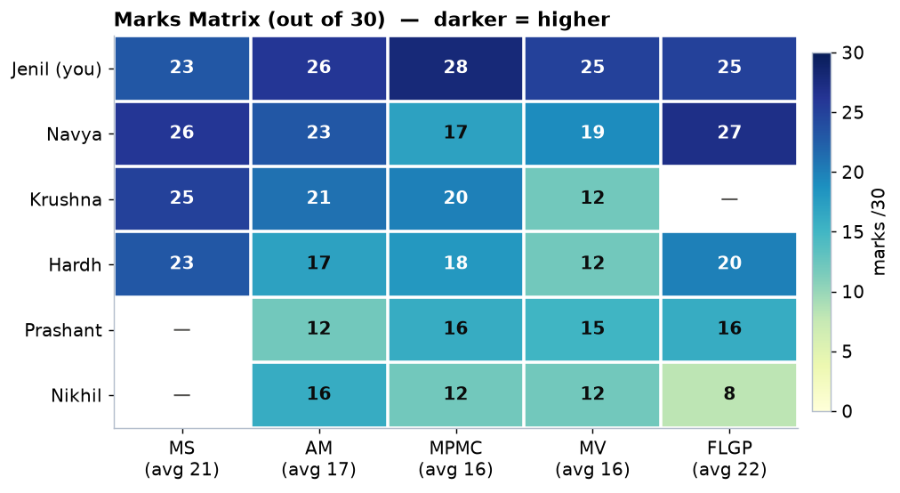
Chart 3: Marks matrix heat-map — Jenil’s row is the darkest; Nikhil’s FLGP (8) is the only below-pass cell.
5. Individual Analysis
Jenil (self) — 127/150 (84.7%) — Group Rank 1
- Class topper in two subjects: AM (26, joint 1st) and MPMC (28, sole 1st — the highest MPMC mark in the class).
- Also strong in MV (25, rank 7 of 76) in the hardest paper of the semester, and solid in FLGP (25).
- Relatively weakest in MS (23, rank ~18) — still good, but this is the one paper where many classmates scored higher (three toppers at 27).
- Takeaway: an excellent, well-rounded result; the only place to gain is MS, where a few more marks would have given a top-5 finish there too.
Navya — 112/150 (74.7%) — Group Rank 2
- Best in the two scoring papers: MS 26 (rank 5) and FLGP 27 (rank 7) — consistently near the top in theory subjects.
- The dip is MPMC (17) and MV (19) — both below her usual level and in the harder papers.
- Takeaway: a strong, consistent performer; focusing on the microprocessor/vision (application) papers would push her past 80%.
Krushna — 78/120 (65.0%) — Group Rank 3
- Strong in MS (25, rank 9) and steady in AM (21) and MPMC (20).
- Clear weak spot: MV (12, rank 57 of 76) — only just passed in the toughest paper. Did not appear in FLGP.
- Takeaway: good theory base; MV is the priority — a focused effort there would lift the overall percentage noticeably.
Hardh — 90/150 (60.0%) — Group Rank 4
- Best mark in MS (23); steady in FLGP (20) and MPMC (18).
- Two soft spots: MV (12, rank 60) and AM (17, about the class average).
- Takeaway: a middle-of-the-group result with no fails; lifting MV and AM out of the "just-above-average" zone is the clearest path up.
Prashant — 59/120 (49.2%) — Group Rank 5
- Marks are clustered just above the pass line in every paper — AM 12 (at the pass mark), MPMC 16, MV 15, FLGP 16. Did not appear in MS.
- No fails, but little margin anywhere; AM at exactly 12 is a warning sign.
- Takeaway: the issue is breadth, not one subject — a steady revision routine across all papers (starting with AM) is needed to build a safe margin before the finals.
Nikhil — 48/120 (40.0%) — Group Rank 6 (needs urgent attention)
- FLGP 8 is below the pass mark (fail), and MPMC (12) and MV (12) are exactly at the pass line.
- Best mark is AM (16); did not appear in MS.
- Takeaway: at-risk. FLGP needs immediate remedial work, and MPMC/MV need to be pulled clear of the pass line. Early, subject-wise help before the end-sem is strongly advised.
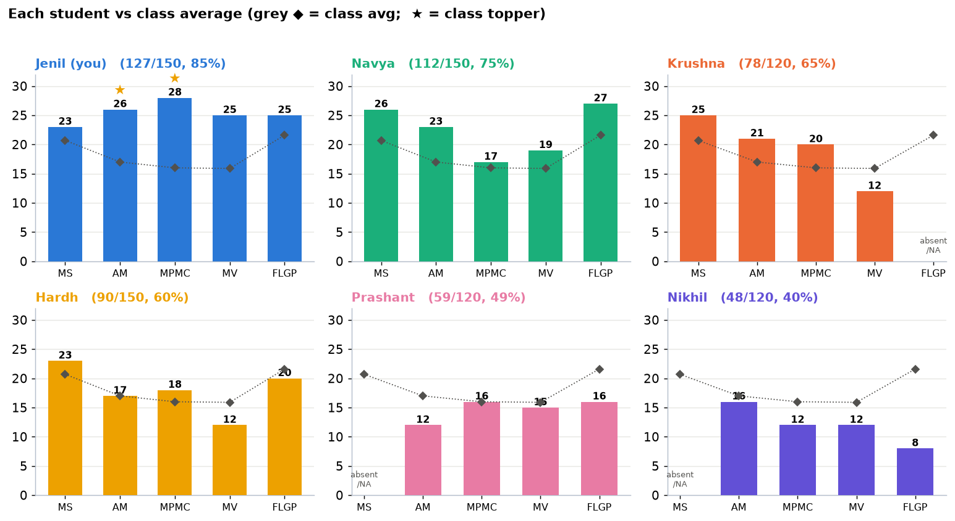
Chart 4: Each student’s marks (bars) against the class average (grey ◆). ★ marks a class topper.
6. Subject Toppers
The highest scorers in each subject (top three) were:
Subject | 1st | 2nd | 3rd
MS | Krupa Mehta, Nai Diya, Divya Gurnani — 27 (tie)
AM | Jenil Patel & Tej Shah — 26 (tie) | Daksh Mahant — 25
MPMC | Jenil Patel — 28 | Nai Diya, Nakrani Meshva — 27
MV | Dudhat Preet — 29 | Yash Brahmbhatt, Ajudiya Pritkumar — 26
FLGP | Dobariya Raj — 29 | Harshit Singh — 28 | Nai Diya — 28

Jenil appears in the topper list twice — joint 1st in AM and sole 1st in MPMC — the only focus-group student to top a subject. Nai Diya is the most consistent topper overall (top-3 in MS, MPMC and FLGP).
7. Key Observations
- Jenil is the stand-out performer of the group (84.7%) and of the class in AM and MPMC — a genuinely strong, all-round result.
- MV is the common weak point for the group — Krushna, Hardh and Nikhil all scored 12 in it. But MV was also the hardest paper for everyone (class avg 15.9), so some of this is the paper, not only the student; Jenil’s 25 shows a high score was still possible.
- The scoring papers (MS, FLGP) separated the group — the students who did well overall (Jenil, Navya) also scored high here, while the lower-ranked students left marks on the table in exactly the papers where the class average was highest.
- Two students need attention: Prashant (thin margins in every paper) and Nikhil (an FLGP fail and two subjects at the pass line).
8. Recommendations
- Jenil: maintain the approach; add a little more preparation in MS (the one mid-table paper) to be a contender for overall class rank.
- Navya: target the application papers (MPMC, MV) — the theory base is already top-5.
- Krushna & Hardh: make MV the priority subject; both scored only 12 there while doing fine elsewhere.
- Prashant: build a steady all-subject revision routine to create a safe margin above the pass line, starting with AM.
- Nikhil: urgent, subject-wise remedial support — clear the FLGP backlog first, then strengthen MPMC and MV before the end-semester exam.
- Whole group: since MV and MPMC were the hardest papers, extra group study / problem practice in these two application subjects would help everyone the most.

Note: all figures are taken directly from the five official mid-sem result sheets; marks are out of 30, pass mark assumed at 40% (12). Ranks are within the students present for that paper.

