MODELLING & SIMULATION · BE05041031
Modelling & Simulation — Assignment Solutions
Solved answers for all five units — CAD standards, geometric modelling and the Finite Element Method
Particulars | Details
Name of the student
Enrolment No. · Branch | Robotics and Automation (Sem 5)
Subject · Code | Modelling & Simulation — BE05041031
Faculty | Prof. Rita Jani
Date · Sign of Faculty

Unit 1 — CAD Standards and Coordinate Systems (CO-1)
Q1. Explain GKS architecture with a neat block diagram.
Ans. GKS (Graphical Kernel System) is an ISO standard (ISO 7942) that defines a device-independent set of functions for 2-D computer graphics. It is organised as a layered architecture so that the application program is isolated from the actual hardware. The application calls GKS through a language-dependent layer (language bindings for C, FORTRAN, Pascal); the GKS kernel/nucleus holds the core graphics functions, state lists and transformations and generates output primitives (polyline, polymarker, text, fill-area, cell-array); the workstation-dependent layer converts these into device commands; and finally the physical devices (display, plotter, keyboard, mouse) produce the output and accept input. This layering makes graphics programs portable across different devices.
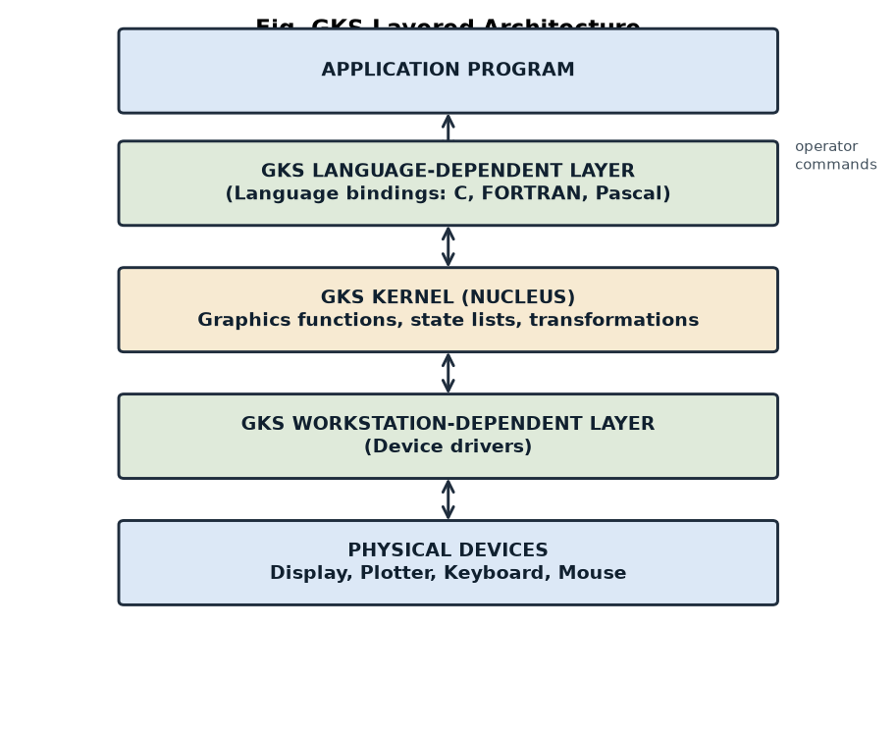
GKS layered architecture.
Q2. Compare IGES, STEP and CALS standards.
Point | IGES | STEP | CALS
Full form | Initial Graphics Exchange Specification | Standard for the Exchange of Product model data | Continuous Acquisition and Life-cycle Support
Standard / origin | ANSI, 1980 (older, neutral) | ISO 10303, 1994 (modern, international) | US Department of Defense
Scope of data | Mainly geometry, drawings, wireframe & surfaces | Complete product data — geometry, topology, features, PDM, tolerances | Technical documentation & digital data exchange over the product life-cycle
Limitation / strength | Large files, some data loss on transfer | Richer, lossless, supports the whole product life-cycle | Focus on documentation rather than CAD geometry
Typical use | Exchanging CAD models between older systems | Modern CAD/CAM/CAE data exchange & archiving | Defence & large-industry data/record management

Q3. Explain OpenGL and its applications.
Ans. OpenGL (Open Graphics Library) is a cross-platform, device- and language-independent API for rendering 2-D and 3-D graphics, originally developed by Silicon Graphics and now maintained by the Khronos Group. It provides a standard set of functions for drawing primitives, applying transformations, lighting, shading, texturing and hidden-surface removal, and it uses the graphics hardware (GPU) for fast rendering through a pipeline. Applications: CAD/CAM modelling, 3-D games, flight and driving simulators, virtual/augmented reality, scientific and medical visualisation, and animation.
Q4. Differentiate Working, Model and Screen coordinate systems with sketch.
Ans. The Working (local) Coordinate System (WCS) is a temporary, user-defined system attached to a particular feature or sketch plane, which makes it easy to create that feature. The Model (world) Coordinate System (MCS) is the single global reference in which the complete model/assembly is defined — all working systems are expressed relative to it. The Screen (device) Coordinate System (SCS) is the 2-D pixel system of the display on which the model is finally shown after projection. In short: geometry is built in the WCS, stored in the MCS, and displayed in the SCS.
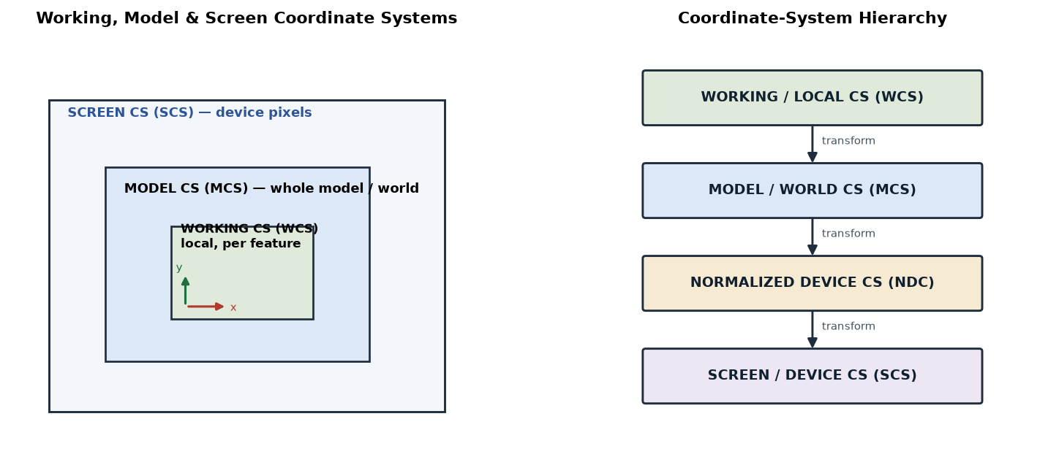
Working, Model & Screen coordinate systems (left) and the coordinate-system hierarchy (right).
Q5. Draw coordinate system hierarchy diagram.
Ans. The transformation chain runs from the local design system down to the physical screen: Working/Local CS → Model/World CS → Normalized Device CS (NDC) → Screen/Device CS. Each arrow is a coordinate transformation (translation, rotation, scaling and finally the viewport mapping). The hierarchy is shown in the right-hand panel of the figure above.
Q6. Explain communication standards in CAD.
Ans. Communication (data-exchange) standards are neutral file formats that let different CAD/CAM systems share model data without being tied to one vendor. They convert a system’s native model into a common, readable format that another system can import. The main ones are IGES (geometry/drawings), STEP / ISO 10303 (complete product data), DXF (Drawing Exchange Format, for 2-D drawings, by Autodesk), STL (triangulated surface, for rapid prototyping/3-D printing), VDA-FS (surfaces, German automotive) and CALS (documentation). They are essential for data exchange between suppliers, vendors and design teams.
Q7. Numerical: A point (20, 30, 40) in model coordinates is translated by (10, 15, 5). Find the new coordinates.
Ans. Translation simply adds the translation vector to each coordinate: P′ = P + T.
x' = 20 + 10 = 30
y' = 30 + 15 = 45
z' = 40 + 5 = 45

New coordinates = ( 30 , 45 , 45 )

Q8. Numerical: Convert coordinates between two Cartesian systems after a 90° rotation about the Z-axis.
Ans. For a rotation by angle θ about the Z-axis: x′ = x cosθ − y sinθ, y′ = x sinθ + y cosθ, z′ = z. For θ = 90° (cos 90° = 0, sin 90° = 1) this reduces to x′ = −y, y′ = x, z′ = z. Taking an example point (10, 5, 3):
| x' | | cos90 -sin90 0 | | x | | 0 -1 0 | |10| | -5 |
| y' | = | sin90 cos90 0 | | y | = | 1 0 0 | | 5 | = | 10 |
| z' | | 0 0 1 | | z | | 0 0 1 | | 3 | | 3 |

Point (10, 5, 3) -> ( -5 , 10 , 3 )

Q9. Short note on CAD standards.
Ans. CAD standards are agreed rules and formats that make CAD data consistent, portable and exchangeable between different software, machines and users. They cover several areas: graphics standards (GKS, PHIGS, OpenGL) for device-independent display; data-exchange standards (IGES, STEP, DXF, STL) for transferring models between systems; and documentation/drafting standards (layering, dimensioning, title blocks). Their benefits are portability, reduced data loss, easier collaboration between vendors and long-term archiving of product data.
Q10. Explain industrial applications of data-exchange standards.
Ans. Data-exchange standards are used wherever product data must move between different systems or organisations. Key applications: supplier–OEM collaboration (an automotive or aerospace OEM shares STEP/IGES models with hundreds of suppliers who use different CAD packages); CAD-to-CAM/CAE transfer (geometry handed to manufacturing or analysis software); rapid prototyping / 3-D printing (STL files sent to the printer); PLM/PDM archiving of product data for the whole life-cycle (STEP); and concurrent engineering, where design, analysis and manufacturing teams work on the same neutral data in parallel.

Unit 2 — Surface, Solid Modelling and Assembly (CO-2)
Q1. Explain Bezier curves with equations.
Ans. A Bézier curve is a parametric curve defined by a set of control points P₀, P₁, …, Pₙ whose positions "pull" the curve into shape. The curve is a weighted blend of the control points using Bernstein polynomials as blending functions:
P(t) = Σ Bi,n(t) · Pi 0 <= t <= 1
i=0..n
where Bi,n(t) = C(n,i) · t^i · (1-t)^(n-i) (Bernstein basis)

Cubic (n = 3):
P(t) = (1-t)^3 P0 + 3(1-t)^2 t P1 + 3(1-t) t^2 P2 + t^3 P3
The curve passes through the first and last control points (P₀ and Pₙ), is tangent to the control polygon at the ends, and always lies inside the convex hull of the control points.
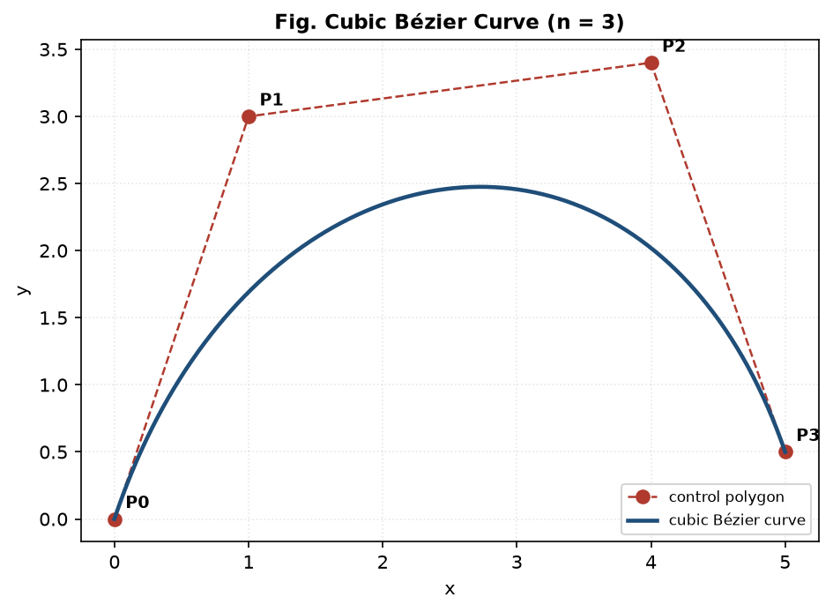
Cubic Bézier curve with its control polygon.
Q2. Explain Cubic Splines and continuity (C0, C1, C2).
Ans. A cubic spline is a smooth curve made of piecewise cubic polynomial segments joined at points called knots, so that a complex shape passes smoothly through many data points without the oscillation of a single high-degree polynomial. The smoothness at each join is described by continuity: C0 — the segments only meet (same position, but a visible corner); C1 — same position and same slope/tangent (first derivative continuous, looks smooth); C2 — same position, tangent and curvature (second derivative continuous, needed for high-quality surfaces and smooth motion).
Q3. Compare Bezier, B-Spline and NURBS.
Point | Bézier | B-Spline | NURBS
Control | Moving one point changes the whole curve (global) | Local control — a point affects only nearby span | Local control, same as B-spline
Degree vs points | Degree fixed by number of control points | Degree independent of number of control points | Degree independent of number of points
Weights | None (all points equal) | None | Each point has a weight (rational)
Conics | Cannot represent circle/ellipse exactly | Cannot represent conics exactly | Can represent conics exactly (circle, ellipse)
Use | Simple curves, fonts | Free-form curves/surfaces | Industry standard for CAD surfaces

Q4. Explain Boolean operations with sketches.
Ans. Boolean operations build a complex solid by combining two simpler solids (A and B) using set logic. Union (A ∪ B) joins the two solids into one. Intersection (A ∩ B) keeps only the common/overlapping volume. Difference (A − B) removes the volume of B from A (used to cut holes, slots and pockets). They are the basis of Constructive Solid Geometry (CSG) modelling.
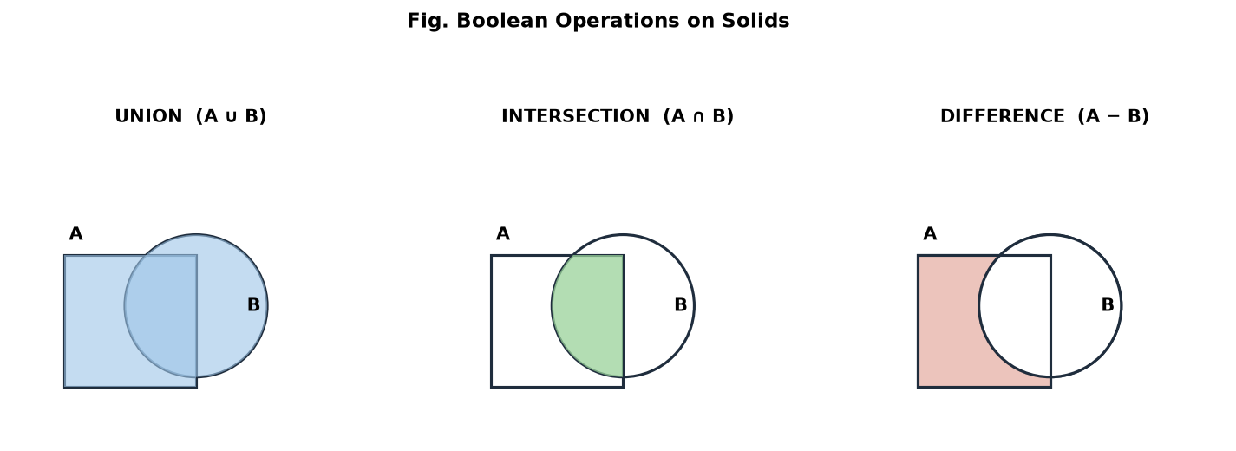
Boolean operations — union, intersection and difference.
Q5. Explain assembly modelling.
Ans. Assembly modelling is the process of bringing individual part models together into a complete product by positioning them correctly and applying mating constraints (such as coincident, concentric, parallel, distance and angle) that define how parts fit and move relative to one another. It maintains parametric links, so a change in a part updates the assembly automatically, and it supports top-down (design within the assembly) or bottom-up (build parts first, then assemble) approaches. It allows interference checking, bills of material and motion study.
Q6. Explain interference checking and tolerance analysis.
Ans. Interference checking detects whether two parts in an assembly overlap or collide (occupy the same space) or whether there is unwanted clearance; CAD software highlights the interfering volume so the design can be corrected before manufacture. Tolerance analysis studies how the permitted dimensional variations (tolerances) of individual parts stack up across the assembly, using worst-case or statistical (RSS) methods, to ensure the parts will still fit and function. Together they guarantee proper fit, assembly and function.
Q7. Numerical: Determine the first point on a cubic Bezier curve for given control points.
Ans. Take control points P₀(1, 1), P₁(2, 3), P₂(4, 3), P₃(5, 1). Using the cubic Bézier equation, the first point is at t = 0, which always equals P₀; the value at t = 0.5 is also shown to illustrate the method:
P(t) = (1-t)^3 P0 + 3(1-t)^2 t P1 + 3(1-t) t^2 P2 + t^3 P3

At t = 0 : P(0) = P0 = ( 1 , 1 ) <-- first point (curve starts at P0)

At t = 0.5 (check):
x = 0.125(1) + 0.375(2) + 0.375(4) + 0.125(5) = 3.0
y = 0.125(1) + 0.375(3) + 0.375(3) + 0.125(1) = 2.5
P(0.5) = ( 3.0 , 2.5 )

Q8. Numerical: Estimate centroid and mass properties of a simple block assembly.
Ans. Assembly of two steel blocks (density ρ = 7.85 × 10⁻⁶ kg/mm³): Block A 40 × 20 × 10 mm with centroid at x = 20 mm, Block B 20 × 20 × 20 mm with centroid at x = 50 mm (placed beside A).
Volumes: VA = 40x20x10 = 8000 mm^3, VB = 20x20x20 = 8000 mm^3
Masses : mA = rho·VA = 0.0628 kg, mB = rho·VB = 0.0628 kg
Total mass M = mA + mB = 0.1256 kg

Composite centroid (x):
X = (mA·xA + mB·xB) / M = (0.0628·20 + 0.0628·50) / 0.1256
= (1.256 + 3.140) / 0.1256 = 35 mm

Q9. Draw a surface modelling flow diagram.
Ans. The usual sequence is: input data points → build the wireframe (bounding curves/edges) → create surface patches (Bézier / B-spline / NURBS) over them → stitch, blend and trim the patches → obtain the surface model (skin) → use it for analysis, CNC tool-path generation or rendering.
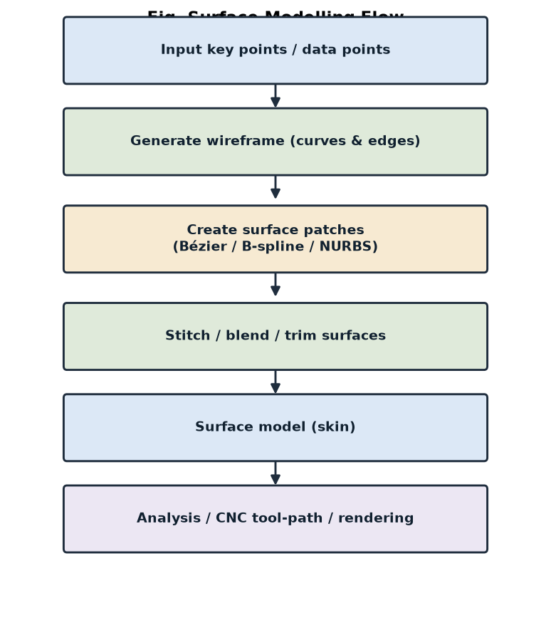
Surface modelling flow.
Q10. List industrial applications of NURBS.
Ans. NURBS surfaces are the industry standard for free-form geometry and are used in: automotive body panels and class-A styling surfaces; aerospace fuselage, wing and turbine-blade surfaces; ship-hull design; consumer-product and industrial design (ergonomic shapes); animation and film (smooth character/organic surfaces); and reverse engineering, where scanned point clouds are fitted with NURBS. They are preferred because they represent both free-form shapes and exact conics in a single, compact mathematical form.

Unit 3 — Introduction to FEM (CO-3)
Q1. Explain all steps of FEM using a flow chart.
Ans. The Finite Element Method (FEM) solves a complex problem by dividing the body into many small, simple parts (elements) and solving each. The standard steps are: (1) Discretize the domain into finite elements (meshing); (2) select the element type and shape (interpolation) functions; (3) derive the element stiffness matrix [k] and load vector {f}; (4) assemble them into the global system [K]{Q} = {F}; (5) apply the boundary conditions; (6) solve for the nodal unknowns {Q}; and (7) post-process to obtain stresses, strains, reactions and plots.
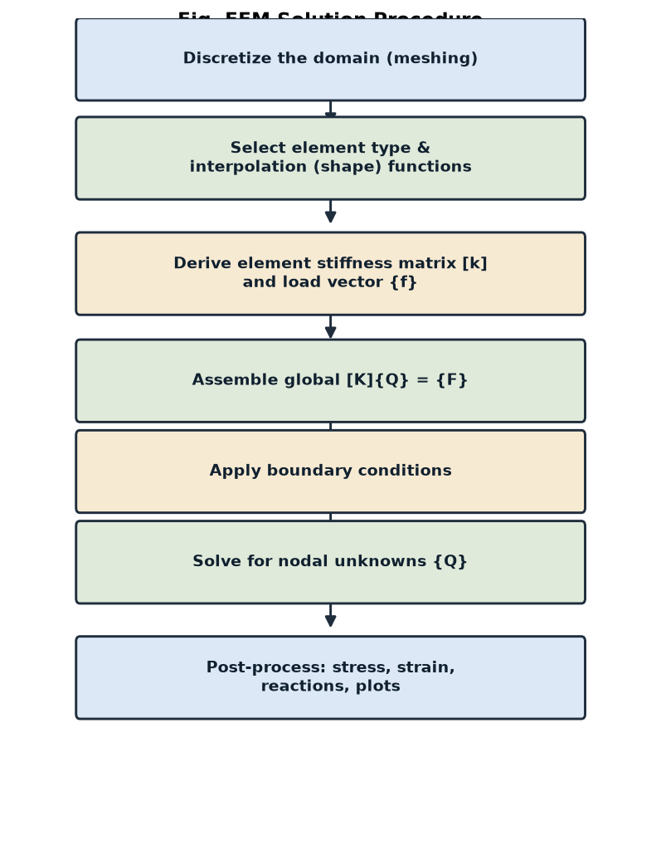
FEM solution procedure (flow chart).
Q2. Explain discretization and meshing.
Ans. Discretization is the process of dividing the continuous body (the domain) into a finite number of small sub-regions called finite elements, which are connected at points called nodes — this converts the continuous problem with infinite unknowns into a finite set of nodal unknowns. Meshing is the practical creation of that network of elements and nodes. Elements may be 1-D (line/bar), 2-D (triangle, quadrilateral) or 3-D (tetrahedron, hexahedron/brick). A finer mesh gives more accuracy but needs more computation.
Q3. Explain mesh refinement and enrichment.
Ans. Both improve accuracy in regions of high stress gradient (e.g. holes, fillets, crack tips). Mesh refinement (h-refinement) keeps the same element type but uses smaller, more numerous elements in the critical region, increasing the number of nodes. Mesh enrichment (p-refinement) keeps the same element size but raises the polynomial order of the interpolation (shape) functions, adding more nodes/degrees of freedom per element. A combination of both is called hp-refinement.
Q4. Explain natural coordinate systems.
Ans. A natural coordinate system is a local, dimensionless (normalised) system attached to the element itself, in which the coordinates are expressed as ratios that range over a fixed interval (typically 0 to 1, or −1 to +1) regardless of the element’s actual size or position. Examples are the area (L1, L2, L3) coordinates for a triangle and the (ξ, η) coordinates for a quadrilateral. They greatly simplify writing the shape functions and performing the numerical (Gauss) integration of the element matrices.
Q5. Explain crack tip elements.
Ans. Crack-tip elements are special elements used in fracture-mechanics FEM to capture the stress singularity (stresses theoretically tend to infinity as 1/√r) that exists right at the tip of a crack. Ordinary elements cannot represent this, so singularity / quarter-point elements are used: the mid-side nodes of standard quadratic elements around the tip are shifted to the quarter-point position, which makes the element reproduce the correct 1/√r field. They allow accurate computation of the stress-intensity factor (K).
Q6. Explain commercial FEM software.
Ans. Commercial FEM (CAE) packages provide a pre-processor (geometry, meshing, loads, boundary conditions), a solver (assembles and solves the equations) and a post-processor (contour plots of stress, strain, deflection, temperature). Widely used ones are ANSYS, Abaqus, NASTRAN (MSC/NX), COMSOL Multiphysics, Altair HyperWorks/OptiStruct, LS-DYNA (impact/crash) and SolidWorks Simulation / Autodesk Fusion. They are used for structural, thermal, fluid, modal, fatigue and crash analysis across automotive, aerospace and mechanical industries.
Q7. Numerical: Divide a rectangular plate into suitable finite elements.
Ans. A rectangular plate (say 40 mm × 20 mm) is divided into a regular grid. Using a 4 × 2 grid gives 8 rectangular (quadrilateral) elements and (4+1) × (2+1) = 15 nodes; if each quad is split along a diagonal, it becomes 16 triangular elements with the same 15 nodes (see the right-hand sketch of the figure in Unit 4 Q9). Finer division (more rows/columns) increases accuracy near edges and holes.
Q8. Numerical: Calculate total DOF for a given mesh.
Ans. Total Degrees of Freedom (DOF) = (number of nodes) × (DOF per node). The DOF per node depends on the problem: 1 for 1-D heat conduction, 2 for 2-D plane stress/strain (u, v), 3 or 6 for 3-D. For the 15-node mesh of Q7 in a 2-D structural (plane-stress) problem:
Total DOF = (no. of nodes) x (DOF per node)
= 15 x 2 = 30 DOF

(If it were a 1-D heat problem: 15 x 1 = 15 DOF)

Q9. Advantages and limitations of FEM.
Ans. Advantages: can handle complex geometries, loads and materials that have no analytical solution; models non-homogeneous and anisotropic materials; easily applies different boundary conditions; gives detailed results (stress, strain, temperature) everywhere; and is adaptable to structural, thermal, fluid and dynamic problems. Limitations: gives only an approximate numerical result whose accuracy depends on mesh quality; needs large computation and skilled modelling; input errors (wrong mesh, loads or properties) give wrong answers ("garbage in, garbage out"); and results must be validated against experiment or theory.
Q10. Draw FEM solution procedure diagram.
Ans. The FEM solution procedure follows the same seven steps — discretization → shape functions → element matrices → assembly → boundary conditions → solve → post-process — as shown in the flow chart in Q1 of this unit.

Unit 4 — Scalar Variable Problems (CO-4)
Q1. Derive triangular element shape functions.
Ans. For a linear (3-node) triangular element the field variable is assumed to vary linearly: φ = α₁ + α₂x + α₃y. Writing this at the three nodes (with nodal values φ₁, φ₂, φ₃ at (x₁,y₁), (x₂,y₂), (x₃,y₃)) and solving for the α’s gives φ = N₁φ₁ + N₂φ₂ + N₃φ₃, where the shape functions are:
Ni = ( ai + bi·x + ci·y ) / (2A) (i = 1, 2, 3)

a1 = x2 y3 - x3 y2 , b1 = y2 - y3 , c1 = x3 - x2 (cyclic for 2,3)
A = area of the triangle

Property: N1 + N2 + N3 = 1 ; Ni = 1 at node i, 0 at the other nodes
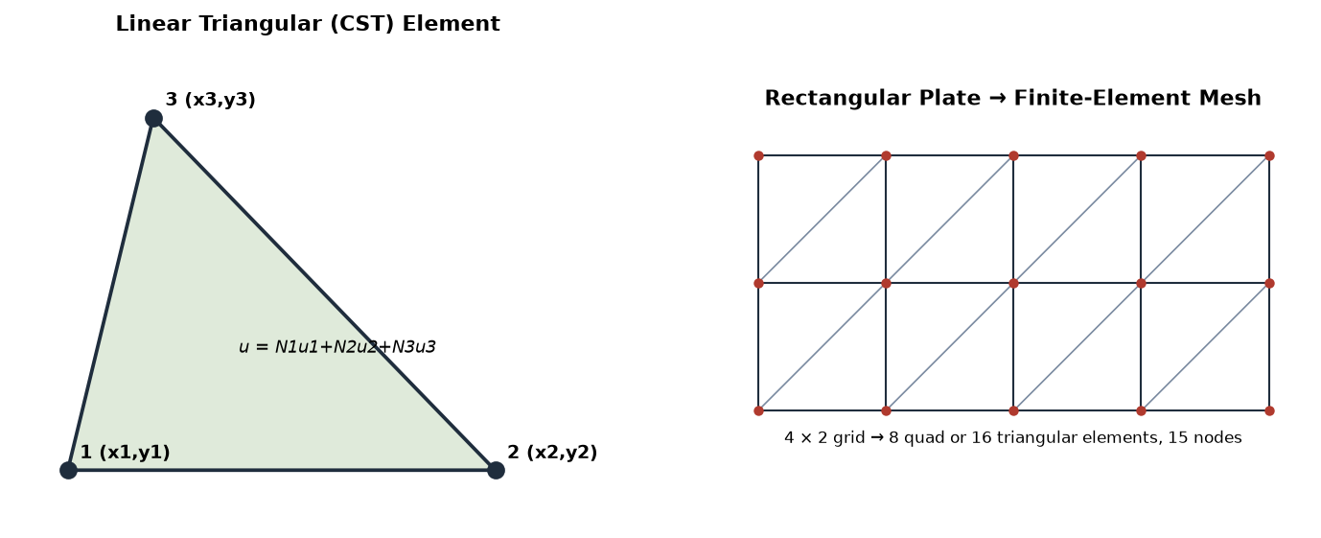
Linear triangular (CST) element (left) and a rectangular plate divided into a mesh (right).
Q2. Explain variational formulation.
Ans. The variational (energy) formulation sets up the FEM equations by making a functional (usually the total potential energy Π of the system) stationary (minimum). Instead of solving the governing differential equation directly, we write the total energy in terms of the nodal unknowns and apply the condition ∂Π/∂{Q} = 0, which yields the equilibrium equations [K]{Q} = {F}. For structural problems Π = (strain energy) − (work done by loads); minimising it is the Rayleigh–Ritz principle, the basis of displacement-based FEM.
Q3. Explain element stiffness matrix.
Ans. The element stiffness matrix [k] relates the nodal displacements {q} to the nodal forces {f} of a single element: {f} = [k]{q}. Each term kij is the force produced at DOF i by a unit displacement at DOF j. It is derived from the strain-displacement matrix [B] and the material (constitutive) matrix [D] as
[k] = ∫ [B]^T [D] [B] dV (integrated over the element volume)
It is square, symmetric and depends on the element geometry and material. The element matrices are then assembled into the global stiffness matrix [K].
Q4. Explain thermal analysis using FEM.
Ans. Thermal analysis by FEM finds the temperature distribution (and heat flow) in a body for given heat inputs and boundary conditions. The governing heat-conduction equation is discretized so that each element has a conductance (thermal stiffness) matrix [k] = ∫[B]ᵀ[D][B]dV (with D containing the conductivity) and a thermal load vector for internal heat generation, convection and flux. Assembling gives [K]{T} = {Q}, where {T} are the unknown nodal temperatures. Boundary conditions are prescribed temperatures, convection (h, T∞) or heat flux. It is used for heat sinks, engine parts, electronic cooling, etc.
Q5. Numerical: Compute the area of a triangular element from nodal coordinates.
Ans. For nodes 1(0, 0), 2(4, 0), 3(0, 3) the area is found from the coordinate formula:
A = (1/2) | x1(y2 - y3) + x2(y3 - y1) + x3(y1 - y2) |
= (1/2) | 0(0 - 3) + 4(3 - 0) + 0(0 - 0) |
= (1/2) | 0 + 12 + 0 | = 6 sq. units

Check (right triangle): A = 1/2 x base x height = 1/2 x 4 x 3 = 6 OK

Q6. Numerical: Solve a one-element steady-state heat conduction problem.
Ans. A 1-D conduction element (a wall/bar) with k = 50 W/m·K, area A = 0.1 m², length L = 0.2 m, node 1 at T₁ = 200 °C and node 2 at T₂ = 40 °C. The element conductance matrix and heat flow are:
[k] = (kA/L) [ 1 -1 ] kA/L = (50 x 0.1)/0.2 = 25 W/K
[ -1 1 ]

Heat flow Q = (kA/L)(T1 - T2) = 25 x (200 - 40) = 25 x 160
Q = 4000 W (flows from node 1 to node 2)

Q7. Explain boundary conditions.
Ans. Boundary conditions are the known conditions imposed on the boundary of the body; without them the global equations [K]{Q}={F} cannot be solved (K is singular). There are two types: essential (Dirichlet / primary) conditions prescribe the field variable itself — e.g. a fixed support (displacement = 0) in structural analysis, or a known temperature in thermal analysis; natural (Neumann / secondary) conditions prescribe its derivative — e.g. applied force/traction, or heat flux/convection. Essential conditions must be applied before solving.
Q8. Compare analytical and FEM solutions.
Point | Analytical (exact) solution | FEM (numerical) solution
Nature of result | Exact, closed-form equation | Approximate, numerical values at nodes
Geometry handled | Only simple, regular shapes | Any complex geometry
Loads / materials | Simple, idealised | Complex, non-uniform, anisotropic
Effort | Quick once a formula exists | Needs meshing and computation (software)
Accuracy | Perfect (within assumptions) | Improves as the mesh is refined

Q9. Draw a triangular finite element.
Ans. A linear triangular element has three nodes (1, 2, 3) at its corners, each carrying the nodal value of the field variable; the variable inside varies linearly as u = N₁u₁ + N₂u₂ + N₃u₃. It is shown in the left-hand sketch of the figure in Q1 of this unit.
Q10. Applications of scalar FEM.
Ans. Scalar-field (single unknown per node) FEM is applied to: steady and transient heat conduction (temperature fields in engine parts, heat sinks, electronics); fluid flow / seepage through soils and porous media (potential flow); electrostatic and magnetostatic field problems; torsion of non-circular shafts; and acoustic pressure fields. In all these the unknown is a single scalar (temperature, potential, pressure) at each node.

Unit 5 — Vector Variable Problems (CO-5)
Q1. Differentiate plane stress and plane strain.
Ans. Both are 2-D idealisations of 3-D elasticity. Plane stress applies to a thin body (like a thin plate loaded in its plane): the stress across the thickness is zero (σ_z = τ_xz = τ_yz = 0) but strain ε_z exists. Plane strain applies to a long/thick body of constant cross-section (like a dam, long pipe or roller): the strain along the length is zero (ε_z = 0) but a stress σ_z exists. They use different elasticity (D) matrices.
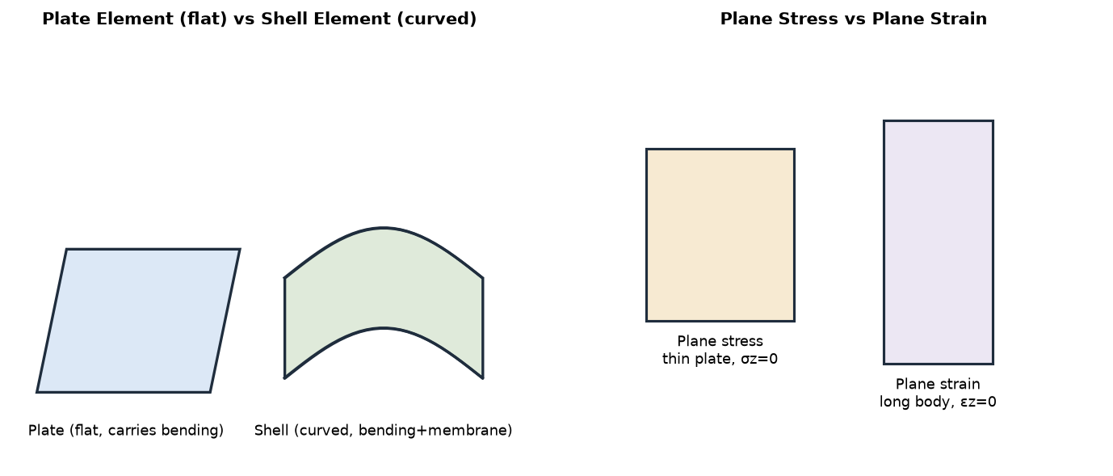
Plate vs shell elements (left) and plane stress vs plane strain (right).
Q2. Explain plate and shell elements.
Ans. A plate element is a flat 2-D element that carries bending loads perpendicular to its plane (like a flat floor slab); its nodes have transverse-displacement and rotation DOF. A shell element is a curved element that combines bending and in-plane (membrane) action, so it can model curved thin structures such as pressure-vessel walls, car bodies, aircraft fuselage and pipes. A shell element is effectively a plate element plus membrane behaviour, and is more general.
Q3. Explain axisymmetric problems.
Ans. An axisymmetric problem is one in which both the geometry and the loading are symmetric about an axis of revolution (e.g. a cylinder, pressure vessel, nozzle, flywheel or circular tank). Because nothing varies in the circumferential (θ) direction, the 3-D solid can be analysed using only a 2-D (r, z) cross-section, which greatly reduces the modelling effort while still giving the full 3-D stress state (including the hoop stress σ_θ).
Q4. Explain body force and temperature effects.
Ans. Body forces are forces distributed throughout the volume of the body rather than on its surface — e.g. self-weight (gravity), centrifugal force in rotating parts and magnetic force; in FEM they are converted into equivalent nodal load vectors. Temperature effects arise when a body is heated or cooled: it tends to expand/contract (thermal strain ε_T = αΔT), and if this is restrained, thermal stresses develop. These are also added as an equivalent nodal (thermal) load vector in the element equations.
Q5. Numerical: Calculate stresses for a plane stress element given strain components.
Ans. For a plane-stress element with E = 200 GPa, ν = 0.3 and strains εx = 0.001, εy = 0.0005, γxy = 0.0002, use the plane-stress constitutive relation {σ} = [D]{ε}:
D factor E/(1-v^2) = 200000 / (1 - 0.09) = 219780 MPa

sigma_x = 219780 (εx + v·εy) = 219780 (0.001 + 0.3x0.0005) = 252.75 MPa
sigma_y = 219780 (εy + v·εx) = 219780 (0.0005 + 0.3x0.001) = 175.82 MPa
tau_xy = G·γxy , G = E/[2(1+v)] = 76923 MPa
tau_xy = 76923 x 0.0002 = 15.38 MPa

Q6. Numerical: Determine the principal stresses from σx, σy and τxy.
Ans. For σx = 100 MPa, σy = 40 MPa, τxy = 30 MPa:
sigma_1,2 = (σx + σy)/2 ± sqrt( ((σx - σy)/2)^2 + τxy^2 )
= (100 + 40)/2 ± sqrt( (30)^2 + (30)^2 )
= 70 ± sqrt(1800) = 70 ± 42.43

sigma_1 = 112.43 MPa , sigma_2 = 27.57 MPa
tau_max = 42.43 MPa
theta_p = (1/2) tan^-1[ 2τxy/(σx-σy) ] = (1/2) tan^-1(1) = 22.5 deg

Q7. Explain elasticity equations.
Ans. The elasticity equations relate stress, strain and displacement in a deformable body. They are of three kinds: (i) equilibrium equations relating the stresses to the body forces; (ii) strain-displacement (compatibility) relations, e.g. εx = ∂u/∂x, εy = ∂v/∂y, γxy = ∂u/∂y + ∂v/∂x; and (iii) the constitutive (stress-strain) law {σ} = [D]{ε} (generalised Hooke’s law, where [D] contains E and ν). Together they form the complete set solved (approximately) by FEM.
Q8. Explain stress calculations in FEM.
Ans. In displacement-based FEM the nodal displacements {q} are found first by solving [K]{Q}={F}. Stresses are then recovered element by element in the post-processing step: the strains are obtained from the displacements using the strain-displacement matrix, {ε} = [B]{q}, and the stresses from the constitutive law, {σ} = [D]{ε} = [D][B]{q}. Stresses are most accurate at the Gauss (integration) points and are then extrapolated/averaged to the nodes for contour plotting.
Q9. Draw plate and shell element sketches.
Ans. A plate element is drawn as a flat quadrilateral that bends out of its plane, while a shell element is drawn as a curved quadrilateral that both bends and stretches. They are shown in the left-hand sketch of the figure in Q1 of this unit.
Q10. Applications in mechanical engineering.
Ans. Vector-field (stress/displacement) FEM is used throughout mechanical engineering for: stress and deflection analysis of machine parts, brackets, gears, shafts and frames; pressure-vessel and piping design; automotive body, chassis and crash simulation; aircraft structures; thermal-stress analysis; vibration/modal and fatigue analysis; and design optimisation (reducing weight while keeping strength). It lets engineers verify strength and stiffness before any prototype is made.

