Mid-Semester Result Analysis
B.E. Semester 5 · Robotics & Automation · September 2026 · 6 subjects (each out of 30)

★ You (Jenil) are CLASS RANK 1
148 / 180 = 82.2% overall · highest average in the class · class topper in AM (26) and MPMC (28)

1. Your Result Card
Subject | Your Mark | Class Avg | Note
Modelling & Simulation (MS) | 23 / 30 | 20.7 | Above average
Automated Manufacturing (AM) | 26 / 30 | 17.0 | ★ Class topper
Microprocessor & Micro-controller (MPMC) | 28 / 30 | 16.0 | ★ Class topper (highest in class)
Machine Vision (MV) | 25 / 30 | 15.9 | Top-10 in the hardest paper
Design of Mechanisms (DM) | 21 / 30 | 14.4 | Well above average
Fuzzy Logic & Genetic Prog. (FLGP) | 25 / 30 | 21.6 | Above average
TOTAL | 148 / 180 (82.2%) | — | Class Rank 1

You scored above the class average in every single subject, and topped the class in two. Your lowest paper (MS, 23) is still above average — there is no weak spot.
2. Class Toppers — Overall Leaderboard
Ranking the whole class by overall average across all subjects taken:
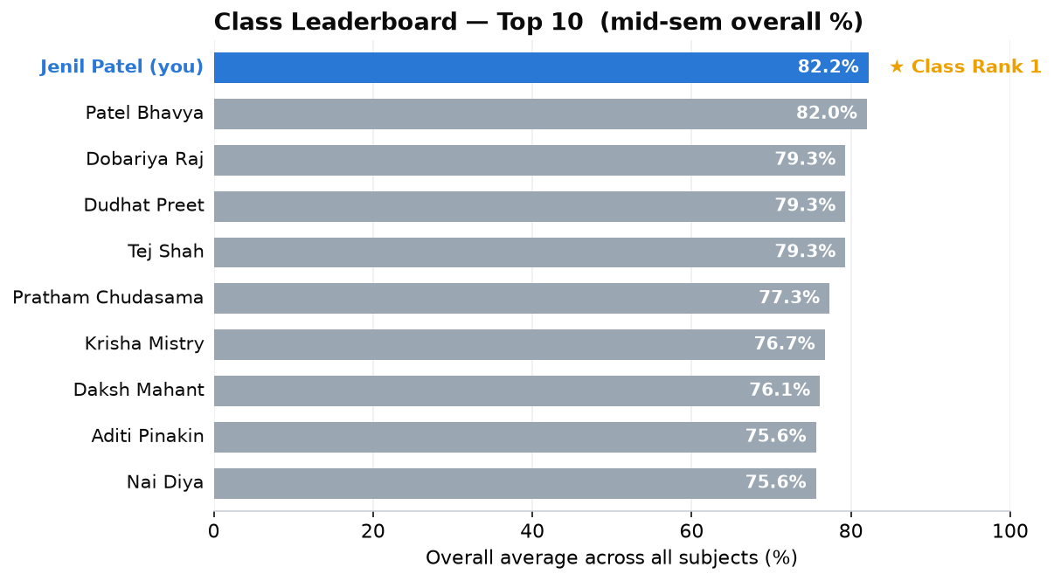
Overall class standing — you lead the class at 82.2%.
You are #1, just ahead of Patel Bhavya (82.0%). The next three — Dobariya Raj, Dudhat Preet and Tej Shah — are tied at 79.3%.
3. Subject Toppers
The highest scorer(s) in each subject:
Subject | Topper(s) | Mark
MS | Krupa Mehta, Nai Diya, Divya Gurnani | 27
AM | Jenil Patel (you) & Tej Shah | 26
MPMC | Jenil Patel (you) | 28
MV | Dudhat Preet | 29
DM | Patel Bhavya | 26
FLGP | Dobariya Raj | 29

You are the only student to top two subjects (AM and MPMC).
4. You vs the Class Average
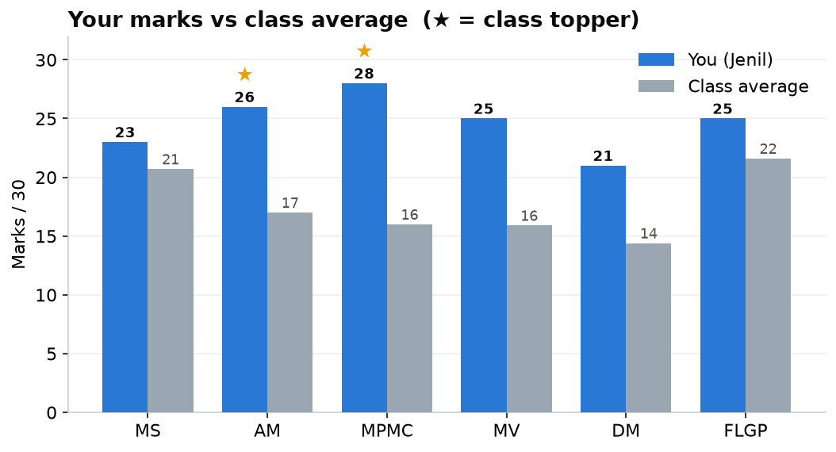
Your mark (blue) against the class average (grey) in every subject.
The gap is largest in MPMC (+12) and AM (+9) — the two you topped — and you stay clearly ahead even in the hardest papers (MV and DM, where the class average was lowest).
5. Your Friends’ Results
Student | MS | AM | MPMC | MV | DM | FLGP | Overall
Jenil (you) | 23 | 26 | 28 | 25 | 21 | 25 | 82.2%
Navya | 26 | 23 | 17 | 19 | 12 | 27 | 68.9%
Krushna | 25 | 21 | 20 | 12 | 17 | — | 63.3%
Hardh | 23 | 17 | 18 | 12 | 5 | 20 | 52.8%
Prashant | — | 12 | 16 | 15 | 12 | 16 | 47.3%
Nikhil | — | 16 | 12 | 12 | 7 | 8 | 36.7%
Class avg | 21 | 17 | 16 | 16 | 14 | 22 | —

- Navya (68.9%) is 2nd in your group — strongest in MS and FLGP.
- Krushna & Hardh both struggled in MV (12); Hardh also had a very low DM (5).
- Nikhil (36.7%) needs the most help — low in DM (7) and FLGP (8).
6. Quick Takeaways
- DM (14.4) and MV (15.9) were the hardest papers for the whole class — low marks there are partly the paper, not the student.
- MS and FLGP were the most scoring (class avg ~21) — easy marks to grab.
- You: an outstanding all-round result — class rank 1 with no weak subject. Keep the same preparation.
- For the group: extra practice in DM and MV (the tough application papers) would help everyone the most.

All numbers are taken directly from the six official mid-sem result sheets. Marks are out of 30; overall % is the average across the subjects each student appeared for.

