Template Matching for Object Detection
Locating an Object in an Image using Normalized Cross-Correlation in MATLAB
1. Aim
To detect and locate a known object (a template) inside a larger scene image in MATLAB using Normalized Cross-Correlation (NCC), and to test how well the method works when the scene brightness, noise and object size are changed.
2. Introduction
A very common machine-vision task is to answer the question "where is this object in the image?" — for example, finding a particular part on a conveyor belt, locating an eye in a face, or tracking an object from frame to frame.
Template matching is the simplest way to do this. A small picture of the object (the template) is slid over every position of the scene, and at each position a similarity score is computed. The position with the highest score is where the object is. This is an important topic of object detection and recognition in the Machine Vision syllabus.
Template matching is used in industrial inspection, robot guidance, face and part localisation and visual tracking, so this work links to SDG 9 (Industry, Innovation and Infrastructure).
3. Theory
3.1 The Template-Matching Idea
The template t is placed at every possible position (u,v) on the scene f, and a measure of how well the template matches the image patch underneath it is calculated. Doing this for all positions produces a similarity map (correlation surface); its highest peak marks the best match.
3.2 Normalized Cross-Correlation (NCC)
A plain sum-of-products correlation fails when the scene is brighter or darker than the template. Normalized cross-correlation fixes this by subtracting the mean and dividing by the standard deviation of each patch, which makes the score independent of overall brightness and contrast:
γ(u,v) = Σ (f − f̄)(t − t̄) / √[ Σ(f − f̄)² · Σ(t − t̄)² ]
The NCC value γ always lies between −1 and +1: a value near +1 means a very strong match, 0 means no relation, and −1 means the patch is the exact opposite of the template. In MATLAB this whole operation is one function, normxcorr2.
3.3 Finding the Match
After the NCC surface is computed, the location of its peak gives the position of the best match. (In MATLAB the surface is larger than the scene, so the peak position is shifted by the template size and must be corrected to get the real top-left corner in the scene.) If several copies of the object are present, every peak above a threshold marks one object.
3.4 Robustness and Limitations
Because NCC removes the effect of brightness and contrast, it is robust to lighting changes and to a reasonable amount of noise. Its main weakness is that the template is a fixed picture, so NCC is sensitive to changes in the object’s size (scale) and rotation — if the object appears larger, smaller or rotated, the match becomes weak or wrong. This is tested in the results below.
4. Methodology
Implemented in MATLAB using the Image Processing Toolbox function normxcorr2. The steps are:
1. Read the scene image and the template, and convert both to grayscale.
2. Compute the NCC surface of the template over the scene with normxcorr2.
3. Find the peak of the surface — this gives the match location and the peak NCC score.
4. Correct the peak position for the template size and draw a box on the detected object.
5. Repeat the match on brightened, noisy and scaled versions to test robustness.
Data flow: Scene + Template → NCC surface (normxcorr2) → find peak → correct position → draw detection box → robustness tests.
5. MATLAB Code
normxcorr2 returns the full correlation surface; its peak gives the match. The peak lies at the bottom-right corner of the template, so the top-left corner in the scene is found by subtracting the template size. Keep scene.png and template.png in the same folder (or crop the template from the scene as shown).
%% Template Matching for Object Detection (Normalized Cross-Correlation)

clc; clear; close all;

% STEP 1 - Read the scene and the template (grayscale)
scene = imread('scene.png');
if size(scene,3) == 3, scene = rgb2gray(scene); end

template = imread('template.png');
if size(template,3) == 3, template = rgb2gray(template); end
% (or crop it from the scene: template = scene(43:112, 38:107); )

% STEP 2 - Normalized cross-correlation surface
C = normxcorr2(template, scene);

% STEP 3 - Find the peak (best match) of the surface
[peak, idx] = max(C(:));
[yp, xp] = ind2sub(size(C), idx);

% STEP 4 - Correct for template size -> top-left corner in the scene
[th, tw] = size(template);
yoff = yp - th + 1;
xoff = xp - tw + 1;
fprintf('Peak NCC = %.3f at row %d, col %d\n', peak, yoff, xoff);

% Draw the detected object on the scene
figure; imshow(scene); hold on;
rectangle('Position', [xoff yoff tw th], 'EdgeColor','g', 'LineWidth',2);
title(sprintf('Detected match, NCC = %.2f', peak));

% Show the correlation surface
figure; surf(C); shading interp; colormap(jet);
title('Normalized Cross-Correlation Surface');
6. Scene and Template
Figure 1 shows the scene (a tray of coins) and the template — a single coin cut out of the scene. The goal is to find where this template coin lies in the scene.
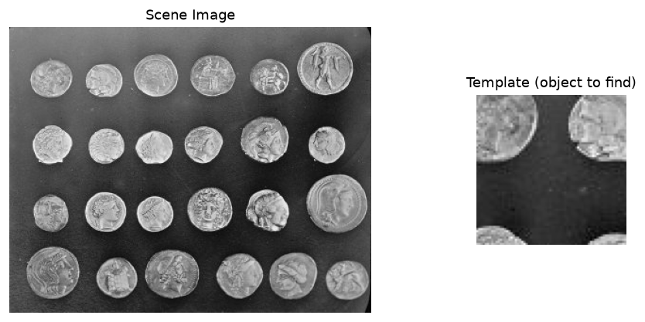
Figure 1: The scene image (left) and the template object to be located (right).
7. Results and Output Images
Figure 2 shows the NCC surface and the detected match. The surface has a bright peak at every coin (because all coins are similar) and its highest peak (marked +) is at the template coin; the green box shows the detected object with a peak NCC of 1.00. Figure 3 shows that the match is still correct when the scene is brightened or made noisy — the box stays on the right coin and the NCC stays high (0.99 and 0.91).
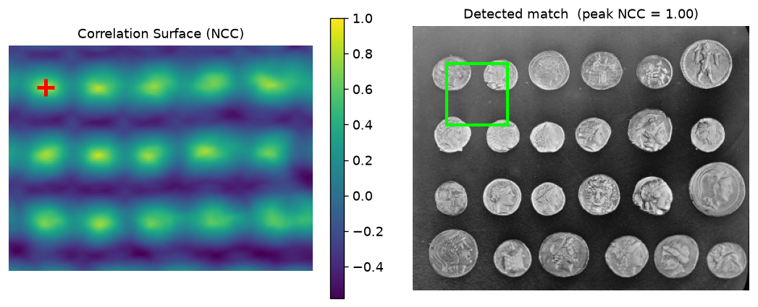
Figure 2: NCC correlation surface with its peak (left) and the detected object boxed on the scene (right).
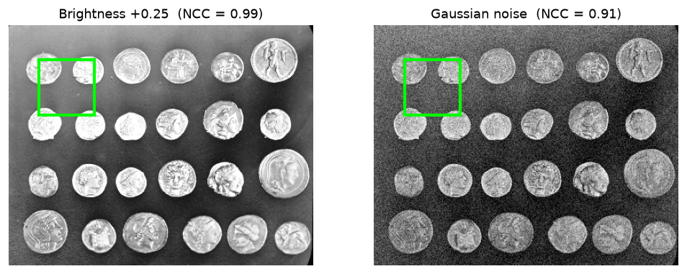
Figure 3: The match stays correct under a brightness increase and added noise (NCC remains high).
8. Quantitative Results
The table lists the peak NCC score and whether the object was located correctly under four conditions.
Condition | Peak NCC | Object Located Correctly?
Original scene | 1.000 | Yes
Brightness increased (+25%) | 0.995 | Yes — NCC is brightness-invariant
Gaussian noise added | 0.908 | Yes — robust to moderate noise
Template scaled 1.3× (size change) | 0.696 | No — wrong location (scale limitation)

9. Result Analysis
- On the original scene the peak NCC was 1.00 at the correct location, because the template was an exact copy of that coin.
- When the scene was brightened the NCC was still 0.995 and the location was unchanged — this proves NCC is independent of overall brightness, which is its biggest advantage over plain correlation.
- With added noise the NCC dropped only to 0.908 and the object was still found correctly, showing good noise robustness.
- When the template was scaled by 1.3× the NCC fell to 0.696 and the match jumped to the wrong coin — confirming that template matching is sensitive to size (scale) changes.
So NCC template matching is accurate and robust to lighting and noise, but it only works well when the object appears at roughly the same size and orientation as the template. For large scale or rotation changes, a multi-scale search or feature-based methods (e.g. SIFT/SURF) are needed.
10. Advantages and Limitations
Aspect | Details
Advantages | Simple and easy to implement; one function (normxcorr2); score is easy to interpret (−1 to +1); robust to brightness, contrast and moderate noise.
Limitations | Sensitive to scale and rotation; slow for large images (checks every position); one template finds only one appearance of the object.

11. Applications
Template matching is used for part detection and alignment in industrial inspection, eye/face feature location, object tracking in video, character/number matching in OCR and number-plate reading, stereo matching for depth, and landmark detection in medical images — wherever a known pattern must be found in an image.
12. Conclusion
An object-detection system was implemented in MATLAB using Normalized Cross-Correlation template matching. The template was located in the scene with a peak NCC of 1.00, and the method stayed correct under brightness changes (NCC 0.99) and added noise (NCC 0.91), confirming its robustness to lighting and noise. However, scaling the template by 1.3× dropped the score to 0.70 and gave a wrong match, confirming that template matching is sensitive to scale and rotation. NCC template matching is therefore a simple and reliable method when the object size and orientation are known. The project meets CO-1 and CO-4 and supports SDG 9 (Industry, Innovation and Infrastructure).
13. Course Outcome and SDG Mapping
CO / SDG | How this project addresses it
CO-1 | Implements an object-detection algorithm (template matching) in MATLAB.
CO-4 | Uses the mathematical basis of correlation / normalized cross-correlation for matching.
SDG 9 | Supports industry and automation — object detection is used in inspection, robotics and tracking.

14. References
[1] R. C. Gonzalez and R. E. Woods, Digital Image Processing, Addison-Wesley.
[2] J. P. Lewis, "Fast Normalized Cross-Correlation," Vision Interface, 1995.
[3] R. Szeliski, Computer Vision: Algorithms and Applications, Springer.
[4] MATLAB Documentation — Image Processing Toolbox: normxcorr2, rgb2gray, ind2sub.

