Medical Image Enhancement using Histogram-Based Techniques
Histogram Equalization, Contrast Stretching and CLAHE in MATLAB
1. Aim
To enhance a low-contrast medical image in MATLAB using three histogram-based techniques — Histogram Equalization, Contrast Stretching and CLAHE — and to compare their results using contrast and detail measures.
2. Introduction
Medical images (X-ray, MRI, CT, ultrasound, retinal fundus) are often low in contrast because of the imaging conditions or poor lighting. Low contrast hides the fine details a doctor needs for a correct diagnosis.
Image enhancement improves the visibility of these details. It adds no new information to the image — it only re-arranges the existing brightness values so features stand out. This project uses histogram-based enhancement, a core topic of Unit 3 (Spatial-Domain Image Enhancement).
The test image is a retinal fundus image (the inside back wall of the eye), used to detect diseases such as diabetic retinopathy and glaucoma. Clearer images support earlier diagnosis, linking this work to SDG 3 (Good Health and Well-being).
3. Theory of the Methods
3.1 Histogram
A histogram shows how many pixels have each gray level (0 = black, 255 = white). In a low-contrast image the pixels are bunched into a narrow band, so the image looks dull. Enhancement works by spreading these values over a wider range.
3.2 Histogram Equalization (HE)
HE spreads the gray levels to use the full 0–255 range, using the cumulative histogram. The output level for each input level is:
sₖ = (L − 1) × Σ j=0…k nⱼ / (M × N)
where sₖ = new level, L = number of levels (256), M × N = total pixels, nⱼ = pixels at level j. It gives a strong automatic contrast boost, but — applied to the whole image at once — it can over-brighten flat areas and amplify noise.
3.3 Contrast Stretching
A simpler method: it picks a low and high limit (here the darkest 1% and brightest 1% of pixels) and linearly stretches everything between them so the low limit becomes 0 and the high limit becomes 255. It keeps the image natural, but one straight-line mapping cannot fix uneven lighting.
3.4 CLAHE (Contrast Limited Adaptive Histogram Equalization)
A local version of HE. It splits the image into small tiles (here 8 × 8) and equalizes each tile separately, so contrast improves in every region even under uneven lighting. A clip limit caps how much any level is boosted, preventing noise amplification; the tiles are then blended smoothly. This makes CLAHE the preferred choice for medical images.
4. Methodology
Implemented in MATLAB using the Image Processing Toolbox. The steps are:
- Read the input image and convert it to grayscale.
- Apply the three methods: histeq, imadjust with stretchlim, and adapthisteq.
- Display the four images (original + three results) side by side.
- Display the histogram of each image.
- Measure each result using mean, standard deviation (contrast) and entropy (detail), then compare.
Data flow: Input image → Grayscale → Three enhancement methods → Display + Histograms → Quality measures → Comparison.
5. MATLAB Code
The script stores the four images in one list and uses short loops for display and for the quality measures, so the three methods are handled in exactly the same way. Keep medical_test.png in the same folder as the script.
%% Medical Image Enhancement using Histogram-Based Techniques
% Methods : Histogram Equalization, Contrast Stretching, CLAHE
% Input : medical_test.png (any grayscale X-ray / MRI / fundus image)

clc; clear; close all;

% STEP 1 - Read the image and make sure it is grayscale
I = imread('medical_test.png');
if size(I,3) == 3 % a colour image has 3 channels (R,G,B)
I = rgb2gray(I); % enhancement works on one gray channel
end

% STEP 2 - Apply the three enhancement methods
HE = histeq(I); % global equalization
Stretch = imadjust(I, stretchlim(I,[0.01 0.99]), []); % linear stretch
CLAHE = adapthisteq(I,'ClipLimit',0.02,'NumTiles',[8 8]); % local, clipped

% Keep the images and their names together so one loop handles all four
images = {I, HE, Stretch, CLAHE};
labels = {'Original','Histogram Equalization','Contrast Stretching','CLAHE'};

% STEP 3 - Show the images and their histograms
figure('Name','Enhanced Images');
for k = 1:4
subplot(2,2,k); imshow(images{k}); title(labels{k});
end

figure('Name','Histograms');
for k = 1:4
subplot(2,2,k); imhist(images{k}); title(labels{k});
end

% STEP 4 - Quality measures: std-dev = contrast, entropy = detail
fprintf('%-24s %8s %8s %9s\n','Image','Mean','StdDev','Entropy');
fprintf('%s\n', repmat('-',1,51));
for k = 1:4
img = images{k};
fprintf('%-24s %8.2f %8.2f %9.3f\n', ...
labels{k}, mean2(img), std2(img), entropy(img));
end
fprintf('\nHigher StdDev = more contrast. Higher Entropy = more detail.\n');
6. Test Image
Figure 1 shows the input image and its histogram. The pixels are crowded into a narrow band (about levels 50–100), with a tall spike near level 30 for the dark background — this narrow spread is what makes the image low in contrast.
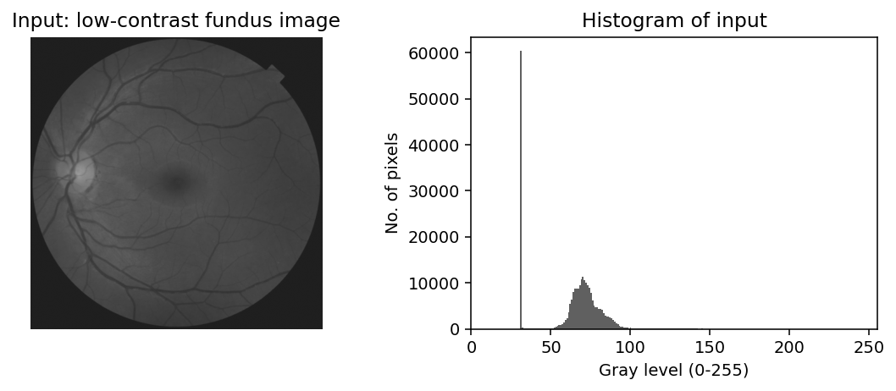
Figure 1: Low-contrast retinal fundus test image (left) and its histogram (right).
7. Results and Output Images
Figure 2 shows the original with the three enhanced results; Figure 3 shows how each histogram changed. In the enhanced images the blood vessels, optic disc (bright spot) and macula (dark central region) are far clearer than in the original.
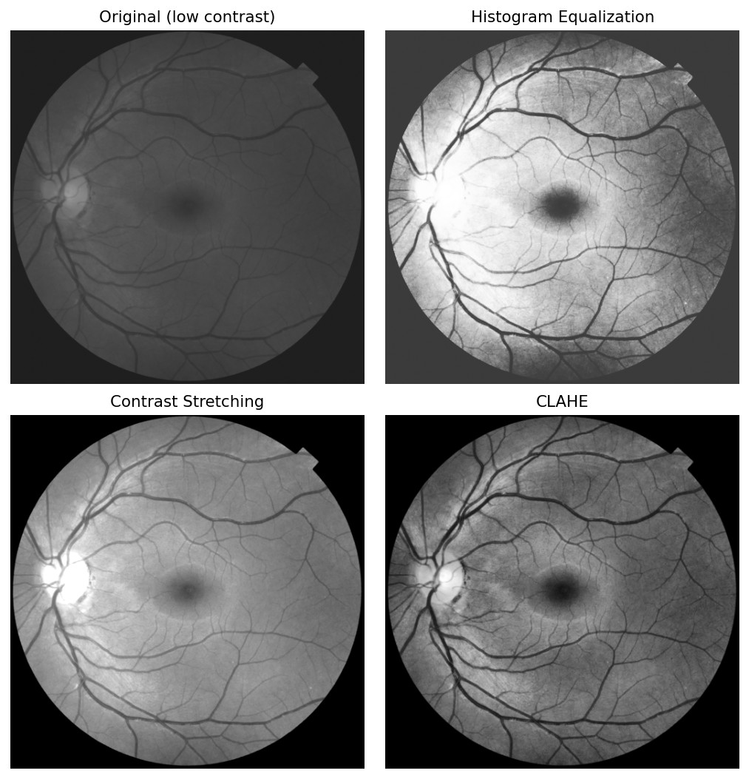
Figure 2: Original image and the three enhanced results.
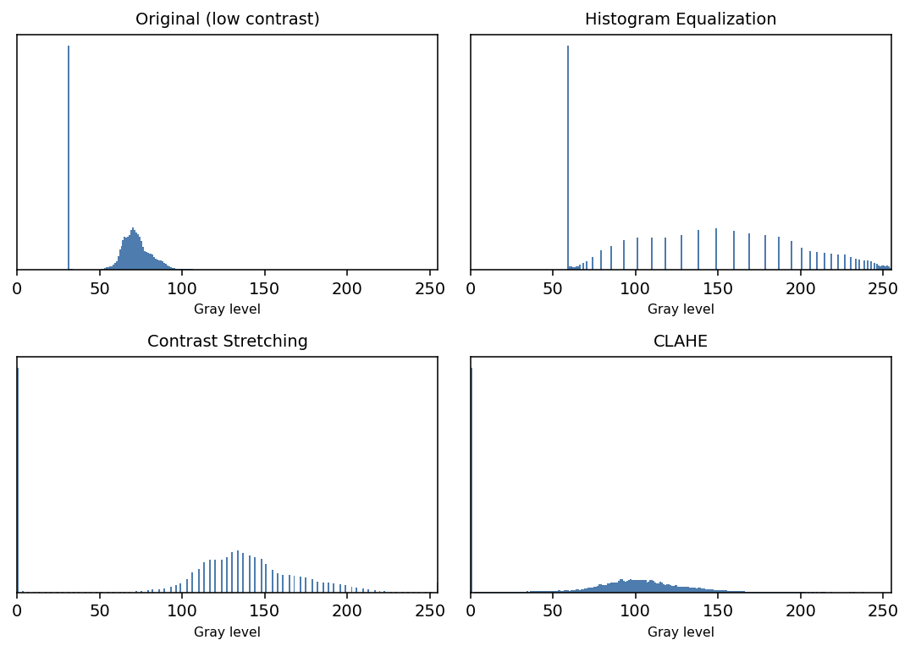
Figure 3: Histograms of the original and the three enhanced images — enhancement spreads the gray levels over a wider range.
8. Quantitative Results
Standard deviation indicates contrast (higher = more contrast); entropy indicates detail (higher = more information revealed).
Image | Mean | Std Dev (Contrast) | Entropy (Detail)
Original (low contrast) | 63.08 | 19.90 | 4.808
Histogram Equalization | 136.91 | 65.10 | 4.700
Contrast Stretching | 109.61 | 66.83 | 4.754
CLAHE | 79.41 | 50.97 | 6.094

9. Result Analysis
All three methods raised the contrast of the original image (std-dev only 19.90):
- Histogram Equalization gave the highest contrast (65.10) but brightened the background and looked slightly noisy, because it works on the whole image at once.
- Contrast Stretching gave similar contrast (66.83) and kept the image natural, but cannot correct uneven lighting.
- CLAHE gave the highest entropy (6.094 vs 4.808 for the original) — it revealed the most detail while staying natural; its contrast (50.97) is moderate but local.
For medical images the detail that can be seen (entropy) matters more than a single global contrast value. CLAHE scored highest on entropy and preserved local detail without over-amplifying the background, so it is the best method here.
10. Advantages and Limitations
Method | Advantage | Limitation
Histogram Equalization | Strong, automatic contrast boost | Can over-brighten and amplify noise
Contrast Stretching | Simple; keeps a natural look | Cannot fix uneven lighting
CLAHE | Best local detail; limits noise | Slower; needs tile and clip settings

11. Applications
Histogram-based enhancement is used in medical imaging (X-ray, MRI, CT, ultrasound, retinal, microscopy), satellite and remote sensing, underwater imaging, security and surveillance, and industrial quality inspection — wherever images are captured in poor or uneven lighting.
12. Conclusion
Three histogram-based enhancement techniques were implemented in MATLAB and tested on a low-contrast retinal fundus image. All three improved the image: HE gave the highest overall contrast, Contrast Stretching gave a clean, natural result, and CLAHE revealed the most detail while staying natural. CLAHE is therefore the most suitable for medical image enhancement. The project meets CO-1, CO-2 and CO-4 and supports SDG 3.
13. Course Outcome and SDG Mapping
CO / SDG | How this project addresses it
CO-1 | Enhances a digital image using various algorithms written in MATLAB.
CO-2 | Applies image processing to the medical field (retinal / diagnostic imaging).
CO-4 | Uses the mathematical basis of histogram equalization and enhancement filters.
SDG 3 | Supports good health and well-being through clearer medical images for diagnosis.

14. References
[1] R. C. Gonzalez and R. E. Woods, Digital Image Processing, Addison-Wesley.
[2] R. C. Gonzalez, R. E. Woods and S. L. Eddins, Digital Image Processing Using MATLAB, Addison-Wesley.
[3] A. K. Jain, Fundamentals of Digital Image Processing, Prentice-Hall of India.
[4] MATLAB Documentation — Image Processing Toolbox: histeq, imadjust, stretchlim, adapthisteq.

