<https://foodprint.org/issues/the-problem-of-food-waste/>

<https://www.financialexpress.com/economy/india-wastes-up-to-16-of-its-agricultural-produce-fruits-vegetables-squandered-the-most/1661671/>

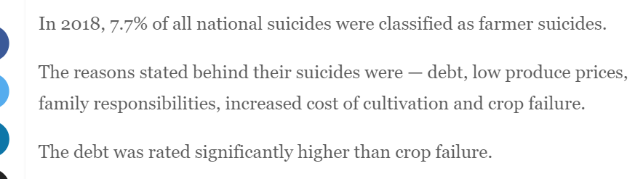

<https://timesofindia.indiatimes.com/readersblog/findustry-insights/farmer-suicides-in-india-26499/>

Research Paper and works

<https://www.researchgate.net/publication/349076060_A_study_of_farmer_suicide_in_Maharashtra_problems_and_Measures>

<https://ideas.repec.org/p/pra/mprapa/35675.html>