INDIVIDUAL PRESENTATION SUBMISSION FORM
INSTRUCTIONS
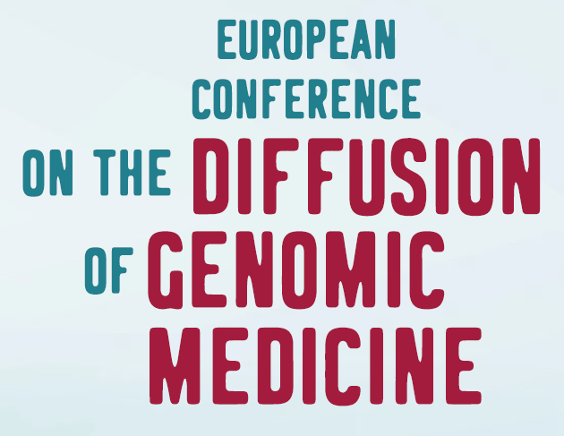
This form should remain anonymous to guarantee the neutrality of the reviewing. Identical submissions from different first authors will be automatically rejected. Submissions must be written in English and in a straightforward style. All fields in grey in the form should be completed. No changes will be accepted after the submission of documents. Figures and tables are not accepted in this form. Please do not add acknowledgements to your original submission because it will help identify authors. Remember to rename your document with the title of your abstract before uploading it to the online platform on the conference website. Non-compliance of these instructions may lead to rejection of your submission.
THEME OF THE PRESENTATION
Please, select the topic category of your individual presentation:

TITLE AND DESCRIPTION OF THE INDIVIDUAL PRESENTATION
Please, give a name to your presentation: My DNA, everybody's business? A citizen forum on the use of genomic information in society and give an abstract:
The aims of precision genomics are ambitious: successful deployment of the genome for preventive and medical purposes requires the development of large representative datasets including health and environmental information of the individuals over a life-course period. However, genomic data are personal and sensitive data, the use of which generally requires informed consent. A positive or negative attitude towards genomics will determine the societal support for the implementation of genomic technologies and individual willingness to participate in genomic screening, research and care. Every individual is a billionaire in genomic data and the maximal aggregator of their personal data. Therefore, it is important to understand how genomics is perceived in society and which norms and values are developed by citizens regarding the governance of genomic data. First, we organised an issue framing workshop where experts in the field formulated the questions they wanted citizens to answer. Subsequently, a panel of 32 citizens, informed by a neutral information package and experts of different backgrounds, debated and reflected in-depth during three weekends with the final aim of producing policy recommendations. These recommendations were presented by the citizens in person to the Secretary of public health on the final day of the forum. Finally, a stakeholder workshop was organised to translate the citizens’ proposals into practical policy outputs. The main conclusion of the citizen forum was that all citizens recognized the potential benefit of genomics for society in general and health care specifically. For this common good, they showed great willingness to share data and participate in genomic medicine. However, from their point of view, volunteering genomic information requires a great deal of trust. The only way to foster this trust is to ensure that a strict legal framework is in place. This framework should protect them from genetic discrimination and violations of their rights to privacy, autonomy and an open future. The best way to develop this framework is in a true partnership with both relevant stakeholders (patients, health professionals, policy makers, industry, …) and the public at large.
KEYWORDS
3 max. public engagement, data sharing, ethics

