Dataset Strategy for SSD Drive Structure Analysis
Priya Pooja Hariharan
Colorado State University Global
Course Code: 25WA-MIS581-1
Orenthio Goodwin
November 23, 2025

Overview of the Dataset Strategy for SSD Drive Analysis

In this capstone project, the dataset is designed to capture both synthetic and real-world SSD benchmark information to support performance and reliability analysis. The primary data consists of researcher-generated SMART logs created through Python scripting, incorporating randomized error injection to simulate fault conditions. These logs include both qualitative variables, such as firmware revision observations and anomaly detection, and quantitative variables, such as temperature thresholds, power cycles, and error counts. Complementing this, secondary data is drawn from internal enterprise SSD deployments and external sources like vendor documentation, technical whitepapers, and published performance benchmarks. By distinguishing between these two categories of data, the project ensures both experimental reproducibility and contextual grounding in industry standards. Together, these structured datasets provide a comprehensive foundation for evaluating SSD behavior under stress, enabling reproducible experimentation and informed analysis aligned with the organization’s problem statement on predictive diagnostics and reliability.
There are two types of variables Qualitative and Quantitative variables: Qualitative variables are descriptive, non-numeric observations. In the SSD drive dataset, include firmware revision notes, anomaly detection patterns, or log parsing behaviors. They provide context and help interpret system behavior beyond raw numbers. The Quantitative variables are measurable, numeric valuesand the variables include temperature thresholds, power cycle counts, and error counts. They allow statistical analysis, trend identification, and predictive modeling.

Dataset Construction via SMART Error Injection Framework.
The dataset generation process for this capstone project involves simulating SSD benchmark logs using synthetic SMART data (Figure 2 below) enriched with randomized error injection. The Python-based generator script (Python code 1 below) creates realistic log files by combining predefined endurance profiles for various SSD capacities (e.g., 3T2, 6T4, 60T) with randomized operational metrics such as power-on hours, temperature readings, read/write throughput, and command counts. Each profile defines ranges for key performance indicators like petabytes read/written, controller busy time, and spare block thresholds, ensuring variability across synthetic devices. When the --inject-errors flag is enabled, the script probabilistically introduces fault conditions such as media errors, critical warnings, and thermal anomalies to emulate real-world failure scenarios. These injected variables like critical_warning, media_errors, and error_log_entries are essential for testing diagnostic tools and reliability models. The resulting dataset includes both quantitative variables (e.g., temperature, power cycles, percentage used) and binary or categorical flags (e.g., firmware version, form factor, error codes), enabling comprehensive analysis of SSD behavior under controlled stress conditions. This synthetic approach ensures reproducibility, scalability, and alignment with the project’s goal of evaluating SSD reliability and performance through structured, fault-aware benchmarking.
These variables (Figure 1 below) span multiple data types of nominals (e.g., firmware version), binary (e.g., critical warning flags), and ratio (e.g., power cycles, data units written) allowing for comprehensive analysis of SSD behavior. By combining structured randomness with domain-specific constraints, the dataset supports reproducible benchmarking, fault modeling, and performance evaluation aligned with the project’s goal of improving SSD reliability and diagnostics.
Figure 1: Summary of Synthetic Data from SMART file
Variable | Type | Purpose
Model Number, Firmware | Nominal | Device identity
Total NVM Capacity | Ratio | Storage size
Temperature | Ratio | Thermal health
Data Units Read/Written | Ratio | Workload profile
Host Commands | Ratio | I/O activity
Power Cycles, Power Hours | Ratio | Usage history
Percentage Used | Ratio | Wear level
Available Spare | Ratio | Remaining endurance
Unsafe Shutdowns | Ratio | Reliability risk
Media Errors, Error Logs | Ratio | Fault indicators
Critical Warning | Binary/Nominal | SMART alert flags
Power States | Ratio | Energy modeling
Namespace Features | Nominal | Capability flags

Figure 2: Smart log sample for dataset generation.
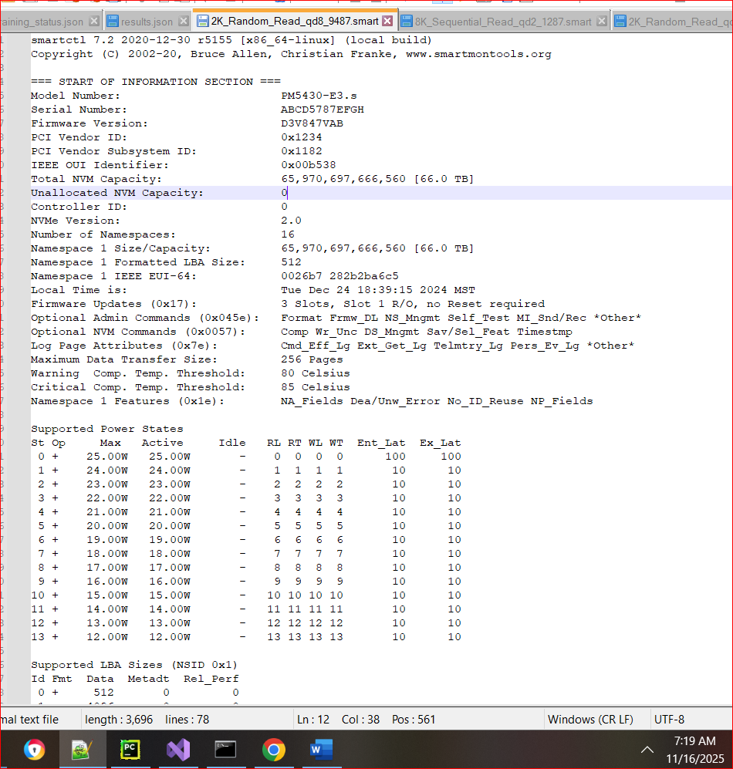

Python code 1: Python code for the data values pulled into CSV from SMART logs.
import os
import random
import argparse
from pathlib import Path
from multiprocessing import Pool, cpu_count
from tqdm import tqdm

# ========== CLI ARGUMENT PARSING ==========
def parse_args():
parser = argparse.ArgumentParser(description="SSD NVMe benchmark log generator")
parser.add_argument('--inject-errors', action='store_true', help='Enable random error injection in generated logs')
parser.add_argument('--num-files', type=int, default=100, help='Number of files per drive per type')
return parser.parse_args()

args = parse_args()
INJECT_ERRORS = args.inject_errors
file_count_per_type = args.num_files

# ========== CONSTANTS ==========
drive_form_factors = ['E3.s', 'U.2']
drive_capacities = ['3T2', '3T8', '6T4', '12T5', '15T', '25T', '60T', '7T6', '1T7']
read_types = ['Random_Read', 'Sequential_Read']
block_sizes = ['512K','2K', '4K', '8K', '16K', '32K', '64K', '128K']
queue_depths = [1, 2, 4, 8, 16, 32]
file_extensions = ['.smart', '.smart.nvme']
root_dir = Path('SSD_Drive_Structure')

# ========== CAPACITY PROFILES ==========
endurance_profiles = {
'1T7': {'read_pb': (3.8, 4.1), 'power_hours': (500, 1000), 'busy_time': (20000, 30000), 'temp_thresh': (70, 75), 'host_cmds': (2e11, 3e11), 'spare_thresh': 9},
'3T2': {'read_pb': (4.0, 4.3), 'power_hours': (1000, 1500), 'busy_time': (25000, 35000), 'temp_thresh': (72, 77), 'host_cmds': (2.5e11, 3.5e11), 'spare_thresh': 9},
'3T8': {'read_pb': (4.2, 4.6), 'power_hours': (1200, 1600), 'busy_time': (28000, 38000), 'temp_thresh': (73, 78), 'host_cmds': (3e11, 4e11), 'spare_thresh': 9},
'6T4': {'read_pb': (4.5, 5.0), 'power_hours': (1500, 2000), 'busy_time': (32000, 42000), 'temp_thresh': (75, 80), 'host_cmds': (3.5e11, 4.5e11), 'spare_thresh': 8},
'7T6': {'read_pb': (4.7, 5.2), 'power_hours': (1700, 2200), 'busy_time': (35000, 45000), 'temp_thresh': (76, 81), 'host_cmds': (4e11, 5e11), 'spare_thresh': 8},
'12T5': {'read_pb': (5.0, 5.4), 'power_hours': (2000, 2600), 'busy_time': (40000, 50000), 'temp_thresh': (77, 82), 'host_cmds': (4.5e11, 5.5e11), 'spare_thresh': 8},
'15T': {'read_pb': (5.2, 5.6), 'power_hours': (2400, 3000), 'busy_time': (45000, 55000), 'temp_thresh': (78, 83), 'host_cmds': (5e11, 6e11), 'spare_thresh': 7},
'25T': {'read_pb': (5.4, 5.8), 'power_hours': (2600, 3200), 'busy_time': (50000, 60000), 'temp_thresh': (79, 84), 'host_cmds': (5.5e11, 6.5e11), 'spare_thresh': 7},
'60T': {'read_pb': (5.8, 6.3), 'power_hours': (3000, 4000), 'busy_time': (55000, 65000), 'temp_thresh': (80, 85), 'host_cmds': (6e11, 7e11), 'spare_thresh': 6},
}

def get_capacity_bytes(cap):
cap_map = {
'1T7': (1.7 * 1024**4),
'3T2': (3.2 * 1024**4),
'3T8': (3.8 * 1024**4),
'6T4': (6.4 * 1024**4),
'7T6': (7.6 * 1024**4),
'12T5': (12.5 * 1024**4),
'15T': (15 * 1024**4),
'25T': (25 * 1024**4),
'60T': (60 * 1024**4),
}
return int(cap_map.get(cap, 3.2 * 1024**4))

def capacity_str(cap_bytes):
tb = cap_bytes / 1e12
if tb < 10:
return f"{tb:.2f} TB"
return f"{tb:.1f} TB"

def inject_errors():
if not INJECT_ERRORS or random.random() > 0.15:
return {'critical_warning': '0x00', 'media_errors': 0, 'error_log_entries': 0, 'temp_warning_time': 0, 'critical_temp_time': 0}
return {
'critical_warning': random.choice(['0x01', '0x02', '0x04']),
'media_errors': random.randint(1, 5),
'error_log_entries': random.randint(10, 100),
'temp_warning_time': random.randint(5, 30),
'critical_temp_time': random.randint(1, 10)
}

def sample_profile(cap):
p = endurance_profiles.get(cap)
read_pb = round(random.uniform(*p['read_pb']), 2)
write_pb = round(read_pb + random.uniform(0.2, 0.5), 2)
power_hours = random.randint(*p['power_hours'])
busy_time = random.randint(*p['busy_time'])
temp_thresh = random.randint(*p['temp_thresh'])
host_reads = int(random.uniform(*p['host_cmds']))
host_writes = int(host_reads * random.uniform(0.8, 1.1))
spare_thresh = p['spare_thresh']
return read_pb, write_pb, power_hours, busy_time, temp_thresh, host_reads, host_writes, spare_thresh

def generate_model_number():
"""Randomly generate a model number ending with E3.s or U.2"""
prefix = random.choice(['XG', 'PM', 'MT', 'NV'])
digits = f"{random.randint(1000,9999)}"
suffix = random.choice(['E3.s', 'U.2'])
return f"{prefix}{digits}-{suffix}"

def generate_smartctl_smart(capacity):
profile = endurance_profiles.get(capacity, endurance_profiles['3T2'])
cap_bytes = get_capacity_bytes(capacity)
readable_cap = capacity_str(cap_bytes)
temps = [random.randint(38, 64) for _ in range(3)]
local_time = f"Tue Dec 24 18:{random.randint(10,59)}:{random.randint(10,59)} 2024 MST"
power_cycles = random.randint(3, 15)
power_on_hours = random.randint(*profile['power_hours'])
busy_time = random.randint(*profile['busy_time'])
read_pb = round(random.uniform(*profile['read_pb']), 2)
write_pb = round(read_pb + random.uniform(0.2, 0.5), 2)
read_units = int(read_pb * 2e9)
write_units = int(write_pb * 2e9)
host_read_cmds = int(random.uniform(*profile['host_cmds']))
host_write_cmds = int(host_read_cmds * random.uniform(0.8, 1.1))
percentage_used = random.randint(5, 15)
available_spare = 100
unsafe_shutdowns = random.randint(0, 5)
temp_thresh = profile['temp_thresh']
spare_thresh = profile['spare_thresh']

return f"""smartctl 7.2 2020-12-30 r5155 [x86_64-linux] (local build)
Copyright (C) 2002-20, Bruce Allen, Christian Franke, www.smartmontools.org

=== START OF INFORMATION SECTION ===
Model Number: {generate_model_number()}
Serial Number: ABCD{random.randint(1000,9999)}EFGH
Firmware Version: D3V{random.randint(100,999)}VAB
PCI Vendor ID: 0x1234
PCI Vendor Subsystem ID: 0x1182
IEEE OUI Identifier: 0x00b538
Total NVM Capacity: {cap_bytes:,d} [{readable_cap}]
Unallocated NVM Capacity: 0
Controller ID: 0
NVMe Version: 2.0
Number of Namespaces: 16
Namespace 1 Size/Capacity: {cap_bytes:,d} [{readable_cap}]
Namespace 1 Formatted LBA Size: 512
Namespace 1 IEEE EUI-64: 0026b7 282b2ba6c5
Local Time is: {local_time}
Firmware Updates (0x17): 3 Slots, Slot 1 R/O, no Reset required
Optional Admin Commands (0x045e): Format Frmw_DL NS_Mngmt Self_Test MI_Snd/Rec *Other*
Optional NVM Commands (0x0057): Comp Wr_Unc DS_Mngmt Sav/Sel_Feat Timestmp
Log Page Attributes (0x7e): Cmd_Eff_Lg Ext_Get_Lg Telmtry_Lg Pers_Ev_Lg *Other*
Maximum Data Transfer Size: 256 Pages
Warning Comp. Temp. Threshold: {temp_thresh[0]} Celsius
Critical Comp. Temp. Threshold: {temp_thresh[1]} Celsius
Namespace 1 Features (0x1e): NA_Fields Dea/Unw_Error No_ID_Reuse NP_Fields

Supported Power States
St Op Max Active Idle RL RT WL WT Ent_Lat Ex_Lat
0 + 25.00W 25.00W - 0 0 0 0 100 100
1 + 24.00W 24.00W - 1 1 1 1 10 10
2 + 23.00W 23.00W - 2 2 2 2 10 10
3 + 22.00W 22.00W - 3 3 3 3 10 10
4 + 21.00W 21.00W - 4 4 4 4 10 10
5 + 20.00W 20.00W - 5 5 5 5 10 10
6 + 19.00W 19.00W - 6 6 6 6 10 10
7 + 18.00W 18.00W - 7 7 7 7 10 10
8 + 17.00W 17.00W - 8 8 8 8 10 10
9 + 16.00W 16.00W - 9 9 9 9 10 10
10 + 15.00W 15.00W - 10 10 10 10 10 10
11 + 14.00W 14.00W - 11 11 11 11 10 10
12 + 13.00W 13.00W - 12 12 12 12 10 10
13 + 12.00W 12.00W - 13 13 13 13 10 10

Supported LBA Sizes (NSID 0x1)
Id Fmt Data Metadt Rel_Perf
0 + 512 0 0
1 - 4096 0 0

=== START OF SMART DATA SECTION ===
SMART overall-health self-assessment test result: PASSED

SMART/Health Information (NVMe Log 0x02)
Critical Warning: 0x00
Temperature: {temps[0]} Celsius
Available Spare: {available_spare}%
Available Spare Threshold: {spare_thresh}%
Percentage Used: {percentage_used}%
Data Units Read: {read_units} [{read_pb:.2f} PB]
Data Units Written: {write_units} [{write_pb:.2f} PB]
Host Read Commands: {host_read_cmds}
Host Write Commands: {host_write_cmds}
Controller Busy Time: {busy_time}
Power Cycles: {power_cycles}
Power On Hours: {power_on_hours}
Unsafe Shutdowns: {unsafe_shutdowns}
Media and Data Integrity Errors: 0
Error Information Log Entries: 0
Warning Comp. Temperature Time: 0
Critical Comp. Temperature Time: 0
Temperature Sensor 1: {temps[0]} Celsius
Temperature Sensor 2: {temps[1]} Celsius
Temperature Sensor 3: {temps[2]} Celsius

Error Information (NVMe Log 0x01, 16 of 256 entries)
No Errors Logged
"""

def generate_nvme_content(cap):
t = [random.randint(40, 60) for _ in range(3)]
rpb, wpb, ph, bt, tt, hr, hw, st = sample_profile(cap)
ru = int(rpb * 2e9); wu = int(wpb * 2e9)
err = inject_errors()
return f"""Model Number: {generate_model_number()}
SMART/Health Information Log
critical_warning : {err['critical_warning']}
temperature : {t[0]} °C
available_spare : 100%
available_spare_threshold : {st}%
percentage_used : {random.randint(5, 15)}%
Data Units Read : {ru} ({rpb:.2f} PB)
Data Units Written : {wu} ({wpb:.2f} PB)
host_read_commands : {hr}
host_write_commands : {hw}
controller_busy_time : {bt}
power_on_hours : {ph}
media_errors : {err['media_errors']}
num_err_log_entries : {err['error_log_entries']}
Warning Temperature Time : {err['temp_warning_time']}
Critical Composite Temperature Time: {err['critical_temp_time']}
Temperature Sensor 1 : {t[0]} °C
Temperature Sensor 2 : {t[1]} °C
Temperature Sensor 3 : {t[2]} °C
"""

def get_generator(ext):
if ext == '.smart':
return lambda cap, *_: generate_smartctl_smart(cap)
elif ext == '.smart.nvme':
return lambda cap, *_: generate_nvme_content(cap)
else:
raise ValueError(f"Unknown extension: {ext}")

def create_task(args):
path, ext, cap, block_size, read_type, qd = args
path.parent.mkdir(parents=True, exist_ok=True)
generator = get_generator(ext)
with open(path, 'w') as f:
f.write(generator(cap, block_size, read_type, qd))

if __name__ == '__main__':
tasks = []
for form in drive_form_factors:
for cap in drive_capacities:
for _ in range(file_count_per_type):
block_size = random.choice(block_sizes)
read_type = random.choice(read_types)
qd = random.choice(queue_depths)
for ext in file_extensions:
file_index = random.randint(1, 9999)
file_name = f"{block_size}_{read_type}_qd{qd}_{file_index:04d}{ext}"
dir_path = root_dir / form / cap / read_type
tasks.append((dir_path / file_name, ext, cap, block_size, read_type, qd))
with Pool(cpu_count()) as pool:
list(tqdm(pool.imap_unordered(create_task, tasks), total=len(tasks), desc='Generating SSD logs'))
print("Log generation complete.")

Dataset Variable Breakdown:
The dataset comprises a rich collection of synthetic SMART log variables (Figure 3 below) designed to emulate SSD performance and reliability metrics under controlled and fault-injected conditions. Each variable serves a specific diagnostic or benchmarking purpose. For instance, temperature (integer, ratio) reflects the thermal state of the drive in Celsius, with sample values like 65°C, while firmware version (alphanumeric text) identifies the operational software layer influencing device behavior. Available spare percentage and percentage used (both integer, ratio) indicate wear-level and endurance thresholds, critical for predicting drive lifespan. Operational counters such as power cycles, power-on hours, and unsafe shutdowns (all integer, ratio) track usage history and reliability risks. Data throughput is captured via data units read/written and host read/write commands (integer, ratio), which quantify workload intensity. Categorical identifiers like model number, form factor, and NAND type (text, nominal) define the physical and architectural characteristics of each SSD. Binary and flag-type variables such as critical warning (hex flag) and media error count simulate fault conditions essential for stress testing and anomaly detection. Together, these variables provide a comprehensive, multi-dimensional view of SSD behavior, enabling reproducible benchmarking and predictive diagnostics aligned with the project’s goal of evaluating storage reliability through synthetic data modeling.
Figure 3: SSD drive dataset variables.
Variable Name | Data Type | Description | Sample Value
System Manufacturer | Text (Nominal) | Name of the system vendor or OEM | HPE
CPU Name | Text (Nominal) | CPU model identifier | NV1237
Model Number | Text (Alphanumeric) | SSD model identifier | ABCDGA456D3V874V7A7D7CCA
Firmware Version | Text (Alphanumeric) | SSD firmware version | D3VB47VAB
PCI Vendor ID | Integer (Hex) | Vendor identifier for PCI interface | 0x01324
IEEE OUI Identifier | Integer (Hex) | Organizationally Unique Identifier for device vendor | 0x00D538
NVMe Version | Float (Ordinal) | NVMe protocol version | 2.0
NAND Type | Text (Nominal) | Flash memory type used in SSD | TLC
Form Factor | Text (Nominal) | Physical design of SSD | E3.s
Total NVM Capacity | Integer (Bytes) | Total storage capacity in bytes | 65,970,697,666,560
Temperature | Integer (Ratio) | Current SSD temperature in Celsius | 65
Available Spare Percentage | Integer (%) | Remaining spare blocks as a percentage | 8
Percentage Used | Integer (%) | Wear level indicator | 13
Power Cycles | Integer (Count) | Number of times SSD has been powered on/off | 8
Power On Hours | Integer (Hours) | Total operational time | 2524
Unsafe Shutdowns | Integer (Count) | Count of improper shutdowns | 0
Media and Error Count | Integer (Count) | Number of media or integrity errors | 5
Data Units Read (Host) | Integer (Bytes) | Total data read by host | 4.84E+11
Data Units Written (Host) | Integer (Bytes) | Total data written by host | 4.03E+11
Host Read Commands | Integer (Count) | Number of read commands issued by host | 101600000
Host Write Commands | Integer (Count) | Number of write commands issued by host | 109000000
Critical Warning | Text (Hex Flag) | SMART alert flags for thermal/media issues | 0x00
Optional Features | Text (Multi-label) | Supported SSD features (e.g., Crypto, Error Recovery) | Crypto, Fr, Err, He
Controller Busy Time | Integer (ms) | Time SSD controller was busy | 46388
Log Page Size | Integer (Bytes) | Size of SMART log page | 495
Max I/O Size | Integer (Bytes) | Maximum I/O transfer size | 4096
Local Time | Text (Datetime) | Timestamp of SMART log capture | Tue Dec 24 18:39:15 2024 MST
File Path | Text | Location of log file | C:\Users\

To analyze the synthetic SSD dataset generated author employed a combination of Python-based tools and structured metadata modeling techniques. Python scripting served as the primary analytical engine, enabling automated parsing of SMART logs, statistical summarization of performance metrics, and visualization of reliability indicators such as temperature trends, power cycles, and error counts. Additionally, Pandas and NumPy libraries were used to structure and manipulate the data, allowing for efficient filtering, aggregation, and anomaly detection across multiple simulated drives. For visual modeling, a comprehensive data dictionary was developed to document each variable’s name, type (e.g., ratio, nominal, binary), description, and sample value.
This metadata model (Figure 3 above, 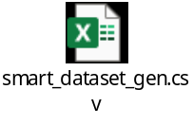) not only supports reproducibility and clarity in analysis but also acts as a reference framework for interpreting log outputs and designing diagnostic workflows. Together, these tools and techniques ensure that the dataset is both analytically robust and pedagogically transparent, aligning with the project’s instructional and diagnostic goals.
Figure 4: Executing the python code to generate the SSD drive dataset.

The rationale for selecting this dataset (Figure 5 below) is grounded in its ability to capture key performance and reliability indicators essential for monitoring SSD health. SMART attributes such as temperature, power cycles, error rates, and reallocated sectors serve as quantifiable markers of wear and degradation. By systematically analyzing these variables, researchers and engineers can detect anomalies, anticipate failures, and understand how SSDs behave under different workloads and environmental conditions. This project combines synthetic SMART logs with real-world data to ensure both reproducibility and realism, enabling the identification of consistent patterns linked to drive aging and reliability. Ultimately, the dataset supports the organization’s goal of enhancing predictive diagnostics and contributes to broader advancements in benchmarking and instructional design.
Figure 5: SSD drive dataset generated from the python code.
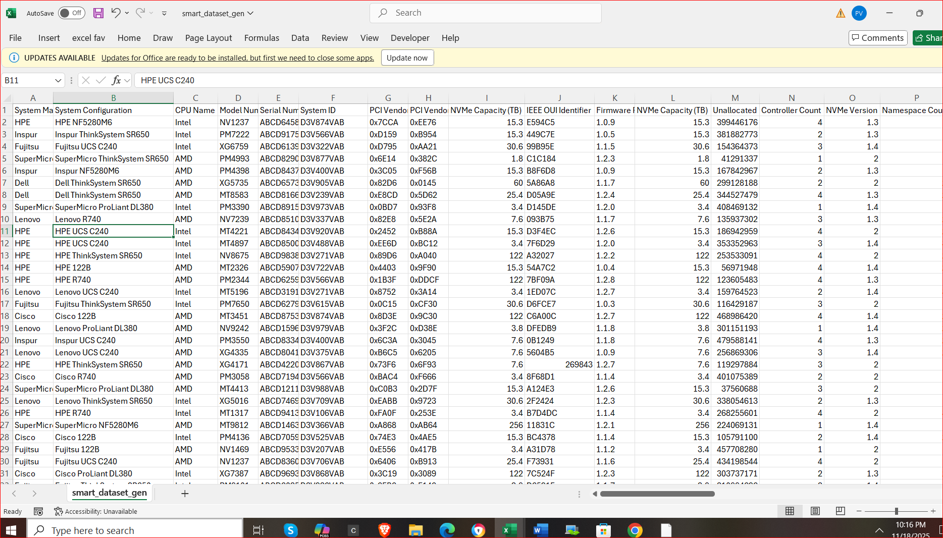

Lessons Learned:
A key lesson learned during this research was the limitation of relying on secondary datasets from platforms like Kaggle and other public repositories. Many of these datasets contained simulated values that did not align with real-world SMART data, making them unsuitable for rigorous reliability analysis. Additionally, several existing datasets were either incomplete or overly summarized, lacking the granularity required for advanced statistical modeling. This posed a significant barrier to understanding nuanced degradation patterns in SSDs. Another challenge anticipated was ensuring reproducibility across diverse SSD models and firmware versions. To address this, the project adopted a modular scripting approach, with each step carefully documented to support consistency and transparency in experimental replication. The overarching goal of the research is to build a reproducible framework for benchmarking SSD reliability using SMART data and synthetic error injection. By introducing controlled stress conditions and capturing detailed SMART responses, the study aims to normalize data across heterogeneous platforms and uncover consistent indicators of drive degradation. This methodology not only improves the precision of reliability assessments but also reinforces best practices in reproducible research. Ultimately, the project delivers both technical insights into SSD behavior and instructional value for validation engineers, bridging the gap between theoretical frameworks and practical implementation.

Conclusion
To conclude, the dataset developed for this capstone project serves as a cornerstone for advancing SSD reliability benchmarking through SMART log analysis and synthetic error injection. Its multidimensional structure capturing variables such as temperature, power cycles, error rates, and firmware identifiers enables organizations to move beyond traditional performance metrics and embrace predictive diagnostics. By normalizing these attributes across diverse SSD models and firmware versions, the dataset supports vendor-agnostic fault detection and comparative reliability assessments. The integration of synthetic and empirical data ensures both experimental control and real-world relevance, allowing for the construction of robust statistical models that forecast degradation trends and streamline troubleshooting. Ultimately, this approach transforms raw diagnostic logs into actionable insights, empowering organizations to reduce downtime, optimize maintenance strategies, and maintain operational resilience in mission-critical environments.

References

Hetman Recovery – Anticipate SSD Failures with Key SMART Metrics https://hetmanrecovery.com/recovery_news/predicting-ssd-failures-ssd-specific-smart-values.htm

SSD Testing: Quick and Simple Approach, SSD Testing: Quick and Simple Approach - ScaleFlux

Monitoring a Mystery SSD Issue with Python and smartctl Lennar Kivistik, 2023 Monitoring a Mystery ssd issue with python and smartctl | Lennar Kivistik

Dataset generated from Synthetic data: 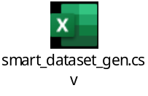

VLDB – SSD-iq: Uncovering the Hidden Side of SSD Performance SSD-iq: Uncovering the Hidden Side of SSD Performance
The Life and Death of SSDs and HDDs: Similarities, Differences, and Prediction Models Riccardo Pinciroli, Lishan Yang, Jacob Alter, Evgenia Smirni 2012.12373

