First Draft of Dataset Strategy for SSD Drive Structure Analysis
Priya Pooja Hariharan
Colorado State University Global
Course Code: 25WA-MIS581-1
Orenthio Goodwin
December 14, 2025

Introduction
Solid-state drives (SSDs) have become the primary storage medium in modern enterprise and hyperscale environments due to their high throughput, low latency, and absence of mechanical components. Unlike traditional hard disk drives, which rely on spinning platters and mechanical actuators, SSDs (Figure 1 below) store data electronically using NAND flash memory (Figure 3 below) and are managed by sophisticated controllers that regulate wear-leveling, garbage collection, thermal throttling, and power states. SSDs are deployed in multiple form factors including U.2, E3.s, and M.2 and increasingly operate over the NVMe protocol, which provides high-bandwidth, low-latency access through PCIe lanes. Industry standards such as the Open Compute Project (OCP) Specification and NVMe Cloud SSD Specification framework define expectations for performance, telemetry, thermal behavior, and power management across vendors. These standards guide validation platforms used in enterprise environments, where SSD reliability directly affects system availability and operational continuity.
Figure 1: Illustrative SSD for Storage and Boot Operations.
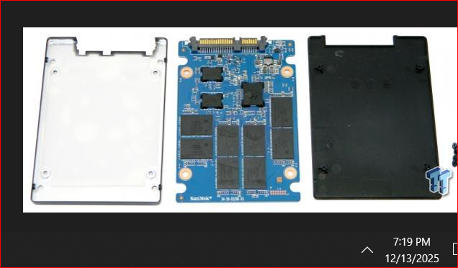
Also, the solid-state drives (SSDs) use NAND flash memory (shown a demo in Figure 2 below) to store data, and the main types such as SLC (Single-Level Cell), MLC (Multi-Level Cell), TLC (Triple-Level Cell), and QLC (Quad-Level Cell) which differ in how many bits of data each memory cell can hold. SLC stores just 1 bit per cell, making it the fastest, most durable, and most expensive option, typically used in enterprise or mission-critical environments. MLC stores 2 bits per cell, offering a balance between performance, endurance, and cost, and is common in both consumer and some enterprise SSDs. TLC, with 3 bits per cell, provides higher storage capacity at a lower price but with reduced speed and endurance, making it the standard for most consumer SSDs. QLC stores 4 bits per cell, delivering the highest storage density and lowest cost per gigabyte, but with the lowest endurance and slower write speeds, so it’s best suited for read-heavy or archival applications.
Figure 2: SSD NAND types Source: 220064-Solidigm-SSDBuyerConsiderations-WP-Final-v2.pdf
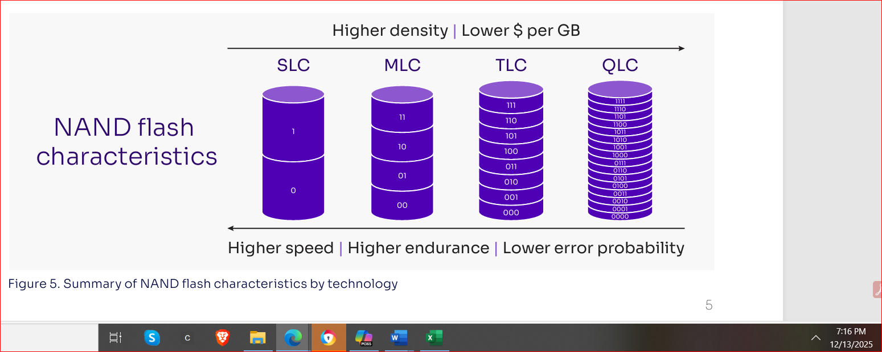

Despite these advancements, current SMART-based diagnostic strategies face several limitations that hinder accurate prediction of SSD degradation. SMART was originally designed as a threshold-based monitoring system, comparing sensor-reported values such as temperature, power cycles, unsafe shutdowns, and media errors against predefined limits. However, modern SSDs exhibit complex, dynamic behaviors that static thresholds cannot fully capture. For example, continuous telemetry collection can induce measurable performance penalties, including approximately 5% throughput loss during monitoring-intensive workloads, as reported in recent storage performance studies. TRIM operations, which deallocate unused blocks, can introduce more than 10% performance degradation when executed concurrently with active I/O, revealing inefficiencies in background maintenance processes.
Additionally, NVMe power-state reporting often diverges from vendor specifications, creating inconsistencies that complicate system-level power management, firmware validation, and energy-aware workload scheduling. These issues are particularly impactful in enterprise environments where SSDs support mission-critical applications, and even minor performance regressions can cascade into service delays, increased latency, or unexpected drive throttling.
Figure 3: Internal architecture of a modern SSD; Source: Microsoft Word - new-smart-SSDs-v39.docx
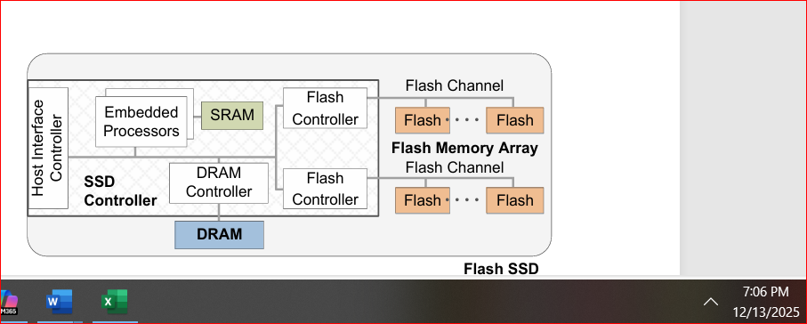

The research problem addressed in this capstone project is the limited predictive capability of existing SMART-based diagnostic methods, which rely heavily on static thresholds and lack the analytical depth required to detect emerging power, thermal, and wear-related anomalies. This limitation is compounded by the absence of integration between SSD telemetry and renewable-energy-aware workload scheduling frameworks, which increasingly influence data-center operations. To address this gap, the study examines both qualitative variables such as firmware revision notes, anomaly descriptions, and controller behavior, and quantitative variables such as temperature, power cycles, controller busy time, data units written, and media error counts. These variables form the basis of a structured dataset designed to support statistical analysis, reliability modeling, and predictive diagnostics.
The dataset developed for this project integrates synthetic SMART logs generated through a Python-based error-injection framework with secondary data from enterprise deployments, vendor documentation, and published research. Synthetic logs allow controlled manipulation of variables such as thermal thresholds, error counts, and power-state transitions, enabling reproducible experimentation. Real-world data provides contextual grounding and ensures alignment with industry-observed degradation patterns. A detailed data dictionary documents each variable’s type, diagnostic purpose, and expected range, ensuring internal consistency between the dataset, the research problem, and the analytical methods selected. This methodological structure aligns with findings from scholarly work, including studies demonstrating the limited correlation between static SMART attributes and SSD failures (Hao et al., 2020), the value of combining SMART data with NAND wear characteristics for improved forecasting (Gu, Wu, & He, 2024), and the importance of large-scale telemetry analysis for understanding population-level reliability trends (Meza et al., 2015).
Together, this section lays the technical groundwork and emphasizes the operational importance of SSD reliability in enterprise environments, leading directly into the project’s goal of creating a reproducible, vendor-agnostic benchmarking framework that leverages SMART data, synthetic error injection, and quantitative analysis to enhance predictive accuracy and support future energy-aware workload management.

Objectives
The primary objective of this capstone project is to develop a reproducible, vendor-agnostic SSD reliability benchmarking framework (Figure 5 below) grounded in structured SMART telemetry and a rigorously constructed dataset that integrates both synthetic error-injected logs and secondary enterprise-level data. By prioritizing the quality, consistency, and interpretability of SMART attributes, the framework aims to overcome the limitations of current diagnostic practices that rely on static thresholds and inconsistent vendor reporting. The resulting dataset is designed to capture realistic degradation patterns, operational anomalies, and cross-vendor variability, providing a foundation for meaningful reliability analysis and long-term benchmarking.
A second objective is to leverage SMART-derived numerical variables such as instantaneous power draw, controller temperature, thermal throttle indicators, and power-cycle behavior etc which evaluates how SSDs respond to dynamic operating conditions. Rather than emphasizing a novel detection method, the focus is on quantifying how SMART telemetry reflects real-world power and thermal irregularities, identifying gaps in vendor-reported states, and determining which attributes offer actionable predictive value. These insights support operational decisions that reduce unnecessary throttling, extend device lifespan, and improve energy-efficiency strategies in data-intensive environments.
Figure 4: Error injected Sample SSD SMART Data.
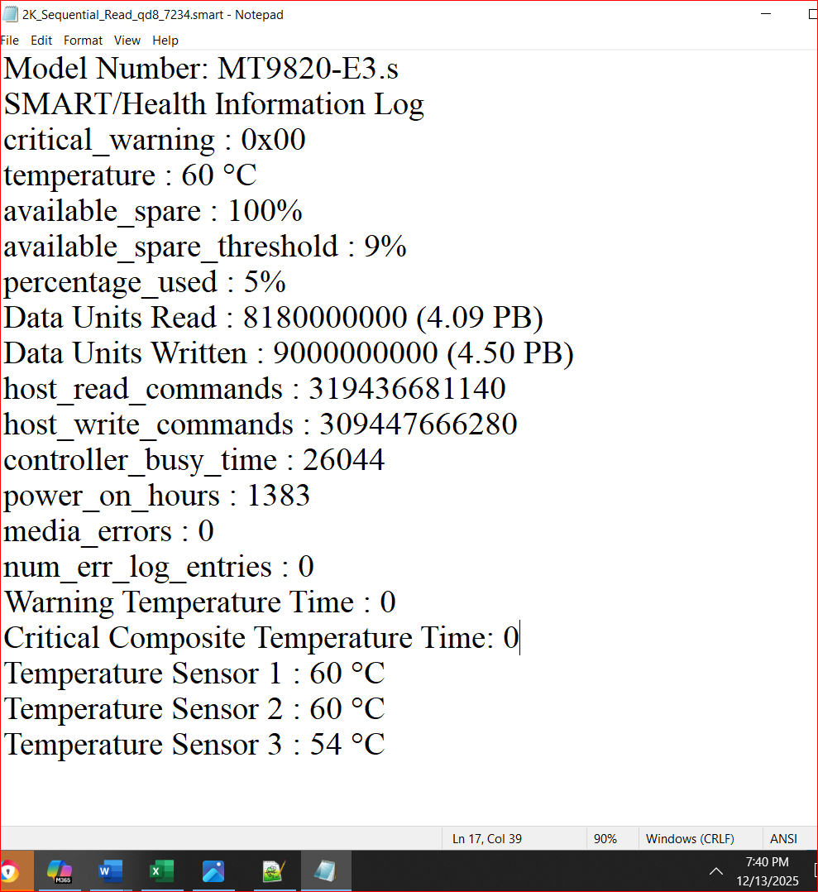
A third objective is to systematically assess the diagnostic usefulness of key SMART variables such as temperature, power cycles, controller busy time, data units written, and media error counts etc, under controlled fault-injection scenarios. This includes examining risks and complications such as Telemetry-induced performance degradation, TRIM-related overhead, Background maintenance inefficiencies, False positives or misleading attribute behavior across vendors.
A fourth objective is to evaluate whether synthetic SMART logs generated through controlled error injection (Figure 4 below) can serve as a credible proxy for real-world SSD behavior. This involves comparing synthetic patterns with those documented in large-scale SSD studies from hyperscale and enterprise environments. Establishing this alignment is essential for ensuring statistical validity, supporting cross-vendor benchmarking, reducing dependence on proprietary or inaccessible datasets, and enabling reproducible academic and industry research. Finally, the project aims to demonstrate how enhanced SMART-based reliability insights can support broader business and operational strategies, such as, Energy-aware workload scheduling, Predictive maintenance planning, Procurement and lifecycle-management decisions, Risk mitigation for thermal and power-related failures, Sustainability and cost-efficiency initiatives in data centers.
By mapping SMART attributes to early indicators of degradation, the project aims to clarify which variables reliably signal emerging failures and which introduce operational risk or noise, thereby identifying the attributes with the strongest predictive and operational value and ultimately contributing to the development of more adaptive, resilient, and cost-effective storage systems.
Figure 5: Interpretability of the SSD SMART attributes; source: table 4 in Scientific Data
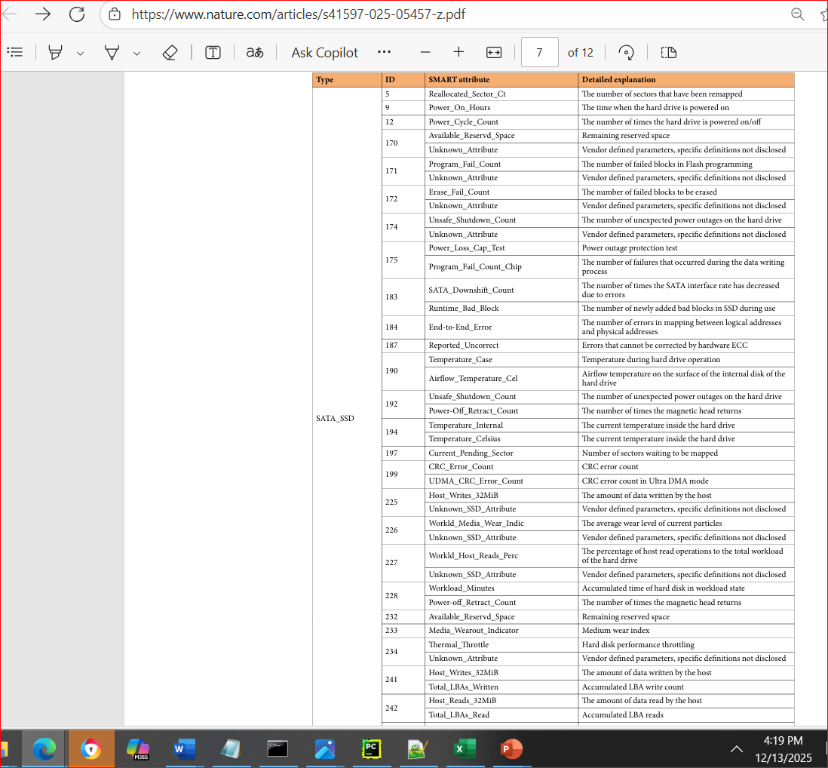

OVERVIEW OF STUDY
The data analysis strategy for this study is grounded in prior research on SSD reliability, SMART-based fault prediction, and firmware-level behavioral characterization. Existing work on SSD failure prediction has primarily relied on raw SMART telemetry, using machine-learning models such as random forests, support vector machines, and one-class classifiers to identify failure-related patterns (Narayanan et al., [7]; Mahdisoltani et al., [15]; Alter et al., [20]; Chandranil et al., [43]). Although these studies demonstrate the predictive potential of SMART attributes, they also reveal limitations in preprocessing, feature selection, and the handling of high-dimensional, temporally correlated telemetry.
Complementary research on SSD firmware integrity further highlights the structural complexity of SSD controllers. Studies have shown that firmware can be modified to introduce backdoors or malicious behaviors (Zaddach et al., [27]; Bogaard & Bruijn, [4]), and that such modifications can be detected through side-channel techniques that analyze power consumption or electromagnetic emissions (Gonzalez & Hinton, [12]; Shey et al., [22]; Melton et al., [19]; Canclini et al., [5]; Johnson et al., [26]). These findings underscore that SSD behavior, whether related to reliability degradation or firmware anomalies manifests through measurable structural signals such as current draw, thermal activity, controller workload, and SMART attribute evolution. Building on this foundation, the present study adopts a structured SSD-drive-analysis approach that integrates SMART telemetry, temporal modeling, and dimensionality-reduction techniques to isolate meaningful patterns from noise. By synthesizing insights from fault-prediction literature and side-channel-based structural analysis, the study positions SMART data not merely as a set of isolated attributes but as a dynamic representation of SSD internal states, enabling a more comprehensive and interpretable analysis of SSD drive structure, behavior, and degradation pathways.
Building on this integrated analytical foundation, the study further emphasizes the importance of treating SSD telemetry as a multi-layered signal that reflects interactions between firmware behavior, controller activity, flash-memory wear mechanisms, and workload-driven stress patterns. Rather than relying on static thresholds or isolated attribute values, the analysis incorporates temporal dependencies, cross-attribute correlations, and structural indicators that emerge only when SMART data is examined as a continuous behavioral sequence. This perspective allows the framework to capture subtle precursors to degradation, such as, shifts in power-state transitions, irregular thermal responses, or anomalous controller-busy patterns etc that traditional snapshot-based diagnostics often overlook. By aligning SMART-derived temporal features with insights from side-channel studies and firmware-modification research, the methodology supports a more holistic interpretation of SSD drive structure, enabling the detection of both reliability-related anomalies and deeper architectural inconsistencies. This comprehensive view strengthens the analytical rigor of the study and ensures that the resulting models reflect the true operational complexity of modern SSDs.
RESEARCH QUESTIONS AND HYPOTHESES
In the third phase of the research design, the focus shifts toward data analysis, which involves systematically examining collected information to uncover patterns, relationships, and insights. Data analysis typically includes segmenting datasets into manageable components, cleaning and organizing variables, and applying statistical techniques to interpret results. This process is essential for answering research questions and testing hypotheses, as it provides the rigor needed to understand how variables behave within the dataset. Analytics extends this process by leveraging larger datasets and computational tools to generate predictions, identify trends, and support decision-making.
While analysis emphasizes interpretation, analytics emphasizes transformation and reduction of data into actionable insights. In the context of this SSD reliability study, analysis may involve examining SMART attributes such as power-cycle counts or error rates to identify correlations, whereas analytics may apply machine-learning models to predict future failures based on normalized attributes across vendors. Selecting between analysis and analytics depends on the research objectives: analysis supports hypothesis testing and statistical significance, while analytics enables forecasting and generalization across heterogeneous environments. Clarifying questions such as “Which analytics method is most appropriate for the data gathered?” and “Where should the data analysis process begin?” ensures alignment between methodological choices, research questions, and hypotheses. Distinguishing between analysis and analytics therefore strengthens the methodological foundation of this study and supports the overarching goal of developing a reproducible framework for SSD reliability benchmarking.
This study addresses a critical gap in SSD reliability research, particularly the lack of standardized reporting of Self-Monitoring, Analysis, and Reporting Technology (SMART) attributes across vendors. By integrating synthetic datasets with empirical SMART logs, the project aims to establish a reproducible framework that supports both technical benchmarking and instructional clarity. Although SMART logs contain rich diagnostic information, their heterogeneity and inconsistent formatting limit their utility in cross-platform analysis. Introducing controlled stress conditions through error injection enables deeper exploration of failure mechanisms and supports the development of predictive fault models that can be generalized across diverse environments. Anticipated challenges include the heterogeneity of SMART logs, vendor-specific attribute definitions, and firmware inconsistencies that complicate normalization and cross-comparison. Additionally, validating synthetic data requires careful calibration to ensure that injected errors reflect real-world degradation patterns.
Based on these considerations, the study is guided by three primary research questions. The first asks whether synthetic error injection, when combined with SMART log analysis, can improve the predictive accuracy of SSD fault models. The second examines how SMART attributes can be normalized across heterogeneous SSD models and firmware versions to enable reliable cross-platform benchmarking. The third investigates whether cumulative power-on hours and repeated power cycles correlate with increased SSD failure likelihood.
To address these questions, the study proposes the following hypotheses. For Research Question 1, the null hypothesis states that normalizing SMART attributes across different SSD vendors does not reveal consistent degradation patterns and that any observed patterns are attributable to random variation or vendor-specific reporting. The alternative hypothesis suggests that normalization will uncover consistent degradation patterns that remain hidden in raw, unstandardized data. For Research Question 2, the null hypothesis asserts that synthetic error injection does not enhance the sensitivity of predictive models and has no significant impact compared to real-world datasets alone, whereas the alternative hypothesis states that synthetic error injection improves model sensitivity by simulating edge-case failure conditions not captured in empirical datasets. For Research Question 3, the null hypothesis states that cumulative power-on hours and repeated power cycles are not significantly correlated with increased SSD failure likelihood, while the alternative hypothesis proposes that these operational metrics are positively correlated with failure risk.
Two exploratory hypotheses extend the analytical scope of the study. The first examines whether Bayesian probabilistic modeling improves the accuracy and reliability of SSD failure predictions by incorporating uncertainty and dynamically updating likelihoods as new SMART data becomes available. The second evaluates whether integrating support vector regression–based anomaly detection with reinforcement-learning-based telemetry scheduling reduces false alarms and enhances predictive maintenance outcomes by aligning monitoring frequency with workload and energy conditions.
The research questions were derived directly from the problem statement by identifying the core challenges that hinder SSD reliability studies and translating those challenges into testable inquiries. The heterogeneity of SMART attributes across vendors motivated the question on normalization, as inconsistent reporting undermines cross-platform benchmarking. The inclusion of synthetic error injection emerged from the need to simulate stress conditions and determine whether predictive models can be strengthened beyond what empirical data alone provides. Operational metrics such as cumulative power-on hours and repeated power cycles were incorporated because they represent quantifiable indicators of degradation that may correlate with failure likelihood. Finally, the emphasis on reproducibility and predictive modeling reflects the broader goal of creating a framework that is both technically rigorous and generalizable across environments. Each research question therefore aligns directly with the practical and methodological gaps identified in SSD reliability research.
RESEARCH DESIGN
The research design for this SSD SMART-based reliability analysis followed a structured, multi-stage methodology to ensure data quality(/Scripts/log_generator.py), reduce noise, and extract meaningful degradation patterns from heterogeneous telemetry sources. The process began with an exploratory data analysis (EDA) phase in which the dataset (MIS581_SSD_dataset.csv) is examined for missing values, attribute sparsity, temporal irregularities, and vendor-specific reporting inconsistencies. This stage also included visualizing attribute distributions, identifying outliers, and assessing correlations among key indicators such as temperature, power-on hours, controller busy time, and media error counts.
Because SMART attributes vary widely across SSD models and firmware versions, a normalization stage (was incorporated to standardize attribute names, scale numerical variables, and align units of measurement, thereby creating a unified analytical space suitable for cross-platform benchmarking and preventing predictive models from inheriting vendor-specific biases. Following normalization, the analysis addressed multicollinearity (Figure 6a below, SSD-SMART-Reliability-Analysis/TestResults) by identifying and consolidating redundant features, particularly among highly correlated I/O metrics such as host_read_commands, data_units_read, and controller_busy_time, as well as their write-side counterparts. To reduce duplicated signal and stabilize model behavior, only one representative variable from each correlated cluster was retained or transformed into engineered workload indicators such as read_intensity, write_intensity, and io_balance.
Distributional properties of all SMART attributes were then examined using histograms and kernel density(Figure 6b below) estimates to detect skewness, heavy-tailed behavior, zero-inflation, and step-wise patterns typical of SSD telemetry, informing the use of log-scaling, binning, or specialized preprocessing. Because SSD degradation processes are often non-linear, additional exploratory techniques, including LOWESS-smoothed scatterplots, pairplots, mutual information scores, and partial-dependence visualizations, were used to reveal relationships that linear correlation alone could not capture, such as latency escalation after specific wear thresholds or temperature spikes under high I/O load.
Figure 6a: SSD SMART Reliability Data Analysis EDA analysis. 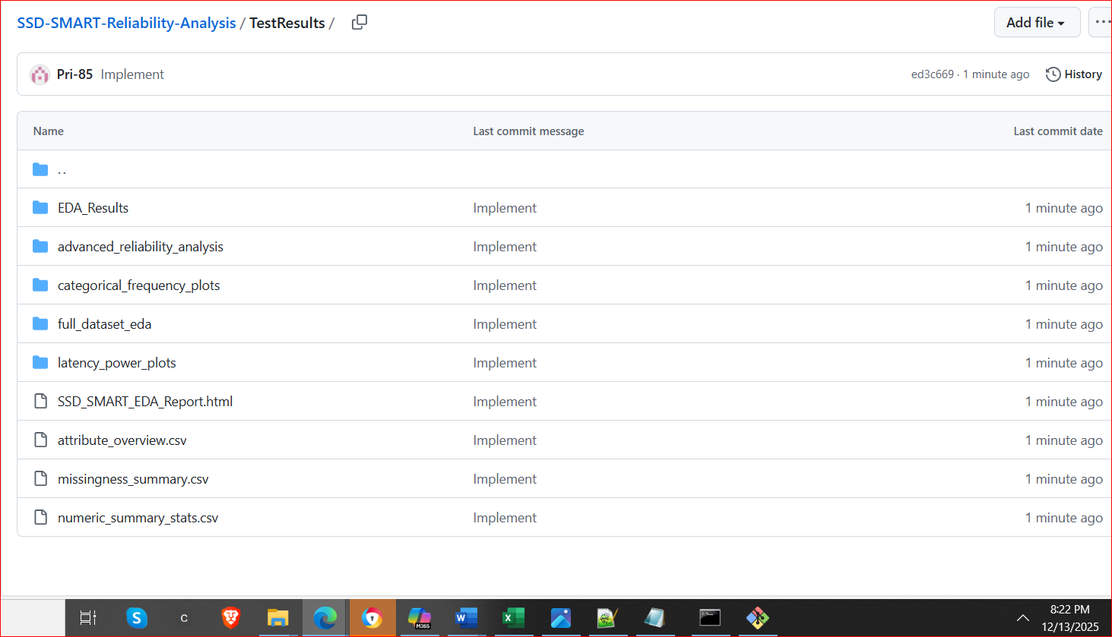

To uncover patterns masked in aggregate statistics, the dataset was segmented into more homogeneous subgroups based on drive age, workload type, and temperature bands, enabling recalculation of means, variances, error rates, and latency distributions within each segment. Outlier-detection methods, including z-scores, interquartile ranges, Isolation Forest, and DBSCAN, were then applied to identify anomalous drives exhibiting sudden latency jumps, thermal excursions, or abnormal error accumulation where signals that may indicate early failures, firmware issues, or misconfigured workloads. Building on these insights, domain-informed feature engineering introduces thermal-stress metrics, I/O-intensity measures, and error-acceleration rates, which provide more stable and interpretable predictors than raw SMART attributes. The research design concluded by selecting an appropriate modeling direction aligned with the study’s objectives, whether predicting failures through rare-event classification, modeling latency using non-linear regression, clustering behavioral patterns via unsupervised learning, or detecting anomalies using isolation-based methods. This comprehensive design ensures that the dataset is denoised, standardized, and analytically robust for downstream reliability modeling.
Figure 7b: SSD SMART Reliability Data Analysis Correlation matrix in EDA analysis. 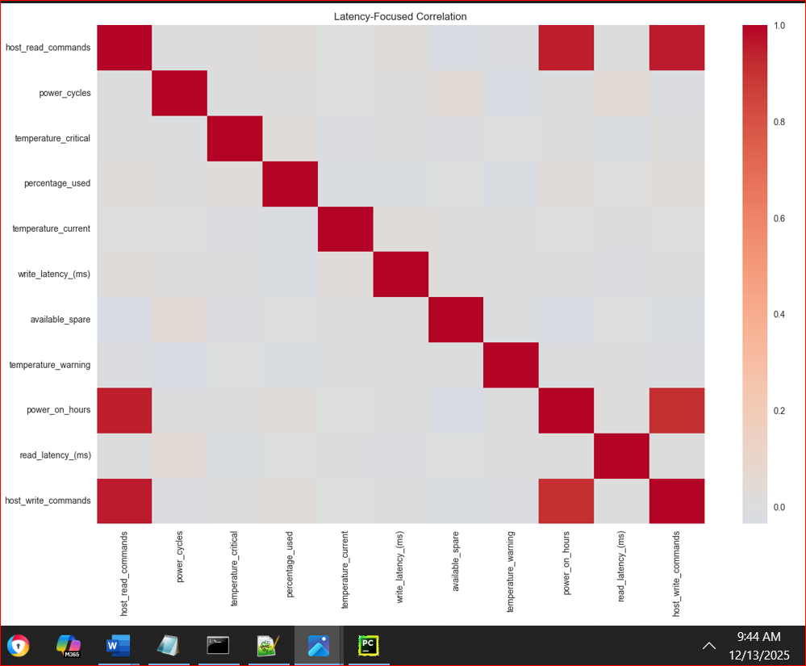
Figure 8c: SSD SMART Reliability Data Analysis EDA analysis categorical data plots.
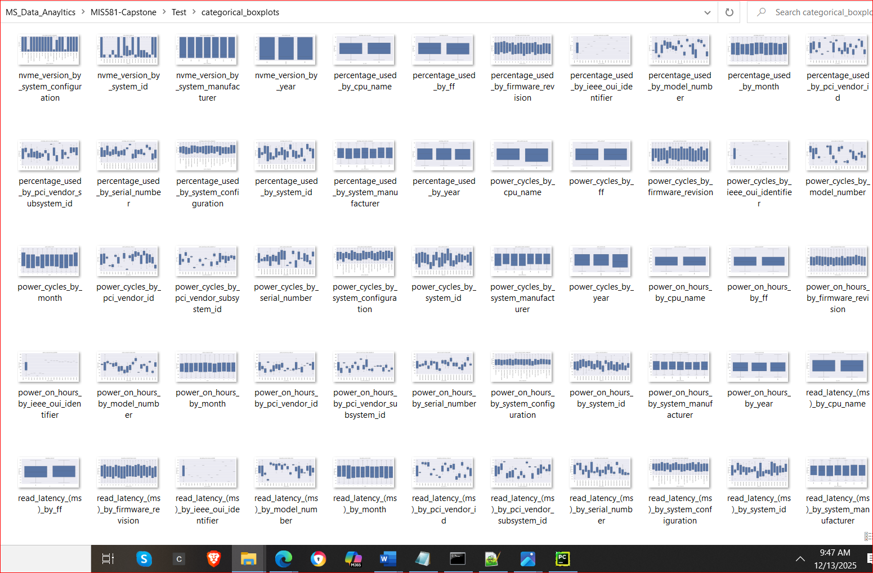
Following normalization, the study transitions into feature engineering and dimensionality reduction to isolate meaningful patterns from noise. Techniques such as principal component analysis (PCA), autoencoders, and temporal smoothing will be evaluated to determine which methods best preserve the temporal structure of SMART telemetry while reducing redundancy. Once a refined feature set is established, the research design introduces a modeling phase that applies supervised and unsupervised learning techniques to predict SSD failures, detect anomalies, and characterize degradation pathways.
Models under consideration include logistic regression, random forests, support vector regression, LSTM networks, and Bayesian probabilistic frameworks, each selected for its ability to capture different aspects of SSD behavior. The predictive modeling stage is complemented by cross-validation, hyperparameter tuning, and performance evaluation using metrics such as precision, recall, F-scores, and ROC-AUC. Finally, the research design incorporates a comparative analysis to assess how synthetic error injection influences model sensitivity and whether normalized SMART attributes improve cross-vendor generalizability. Through this structured sequence such as EDA, normalization, feature engineering, modeling, and validation, the study develops a comprehensive analytical pipeline that supports both technical benchmarking and the broader goal of creating a reproducible framework for SSD reliability prediction.
In addition to the distributional and non-linear analyses, the correlation structure of the dataset revealed several clusters of highly collinear variables that reflect expected operational relationships within NVMe devices. Extremely strong correlations were observed between host_read_commands and data_units_read (r ≈ .95) and between host_write_commands and data_units_written (r ≈ .90), indicating that the number of host-initiated I/O commands scales directly with the volume of data transferred. Similarly, controller_busy_time demonstrated a strong association with both read and write command counts (r ≈ .94), reflecting the intuitive relationship between I/O load and controller utilization. Power_on_hours also correlated strongly with cumulative I/O activity (r ≈ .94), suggesting that older drives naturally accumulate more read and write operations over time. These patterns are expected in storage-system telemetry and indicate structural multicollinearity rather than meaningful causal relationships. As such, these variables should be treated cautiously in downstream modeling, either by removing redundant predictors, selecting a single representative feature from each correlated cluster, or transforming them into composite workload-intensity metrics to avoid inflating model variance or obscuring true reliability-related signals.
To reduce noise and improve the reliability of subsequent modeling, the analysis first addressed multicollinearity by removing or consolidating redundant features that exhibited extremely high correlations, such as host_read_commands, data_units_read, and controller_busy_time on the read path, and their corresponding write-side metrics. Retaining only one representative variable from each correlated cluster or by replacing them with engineered ratios such as read_intensity, write_intensity, and io_balance helped prevent inflated variance and reduced the influence of duplicated signals.
Following this, distributional assessments were conducted using histograms and kernel density estimates to identify skewness, heavy-tailed behavior, zero-inflation, and step-wise patterns common in SMART telemetry. These insights guided the application of log-scaling, binning, and other transformations to stabilize variance and reduce distribution-driven noise. Because SSD degradation processes are often non-linear, additional exploratory techniques including LOWESS-smoothed scatterplots, pairplots, mutual information scores, and partial-dependence visualizations were used to detect relationships that linear correlation could not capture, thereby reducing model misspecification noise. The dataset was then segmented by drive type, workload type, and temperature bands, allowing summary statistics and error behaviors to be recalculated within more homogeneous subgroups and this stratification reduces aggregation noise and reveals patterns masked in the full dataset.
Outlier detection methods such as z-scores, interquartile ranges, Isolation Forest, and DBSCAN were applied to identify anomalous drives exhibiting sudden latency spikes, thermal excursions, or abnormal error accumulation, ensuring that rare but meaningful signals were separated from random noise. Finally, domain-informed feature engineering introduced wear indicators, thermal-stress metrics, I/O-intensity measures, and error-acceleration rates, which distilled raw SMART attributes into more stable, interpretable predictors. Collectively, these steps reduced statistical noise, mitigated redundancy, and enhanced the dataset’s suitability for downstream tasks such as failure prediction, latency modeling, behavioral clustering, or anomaly detection.
Figure 9a: lowess-smoothed plots incorporated in the EDA process.
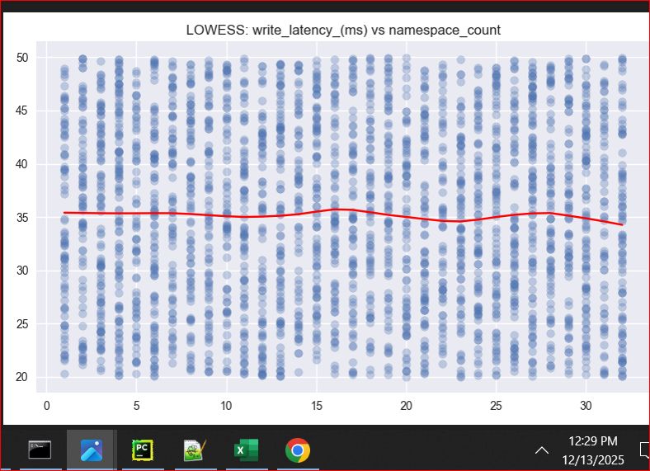
Figure 10b: lowess-smoothed plots incorporated in the EDA process. 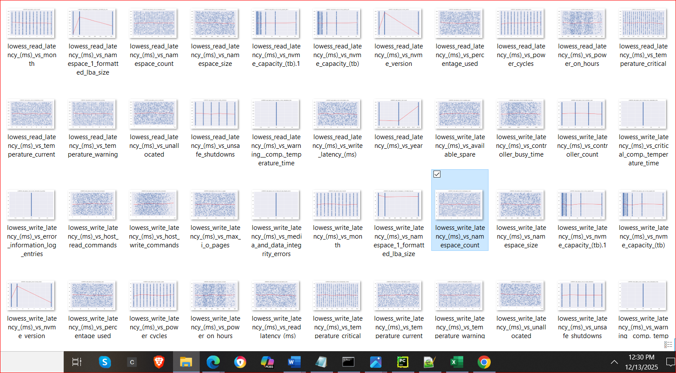

METHODOLOGY
This study employed a structured, multi-stage analytical methodology to evaluate SSD reliability using SMART telemetry collected across multiple vendors, firmware versions, and device classes. The workflow was implemented as a modular Python pipeline, enabling reproducibility, extensibility, and clear separation of analytical tasks. The process began with, log_generator.py and pre-process.py where raw SMART logs were loaded, parsed, and consolidated into a unified schema. Because SMART reporting varies widely across manufacturers, the preprocessing stage included attribute standardization, type casting, unit alignment, and schema harmonization to ensure cross-platform comparability. Subsequent cleaning procedures addressed missing values, sparsity, temporal irregularities, and malformed entries, while data ingestion introduced controlled synthetic patterns such as simulated wear progression or temperature spikes to evaluate model robustness under rare but operationally meaningful conditions.
Next the Exploratory Data Analysis (EDA) is conducted to characterize the statistical properties (/Scripts/SSD_DataInjection_V1.2.py) of the dataset. This included visualizing attribute distributions, identifying skewness, heavy-tailed behavior, and zero-inflation, and assessing correlations among key indicators such as temperature, power-on hours, controller busy time, and error counts. Because SSD degradation processes are often non-linear, the analysis (Figure 7 above) incorporated LOWESS-smoothed scatterplots, pairplots, and mutual information scores to detect relationships not captured by linear correlation alone. The dataset is further segmented by workload type, and temperature bands to reveal patterns masked in aggregate statistics. Outlier detection methods including z-scores, interquartile ranges, Isolation Forest, and DBSCAN were applied to identify anomalous drives exhibiting sudden latency spikes, thermal excursions, or abnormal error accumulation.
Figure 11: SSD SMART Data Reliability Analysis.
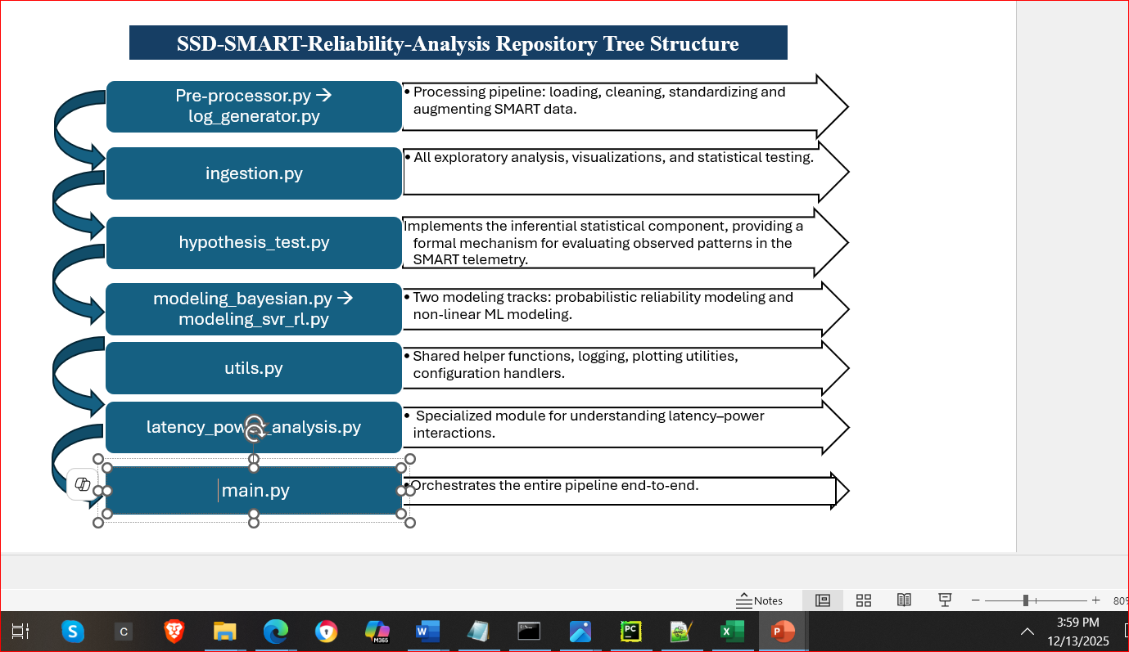
To validate insights (Figure 8 above) from the exploratory phase, hypothesis_tests.py is implemented inferential statistical tests, including t-tests, ANOVA, non-parametric alternatives, correlation significance tests, and effect-size calculations. These tests provide formal evidence for relationships between operational conditions and reliability outcomes. Feature engineering then transformed raw SMART attributes into domain-informed predictors such as wear rate, thermal stress, I/O intensity, and error-acceleration metrics, which offer more stable and interpretable signals for modeling.
The modeling stage consisted of two complementary tracks. modeling_bayesian.py implemented Bayesian reliability models to estimate posterior distributions of degradation parameters and quantify uncertainty in failure-risk predictions. In parallel, modeling_svr_rl.py applied non-linear machine-learning approaches including Support Vector Regression and reinforcement-learning-inspired optimization to predict latency, workload intensity, or wear-related outcomes. A specialized module, latency_power_analysis.py, examined the interaction between latency, power consumption, and workload characteristics to contextualize performance-related degradation. Shared utilities for logging, plotting, and configuration management were encapsulated in utils.py, and the entire workflow was orchestrated through main.py, ensuring a reproducible end-to-end pipeline.
This methodology integrates data normalization, statistical rigor, exploratory visualization, synthetic augmentation, and advanced modeling to produce a comprehensive and reliable assessment of SSD health and degradation behavior.

LIMITATIONS
Developing predictive models for SSD reliability using SMART telemetry involves several inherent limitations that must be acknowledged to ensure methodological rigor and appropriate interpretation of results. First, SMART data is heterogeneous across vendors, with differences in attribute naming, scaling, units, and reporting frequency. This variability can introduce structural noise and bias into models if not properly normalized. To mitigate this limitation, the study incorporates a comprehensive normalization stage that standardizes attribute names, aligns measurement units, and harmonizes schema differences before modeling. Second, SMART attributes often exhibit missingness, sparsity, and irregular temporal sampling, particularly for error-related metrics that remain at zero for long periods. These characteristics can distort statistical relationships and reduce model stability. Addressing this requires a combination of imputation strategies, zero-inflation-aware transformations, and temporal smoothing to ensure that models do not overfit to sparse or irregular patterns.
A third limitation arises from multicollinearity among workload-related attributes, such as read commands, write commands, data units transferred, and controller busy time. These variables are often highly correlated because they reflect the same underlying workload intensity. If left unaddressed, multicollinearity inflates variance, destabilizes regression coefficients, and obscures true causal signals. This study mitigates the issue by removing redundant features or replacing them with engineered metrics such as read intensity, write intensity, and I/O balance, which capture the underlying behavior more parsimoniously. Fourth, SSD degradation processes are non-linear and threshold-driven, meaning that linear models or correlation-based feature selection may fail to detect meaningful patterns. To address this, the methodology incorporates non-linear exploratory tools such as LOWESS smoothing, mutual information, and partial-dependence analysis and employs non-linear modeling approaches including Support Vector Regression and Bayesian models.
Another limitation is the scarcity of failure events in real-world datasets. SSDs rarely fail within typical observation windows, resulting in highly imbalanced data that can bias models toward predicting “no failure.” To mitigate this, the study uses synthetic injection techniques to simulate rare but realistic degradation patterns, and applies imbalance-aware modeling strategies such as weighted loss functions, anomaly detection, and probabilistic modeling. Additionally, SMART telemetry may not capture all relevant physical degradation mechanisms, such as NAND cell-level wear or firmware-level corrections, leading to partial observability. This limitation is addressed by engineering higher-level indicators such as wear rate, thermal stress, and error acceleration that approximate underlying physical processes more effectively than raw attributes.
Finally, predictive models may suffer from generalization limitations, performing well on the training dataset but poorly on unseen devices, workloads, or firmware versions. This risk is mitigated through cross-validation across vendors, segmentation-based evaluation, and stress-testing models using synthetic perturbations. Together, these mitigation strategies ensure that the limitations inherent in SMART-based reliability modeling are explicitly addressed, improving the robustness, interpretability, and practical relevance of the resulting models.

ETHICAL CONSIDERATIONS
The ethical considerations for this SSD SMART reliability analysis primarily relate to data representativeness, fairness, transparency, and the responsible interpretation of results. Because the current study relies on SMART telemetry from a single company’s SSDs, the dataset may not fully capture the diversity of behaviors, failure modes, or reporting conventions present across the broader SSD ecosystem. This introduces a risk of model bias, where conclusions or predictive models may generalize poorly to devices from other manufacturers, different NAND technologies, or alternative firmware architectures. To mitigate this limitation, the study explicitly acknowledges the restricted scope of the dataset and avoids making universal claims about SSD reliability. Future work should incorporate multi-vendor datasets to ensure broader applicability and reduce the risk of vendor-specific overfitting.
Another ethical concern arises from the heterogeneity of attributes across SKUs, capacities, and product lines. Different SSD models expose different SMART fields, use different scaling factors, or report telemetry at different frequencies. If these differences are not carefully normalized, models may inadvertently learn SKU-specific patterns rather than genuine reliability signals, leading to algorithmic unfairness where certain device families are systematically mischaracterized. To address this, the methodology includes a rigorous normalization stage that aligns units, harmonizes attribute names, and documents any attributes excluded due to inconsistent reporting. This transparency ensures that downstream interpretations are grounded in comparable data rather than artifacts of vendor or SKU design. The study also considers the ethical implications of data completeness and observability. SMART telemetry provides only a partial view of internal SSD behavior, and some degradation mechanisms—such as NAND cell-level wear, ECC correction depth, or firmware-level remapping which are not directly observable. Over-interpreting these limited signals could lead to misleading conclusions about device health or lifespan. To avoid this, the analysis emphasizes uncertainty quantification, avoids deterministic claims, and uses Bayesian modeling to explicitly represent uncertainty in reliability estimates.
Additionally, the use of synthetic data injection introduces ethical responsibilities regarding transparency and reproducibility. Synthetic perturbations must be clearly documented to avoid misrepresenting real-world behavior or overstating model performance. The study ensures that synthetic patterns are used only to test robustness, not to inflate predictive accuracy, and that all synthetic procedures are disclosed in the methodology.
Finally, ethical considerations extend to data privacy and responsible use. Although SMART data does not contain personal information, it may reveal operational patterns, workload characteristics, or device usage profiles that could be sensitive in enterprise environments. The study therefore treats all telemetry as confidential, anonymizes device identifiers, and avoids linking SMART attributes to user-specific behaviors.
Taken together, these ethical considerations ensure that the reliability analysis is conducted responsibly, transparently, and with appropriate caution regarding the limitations of single-vendor data, SKU variability, partial observability, and the potential for model bias. They also establish a foundation for future work that expands the dataset, strengthens fairness, and enhances the generalizability of SSD reliability modeling.

CONCLUSION
This first draft of the SSD SMART reliability analysis has been an essential learning experience, revealing both the analytical potential of SMART telemetry and the practical challenges inherent in working with real-world device data. Throughout the project, several issues emerged, including inconsistent attribute reporting across SKUs, missing or sparse telemetry fields, high multicollinearity among workload metrics, and the difficulty of interpreting non-linear degradation patterns from limited observability. Addressing these challenges required iterative refinement of the preprocessing pipeline, the development of a robust normalization framework, and the use of synthetic data injection to compensate for the scarcity of failure events. The exploratory analysis highlighted the importance of understanding distributional behavior, segmenting devices by operational context, and validating insights through formal hypothesis testing rather than relying solely on visual patterns. Building the modeling components underscored the need for engineered features that better reflect underlying physical processes, as well as the value of uncertainty-aware approaches such as Bayesian modeling. Overall, this draft demonstrates a clear methodological foundation while also clarifying the next steps: expanding the dataset beyond a single vendor, strengthening cross-platform generalizability, and refining the modeling pipeline to better capture the complex, non-linear nature of SSD degradation. The lessons learned in this phase provide a strong direction for the next iteration of the capstone and establish a solid base for more comprehensive reliability modeling.

References
Cai, Y., Ghose, S., Mutlu, O., & Haratsch, E. F. (2017). Error characterization, mitigation, and recovery in flash-memory-based solid-state drives. Proceedings of the IEEE, 105(9), 1666–1704. Error Characterization, Mitigation, and Recovery in Flash-Memory-Based Solid-State Drives

Meza, J., Wu, Q., Kumar, S., & Mutlu, O. (2015). A large-scale study of flash memory failures in the field. ACM SIGMETRICS Performance Evaluation Review, 43(1), 177–190. A Large-Scale Study of Flash Memory Failures in the Field

Schroeder, B., & Gibson, G. A. (2010). A large-scale study of failures in high-performance computing systems. IEEE Transactions on Dependable and Secure Computing, 7(4), 337–350. A Large-Scale Study of Failures in High-Performance Computing Systems | IEEE Journals & Magazine | IEEE Xplore

Gelman, A., Carlin, J. B., Stern, H. S., Dunson, D., Vehtari, A., & Rubin, D. B. (2013). Bayesian data analysis (3rd ed.). CRC Press. Bayesian Data Analysis

McElreath, R. (2020). Statistical rethinking: A Bayesian course with examples in R and Stan (2nd ed.). CRC Press. yfish.org/assets/pdf/McElreath_2020_Statistical_Rethinking.pdf
GitHub: SSD-SMART-Reliability-Analysis/
The Life and Death of SSDs and HDDs: Similarities, Differences, and Prediction Models Riccardo Pinciroli, Lishan Yang, Jacob Alter, and Evgenia Smirni 2012.12373

Improving accuracy and adaptability of SSD failure prediction in hyper-scale data centers Wenwen Hao, Kangkang Liu, Ben Niu, Yin Luo, Na Liu, WAIN_2021_paper_4_Hao.pdf

Query Processing on Smart SSDs: Opportunities and Challenges Jaeyoung Do+,#, Yang-Suk Kee*, Jignesh M. Patel+, Chanik Park*, Kwanghyun Park+, David J. DeWitt# +University of Wisconsin – Madison; Microsoft Word - new-smart-SSDs-v39.docx
A Study of SSD Reliability in Large Scale Enterprise Storage Deployments Stathis Maneas and Kaveh Mahdaviani, University of Toronto; Tim Emami, NetApp; Bianca Schroeder, University of Toronto https://www.usenix.org/conference/fast20/presentation/maneas

Human reliability analysis: Exploring the intellectual structure of a research field
Riccardo Patriarca, Marilia Ramos, Nicola Paltrinieri, Salvatore Massaiu, Francesco Costantino, Giulio Di Gravio , Ronald Laurids Boring Human reliability analysis: Exploring the intellectual structure of a research field - ScienceDirect

A self-monitoring analysis and reporting technology dataset of 147,496 hard disks Shuting Wei, Hongzhang Yang, Zhengguang Chen & Ping Wang A self-monitoring analysis and reporting technology dataset of 147,496 hard disks | Scientific Data

