# ИНДУКТИВНОСТИ

10мкГн

|  |  |  |  |  |
| --- | --- | --- | --- | --- |
| Типоразмер | Высота | Наименование | Ток | Номиналы |
| 12.8x12.8 | 8мм | B82477G4103M | IR = 5.4A  ISAT = 6.4A  R = 0.022 |  |
| 7x7 | 3mm | IHLP-2525CZ | IR = 3  ISAT = 7  R=0.1 | **0.1…10** |
| 11x11 | 4мм | IHLP-4040DZ | IR = 7  ISAT = 7.1  R = 0.03 | **0.19…100** |
| 13x13 | 3.5mm | IHLP-5050CE | IR=7  ISAT =14  R = 0.03 | **0.10 … 10** |
| 17x17 | 7mm | IHLP-6767GZ | IR=16  ISAT=25  R=0.012 | **0.33…100** |
| 12x12 | 4.5 | CDRH124 |  |  |
| 12x12 | 8mm | CDRH127 | IR = 5.4A  ISAT =  R = 0.022 |  |
| 7.2x7.2 | 3.2 | CDRH73 | IR = 1.68A  R = 0.05 | 10…1000 |
| 6.3x6.3 | 4.7mm | LQH66S | IR = 1.6  R = 0.05 |  |
| 6.7x6.7mm | 2.8mm | CDRH6D28 | IR= 1.7  R = 0.065 | 3..100 |

# §MLCC

## 3-digit capacitance

|  |  |  |  |  |  |  |  |
| --- | --- | --- | --- | --- | --- | --- | --- |
| **1R0** | **100** | **101** | **102** | **103** | **104** | **105** | **106** |
| 1pF | 10pF | 100pF | 1000pF |  |  |  |  |
|  |  |  | 1nF | 10nF | 100nF |  |  |
|  |  |  |  | 0.01uF | 0.1uF | 1uF | 10uF |

## murata

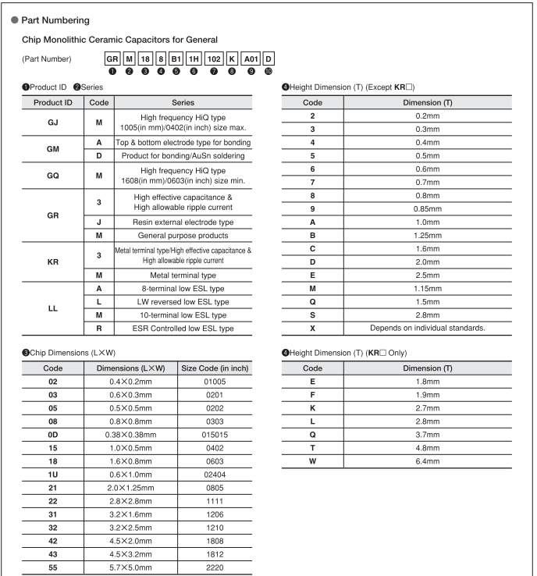

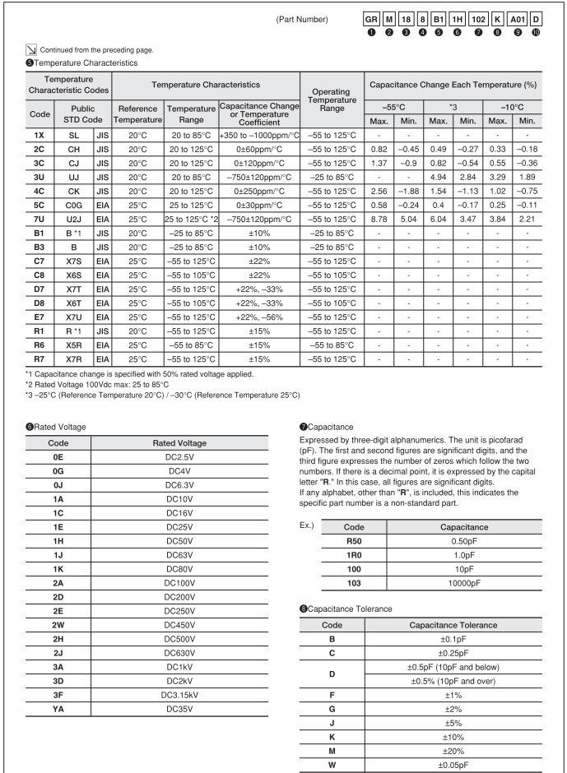

## samsung

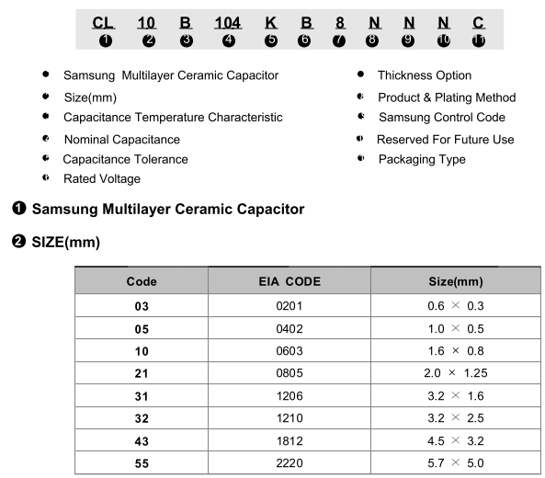

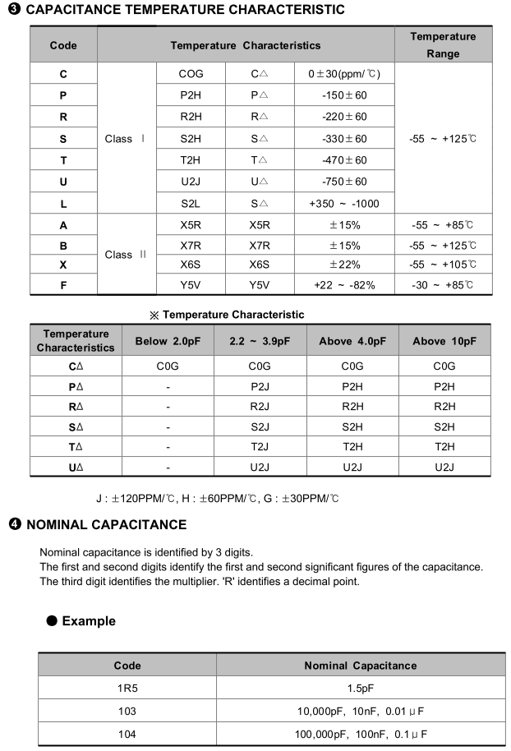

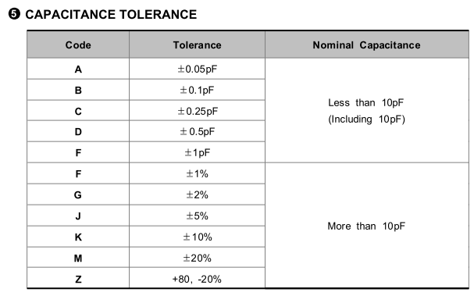

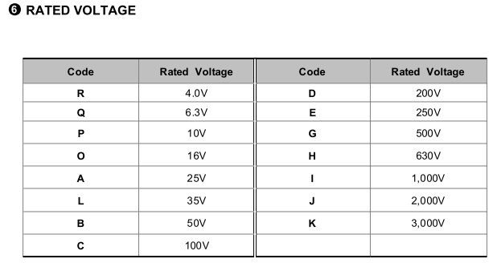

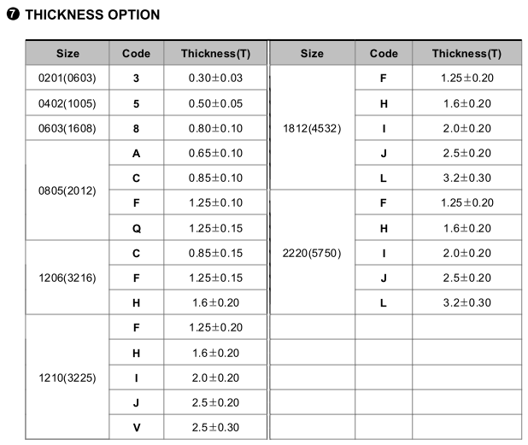

## yageo

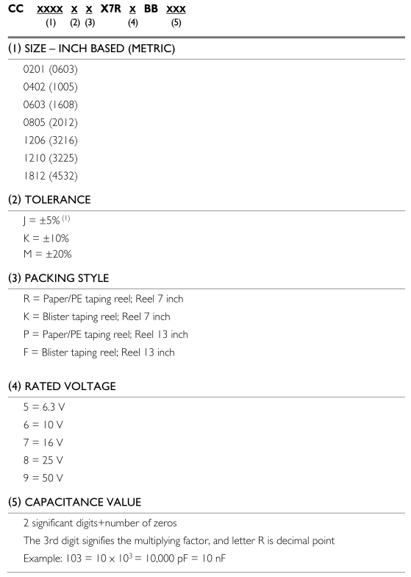

# ФИЛЬТРЫ

|  |  |  |  |
| --- | --- | --- | --- |
| NAME | AC | I | DC |
| BLM18AG121SN1D | 120 ohm | 500 mA | 0.18 ohm |
|  |  |  |  |
|  |  |  |  |
|  |  |  |  |
|  |  |  |  |
|  |  |  |  |
|  |  |  |  |

# §ELECTROLYTIC CAPACITORS

## **SMD**

B41121

Всего 5 размеров (диаметр х высота)

|  |  |  |  |  |
| --- | --- | --- | --- | --- |
| 4 x 5.4 | 5 x 5.4 | 6.3 x 5.4 | 8 x 10 | 10 x 10 |

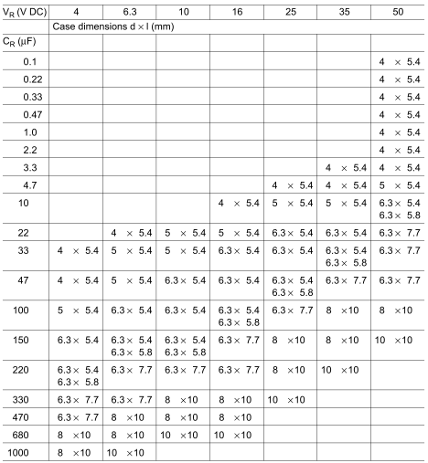

## **YAGEO ECAP**

SH-series - general

SK-series - general

|  |  |  |  |
| --- | --- | --- | --- |
| Case diameter | Pitch | Pin diameter | Length |
| 4 | 1.5 | 0.45 |  |
| 5 | 2 | 0.5 |  |
| 6.3 | 2.5 | 0.5 |  |
| 8 | 3.5 | 0.5 |  |
| 10 | 5 | 0.6 | 12,15,19.5 |
| 12 | 5 | 0.6 |  |
| 13 | 5 | 0.6 |  |
| 16 | 7.5 | 0.8 |  |
| 18 | 7.5 | 0.8 |  |
| 22 | 10 | 0.8 |  |

# НОРМЫ

Типовой процесс

|  |  |  |  |  |
| --- | --- | --- | --- | --- |
|  | 18um  0.5oz | 35um  1oz | 70um  2oz | 105um  3oz |
| Минимальная ширина проводника, элемента топологии  Минимальный зазор проводник/проводник/площадка | 0,2 | 0,2 | 0,3 | 0,35 |
| Минимальный поясок металлизированного отверстия | 0,2 | 0,2 | 0,25 | 0,25 |
| Поясок площадки внутреннего слоя | 0,3 | 0,3 | 0,3 | 0,3 |
|  |  |  |  |  |
|  |  |  |  |  |
|  |  |  |  |  |
|  |  |  |  |  |

|  |  |
| --- | --- |
| Диаметр металлизированного отверстия | 0,4 (1:4 к толщине платы) |
|  |  |
|  |  |
|  |  |
|  |  |
|  |  |
|  |  |
|  |  |