YAGEO general purpose chip resistors

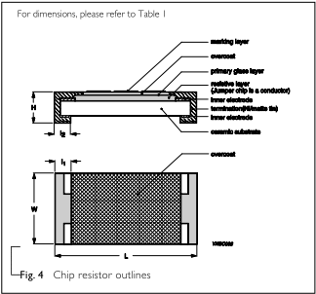
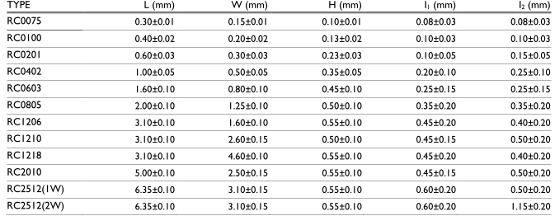
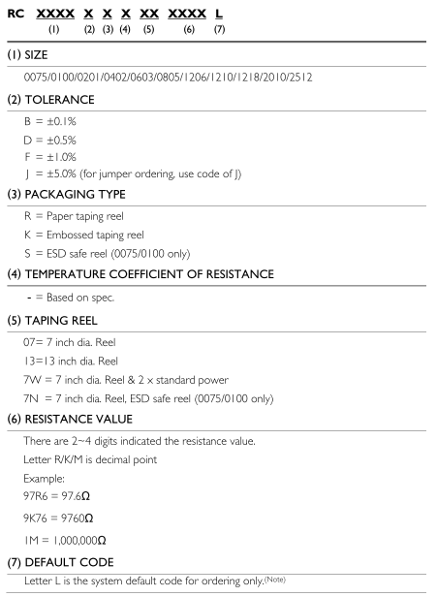
/RC0603FR-0747RL | 47 | +/-1.00% | 100mW | 100ppm/K
RC0603JR-0747RL |  | +/-5.00% | 100mW | 100ppm/K

