# ИНДУКТИВНОСТИ

10мкГн

|  |  |  |  |  |
| --- | --- | --- | --- | --- |
| Типоразмер | Высота | Наименование | Ток | Номиналы |
| 12.8x12.8 | 8мм | B82477G4103M | IR = 5.4A  ISAT = 6.4A  R = 0.022 |  |
| 7x7 | 3mm | IHLP-2525CZ | IR = 3  ISAT = 7  R=0.1 | **0.1…10** |
| 11x11 | 4мм | IHLP-4040DZ | IR = 7  ISAT = 7.1  R = 0.03 | **0.19…100** |
| 13x13 | 3.5mm | IHLP-5050CE | IR=7  ISAT =14  R = 0.03 | **0.10 … 10** |
| 17x17 | 7mm | IHLP-6767GZ | IR=16  ISAT=25  R=0.012 | **0.33…100** |
| 12x12 | 4.5 | CDRH124 |  |  |
| 12x12 | 8mm | CDRH127 | IR = 5.4A  ISAT =  R = 0.022 |  |
| 7.2x7.2 | 3.2 | CDRH73 | IR = 1.68A  R = 0.05 | 10…1000 |
| 6.3x6.3 | 4.7mm | LQH66S | IR = 1.6  R = 0.05 |  |
| 6.7x6.7mm | 2.8mm | CDRH6D28 | IR= 1.7  R = 0.065 | 3..100 |

# §MLCC

## 3-digit capacitance

|  |  |  |  |  |  |  |  |
| --- | --- | --- | --- | --- | --- | --- | --- |
| **1R0** | **100** | **101** | **102** | **103** | **104** | **105** | **106** |
| 1pF | 10pF | 100pF | 1000pF |  |  |  |  |
|  |  |  | 1nF | 10nF | 100nF |  |  |
|  |  |  |  | 0.01uF | 0.1uF | 1uF | 10uF |

## murata

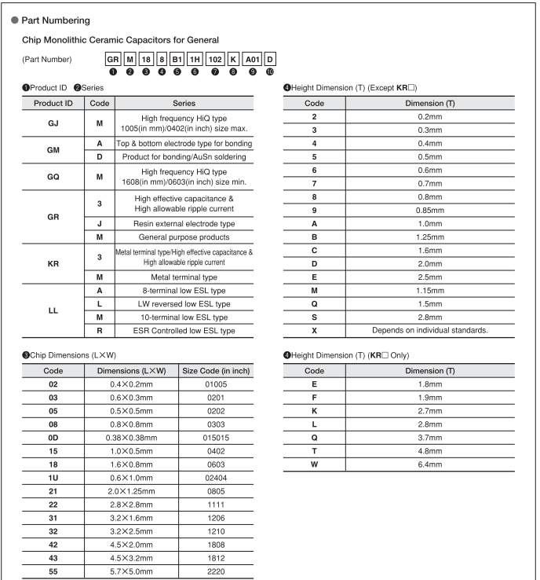

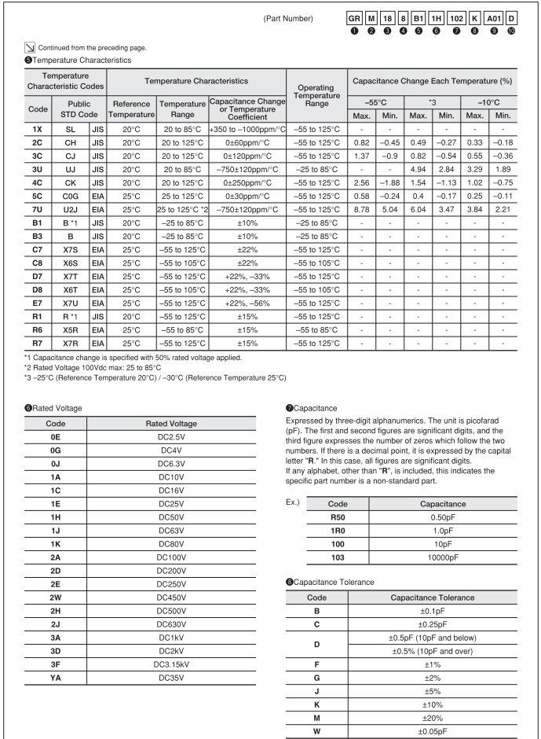

## samsung

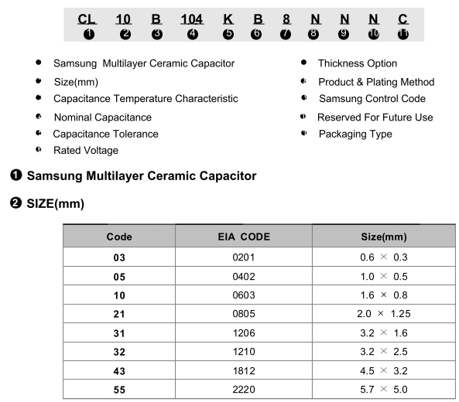

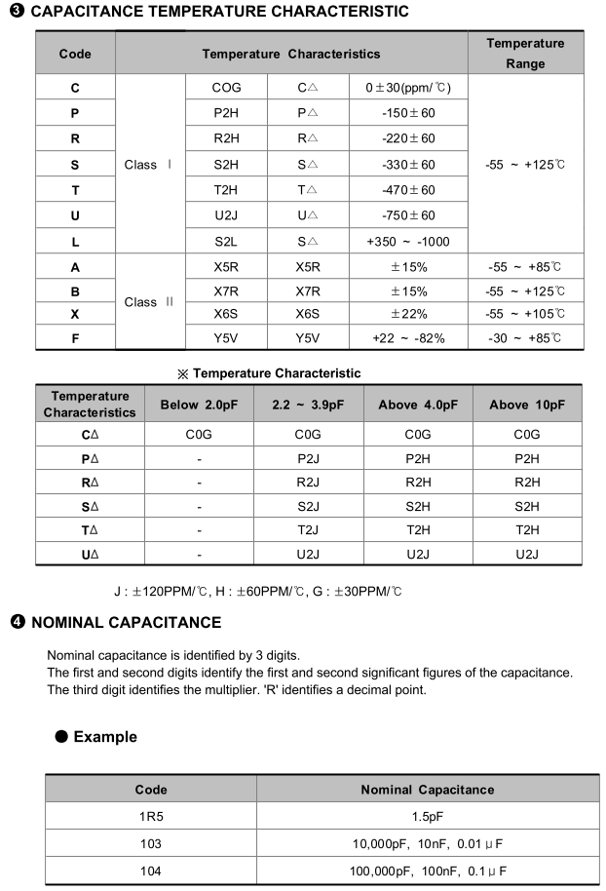

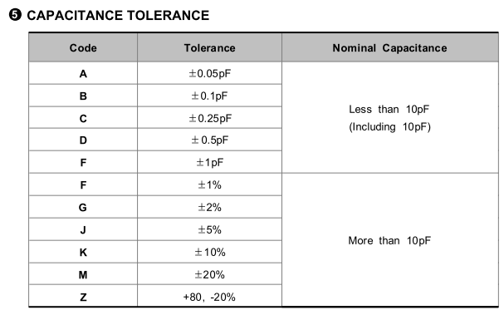

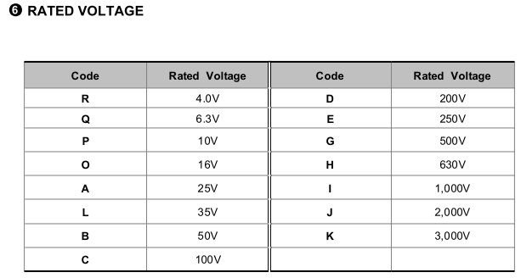

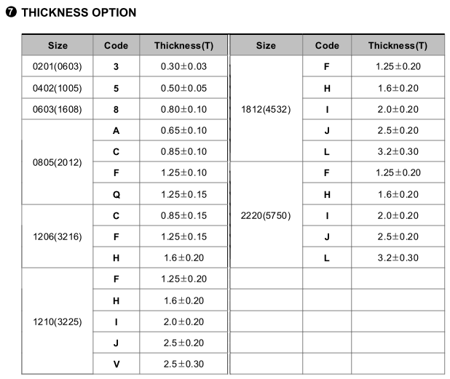

## yageo

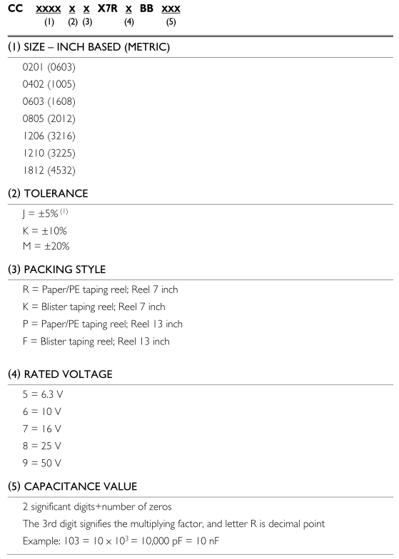

# ФИЛЬТРЫ

|  |  |  |  |
| --- | --- | --- | --- |
| NAME | AC | I | DC |
| BLM18AG121SN1D | 120 ohm | 500 mA | 0.18 ohm |
|  |  |  |  |
|  |  |  |  |
|  |  |  |  |
|  |  |  |  |
|  |  |  |  |
|  |  |  |  |

# §ELECTROLYTIC CAPACITORS

## **SMD**

B41121

Всего 5 размеров (диаметр х высота)

|  |  |  |  |  |
| --- | --- | --- | --- | --- |
| 4 x 5.4 | 5 x 5.4 | 6.3 x 5.4 | 8 x 10 | 10 x 10 |

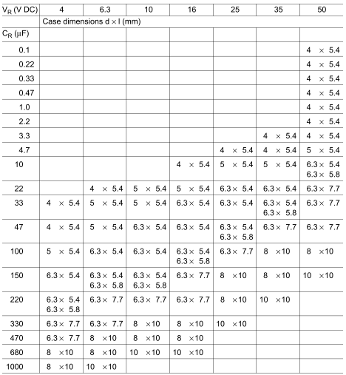

## **YAGEO ECAP**

SH-series - general

SK-series - general

|  |  |  |  |
| --- | --- | --- | --- |
| Case diameter | Pitch | Pin diameter | Length |
| 4 | 1.5 | 0.45 |  |
| 5 | 2 | 0.5 |  |
| 6.3 | 2.5 | 0.5 |  |
| 8 | 3.5 | 0.5 |  |
| 10 | 5 | 0.6 | 12,15,19.5 |
| 12 | 5 | 0.6 |  |
| 13 | 5 | 0.6 |  |
| 16 | 7.5 | 0.8 |  |
| 18 | 7.5 | 0.8 |  |
| 22 | 10 | 0.8 |  |

# §НОРМЫ И ОГРАНИЧЕНИЯ

[Библия и камасутра](http://www.rezonit.ru/support/technology/urgent/)

Стандартный процесс

|  |  |  |  |  |
| --- | --- | --- | --- | --- |
|  | 18um  0.5oz | 35um  1oz | 70um  2oz | 105um  3oz |
| Минимальная ширина проводника, элемента топологии  Минимальный зазор проводник/проводник/площадка | 0,2 | 0,2 | 0,3 | 0,35 |
| Минимальный поясок металлизированного отверстия | 0,2 | 0,2 | 0,25 | 0,25 |
| Поясок площадки внутреннего слоя | 0,3 | 0,3 | 0,3 | 0,3 |
| Металлизированное отверстие | 0,300 | 0,300 | 0,300 | 0,300 |
|  |  |  |  |  |
|  |  |  |  |  |
|  |  |  |  |  |

|  |  |
| --- | --- |
| Диаметр металлизированного отверстия | 0,4 (1:4 к толщине платы) |
|  |  |
|  |  |
|  |  |
|  |  |
|  |  |
|  |  |
|  |  |

Резонит – максимальный размер

|  |  |
| --- | --- |
| ОДНО- И ДВУСТОРОННИЕ ПЕЧАТНЫЕ ПЛАТЫ | МНОГОСЛОЙНЫЕ ПЕЧАТНЫЕ ПЛАТЫ |
| 390x485 мм для PCB толщиной ≥ 1,0 мм  379 x 475 мм с покрытием ImmGold  309 x 368 мм с  покрытием ImmAg | 350x475 мм для PCB толщиной ≥ 1,0 мм  285 x 355 мм с покрытием ImmAg |

# §МАТЕРИАЛЫ

|  |  |  |  |  |  |
| --- | --- | --- | --- | --- | --- |
| Material | Resistivity  [ohm*m] | Thermal conductivity [W/m/K] |  |  |  |
| copper | 1.68e-8 | 401 |  |  |  |
| aluminium | 2.82e-8 | 237 |  |  |  |
| gold | 2.44e-8 | 310 |  |  |  |
| silver | 1.59e-8 | 429 |  |  |  |
| nickel | 6.99e-8 | 91 |  |  |  |
| tin | 1.09e-7 | 67 |  |  |  |
| lead | 2.20e-7 | 35 |  |  |  |
| Sn60Pb40 | 1.45e-7 | 49.8 |  |  |  |
|  |  |  |  |  |  |
|  |  |  |  |  |  |

# §CRYSTAL OSCILLATOR

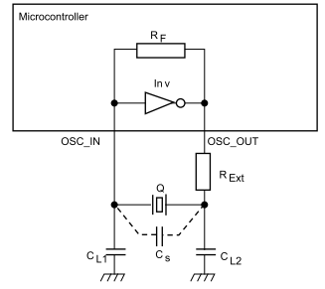

CL1 and CL2: are the two external load capacitances

Cs: stray capacitance is the addition of the microcontroller pin capacitance (OSC_IN and OSC_OUT) and the PCB capacitance: it is a parasitic capacitance.

The load capacitance is the terminal capacitance of the circuit connected to the crystal

oscillator. This value is determined by CL1 CL2 and Cs.

The CL value is specified by the crystal manufacturer. ***Mainly, for the frequency to be accurate, the oscillator circuit has to show the same load capacitance to the crystal as the one the crystal was adjusted for.***

Frequency stability mainly requires that the load capacitance be constant.

The external capacitors CL1 and CL2 are used to tune the desired value of CL to reach the value specified

by the crystal manufacturer.



$$C_{L1,2}=2×(C_{L}-C_{s})$$

|  |  |  |
| --- | --- | --- |
| CL | CS | CL1,CL2 |
| 8 | 2 | 12 |
| 10 | 2 | 16 |
| 12 | 2 | 20 |
| 18 | 2 | 32 |
| 8 | 5 | 6 |
| 10 | 5 | 10 |
| 12 | 5 | 14 |
| 18 | 5 | 26 |