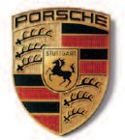

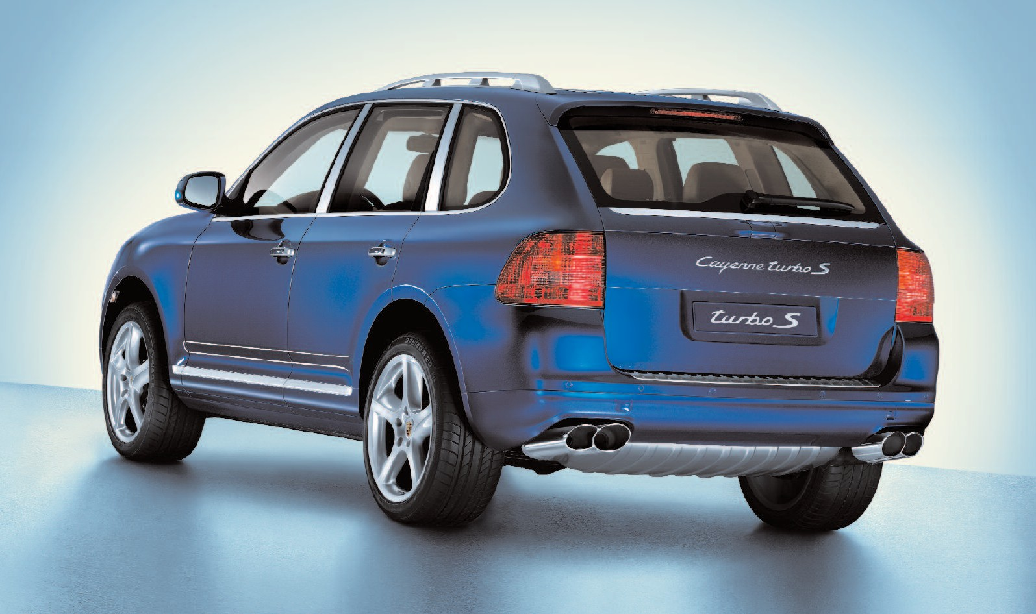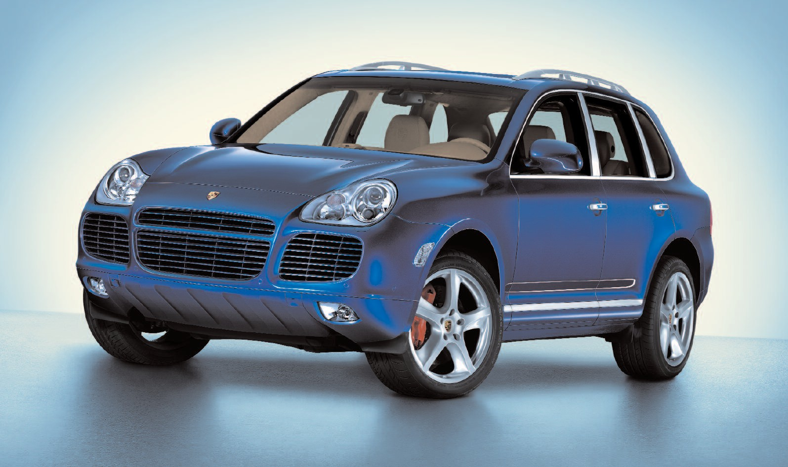

The model illustrated is approved for road use in Germany. Some items of equipment are available as extra-cost options only. The availability of models and options may vary from market to mar- ket due to local restrictions and regulations. For information on standard and optional equipment, please consult your Porsche Centre.

All information is valid at the time of going to press. Colours may differ from those illustrated. Errors and omissions excepted.

Porsche, the Porsche Crest, Cayenne, PCM, PSM and Tiptronic are registered trademarks of

Dr. Ing. h.c. F. Porsche AG Porscheplatz 1

D-70435 Stuttgart [www.porsche.com](http://www.porsche.com/)

Edition: 10/05 Printed in Germany

WVK 413 420 06 E/ WW

The new Cayenne Turbo S

# Every limit set becomes our next challenge. The new Cayenne Turbo S.

in every new car we make. It can also be experienced on every journey as pure driving pleasure.

Once again, we’ve set ourselves

This time, we’ve blended turbo- charging technology with another Porsche tradition: the famous ‘S’ designation. Combined, they offer a quality of acceleration that

This unique capability is embodied within a car that redefines the limits of all-terrain performance.

More powerful, more dynamic,

When Porsche engineers go to work on a project, the challenge is clearly defined:

Achieve the unachievable. Facili- tate the impossible. Reconcile

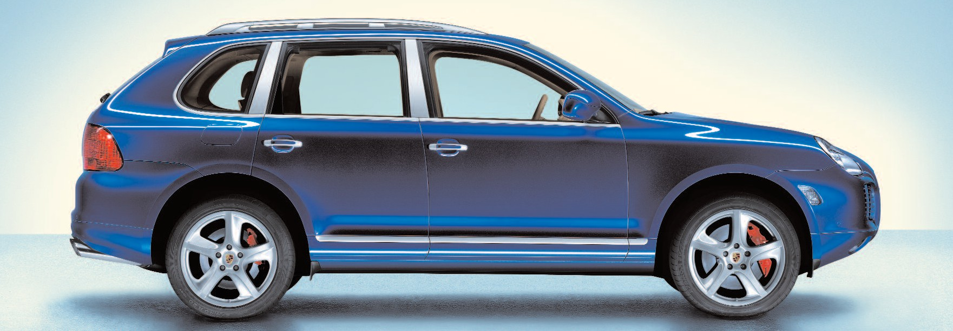all contradictions. Only by pushing to the limits and beyond do we arrive at what our customers expect: another exhilarating in- novation.

Each new idea should defy ex- pectations while offering generous scope for development. This ap- proach is just one of the benefits of our many years in international motorsport. Our passion for performance is directly expressed

the task of challenging limits that we ourselves have set. New engineering solutions were tested and refined, apparent contradictions resolved.

engages all the senses.

more athletic, more adept:

The new Cayenne Turbo S.

# Unprecedented energy. Inspirational sound. Powering the new Cayenne Turbo S.

between 2,750 and 3,750 rpm.

That’s 100 Nm more than in the standard Cayenne Turbo.

To achieve this performance, we’ve

610

580

550

520

490

460

430

780

750

720 Nm (2,750–3,750 rpm)

620 Nm (2,250–4,750 rpm)

383 kW (521 bhp)

331 kW (450 bhp)

Cayenne Turbo S Cayenne Turbo

720

690

660

630

600

Cayenne Turbo S: the name alone is enough to set the pulse racing. Encapsulated within it is a vision of superlative performance. In every type of tarmac and off-road terrain.

This powerful potential is some- thing you sense the moment you turn the key. The 4.5-litre twin-turbo V8 is derived from the Cayenne Turbo. Specially enhanced, its character and

capability are however unique to the Cayenne Turbo S.

Maximum power of 383 kW

(521 bhp) is available at 5,500 rpm. Maximum torque output is 720 Nm

combined a modified throttle map in the engine management system with a set of larger and more powerful intercoolers. The twin cooler units feature revised flow dynamics offering a major reduction in pressure losses. This, in turn, provides the thermo- dynamic basis for increased power and torque.

400

370

Power (kW)

340

310

280

250

220

190

160

130

100

500 1000 1500 2000 2500 3000 3500 4000 4500 5000 5500 6000 6500 7000

### Engine speed (rpm)

570

540

Torque (Nm)

510

480

450

420

390

360

330

300

270

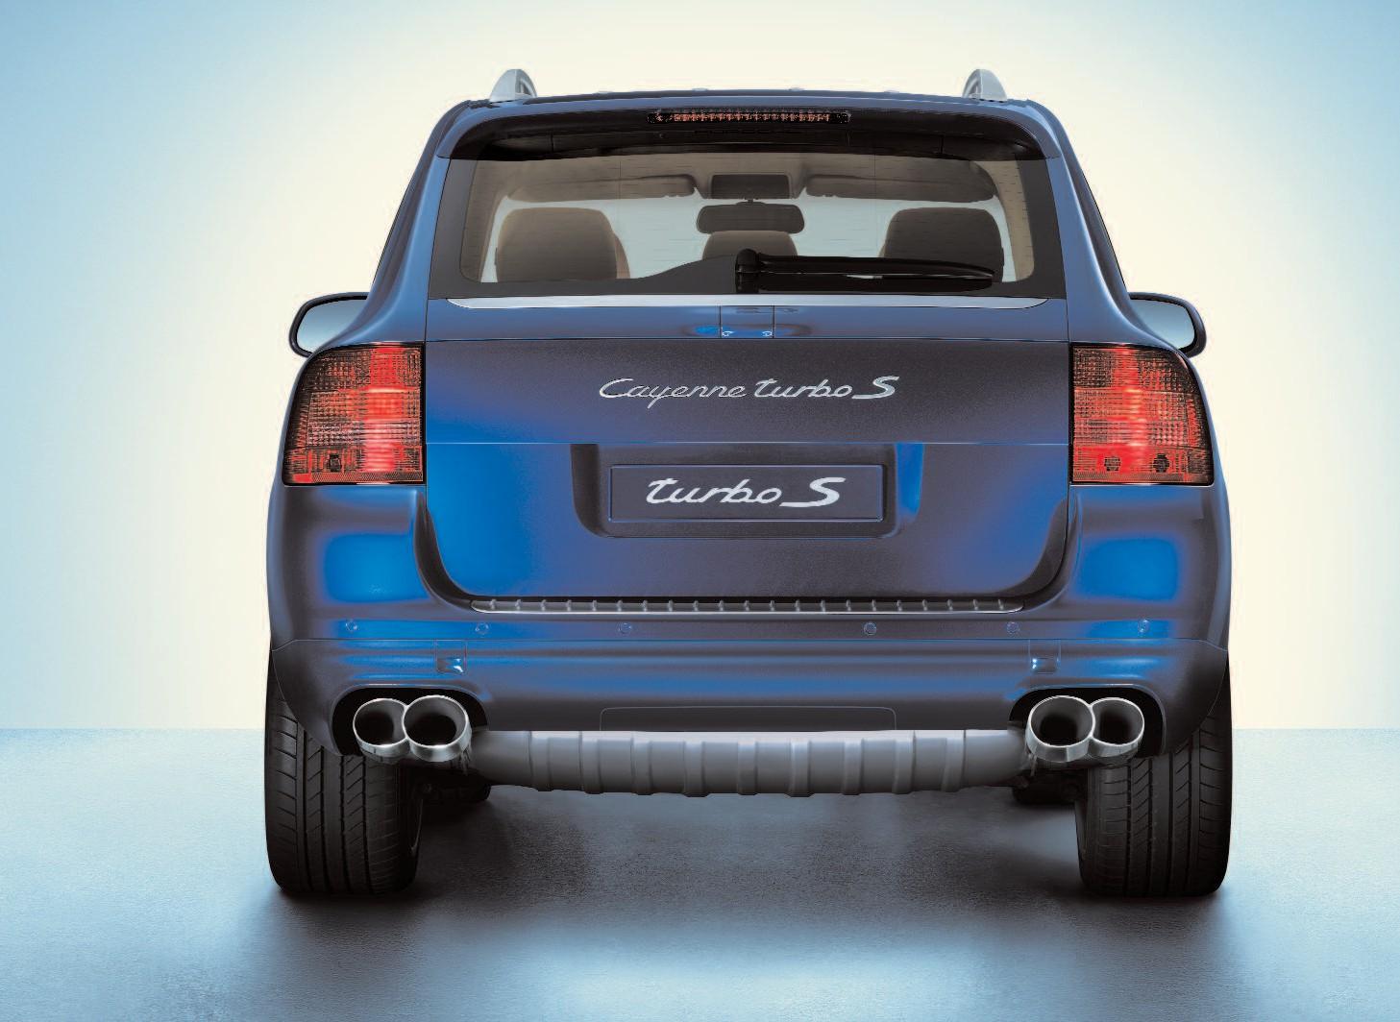So what does that mean in practice?

When you apply the throttle fully from a standing start, you are immediately aware of the gravi- tational forces as they press you into your seat. The standard 20-inch Cayenne SportTechno wheels ensure optimum traction against a powerful backdrop of sound.

The benchmark sprint to 100 km/h (62 mph) is completed in 5.2 sec- onds. In appropriate track condi- tions, you can stay on the power to a maximum speed of 270 km/h (168 mph).

When you lift off the throttle and apply the brakes, you’ll quickly discover how effectively this sys- tem has been matched to the car’s performance. This powerful deceleration is an essential feature in every Porsche vehicle.

# Power is only one aspect of performance. Transmission and chassis in the new Cayenne Turbo S.

The enormous potential of the Cayenne Turbo S engine is chan- nelled with precision through

a six-speed Tiptronic S gearbox. This automatic unit uses intelli- gent control to ensure optimum transmission on all types of tarmac and off-road terrain.

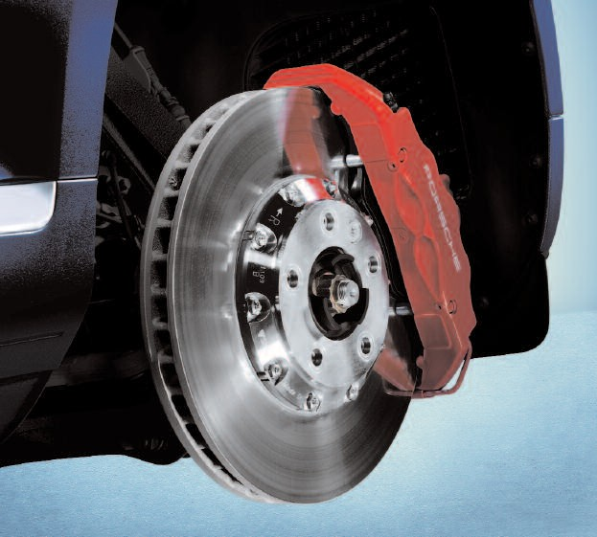

Brake disc and caliper

As on the Cayenne Turbo, the

all-round independent suspension features large-format double wishbones on each of the front wheels and a multi-link arrange- ment at the rear. To cope with the added power, we’ve made preci- sion modifications to a number

of front axle components, includ- ing the tie rods, wishbone mounts and shock absorber units. Added to these is the revised manage- ment software for the pneumatic suspension system.

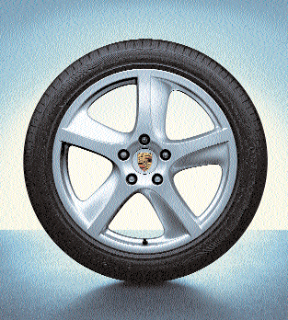

20-inch Cayenne SportTechno wheel

Another special feature on the Cayenne Turbo S is the uprated brake performance. The front wheels are fitted with six-piston monobloc aluminium calipers and internally vented, two-piece discs. The discs are larger than those on the Cayenne Turbo, measuring 380 mm in diameter and 38 mm in thickness, up from 350 mm and 34 mm, respectively.

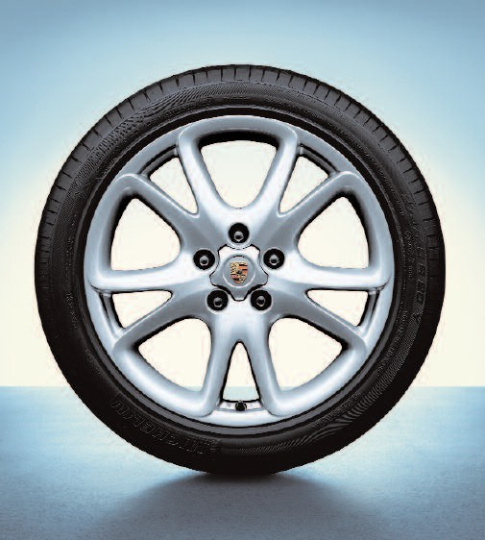

20-inch Cayenne SportDesign wheel

Front brake ventilation has been further enhanced with the aid

of specially developed cooling air ducts. The rear brake units feature four-piston monobloc calipers with internally vented discs. The rear disc diameter is 358 mm – increased from 330 mm on

the Cayenne Turbo – with an un- changed thickness of 28 mm. These generous proportions en- able measured control of the car’s enormous engine potential.

Other standard features include

20-inch Cayenne SportTechno wheels (20-inch Cayenne SportDesign wheels available as no-cost option). Tyre Pressure Monitoring (TPM) provides continuous surveillance

of all four tyre pressures and includes a status display in the instrument cluster. The permanent all-wheel drive system uses Porsche Traction Management (PTM) to vary the distribution of engine torque based on the relative levels of front

and rear grip. Porsche Stability Management (PSM) ensures optimum control in challenging situations, on and off-road.

And Porsche Active Suspension Management (PASM) provides continuous adjustment of damping force based on current road conditions and driving dynamics.

# The smallest details can make the biggest difference.

Exterior design and passenger compartment in the new Cayenne Turbo S.

The Cayenne Turbo S has a power- ful presence that is instantly recognisable. Externally, its char- acter is clearly conveyed through a range of subtle yet distinctive details. The most obvious of these is the new exterior colour – Marine Blue Metallic – which is exclusive to the Cayenne Turbo S. Colour-coded features include the front intake grilles, which are also available black as a no-cost option. Naturally, you can choose from all the other colour options currently available for the Cayenne range.

Viewed from the rear, the car’s athletic capability is elegantly reflected in the high-gloss four- tube sports tailpipes. A matching finish can also be found on the Cayenne Turbo S logo on the tailgate.

For even greater impact, you can enhance your Cayenne Turbo S with the optional SportDesign pack. Winner of an iF Design Award in 2005, it is the perfect addition to this superlative high- performance vehicle. Included

in the pack are a modified lower front moulding with integral round foglights, a modified lower rear moulding, a larger roof spoiler and specially designed side skirt elements. Aerodynamically re- fined in the Porsche wind tunnel, the SportDesign pack appears

to lower the car’s ride height to create a more purposeful stance on the road. Selected areas of the lower front moulding, diffuser- style rear moulding and roof spoiler element feature a matt Aluminium Look paint finish.*

Step inside and it is immediately apparent precisely which car you are in. The model designation can be found on the stainless steel door-sill guards (‘Cayenne turbo S’) and the cover for the air- conditioning controls (‘turbo S’).

The seats are upholstered in sumptuous leather with em- bossed Porsche Crest on each of the front head restraints. The padded leather steering wheel is elegantly designed with a secure and positive grip.

In short: the perfect environment for the ultimate Cayenne experi- ence.

Cockpit

Front view with SportDesign pack and 20-inch Cayenne SportTechno wheels in exterior colour

* Porsche recommends fitment of the SportDesign pack in combination with one of the darker exterior colours. Please note that this option reduces off-road capability.

Porsche Crest embossed on head restraint

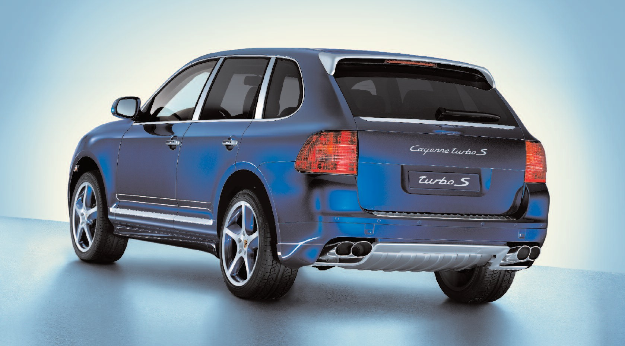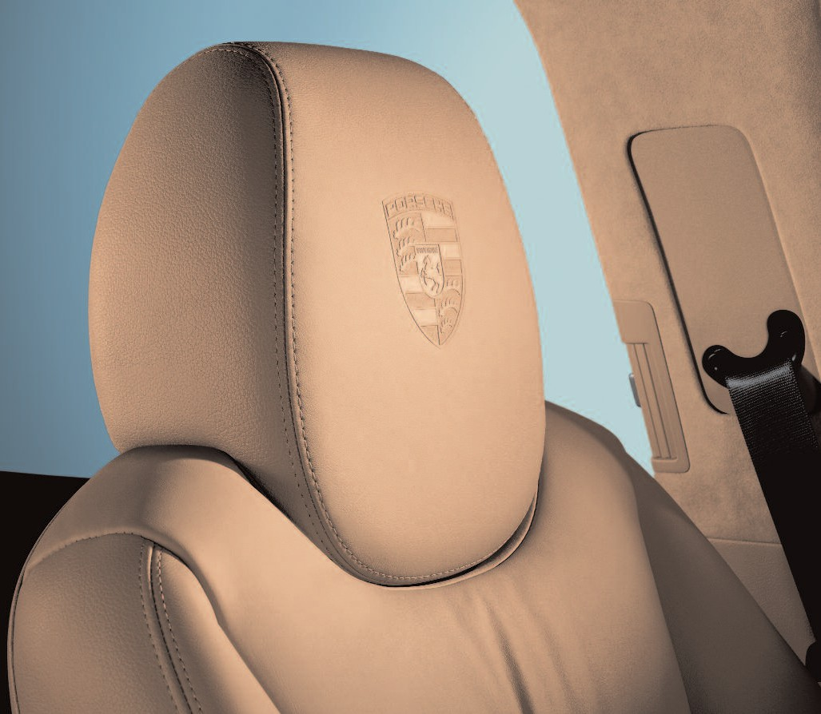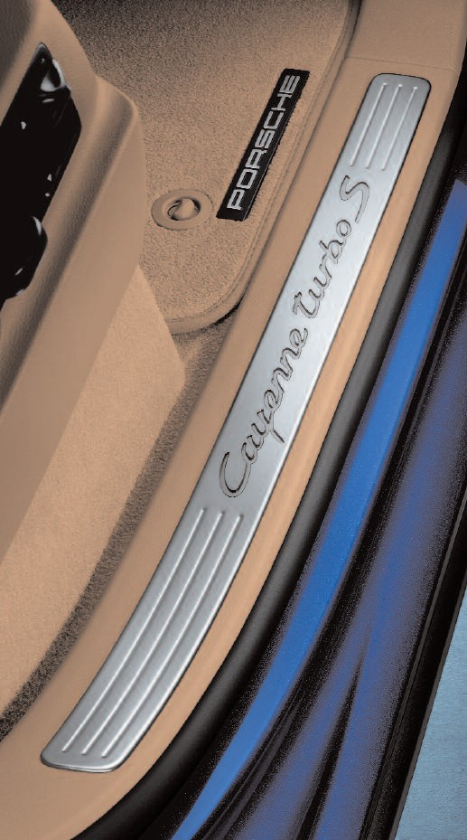Door-sill guard Rear view with SportDesign pack and 20-inch Cayenne SportTechno wheels in exterior colour

# Personalisation. Technical data.

Porsche recommends the following options* which are currently offered on the Cayenne Turbo (see Cayenne price list for more details).

Please note that some of the options available for the Cayenne Turbo are standard equipment on the Cayenne Turbo S.

## Option I no.

* SportDesign pack (see page 10)** 2D1, 2
* Porsche Entry & Drive System 4F2
* Privacy glass PJ2
* Panoramic roof system 3FU
* 20-inch Cayenne SportTechno wheel in exterior colour (see page 10) CY4
* Roll-up sunblinds on rear side windows 3Y4
* Electrically retractable towbar system 1D9
* Three-spoke multifunction steering wheel in leather PI1, 2
* Sports seats (front) PE3
* Four-zone air-conditioning system 9AH
* Auxiliary heating system 7VL
* TV tuner for PCM (analogue terrestrial reception)*** QV1
* Reversing camera 7X1
* PCM telephone module with active handset 9ZP
* Six-disc CD autochanger 7A2
* Servotronic 1N3
* Ski-bag 3X1
* HomeLink® (garage-door opener) VC1
* Light Comfort pack PO2
* Electronic logbook 9NY
* Voice control for PCM QH1

* The options presented here are just a few of the possibilities available for your Porsche.

Panoramic roof system

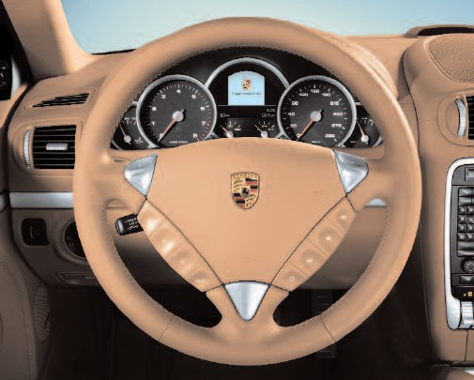

Three-spoke multifunction steering wheel

in padded leather

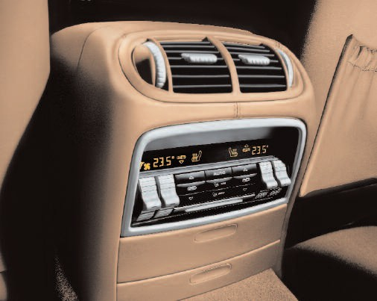

Four-zone air-conditioning system

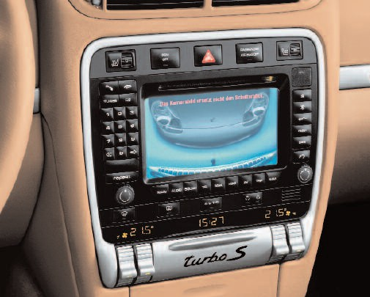

Reversing camera display in PCM

## Engine

Cylinders 8

Displacement 4,511 cm3

Max. power 383 kW (521 bhp)

at 5,500 rpm

Max. torque 720 Nm

## at 2,750 –3,750 rpm

Compression ratio 9.5 : 1

## Transmission

Layout All-wheel drive

Tiptronic S (standard) Six-speed

Low-range gear ratio 2.7

## Chassis

Front axle Independent double- wishbone suspension

Rear axle Independent multi-link suspension

Steering Power-assisted (hydraulic)

Brakes (front) Six-piston monobloc aluminium calipers; internally vented, two-piece discs;

disc diameter: 380 mm; disc thickness: 38 mm

Brakes (rear) Four-piston monobloc aluminium calipers; internally vented discs; disc diameter: 358 mm; disc thickness: 28 mm

Wheels (front) 9J x 20,

Wheels (rear) 10J x 20**

Tyres 275 /40 R 20

## Weights

Unladen weight (DIN) 2,355 kg Unladen weight (EC)* 2,430 kg Permissible gross weight 3,080 kg Payload 725 kg

## Performance

Top speed 270 km/ h (168 mph)

0 –100 km/h (0 – 62 mph) 5.2 secs

Flexibility 80 –120 km/h

(50 –75 mph) 5.4 secs (5th gear)

## Fuel consumption/emissions

In accordance with 80/1268/EC as valid at time of going to press:

## Urban 21.9 l/100 km (12.9 mpg)

Extra urban 11.9 l/100 km (23.7 mpg)

Combined 15.7 l/100 km (18.0 mpg)

CO2 emissions 378 g/km

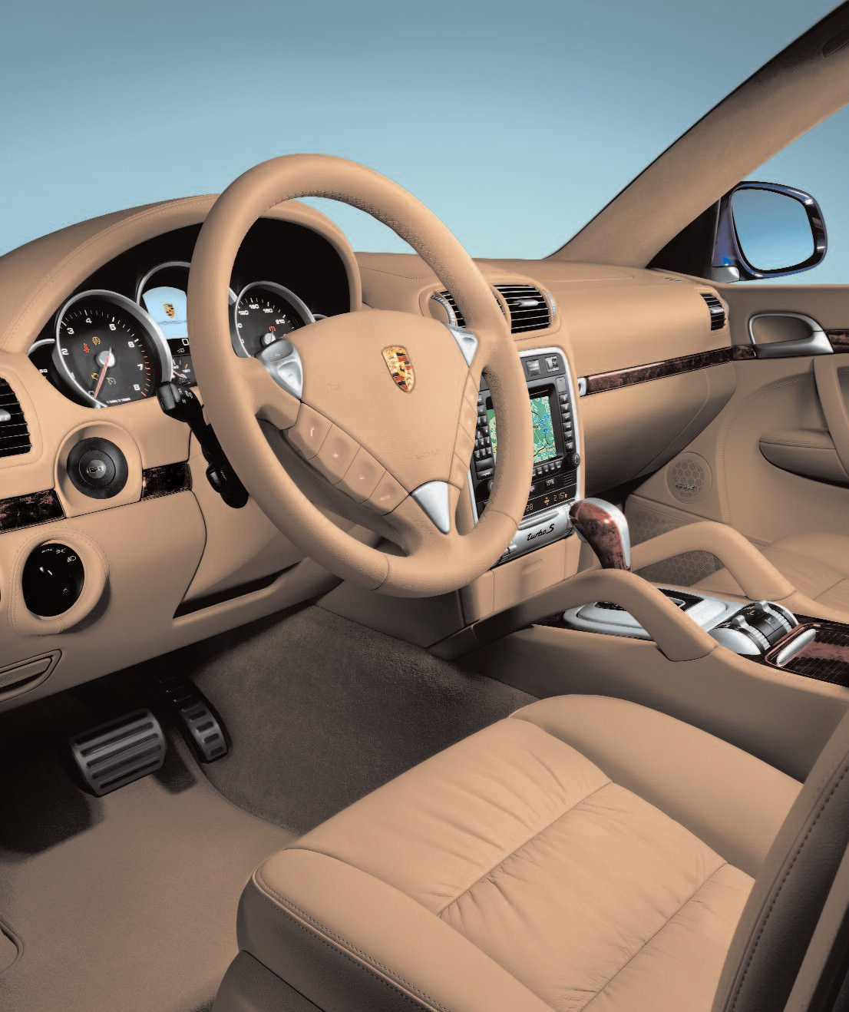To view the full range of options, please refer to the Cayenne Turbo S price list.

** Fitment restricts off-road capability.

*** Terrestrial television may be unavailable in some areas.

* Weight is calculated in accordance with the relevant EC Directives and is valid for standard specification vehicles only. Optional equipment means greater weight. The figure given includes 68 kg representing the driver and 7 kg for luggage.

** Optional: 9J x 20 front and rear if fitted with 20-inch Cayenne SportDesign wheels.