# Always mid-engined. Never middle ground.

Boxer engines.

At Porsche, the mid-mounted boxer engine is more than a tradition, it is a legend.

One of the most renowned examples of its use was in the 550 Spyder. In conjunction with an intelligent lightweight construction, this arrangement delivered outstanding agility and cornering dynamics and proved to be a key factor in the countless victo- ries achieved on some of the world’s

most famous racetracks. In the 1960s, the 718 RS 60 Spyder contributed to the triumphant success of the mid-engined race car with wins in hillclimbing and endurance events.

The mid-mounted engine belongs at Porsche and it belongs in the Boxster. The advantages speak for themselves. The concentration of mass close to the centre of the vehicle and the low centre of gravity produce extraordinary agility and cornering dynamics. At the same time, weight is uniformly distributed between the front and rear axles and handling characteristics are particularly well balanced. The combined result enables the driver to fully enjoy every corner and maintain excellent control over the vehicle.

For us, there are many reasons to remain faithful to the mid-mounted engine con- cept, to keep transferring performance from the racetrack to the road and to continue to combine tradition with innova- tion. And we do this always on the proviso that high power is achieved with comparatively low fuel consumption and emission figures.

With this aim, we developed two compact and lightweight boxer engines that are characterised by their ability to deliver high levels of power and efficiency simul- taneously. Both engines are equipped

with efficient technologies as standard, including VarioCam Plus, direct fuel injection (DFI), auto start/stop, electrical system recuperation and enhanced thermal management.

What else could we have given the

mid-mounted engine? An even more agile response. One press of the SPORT button on the centre console makes engine performance even more dynamic for driving pleasure at the limits of performance. Let’s take a look in more detail.

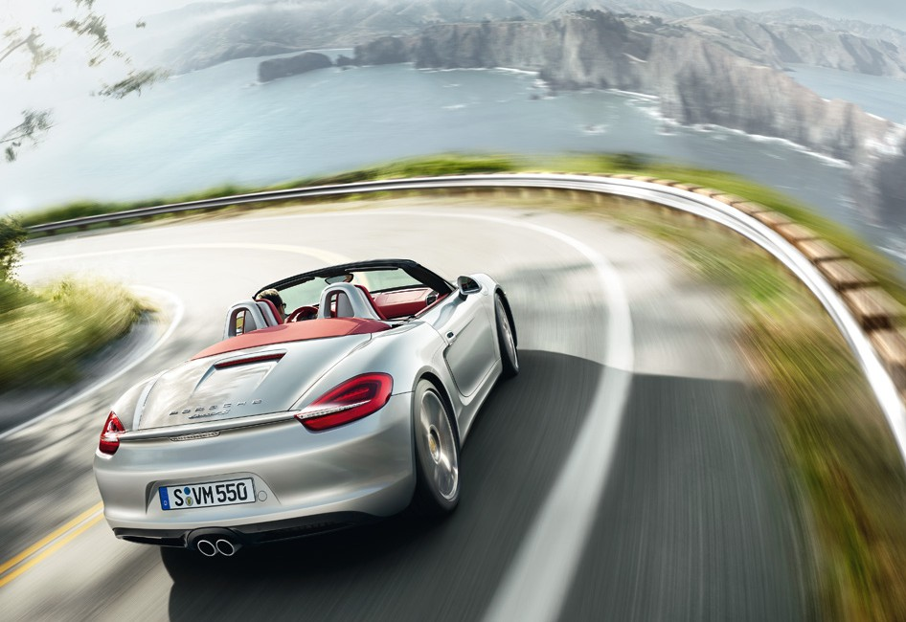

28

29

For fuel consumption, CO2 emissions and efficiency class please refer to page 131.

Forward thrust | Engine

280

260

240

220

200

Power (kW)

180

160

140

120

100

80

60

40

1000

195 kW (265 hp)

280 Nm

1500

2000 2500 3000 3500 4000 4500 5000 5500 6000 6500 7000

Engine speed (rpm)

7500 8000

440

420

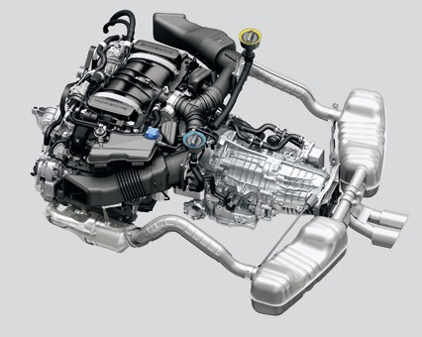

3

400

380

360

Torque (Nm)

340

320

300

280

260

240

220

200

1

280

260

240

220

200

Power (kW)

180

160

140

120

100

80

60

40

1000

232 kW (315 hp)

360 Nm

1500

2000 2500 3000 3500 4000 4500 5000 5500 6000 6500 7000

Engine speed (rpm)

7500 8000

440

420

400

380

360

Torque (Nm)

340

320

300

280

260

240

220

200

2

## 2.7-litre engine.

The Boxster is equipped with a 2.7-litre flat-six engine with direct fuel injection (DFI) and VarioCam Plus. It generates 195 kW (265 hp) at 6,700 rpm. The maximum torque of 280 Nm is available over a broad engine speed range from 4,500 to 6,500 rpm.

The Boxster with six-speed manual gearbox accelerates from 0 to 100 km/h in 5.8 seconds and reaches a top speed of 264 km/h. With the optional Porsche Doppelkupplung (PDK), it completes the 0 to 100 km/h sprint in 5.7 seconds and

achieves a maximum speed of 262 km/h. In conjunction with the optional Sport

Chrono Package, the sprint time is reduced to just 5.5 seconds.

## 3.4-litre engine.

The Boxster S is powered by a 3.4-litre flat-six engine with direct fuel injection (DFI) and VarioCam Plus. It develops 232 kW (315 hp) at 6,700 rpm and the

maximum torque of 360 Nm is produced between 4,500 and 5,800 rpm.

The Boxster S with six-speed manual gearbox races from 0 to 100 km/h in

5.1 seconds and reaches a top speed of 279 km/h. With optional PDK, an accelera- tion time of 5.0 seconds and a maximum speed of 277 km/h are achieved. In con- junction with the optional Sport Chrono

Package, the Boxster S with PDK finishes the sprint in only 4.8 seconds.

1. Power output and torque chart for the Boxster
2. Power output and torque chart for the Boxster S
3. Engine, gearbox and exhaust system of the Boxster S
4. Boxster S engine

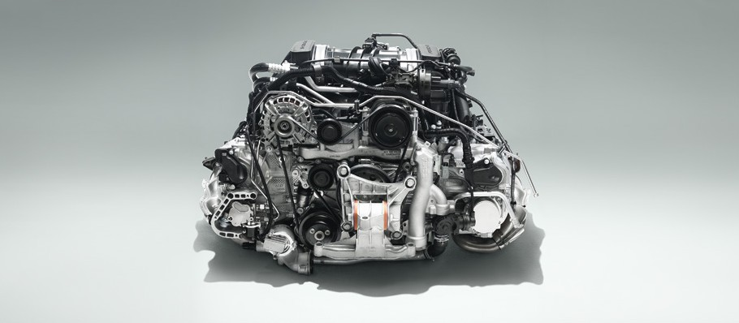

4

Forward thrust | Engine

For fuel consumption, CO2 emissions and efficiency class please refer to page 131.

30

31

## Resonance intake manifold.

The resonance effect, where the air mass inside the intake manifold is caused to oscillate, is used to optimise the induction process at all engine speeds. The engine in the Boxster S is additionally equipped with a switchable resonance valve.

The results are high torque, a flatter torque curve and high power output. The sound produced is characteristically resonant and deep, as you would expect of a Boxster.

## Direct fuel injection (DFI).

Direct fuel injection (DFI) is featured as standard in both Boxster models.

Multi-hole injectors deliver fuel directly into the combustion chamber with milli- second precision. The injection pattern has been optimised for torque, power output, fuel consumption and emissions.

With direct injection, the engine manage- ment system regulates injection timing individually for each cylinder, as well as the injection rate for each cylinder bank. This optimises the combustion process and therefore fuel economy. Depending on the engine operating conditions, multi- ple fuel injections can take place on each operating cycle. This allows the catalytic

converter to reach normal operating temperature sooner after a cold start and a higher maximum torque to be achieved.

DFI improves the internal cooling of the combustion chamber by having the mixture prepared directly in the cylinder. This allows for a higher compression ratio, which helps to deliver higher power output at the same time as enhanced engine efficiency. Injection is regulated by the electronic engine management system and emissions are monitored by the stereo Lambda sensors.

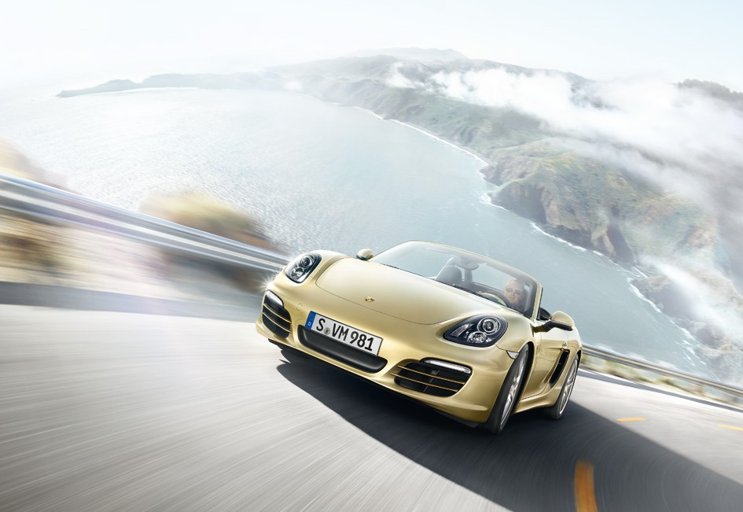

For fuel consumption, CO2 emissions and efficiency class please refer to page 131.

32

33

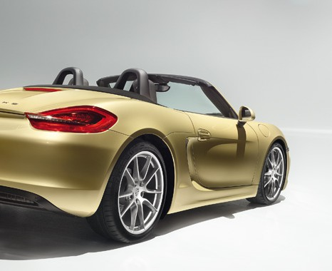

## VarioCam Plus.

VarioCam Plus is a two-in-one engine concept for adjusting the intake camshafts and switching the lift of the intake valves.

The system first differentiates between driver inputs that typify normal, everyday driving and those inputs that demand maximum performance. The electronic engine management system then imperceptibly adapts valve operation

to the prevailing conditions.

This results in instant acceleration and extremely smooth running.

In short, VarioCam Plus provides extraordinary power with comparatively low fuel consumption.

## Integrated dry-sump lubrication.

Integrated dry-sump lubrication ensures

a reliable supply of oil even when a sporty driving style is adopted and the vehicle is experiencing powerful lateral acceleration. It also has additional cooling functions.

The oil tank is located in the engine, thereby eliminating the need for an exter- nal oil tank which saves both space

and weight.

To reduce power losses and increase efficiency, an electronically controlled oil pump supplies the lubricating points inside the engine as and when required. This results in optimum supply of oil, lower fuel consumption and reduced emissions.

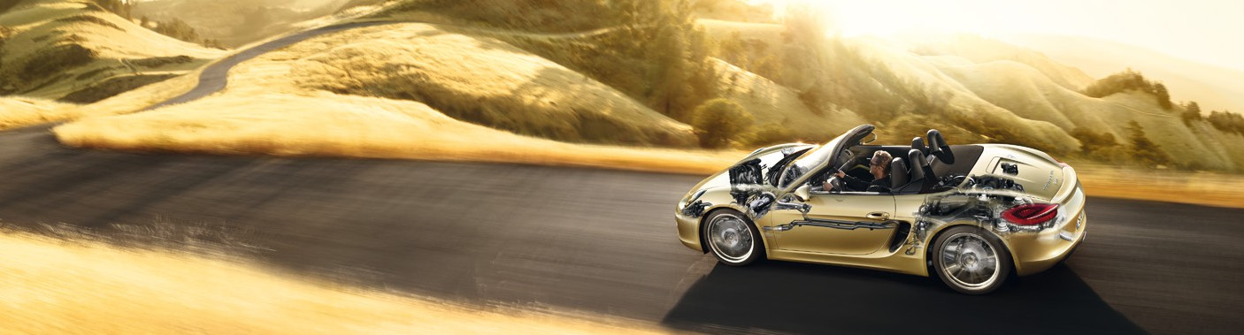

Forward thrust | Engine

For fuel consumption, CO2 emissions and efficiency class please refer to page 131.

34

35

## Thermal management.

The Boxster models feature a new version of thermal management to reduce friction losses that arise during the warm-up phase.

Thanks to the selective control strategy and on-demand, gradual activation of the various cooling circuits, the engine and gearbox warm up to normal operating temperature more rapidly. The conse- quent reduction in friction also reduces fuel consumption and CO2 emissions.

During sporty driving, thermal manage- ment also acts to reduce temperatures so that a high level of performance is maintained.

Our cross-flow cooling system, as used in motorsport, supplies each engine cylinder uniformly with coolant, which protects the valves against thermal overload and, therefore, premature wear. This improves combustion and keeps emissions, fuel consumption and noise comparatively low.

## Exhaust system.

In the Boxster models, each cylinder bank has its own stainless-steel exhaust tract. Downstream of their respective rear silencer, the tracts converge into a connecting tube and a single (Boxster) or twin (Boxster S) tailpipe. The stereo Lambda control circuitry controls and

monitors each cylinder bank separately. For each exhaust tract, four correspond- ing oxygen sensors regulate the composi- tion of the exhaust gas and monitor the performance of the catalytic converters. Having separate tracts means that the exhaust gas can flow more freely. The resulting reduction in pressure loss has a positive impact on power output, torque and the unmistakable engine sound.

Available as an option for the Boxster models is the sports exhaust system including sports tailpipe. It produces an even more resonant Porsche sound.

1 Boxster tailpipe

2 Boxster S twin tailpipe

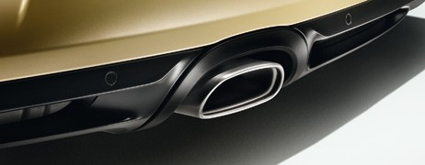

1

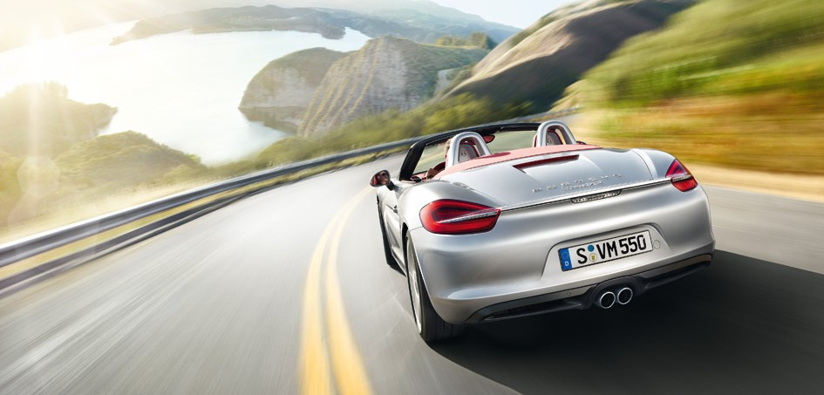

36

37

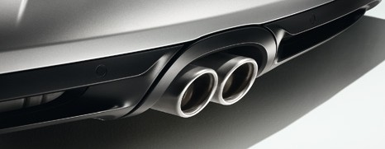

2

For fuel consumption, CO2 emissions and efficiency class please refer to page 131.

Forward thrust | Engine

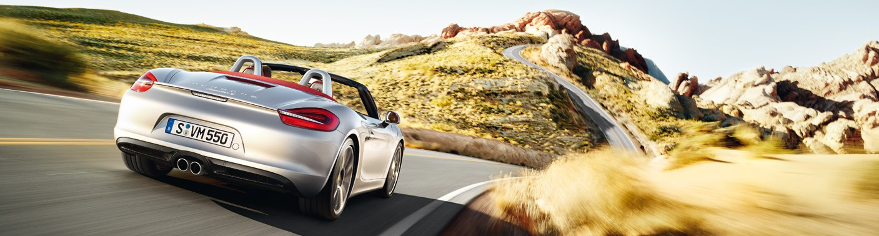

## Engine management.

The electronic engine management system ensures optimum engine perfor- mance at all times. It regulates all engine-related functions and assemblies. The results are optimum power output and torque with comparatively low fuel consumption and emissions.

Another function is the cylinder-specific knock control. Since engine cylinders never all work under exactly the same conditions, the knock control function monitors each one separately. The igni- tion point is shifted individually, as and when necessary, to protect the cylinders and pistons at high engine speeds and

loads. For compliance with EU Standards, the on-board diagnostics detect any faults and defects that may occur in the exhaust and fuel systems and then

notify the driver immediately. This also prevents increased pollutant emissions and unnecessary fuel consumption.

## SPORT button.

The SPORT button on the centre console is fitted as standard. When selected, ‘Sport’ mode is activated to provide greater response and enhanced driving pleasure. Throttle response becomes even more direct, the rev-limiter is adjusted to a harder setting and engine dynamics are

tuned for performance driving. The auto start/stop function is also deactivated.

With the optional Porsche Doppelkupplung (PDK) transmission, the shift points

are reconfigured to operate at higher engine speeds. Shift times are reduced and gearshifts become firmer and more

immediate, while throttle-blip downshifts are accompanied by an emotive engine sound. Coasting mode (p. 46) is deacti- vated automatically.

1 SPORT button

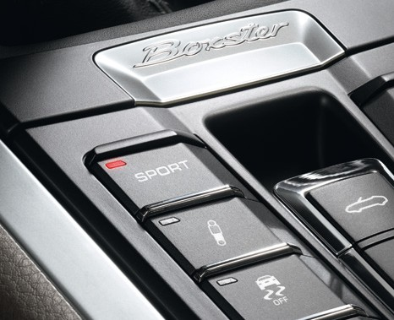

1

Forward thrust | Engine

For fuel consumption, CO2 emissions and efficiency class please refer to page 131.

38

39

## Auto start/stop function.

The auto start/stop function, which is integrated as standard in the Boxster models, switches off the engine when you stop, select neutral and release the clutch pedal. In cars with Porsche Doppelkupplung (PDK), it is simply a case of applying and holding the brake.

All audio and communication systems remain switched on. The engine will restart as soon as you operate the clutch or, in cars with PDK, release the brake.

This fuel-saving innovation is designed primarily for use in towns or congested motorway traffic.

The auto start/stop function can be deactivated and reactivated using a sepa- rate button on the centre console. The function may be deactivated automatical- ly under particular circumstances, for example in extreme outside tempera- tures, when the SPORT button is selected or when there is low battery charge.

## Cruise control.

This optional automatic speed controller for the 30 to 240 km/h speed range is operated using a switch on a separate control stalk on the steering column. The advantages are clear, not only can cruise control be used as a means of staying

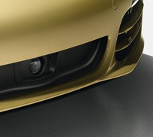

2

within the speed limit, it also helps you to save fuel by maintaining a constant speed.

## Adaptive cruise control including Porsche Active Safe (PAS).

Also available as an option is the enhanced version of cruise control, which

regulates the speed of your vehicle in line with the speed of the vehicle in front. A radar sensor scans the road ahead up to a distance of 200 m.

Imagine you’ve selected a cruising speed but have begun to gain on the vehicle in

front because it is driving more slowly – this is detected by the radar sensor. The system now reduces the speed of your vehicle by restricting throttle or by gently applying the brakes until your chosen distance from the vehicle in front is main- tained. If the vehicle ahead slows further,

adaptive cruise control will decelerate your vehicle accordingly – even down to a halt.

1 Auto start/stop button

2 Adaptive cruise control radar sensor

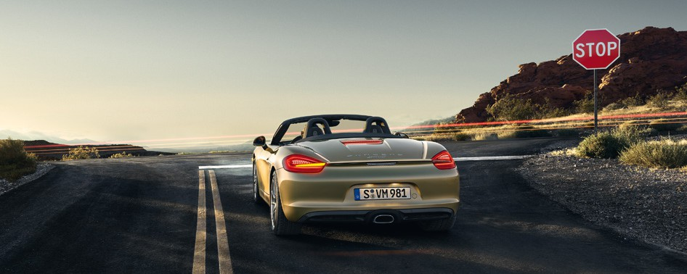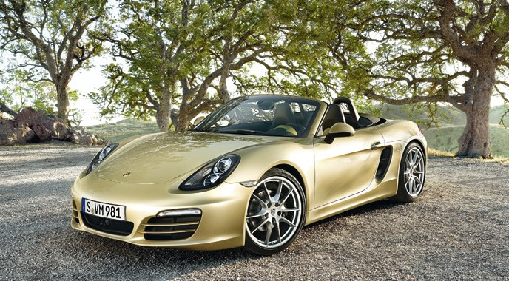

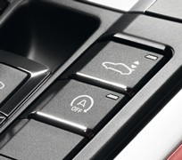

1

Forward thrust | Engine

For fuel consumption, CO2 emissions and efficiency class please refer to page 131.

40

41

For increased safety, the system also readies the brakes whenever it detects that the distance from the vehicle is decreasing. However, the driver should be prepared to intervene manually if heavier braking is required. As soon as the road ahead clears, your vehicle will accelerate back up to the cruising speed originally set.

Porsche Active Safe (PAS) issues an audi- ble and a visual warning if the system detects that your vehicle is approaching the vehicle in front too quickly. This is accompanied by a brief application of brake force and, where necessary, the

initiation of targeted braking. During this process, any braking by the driver is boosted to achieve the maximum braking force that the system is able to provide.

## Electrical system recuperation.

For enhanced efficiency the Boxster models are equipped with intelligent elec- trical system recuperation. The vehicle battery is recharged by the generator predominantly under braking. Thanks to this selective recharging, when you request full driving power the maximum possible output can be directed straight to the road.

## Servicing.

In the Boxster models, the generator and air conditioning system are driven by a single self-adjusting belt. The drive chains on the camshafts do not normally require servicing. With the sole exception of the spark plugs, the ignition system is also maintenance-free in normal servicing. In short, longer service intervals mean longer- lasting driving pleasure.

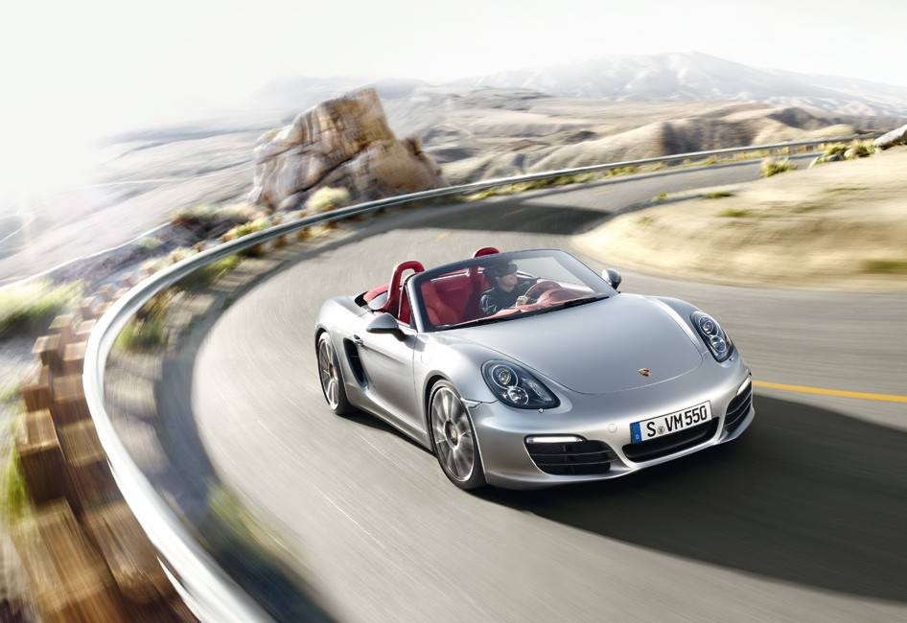

42

43

For fuel consumption, CO2 emissions and efficiency class please refer to page 131.

Forward thrust | Engine

5 7 3 1R 2 6 4

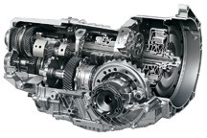

4

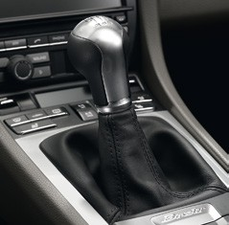

1

# Act or relax as you please. Transmission.

## Six-speed manual gearbox.

Both Boxster models are equipped as standard with a lightweight six-speed manual gearbox. Gearshifts are smooth and optimally adapted to the respective engine map. Shift throws are short and sporty and the gear lever is easy to oper- ate, enabling a rapid gearshift action and providing a truly engaging driving experi- ence. The upshift indicator located in the central circular instrument helps you to maximise fuel efficiency.

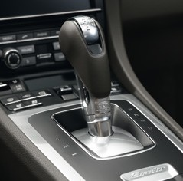

2

The ascending centre console gives you an authentic sports car feel. It positions the gear lever close to the steering wheel, which enables you to change gear as fast and as ergonomically as possible. In con- junction with the optional Sport Chrono

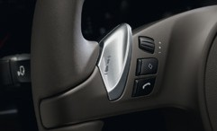

3

Package, the SPORT PLUS button acti- vates the throttle-blip function to make the gearshift process an even more engaging experience.

Porsche Doppelkupplung (PDK). Available as an option for the Boxster models is 7-speed Porsche Doppelkupplung (PDK), featuring both manual and automatic modes. PDK offers extremely fast gear changes with no interruption in the flow of power, improved acceleration over the man- ual gearbox, very short response times, reduced fuel consumption and a distinct increase in comfort.

In total, PDK has seven forward gears at its disposal. Gears 1 to 6 have a sports ratio and top speed is reached in 6th gear.

The 7th gear ratio is longer and keeps engine speed low to improve ride comfort and reduce fuel consumption at higher speeds.

The design of PDK is similar to two conventional gearboxes in one. The odd numbered gears are housed on one assembly and the even numbered gears on another, each having its own clutch. While one gear is engaged, PDK pre-selects the next gear based on driver input. When the next gear is requested, drive is switched from one clutch to the other in millisec- onds, delivering gear changes with no loss of drive.

With the SPORT button selected, the full advantages of PDK are brought into play:

1 Gear lever for six-speed manual gearbox

2 PDK gear selector

3 PDK gearshift switches on multifunction steering wheel

4 Porsche Doppelkupplung (PDK) Half gearbox 1: gears 1, 3, 5, 7, R

Half gearbox 2: gears 2, 4, 6

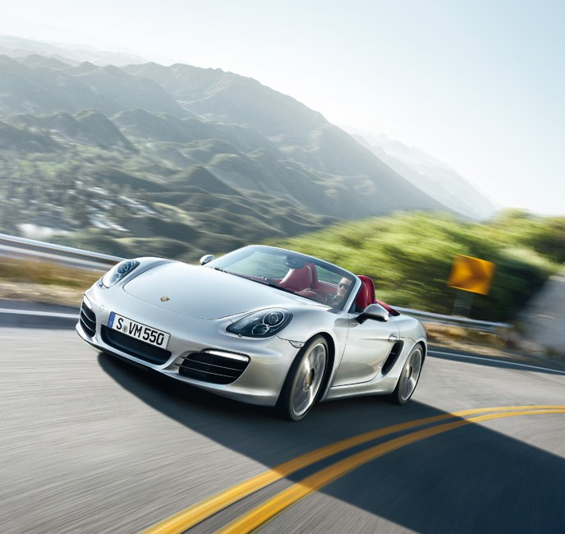

For fuel consumption, CO2 emissions and efficiency class please refer to page 131.

44

45