**PIZZA SALES SQL QUERIES**

**A. KPI’S**

**1. Total Revenue:**

SELECT SUM(total_price) AS Total_Revenue FROM pizza_sales;

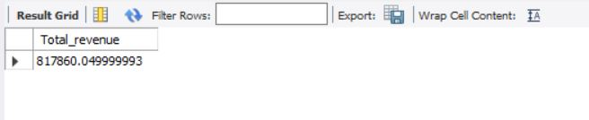

**2. Average Order Value**

SELECT (SUM(total_price) / COUNT(DISTINCT order_id)) AS Avg_order_Value FROM pizza_sales

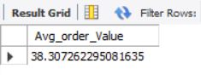

**3. Total Pizzas Sold**

SELECT SUM(quantity) AS Total_pizza_sold FROM pizza_sales

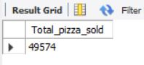

**4. Total Orders**

SELECT COUNT(DISTINCT order_id) AS Total_Orders FROM pizza_sales

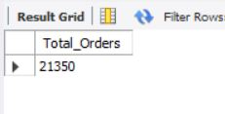

**5. Average Pizzas Per Order**

SELECT CAST(CAST(SUM(quantity) AS DECIMAL(10,2)) /

CAST(COUNT(DISTINCT order_id) AS DECIMAL(10,2)) AS DECIMAL(10,2))

AS Avg_Pizzas_per_order

FROM pizza_sales

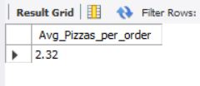

**B. Daily Trend for Total Orders**SELECT DAYNAME(STR_TO_DATE(order_date, '%d-%m-%Y')) AS order_day, COUNT(DISTINCT order_id) AS total_orders

FROM pizza_sales

GROUP BY DAYNAME(STR_TO_DATE(order_date, '%d-%m-%Y'));  
***Output:***

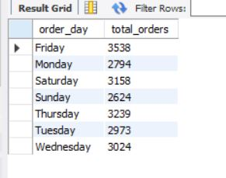

**C. Monthly Trend for Orders**

SELECT MONTHNAME(STR_TO_DATE(order_date, '%d-%m-%Y')) AS Month_Name, COUNT(DISTINCT order_id) AS Total_Orders

FROM pizza_sales

GROUP BY MONTHNAME(STR_TO_DATE(order_date, '%d-%m-%Y'));  
***Output***

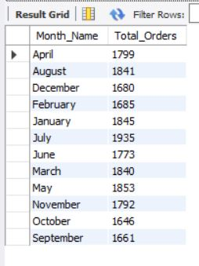

**D. % of Sales by Pizza Category**

SELECT pizza_category, CAST(SUM(total_price) AS DECIMAL(10,2)) as total_revenue,

CAST(SUM(total_price) * 100 / (SELECT SUM(total_price) from pizza_sales) AS DECIMAL(10,2)) AS PCT

FROM pizza_sales

GROUP BY pizza_category

***Output***

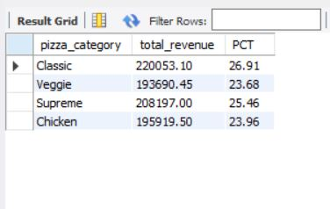

**E. % of Sales by Pizza Size**

SELECT pizza_size, CAST(SUM(total_price) AS DECIMAL(10,2)) as total_revenue,

CAST(SUM(total_price) * 100 / (SELECT SUM(total_price) from pizza_sales) AS DECIMAL(10,2)) AS PCT

FROM pizza_sales

GROUP BY pizza_size

ORDER BY pizza_size

***Output***

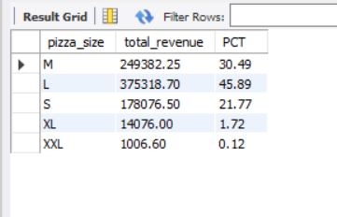

**F. Total Pizzas Sold by Pizza Category**

SELECT pizza_category, SUM(quantity) as Total_Quantity_Sold  
FROM pizza_sales  
GROUP BY pizza_category  
ORDER BY Total_Quantity_Sold DESC;  
***Output***

**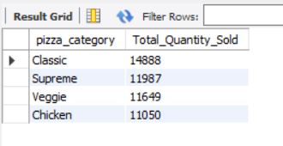  
G. Total Revenue**SELECT pizza_name, SUM(total_price) AS Total_Revenue   
FROM pizza_sales  
GROUP BY pizza_name  
ORDER BY Total_Revenue DESC  
***Output***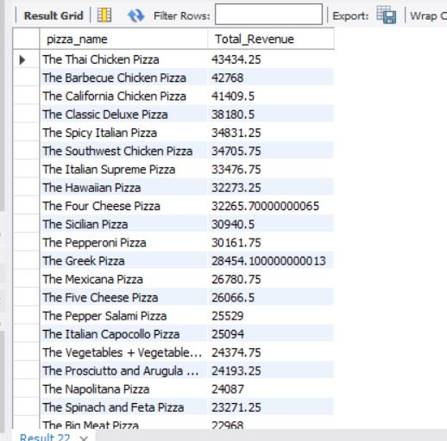

**H. Top 5 Pizzas by Revenue**

SELECT pizza_name, SUM(total_price) AS Total_Revenue  
FROM pizza_sales

GROUP BY pizza_name

ORDER BY Total_Revenue DESC

LIMIT 5;  
***Output***

**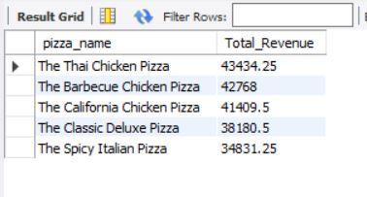  
  
I. Bottom 5 Pizzas by Revenue**

SELECT pizza_name, SUM(total_price) AS Total_Revenue

FROM pizza_sales

GROUP BY pizza_name

ORDER BY Total_Revenue ASC

LIMIT 5;  
  
***Output*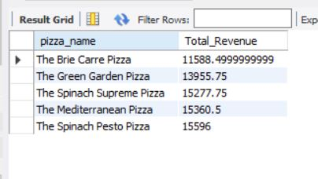**

**J. Top 5 Pizzas by Quantity**

SELECT pizza_name, SUM(quantity) AS Total_Quantity

FROM pizza_sales

GROUP BY pizza_name

ORDER BY Total_Quantity DESC

LIMIT 5;

***Output***

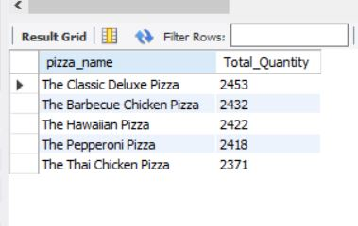

**K. Bottom 5 Pizzas by Quantity**

SELECT pizza_name, SUM(quantity) AS Total_Quantity

FROM pizza_sales

GROUP BY pizza_name

ORDER BY Total_Quantity ASC

LIMIT 5; ***Output***

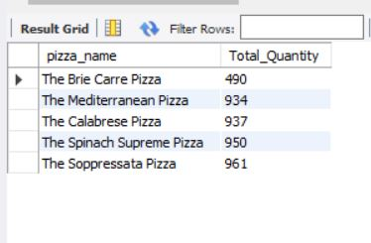

**L. Top 5 Pizzas by Total Orders**

SELECT pizza_name, COUNT(DISTINCT order_id) AS Total_Orders

FROM pizza_sales

GROUP BY pizza_name

ORDER BY Total_Orders ASC

LIMIT 5;  
***Output***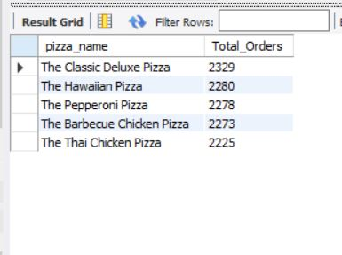

**M. Bottom 5 Pizzas by Total Orders**

SELECT pizza_name, COUNT(DISTINCT order_id) AS Total_Orders

FROM pizza_sales

GROUP BY pizza_name

ORDER BY Total_Orders ASC

LIMIT 5; ***Output  
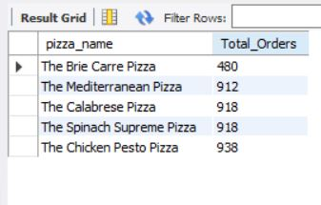***

***NOTE***

If you want to apply the pizza_category or pizza_size filters to the above queries you can use WHERE clause. Follow some of below examples

SELECT Top 5 pizza_name, COUNT(DISTINCT order_id) AS Total_Orders

FROM pizza_sales

WHERE pizza_category = 'Classic'

GROUP BY pizza_name

ORDER BY Total_Orders ASC

Percentage of sales by pizza category for 1st month jan  
  
Select pizza_category, CAST(SUM(total_price) AS DECIMAL(10,2)) as total_revenue, CAST(sum(total_price) * 100 / (Select sum(total_price) from pizza_sales Where DATE_FORMAT(STR_TO_DATE(order_date, '%d-%m-%Y'), '%m') = 1) AS DECIMAL(10,2)) As PCT from pizza_sales Where DATE_FORMAT(STR_TO_DATE(order_date, '%d-%m-%Y'), '%m') = 1 GROUP BY pizza_category;  
  
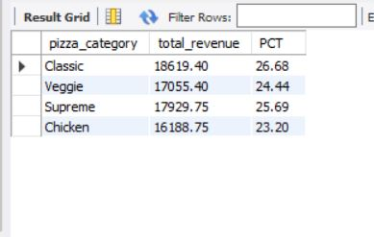  
  
Total pizza sold by pizza category

SELECT pizza_category, SUM(quantity) as Total_Quantity_Sold

FROM pizza_sales

WHERE MONTH(STR_TO_DATE(order_date, '%d-%m-%Y')) = 2

GROUP BY pizza_category

ORDER BY Total_Quantity_Sold DESC;  
  
