1. **Total Sales : -**Select format(sum(Total),3) As Total_sales from sales;  
     
   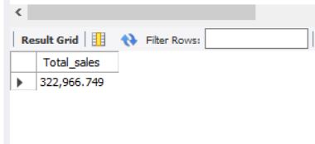
2. **Total Profit : -**Select round(sum(Total - cogs),3) As Total_profit from sales;  
     
   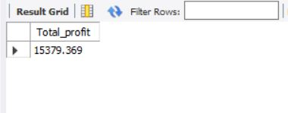  
     
   the total column and cogs the cost of goods sold has been minus and sum up the total for profit
3. **Total Quantity : -**Select sum(Quantity) from sales;  
     
   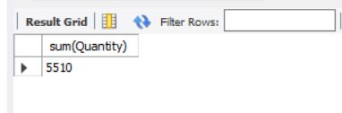
4. **Total Payment : -**Select count(payment) from sales; 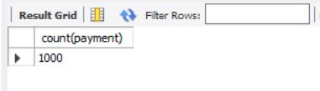
5. **Total Tax % : -**Select round(sum(tax_5),3) from sales; 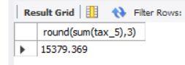
6. **Gender By Total Sales : -**Select gender, round(sum(Total),2) As Total_sales from sales group by gender order by Total_sales desc; 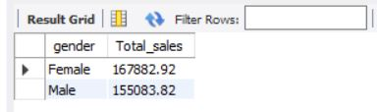
7. **Total Sales By City : -**Select city, round(sum(Total),3) AS Total_sales from sales group by city order by Total_sales desc; 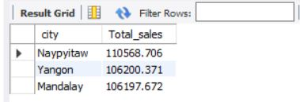
8. **Total Sales By Branch : -**Select Branch, round(sum(Total),3) As Total_sales from sales group by branch order by Total_sales desc; 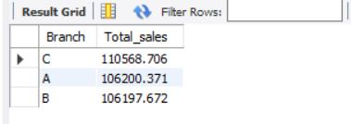
9. **Total Sales By Product : -**Select Product_line, round(sum(Total),2) As Total_sales from sales group by Product_line order by Total_sales desc; 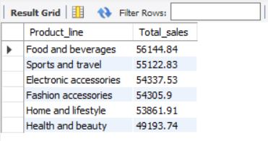
10. **Total Sales By Profit From Particular City : -**Select City, round(sum(Total - cogs),2) As Total_profit from sales group by City; 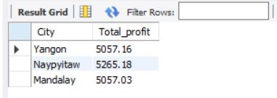
11. **Total Sales By Year : -**SELECT YEAR(STR_TO_DATE(Date, '%m/%d/%Y')) AS Years, SUM(Total) AS Total_sales FROM sales GROUP BY YEAR(STR_TO_DATE(Date, '%m/%d/%Y')) ORDER BY Total_sales; 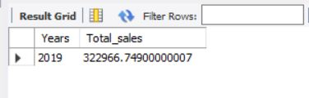
12. **Total Sales By Month : -**SELECT MONTH(STR_TO_DATE(Date, '%m/%d/%Y')) AS Month, round(sum(Total),2) AS Total_sales FROM sales GROUP BY MONTH(STR_TO_DATE(Date, '%m/%d/%Y')) ORDER BY MONTH(STR_TO_DATE(Date, '%m/%d/%Y'));  
    SELECT MONTHNAME(STR_TO_DATE(Date, '%m/%d/%Y')) AS Month_Name, round(sum(Total),2) AS Total_sales FROM sales GROUP BY MONTHNAME(STR_TO_DATE(Date, '%m/%d/%Y')) ORDER BY MONTHNAME(STR_TO_DATE(Date, '%m/%d/%Y')) ASC;  
      
      
    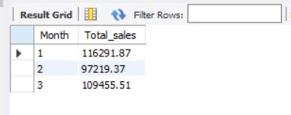  
      
    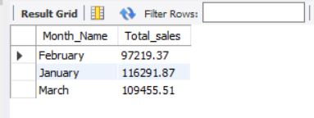
13. **Total Sales By Quarter : -**SELECT Quarter(STR_TO_DATE(Date, '%m/%d/%Y')) AS Quarter, round(sum(Total),2) AS Total_sales FROM sales GROUP BY Quarter(STR_TO_DATE(Date, '%m/%d/%Y')) ORDER BY Quarter(STR_TO_DATE(Date, '%m/%d/%Y'));  
      
    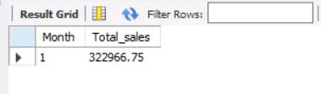  
      
      
    Note:-   
    alternate query for extract month from date column which is text data type  
    SELECT

MONTH(

CASE

WHEN INSTR(Date, '-') > 0 THEN STR_TO_DATE(Date, '%m-%d-%Y')

WHEN INSTR(Date, '/') > 0 THEN STR_TO_DATE(Date, '%m/%d/%Y')

END

) AS Month,

ROUND(SUM(Total), 2) AS Total_sales

FROM

sales

GROUP BY

MONTH(

CASE

WHEN INSTR(Date, '-') > 0 THEN STR_TO_DATE(Date, '%m-%d-%Y')

WHEN INSTR(Date, '/') > 0 THEN STR_TO_DATE(Date, '%m/%d/%Y')

END

)

ORDER BY

MONTH(

CASE

WHEN INSTR(Date, '-') > 0 THEN STR_TO_DATE(Date, '%m-%d-%Y')

WHEN INSTR(Date, '/') > 0 THEN STR_TO_DATE(Date, '%m/%d/%Y')

END

);  
   
 Integrate month name with sub query  
   
SELECT

Month_Number,

CASE

WHEN Month_Number = 1 THEN 'January'

WHEN Month_Number = 2 THEN 'February'

WHEN Month_Number = 3 THEN 'March'

WHEN Month_Number = 4 THEN 'April'

WHEN Month_Number = 5 THEN 'May'

WHEN Month_Number = 6 THEN 'June'

WHEN Month_Number = 7 THEN 'July'

WHEN Month_Number = 8 THEN 'August'

WHEN Month_Number = 9 THEN 'September'

WHEN Month_Number = 10 THEN 'October'

WHEN Month_Number = 11 THEN 'November'

WHEN Month_Number = 12 THEN 'December'

END AS Month_Name,

Total_sales

FROM (

SELECT

MONTH(STR_TO_DATE(Date, '%m/%d/%Y')) AS Month_Number,

ROUND(SUM(Total), 2) AS Total_sales

FROM

sales

GROUP BY

MONTH(STR_TO_DATE(Date, '%m/%d/%Y'))

) AS MonthlySales

ORDER BY

Month_Number;