To implement various Online Analytical Processing (OLAP) operations for multidimensional analysis for a given data warehouse on Sales History Schema of Oracle 11g and comparison of results with the following set of operations.

a. Roll up and Partial Roll Up

b. Cube and Partial Cube

c. Grouping Sets

d. Grouping ID’s

Q1. Find the total sales by country_id and channel_desc for the US and GB through the

Internet and direct sales in September 2000 and October 2000 using ROLL-UP Extension. The

query should return the following:

• The aggregation rows that would be produced by GROUP BY ,

• The First-level subtotals aggregating across country_iso_code for each combination

of channel_desc and calendar_month.

• Second-level subtotals aggregating

across calendar_month_desc and country_iso_code for each channel_desc value.

• A grand total row.

select sum(AMOUNT_SOLD),country_iso_code,CHANNEL_DESC,CALENDAR_MONTH_NUMBER

from sh.channels natural join sh.countries natural join sh.times natural join sh.sales

where country_iso_code in ('US','GB')

and channel_desc in ('Direct Sales','Internet')

and CALENDAR_MONTH_NAME in ('September','October')

and CALENDAR_YEAR='2000'

group by rollup (CHANNEL_DESC,CALENDAR_MONTH_NUMBER,country_iso_code);

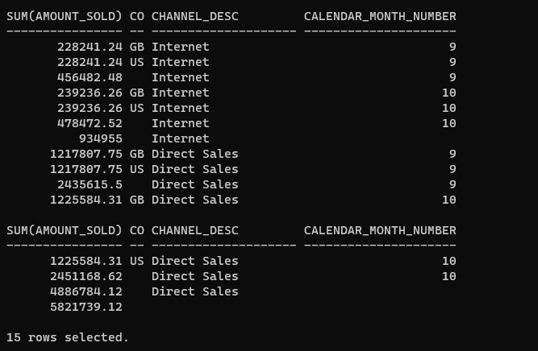

Q2. Find the total sales by country_iso_code and channel_desc for the US and GB through the Internet and direct sales in September 2000 and October 2009 using CUBE aggregation across three dimensions- channel_desc, calendar_month_desc, countries. country_iso_code.

select sum(AMOUNT_SOLD),country_iso_code,CHANNEL_DESC,calendar_month_desc

from sh.channels natural join sh.countries natural join sh.times natural join sh.sales

where country_iso_code in ('US','GB')

and channel_desc in ('Direct Sales','Internet')

and CALENDAR_MONTH_DESC in ('2000-09','2000-10')

group by cube (CHANNEL_DESC,calendar_month_desc,country_iso_code);

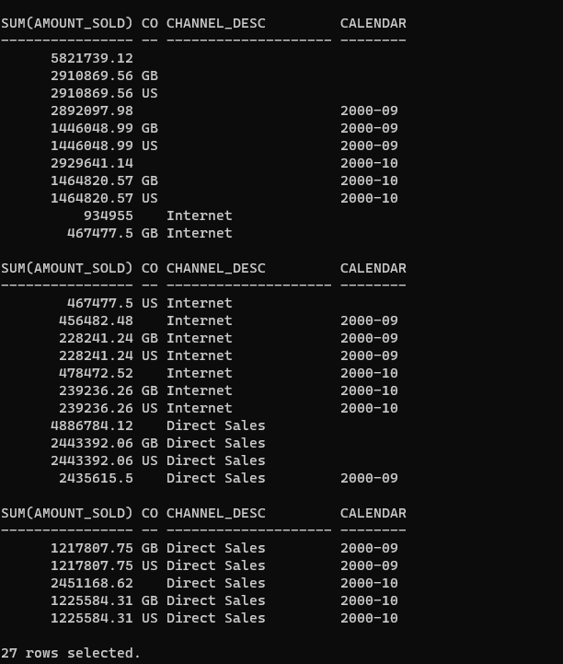

Q3. Find the total sales by country_iso and channel_desc for the US and France through the Internet and direct sales in September 2000

SELECT channels.channel_desc, countries.country_iso_code,

TO_CHAR(SUM(amount_sold), '9,999,999,999') SALES$

FROM sh.sales, sh.customers, sh.times, sh.channels, sh.countries

WHERE sales.time_id=times.time_id AND sales.cust_id=customers.cust_id AND

sales.channel_id= channels.channel_id AND channels.channel_desc IN

('Direct Sales', 'Internet') AND times.calendar_month_desc='2000-09'

AND customers.country_id=countries.country_id

AND countries.country_iso_code IN ('US','FR')

GROUP BY CUBE(channels.channel_desc, countries.country_iso_code);

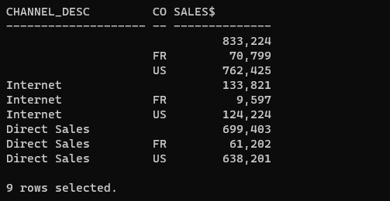

Q4. Find the total sales by country_iso and channel_desc for the US and GB through the Internet and direct sales in September 2000 and October 2009 using PARTIAL ROLL-UP. The query should return the following:

• Regular aggregation rows that would be produced by GROUP BY without

using ROLLUP.

• First-level subtotals aggregating across country_iso for each combination

of channel_desc and calendar_month_desc.

• Second-level subtotals aggregating across calendar_month_desc and country_iso for

each channel_desc value.

• It does not produce a grand total row.

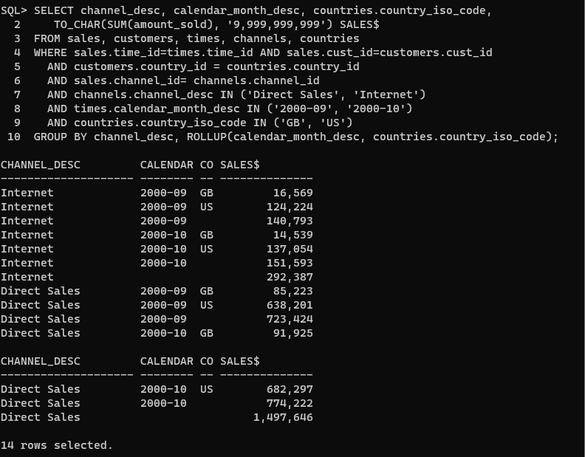

Q5. Find the total sales by country_id and channel_desc for the US and GB through the Internet and direct sales in September 2000 and October 2009 using PARTIAL CUBE aggregation on month and country code and GROUP BY on channel_desc.

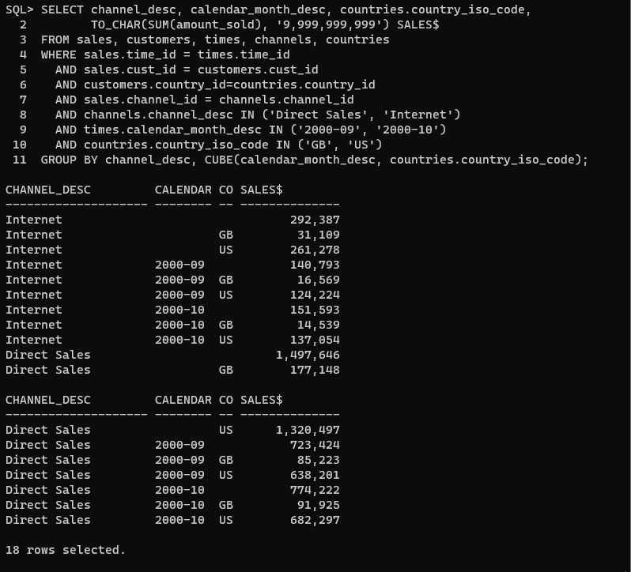

Q6. Use GROUPING to create a set of mask columns for the result set of Q1.

• Create grouping on channel_desc and name it as CH

• Create grouping calendar_month_desc and name it as MO

• Create grouping on country_iso_code and name it as CO

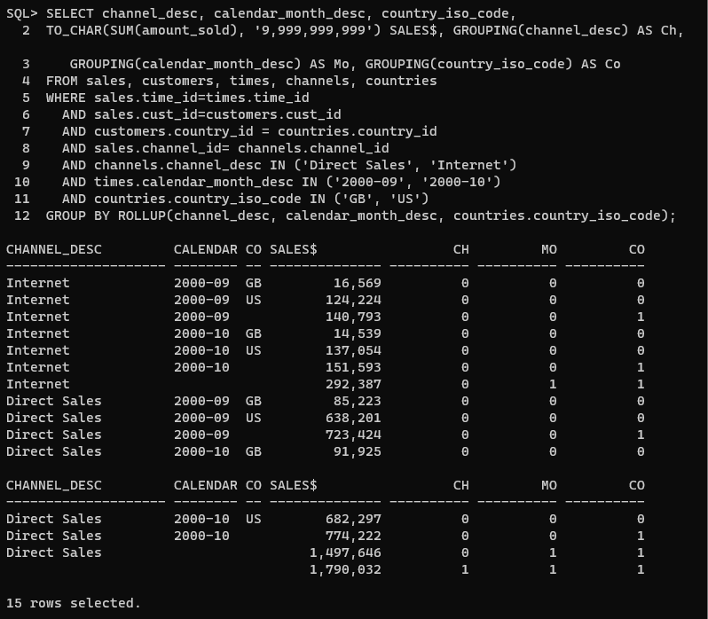

Q7.  Find the total sales by country_id and channel_desc for the US and GB through the

Internet and direct sales in September 2000 and October 2009 using GROUPING SETS.

Calculate aggregates over three groupings:

• (channel_desc, calendar_month_desc, country_iso_code)

• (channel_desc, country_iso_code)

• (calendar_month_desc, country_iso_code)

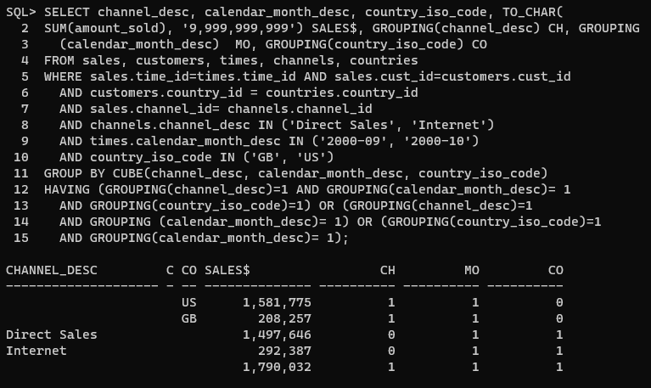

Q8. Consider the following Query and make conclusion from the result obtained.

Query: (scott Schema)

SELECT deptno, job, SUM(sal)

FROM emp

GROUP BY CUBE(deptno, job)

SQL> SELECT deptno, job, SUM(sal)

2 FROM emp

3 GROUP BY CUBE(deptno, job);

Q9. Calculate the salary for each department present in different cities of hr schema using rollup.

select sum(salary),city,department_id,department_name

from hr.employees natural join hr.departments natural join hr.locations

group by rollup(city,department_id,department_name);

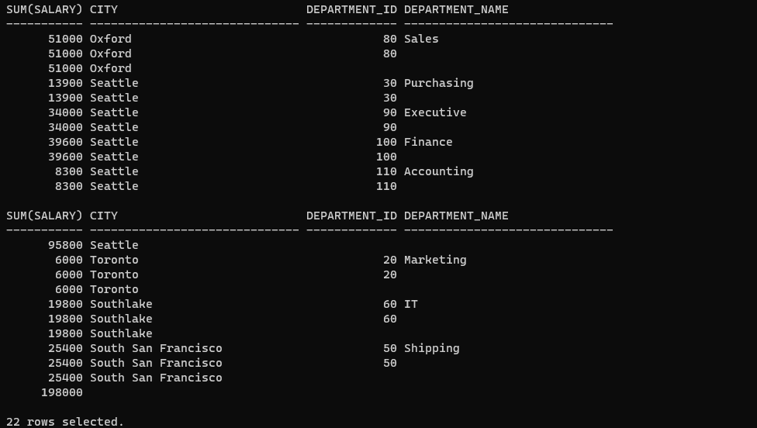

Q10. Calculate the salary for each department present in different cities of hr schema using cube.

select sum(salary),city,department_id,department_name

from hr.employees natural join hr.departments natural join hr.locations

group by cube(city,department_id,department_name);

