**MYSQL ASSIGNMENT 4**

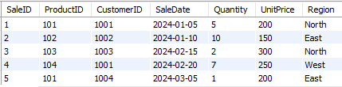

**1. Write a query to calculate the total sales (Quantity * UnitPrice) for each product.**

**select ProductID, SUM(quantity*UnitPrice) as total_sales from Sales group by ProductID;**

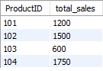

**2.** Write a query to find the total number of products sold in each region.

**select region,sum(Quantity) as ProductsSold from Sales group by region;**

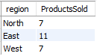

**3.** Write a query to get the average sales amount per product.

**select ProductID, avg(quantity*UnitPrice) as AverageSale from Sales GROUP BY ProductID;**

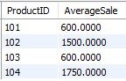

**4.** Find the regions where total sales are more than 3000.

**select region, sum(quantity*UnitPrice) as total_sales from Sales group by region having total_sales>3000;**



**5.** Write a query to get the maximum quantity sold for each product.

**select ProductID, max(quantity) as maxquantity from Sales group by ProductID;**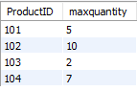

**6.** Write a query to calculate the average quantity of products sold per region.

**select Region, avg(quantity) as avgQuantity from Sales group by Region;**

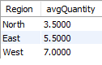

**7.** Find the product IDs that have generated a total sales amount of more than 1000.

**select ProductID, sum(Quantity*UnitPrice) as TotalSales from Sales group by ProductID having TotalSales>1000;**

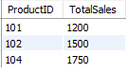

**8.** Write a query to get the total number of sales (rows) made for each customer.

**select CustomerID, count(Quantity) as SalesRows from Sales group by CustomerID;**

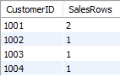

**9.** Find the products for which the average quantity sold is less than 5.

**select ProductID, avg(Quantity) as avgQuantity from Sales group by ProductID having avgQuantity<5;**

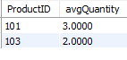

**10.** Write a query to find the sum of total sales for each customer in each region.

**select CustomerID, Region, Quantity*UnitPrice as TotalSale from Sales;**

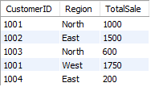

**11.** Write a query to calculate the total sales for each month.

**select month(SaleDate) as SaleMonth, sum(Quantity*UnitPrice) as TotalSale from Sales GROUP BY SaleMonth;**

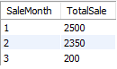

**12.** Find the regions where the average unit price is more than 200.

**select Region, avg(UnitPrice) as avgUnitPrice from Sales group by Region having avgUnitPrice>200;**

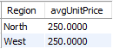

**13.** Write a query to get the minimum and maximum quantity sold per region.

**select Region, max(Quantity) as maxQuantity, min(Quantity) as minQuantity from Sales group by Region;**

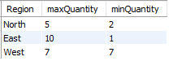

**14.** Find the customers who have made more than 2 purchases.

**select CustomerId, count(SaleID) as Purchases from Sales group by CustomerID having Purchases>2;**



**15.** Write a query to find the total sales for each product and filter only those products where the total sales exceed 1500.

**select ProductID Sum(Quantity*UnitPrice) as TotalSale from Sales group by ProductID having TotalSale>1500;**

