**IM2-Basics of Python**

**Brief History of Python**

- Created by Guido van Rossum in 1990

- Specifically designed as an easy to use language

- High focused on readability

- Interpreted and cross platform

**Why Choose Python?**

- Designed for clear, logical code that is easy to read and learn

- Lots of existing libraries and frameworks written in Python

- Focuses on optimizing developer time

- Great documentation online docs.python.org/3

**What can you do with Python?**

Automate simple task

- Searching for files, read and modify them

- Scraping information from websites

- Reading and editing excel files

- Work with PDFs

- Automate emails and text messages

- Connect to database systems

**What can you do with Python?**

Data Science and Machine Learning

- Analyze large data files (numbpy, pandas)

- Create visualizations (seaborn, plotly)

- Perform machine learning tasks (sci-kit-learn, tensorflow)

- Create and run predictive algorithms

**What can you do with Python?**

Create websites

- Use web frameworks such as Django and Flask to handle backend of a website and user data

- Create interactive dashboards for users such as plotly and dash

**What can you do with Python?**

Software development

- Building desktop applications, automation scripts, and support tools for software development.

**Python**

Create websites

- Use web frameworks such as Django and Flask to handle backend of a website and user data

- Create interactive dashboards for users such as plotly and dash

**Installing Python**

Tools

- Python 3 python.org/downloads

- IDE (VS Code)

- VS Code Python Extension

**Create Virtual Environment**

Create a virtual environment

- Open the Command Palette (Ctrl+Shift+P) or From the **View** menu, click **Command Pallete**

- Start typing the **Python: Create** **Environment** command to search, and then select the command.

**Create Virtual Environment**

Create a virtual environment

- Select .venv

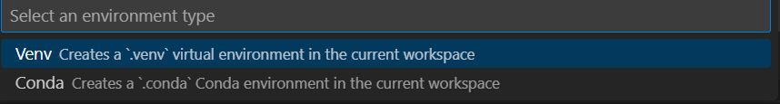

- Select the Python interpreter you installed

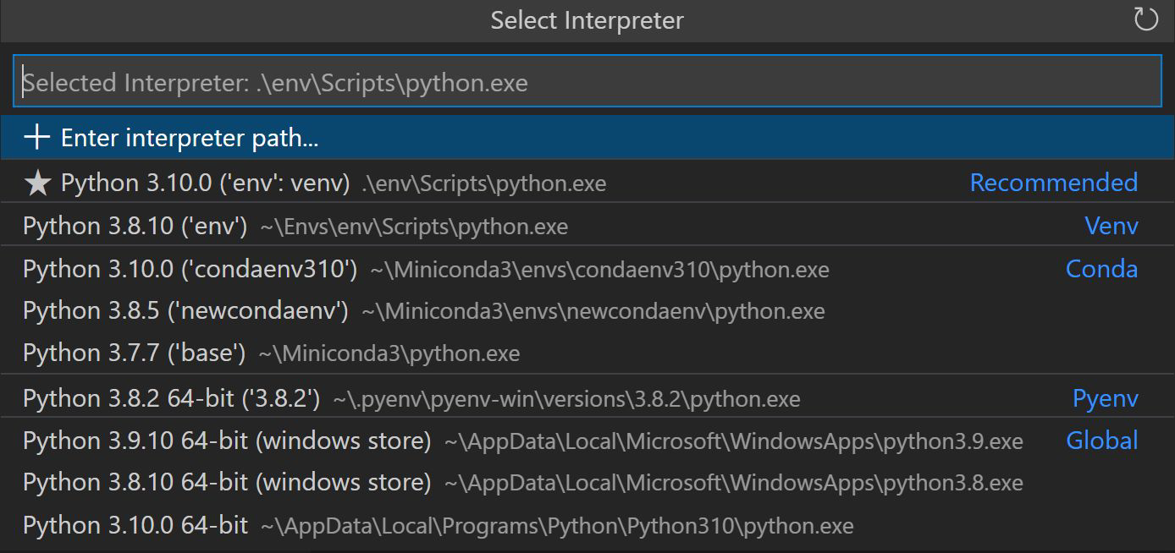

**Configure and Run the Debugger**

View>Extensions (Ctrl+Shift+X)

- Search for the installed **Python debugger extension** or if not install the extension by typing **Python debugger** on the search bar

**Configure and Run the Debugger**

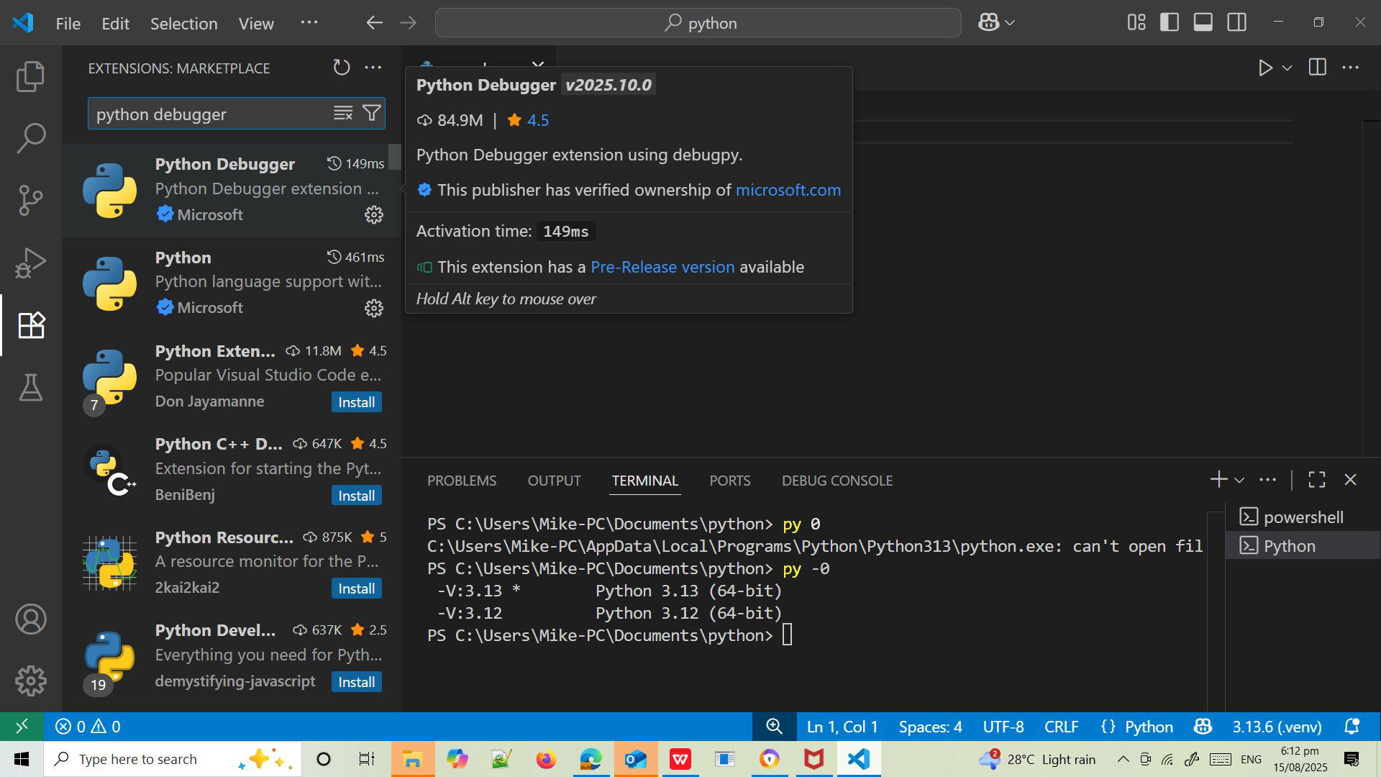

Since this is your first time debugging this file, a configuration menu will open from the Command Palette allowing you to select the type of debug configuration you would like for the opened file.

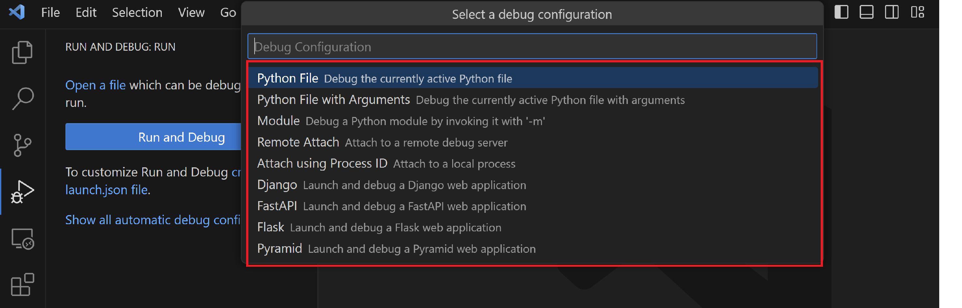

**Create Python source file**

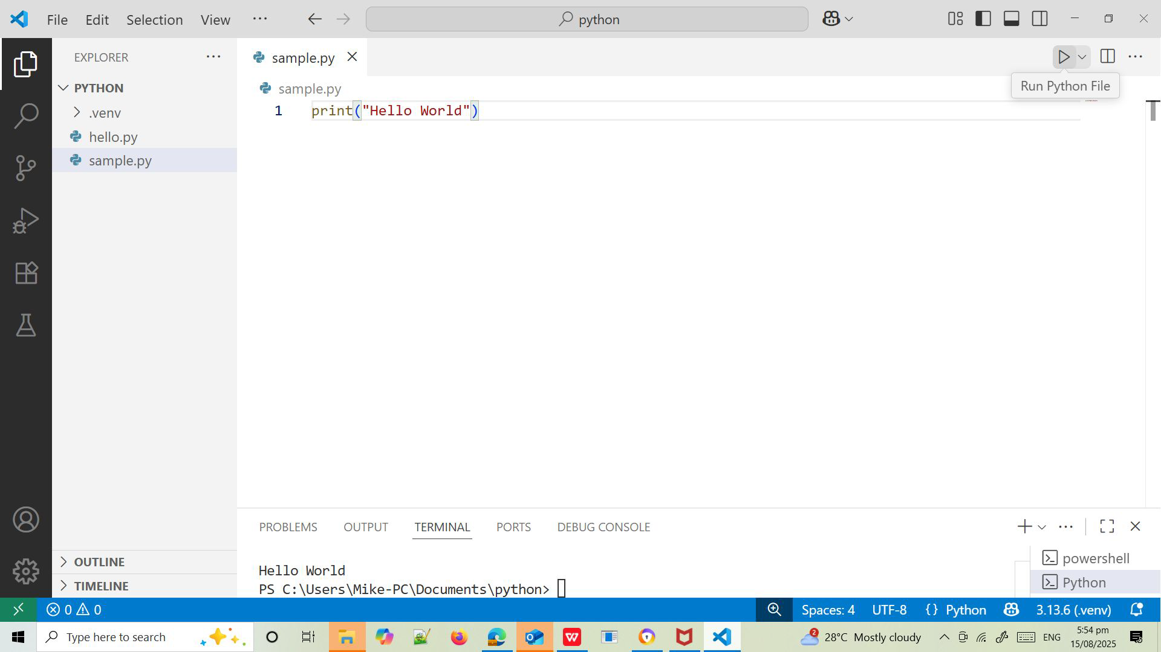

**Syntax**

- Python uses new lines to complete a command

- Python relies on **indentation**, using whitespace, to define scope; such as the scope of loops, functions and classes print("Hello, World!")

**Creating a Comment**

#This is a comment

print("Hello, World!")

#This is a comment

#written in

#more than just one line

print("Hello, World!")

**Variables**

Rules for Python variables

- Must start with a letter or the underscore character

- Names cannot start with a number

- It can only contain alpha-numeric characters and underscores (A-z, 0-9, and _ )

- There can be no spaces in the name, use _ instead

- Names are case-sensitive

- Names cannot be a Python reserved word

**User Input**

Syntax

**msg=input**("Enter your name: ")

print(f"Your name is: {msg}")

print("Enter your name:")

**msg=input()**

print(f"Your name is: {msg} ")

**Assigning Values**

Multiple Values to Multiple Variables

x, y, z = "Mike", "Esteron", "Acosta"

print(x)

print(y)

print(z)

One Value to Many Variables

x = y = z = "Mike"

print(x)

print(y)

print(z)

**Unpacking a Collection**

color = ["blue", "red", "yellow"]

x, y, z = color

print(x)

print(y)

print(z)

**Variables**

x = "I love Python"

print(x)

x = "Python "

y = "is "

z = "awesome "

print(x, y, z)

x = 5

y = 10

print(x + y)

x = "Python "

y = "is "

z = "awesome"

print(x + y + z)

**Data Types**

|  |  |  |
| --- | --- | --- |
| **Name** | **Type** | **Des** |
| **integers** | int | Whole numbers:  3 200 300 |
| **floating point** | float | Numbers with decimal point:  2.3 4.6 100.0 |
| **complex** | complex | Represents complex numbers, which have both a real and an imaginary part, j represents the imaginary (the square root of -): 3 2j |
| **string** | str | Ordered sequence of characters:  “hello” ‘Sammy’ “200” |
| **boolean** | bool | Logical value indicating True or False |
| **lists** | list | Ordered sequence of objects:  [10, “hello”, 200.3 |
| **tuples** | tup | Ordered immutable sequence of objects:  (10, “hello”, 200.3) |
| **dictionary** | dict | Unordered key: value pairs: {“mykey” : “value” , “name” : “frankie”} |
| **sets** | set | Unordered collection of unique objects: {“a” , “b”} |

**Strings**

They are sequences of characters

by either single quotation marks,

or double quotation marks.

- ‘hello’

- “Hello”

- “100.50”

- Because strings are ordered sequence, we can slice and index to grab subsections of the string

- Indexing notation uses [ ] symbol

- Because strings are ordered sequence, we can slice and index to grab subsections of the string

- Indexing notation uses [ ] symbol

Character : h e l l o

Index : 0 1 2 3 4

Reversed : 0 -4 -3 -2 -1

**Looping through Strings, len(), in() not in()**

for x in "banana":

print(x)

a = "Hello, World!"

print(len(a))

txt = "The best things in life are free!"

print("free" in txt)

txt = "The best things in life are free!"

print("expensive" not in txt)

**Slicing Strings**

Slicing allows you to grab a sub-section of mutiple characters, a “slice”of the string

Syntax

[start:stop:step]

**start** is the numerical index for the slice start

**stop** is the index you will go up to (but dont include)

**step** is the size of the “jump” you take

**Slicing Strings**

b = "Hello, World!"

print(b[2:5])

b = "Hello, World!"

print(b[:5])

b = "Hello, World!"

print(b[-5:-2])

myString="abcdefghijk"

print(myString[2:7:2])

print(myString[::3])

print(myString[::-1])

**Modifying Strings**

|  |  |
| --- | --- |
| **String Function** | **Example** |
| **upper()** | a = “Hello, World!” print(a.upper()) |
| **lower()** | a = “Hello, World!” print(a.lower()) |
| **strip()** | a = “Hello, World!” print(a.strip())  # returns “Hello, World!” |
| **replace()** | a = “Hello, World!” print(a.replace(“H” , “J”)) |
| **split()** | a = “Hello, World!” print(a.split(“,”))  # returns [‘Hello’,’World!’] |

**Concatenation**

a = "Hello"

b = "World"

c = a + " " + b

print(c)

**f Strings**

Syntax:

f"some text {placeholder}"

age = 36

txt = f"My name is John, I am {age}"

print(txt)

A **placeholder** can include a modifier to format the value.

price = 59

txt = f"The price is {price:.2f} dollars"

print(txt)

price = 59000

txt = f"The price is {price:,} dollars"

print(txt)

**Escape sequence**

|  |  |
| --- | --- |
| **Code** | **Result** |
| \’ | Single quote |
| \\ | Backlash |
| \n | New line |
| \r | Carriage return |
| \t | Tab |

Error

txt = "We are the so-called "Vikings" from the north."

**Arithmetic Operators**

|  |  |  |  |
| --- | --- | --- | --- |
| **Operator** | **Name** | **Example x = 5; y = 3** | **Result** |
| + | Addition | x+ y | 8 |
| - | Subtraction | x - y | 2 |
| * | Multiplication | x * y | 15 |
| / | Division | x / y | 1.666…7 |
| % | Modulo | x % y | 2 |
| ** | Exponentiation | x ** y | 125 |
| // | Floor division | x // y | 1 |

**Comparision Operators**

|  |  |  |  |
| --- | --- | --- | --- |
| **Operators** | **Name** | **Example**  **x = 5; y = 3** | **Result** |
| == | equal | x==y | false |
| ! | not equal | x!y | true |
| > | greater than | x>y | true |
| < | less than | x<y | false |
| >= | greater than or equal | x>=y | true |
| <= | less than or equal | x<=y | false |

**Assignment Operators**

|  |  |  |
| --- | --- | --- |
| **Operators** | **Same as…** | **Description** |
| x = y | x = y | The left operand gets set to the value of the expression on the right |
| x += y | x = x + y | Addition |
| x -= y | x = x - y | Subtraction |
| x *= y | x = x * y | Multiplication |
| x /= y | x = x / y | Division |
| x %= y | x = x % y | Modulos |

Logical Operators

|  |  |  |
| --- | --- | --- |
| **Operator** | **Description** | **Example** |
| not | Reverse the result, returns False if the result is true | not(x < 5 and x < 10) |
| and | Returns True if both statements are true | x < 5 and x < 10 |
| or | Returns True if one of the statements is true | x < 5 or x < 4 |

**Identity Operators**

Used to compare objects if they are actually the same object with the same memory location

|  |  |  |
| --- | --- | --- |
| **Operators** | **Description** | **Example** |
| is | Returns True if both variables are the same object | x is y |
| is not | Returns True if both variables are not the same object | x is not y |

**Identity Operators**

x = ["apple", "banana"]

y = ["apple", "banana"]

z = x

print(x is z)

# returns True because z is the same object as x

print(x is y)

# returns False because x is not the same object as y,

even if they have the same content

**Membership Operators**

Used to itself if a sequence is presented in an object:

|  |  |  |  |
| --- | --- | --- | --- |
| **Operators** | **Description** | **Example** |  |
| in | Returns True if a sequence with the specified value is present in the object | x in y | x = [“apple”, “banana”]  print(“banana” in x) |
| not in | Returns True if a sequence with the specified value is not present in the object | x not in y | x = [“apple”, “banana”]  print(“pineapple” not in x) |

**Conditional Statements**

**if statement** - executes some code only if a specified condition is true

**if...else statement** - executes some code if a condition is true and another code if the condition is false

**if...elif....else statement** - specifies a new condition to test, if the first condition is false

**match statement** - selects one of many blocks of code to be executed

**if Statements**

Syntax

**if expression:**

**statementN**

day1=100

day2=7

if (day1 - day2) < 100:

print(f"Its {day1-day2} days left before Christmas ")

**if else Statements**

Syntax

**if condition:**

**statmentN**

**else:**

**statementN**

mood="Sad"

if mood="Happy":

print("Yehey! Masaya ako nasa mood ako")

else:

print("Di masaya kaya malungkot")

**if elif Statements**

Syntax

**if expression:**

**statementN**

**elif expression:**

**statementN**

**else:**

**statementN**

score = 85

if score >= 90:

print("Grade A")

elif score >= 80:

print("Grade B")

elif score >= 70:

print("Grade C")

else:

print("Grade D")

**Match Statements**

Syntax

**match expression:**

**case x:**

**statmentN**

**case y:**

**statementN**

**case z:**

**statementN**

**case _:**

day = 4

match day:

case 6:

print("Today is Saturday")

case 7:

print("Today is Sunday")

case _:

print("Looking forward to the Weekend")

**While loop**

Syntax

**while expression:**

**statementN**

i = 1

while i < 6:

print(i)

i += 1

**Break statement**

i = 1

while i < 6:

print(i)

if i == 3:

break

i += 1

**Continue statement**

i = 0

while i < 6:

i += 1

if i == 3:

continue

print(i)

**range()**

- loop through a set of code a specified number of times

- returns a sequence of numbers, starting from 0 by default, and increments by 1 (by default), and ends at a specified number.

for x in range(6):

print(x)

for x in range(2, 6):

print(x)

The range() function defaults to increment the sequence by 1, however it is possible to specify the increment value by adding a third parameter

for x in range(2, 30. 3):

print(x)

**range(): Exercises**

Write a Python program using the following patterns:

1 2 3 4 5

6 7 8 9 10

*

* *

* * *

* * * *

* * * * *

* 0 * 0 *

* 0 * 0 *

* 0 * 0 *

**for loop**

Syntax

**for var in object:**

**statementN**

fruits = ["apple", "banana", "cherry"]

for x in fruits:

print(x)

**nested loop**

for x in range(1,5):

for y in range(6,10):

print(f"{x}{y} ", end="")

print("")

**IM2 - Python Data Structures**

**List []**

- Ordered sequences that can hold a variety of object types.

- It uses [ ] brackets and commas to separate objects in the list.

- Lists can be nested

**List Operations**

▪ Index

▪ Slicing

▪ Adding Items

▪ Changing Items

▪ Deleting Items

▪ Loop Lists

**List Indexing**

mylist=["honda", "toyota", "nissan", "mitsubishi"]

print(mylist[2])

print(mylist[-1])

print(mylist[1:3])

print(mylist[-3:-1])

print(mylist[:3:2])

print(mylist[::2])

print(mylist[::-1])

**Insert Items**

mylist=["honda", "toyota", "nissan", "mitsubishi"]

print(mylist.append("hyundai"))

print(mylist.insert(1,"byd"))

**Changing Items**

mylist=["honda", "toyota", "nissan", "mitsubishi"]

mylist[3]="byd"

**Deleting Items**

mylist=["honda", "toyota", "nissan", "mitsubishi"]

print(mylist.remove("nissan"))

print(mylist.pop(1))

print(mylist.pop())

**Sort Items**

mylist=["honda", "toyota", "nissan", "mitsubishi"]

print(mylist.sort())

**Looping Items**

mylist=["honda", "toyota", "nissan", "mitsubishi"]

for x in mylist:

print(x)

for x in range(len(mylist)):

print(mylist[x])

**Nested Loop Items**

nested_list = [[1, 2, 3], [4, 5, 6], [7, 8, 9]]

for sublist in nested_list:

for item in sublist:

print(item, end=" ")

print("")

**Tuples ( )**

They are very similar to lists, however, tuples are IMMUTABLE.

**Accesing Tuples**

mytuple=("honda", "toyota", "nissan", "mitsubishi")

print(mytuple[2])

print(mytuple[-1])

print(mytuple[1:3])

print(mytuple[-3:-1])

print(mytuple[1:])

print(mytuple[:3:2])

print(mytuple[::2])

print(mytuple[::-1])

**Insert, Changing, Deleting Tuple Values**

#adding values

mytuple=("honda", "toyota", "nissan", "mitsubishi")

mytuple2=list(mytuple)

mytuple2.append("byd")

mytuple=tuple(mytuple2)

print(mytuple)

#changing values

mytuple=("honda", "toyota", "nissan", "mitsubishi")

mytuple2=list(mytuple)

mytuple2[1]="byd"

mytuple=tuple(mytuple2)

print(mytuple)

**Tuple index(), count() methods**

mytuple=("honda", "toyota", "nissan", "mitsubishi", "nissan")

print(mytuple.index("nissan"))

print(mytuple.count())

**Dictionaries { }**

- Unordered mappins for storing objects.

- It uses key-value pairing

- This key value-pir allows user to quickly grab objects without needing to know an index location.

tala={

"id": 1111,

"name": "Mike Acosta",

"location": "Urdaneta"

}

**Accesing Dictionaries**

tala={

"id": 1111,

"name": "Mike Acosta",

"location": "Urdaneta"

}

print(tala[name]);

**Inserting and Changing Items**

tala={

"id": 1111,

"name": "Mike Acosta",

"location": "Urdaneta"

}

#adding items

tala["salary"]=5000;

print(tala.keys());

#changing items

tala["salary"]=15000;

print(tala);

**Removing Items**

tala={

"id": 1111,

"name": "Mike Acosta",

"location": "Urdaneta"

}

print(tala.pop("name"));

#delete last item

print(tala.popitem());

**Looping Items in Dict**

tala={

"id": 1111,

"name": "Mike Acosta",

"location": "Urdaneta"

}

#display all keys

for x in tala:

print(x)

#display all keys value pairs

for x,y in tala.items:

print(x,y)

#display all values

for x in tala:

print(tala[x])

**Nested Loop in Dictionaries**

myfamily = {

"child1" : {

"name" : "Emil",

"year" : 2004

},

"child2" : {

"name" : "Tobias",

"year" : 2007

},

"child3" : {

"name" : "Linus",

"year" : 2011

}

}

for x, obj in myfamily.items():

print(x)

for y in obj:

print(y + ':', obj[y])