Rank Bounded Source Coverage for Multi Document RAG in InsightEdge
Usha C.R.  Department of Computer Science and Engineering  Dayananda Sagar Academy of Technology and Management  Bengaluru, India  usha-cse@dsatm.edu.in | K Sainath Reddy  Department of Computer Science and Engineering  Dayananda Sagar Academy of Technology and Management  Bengaluru, India  1dt23cs100@dsatm.edu.in | Jayanth V Bhat  Department of Computer Science and Engineering  Dayananda Sagar Academy of Technology and Management  Bengaluru, India  1dt23cs080@dsatm.edu.in
K Varshith Anjan  Department of Computer Science and Engineering  Dayananda Sagar Academy of Technology and Management  Bengaluru, India  1dt23cs240@dsatm.edu.in | Manith Reddy M  Department of Computer Science and Engineering  Dayananda Sagar Academy of Technology and Management  Bengaluru, India  1dt23cs120@dsatm.edu.in

Abstract—Private-document RAG must keep evidence tied to its file while covering enough distinct files for cross-document questions. We present InsightEdge, a local-first document question-answering system with a scope-consistency contract, and evaluate a bounded source-coverage policy that limits each document to two chunks within a small rank window before filling the fixed context budget from the original top-k. On the complete EnterpriseRAG-Bench v1.0.0 document archive (511,962 documents), we evaluate 470 questions with annotated supporting document IDs and compare BM25, source diversification, per-document caps, and query-routed policies at candidate@100/context@8. On the 92 multi-document questions, the bounded policy changed document recall from 0.551 to 0.581 (paired Δ +0.029, 95% CI [+0.010, +0.054]); complete evidence-set recall changed from 0.207 to 0.239, while gold-document chunk share changed from 0.414 to 0.364. These retrieval-only results expose a coverage–precision tradeoff and do not establish answer correctness or citation entailment. The implementation also enforces named-file scope before generation and citation, and the 62-test backend suite passes.
Keywords—retrieval-augmented generation, local language models, hybrid retrieval, document provenance, evidence-grounded question answering, privacy-preserving systems

I. INTRODUCTION
Organizations rely on reports, manuals, presentations, and spreadsheets whose contents are difficult to explore with exact keyword queries. Neural language models can summarize and explain such material, but a model operating without retrieved evidence may produce unsupported details. Sending private files to a hosted service also creates a data-handling boundary that some users cannot accept. Retrieval-augmented generation (RAG) addresses the first problem by retrieving external passages at query time and conditioning generation on them [1]. InsightEdge applies this pattern to a locally operated document workspace.
The engineering problem is broader than connecting a vector database to a chat model. A practical assistant must extract different file types, preserve useful structure, infer whether a user asks for a summary or a precise fact, keep a named-file question from drifting to another source, and expose the evidence used. It must also communicate when retrieval is weak. These requirements motivate an integrated system with transparent routing, source metadata, and a local inference path.
This paper describes the completed InsightEdge system and studies a common failure in multi-file chat: a relevance-ranked context can over-allocate to one file and omit complementary evidence from another. The contributions are (1) a scope-consistency contract enforced before generation and citation, (2) a rank-bounded source-coverage selector that limits document repetition within a fixed context budget while retaining the original top-k as fallback, and (3) a paired retrieval evaluation over 470 labeled questions from the full EnterpriseRAG-Bench v1.0.0 archive. We treat document diversity as a relevance–coverage tradeoff, not as a universal improvement, and do not claim a new neural ranker or answer-quality result.

II. RELATED WORK
A. Retrieval-Augmented Generation: Lewis et al. combine parametric generation with a non-parametric document index to support knowledge-intensive tasks [1]. Dense Passage Retrieval shows how learned representations can identify semantically related passages beyond literal term overlap [2]. These methods provide the basic retrieval-and-generation pattern used here.
B. Lexical and Hybrid Retrieval: BM25 remains a strong lexical baseline for exact terminology and rare terms [3]. Dense retrieval can help when the query and source use different wording, while lexical matching can recover names, identifiers, and table values. Rank-fusion methods such as reciprocal rank fusion combine ranked lists without requiring their raw scores to share a scale [6]. InsightEdge uses dense and independent BM25-style candidates in its hybrid path; its current implementation is dense-priority with lexical backfill and should not be confused with canonical RRF.
C. Query Transformation and Evaluation: Dense Passage Retrieval and sentence-level embedding models support semantic passage matching [2], [4]. Generative passage fusion offers another RAG design point [5]. HyDE generates a hypothetical passage to improve zero-shot dense retrieval [7], and Self-RAG studies explicit retrieval and self-critique decisions in a trained generation framework [8]. InsightEdge exposes optional local query transformation and follow-up retrieval controls; these are engineering options, not reproductions of the original trained methods. RAGAS separates retrieval and generation evaluation [9]. Recent citation work motivates measuring attribution alongside answer relevance [16], [17]. Our fixture evaluator provides retrieval regression measures, while live probes check source scope and refusal behavior without claiming human-judged entailment.
D. Diversity and Enterprise Retrieval: Maximal Marginal Relevance (MMR) explicitly trades query relevance against redundancy [18], and recent DF-RAG dynamically adjusts diversity for reasoning-intensive questions [19]. Multi-document context evaluation also emphasizes coverage and redundancy rather than relevance alone [21]. These works establish that diversity is not a new idea. Our study isolates a narrower systems question: under an eight-chunk context budget and document-ID labels, how much source coverage can a small rank-bounded document cap add before the gold-document chunk share falls? We use EnterpriseRAG-Bench v1.0.0, a public synthetic enterprise corpus and question set [20], and report the runtime intent heuristic separately from an oracle label-based upper bound.

III. DESIGN OBJECTIVES AND SYSTEM BOUNDARY
A. Local processing: The default workflow performs extraction, embedding, vector search, and model generation through local services. Documents are not sent to a hosted AI API by the normal query path. This describes the configured path, not a guarantee independent of provider settings, network exposure, logs, backups, or host administration.
B. Action-aware retrieval: The system treats a request as an action to route, not only a string to match. Summary requests retrieve representative content; table questions prioritize structured blocks; OCR questions prioritize OCR-marked material; and comparisons can widen their candidate set. A named filename or file type narrows eligible documents before ranking.
C. Traceability and abstention: Retrieved chunks retain source identifiers and structural metadata so the interface can show where evidence came from. The backend may withhold an answer when retrieval is empty or heuristic support is weak. A citation identifies retrieved material; it does not prove that every generated claim is entailed by that material.
D. Organizational access: Optional account authentication provides sign-in, administrator-managed accounts, and expiring signed sessions. The prototype uses a shared server and workspace-level retrieval boundaries; it does not enforce per-user or per-team document permissions, enterprise SSO, or distributed multi-tenant storage.

IV. ARCHITECTURE AND METHODOLOGY
A. Ingestion and Representation: The browser uploads supported text, PDF, Word, spreadsheet, HTML, EPUB, and PowerPoint files to a FastAPI service. Format-specific loaders extract text and preserve structural cues such as headings, paragraphs, tables, pages, slides, and OCR markers when available. Scanned PDF pages can use a Tesseract OCR fallback when digital extraction yields little text. A structure-aware chunker produces overlapping segments; each indexed chunk carries document and chunk identifiers, source name, offsets, and applicable page, slide, section, table, or OCR metadata. The embedding service maps chunks into the local vector store. ChromaDB persists vectors; SQLite stores authentication, conversation, and ingestion-job state.
B. Intent-Aware Retrieval: A deterministic classifier routes greetings and capability questions without document search and recognizes summaries, outlines, tables, OCR questions, comparisons, multi-document synthesis, and factual lookups. Summary requests retrieve a wider set of representative chunks across sources. Structured-data and OCR requests prioritize matching metadata, while ordinary fact questions use hybrid candidates. A document-scope resolver detects named files and common file types, then applies a document identifier or extension filter before retrieval. This design addresses a practical failure mode in multi-file chat: a semantically similar chunk from an unrelated document should not silently answer a file-specific question.
C. Grounded Generation and Provenance: Retrieved passages are supplied to the configured Ollama model together with the query and conversation context. The backend streams generated tokens through server-sent events and emits answer metadata and citations. Citation fields are projected from retrieved metadata rather than parsed from generated prose. The answer path rechecks each retrieved chunk against the active metadata filter before generation; the same filtered evidence produces JSON and SSE citations. This enforces source-set consistency, but not claim-level entailment. Evidence checks can abstain on empty or weak retrieval; heuristic support is not a proof of factual correctness [16], [17].
D. Processing Boundary and Access: In the default configuration, extraction, embedding, vector search, and generation use local services, so document text is not sent to a hosted AI API by the normal query path. This describes the configured data path, not a universal security guarantee: optional providers, network exposure, backups, logs, and host administration remain deployment responsibilities. Optional organization sign-in uses salted PBKDF2-HMAC-SHA256 password hashes and signed, expiring sessions [15]; administrators can provision or disable accounts. User-level document authorization and enterprise SSO are outside the current prototype.
E. Scope-Consistent Evidence Routing (SCER): Let A(q) be the allowed document-ID set resolved from an explicit filename or file type; for a workspace-wide request, A(q) is the full workspace. Let R(q) be the chunks admitted to the answer context and C(q) the chunk-level citations returned to the client. SCER requires citations to be drawn from retrieved evidence and retrieved evidence to be contained in the allowed set. InsightEdge resolves A(q), combines its source filter with any intent filter, retrieves candidates, reapplies the filter to returned metadata, and derives citations from the remaining chunks. Both JSON and SSE invoke this same sequence. This makes source membership auditable; it does not establish that a cited chunk entails every answer claim.
For a file-specific request, every evidence chunk and citation must belong to the selected document. For a multi-document overview, the allowed set intentionally spans the workspace, and the overview selector allocates representative chunks across documents before generation. This distinction avoids both cross-file substitution and over-narrowing broad summary requests.
F. Rank-Bounded Source Coverage (RBSC): Let R=(r1,…,rn) be the ranked candidate list, K the context budget, w a rank window, and c a per-document cap. RBSC scans the first K+w candidates in rank order and selects no more than c chunks per document until K slots are filled. If the window does not supply K chunks, it fills remaining slots from the original top K; the final context is returned in original rank order. In the serving configuration, K=8, c=2, and w=4. This bounded swap policy preserves a fallback to high-ranked chunks while allowing a near-top alternative document into the prompt. It is activated only for requests classified as multi-source; it is not a claim that every long query needs diversity.
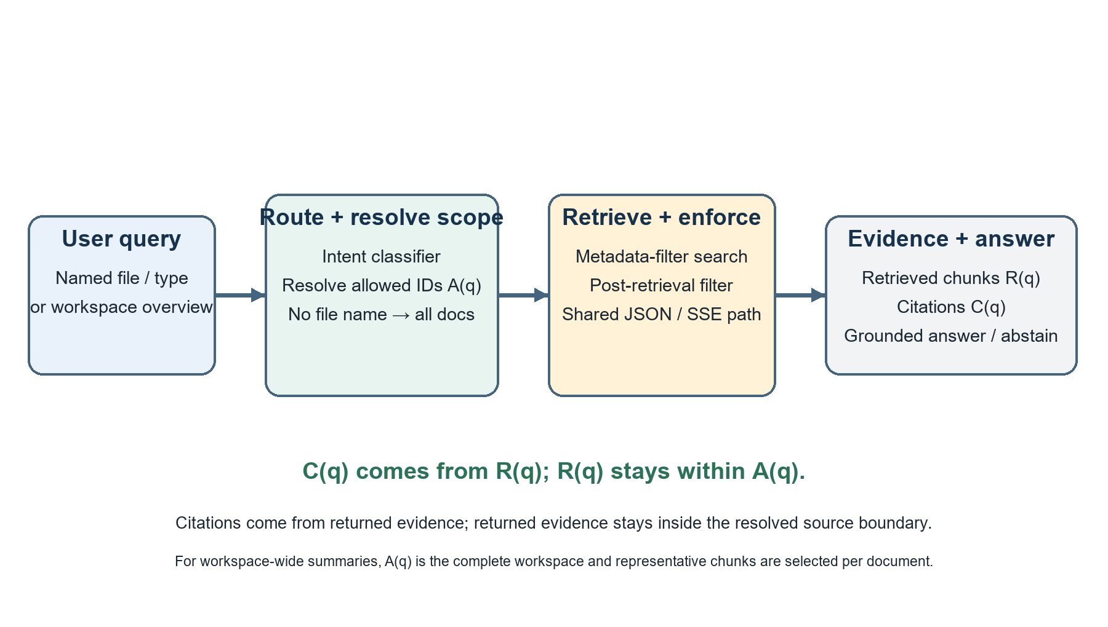
Fig. 1. Scope resolution and evidence flow for named-file and workspace-wide requests.
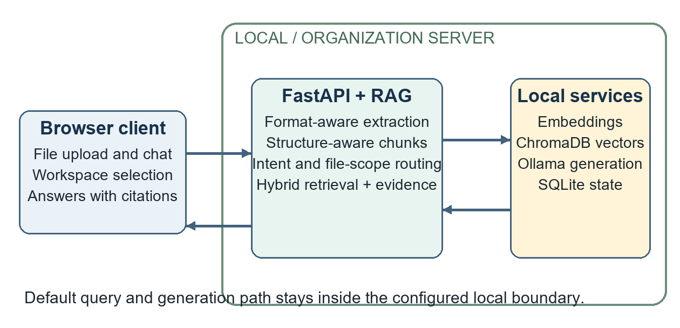
Fig. 2. InsightEdge client, retrieval service, local stores, and inference boundary.
Input class | Extraction and preserved structure
TXT / Markdown | Text, headings, lists, offsets
PDF | Text and tables; page markers; optional OCR
DOCX / HTML / EPUB | Paragraph or section text, headings
CSV / XLSX | Row-oriented content and table metadata
PPTX | Slide text, indices, and table content
TABLE I. DOCUMENT INPUTS AND STRUCTURE
Intent | Route and candidates | Selection behavior
Overview | Dense; 64 | Representative chunks; final 6 or 8
Heading/list | Lexical; 64 | Heading blocks; final up to 32
Table | Lexical; 16 | Prioritize table metadata
OCR/scanned | Hybrid; 16 | OCR metadata and compression
Factual | Hybrid; 12 | Dense plus lexical candidates
Compare / multi-file | Hybrid-rerank; 24 | Wider set; optional expansion
Greeting/meta | None | No document retrieval
TABLE II. QUERY INTENTS AND RETRIEVAL ACTIONS
Metadata | Role in the pipeline
document_id, source | Workspace/file filter and citation label
chunk_id, offsets | Chunk identity and source location
page / slide / section | Human-readable evidence location
block_type, table_used | Structure-aware routing
ocr_used | Identify OCR-derived content
snippet / rank / score | Evidence inspection in the client
TABLE III. CHUNK PROVENANCE FIELDS

V. IMPLEMENTATION AND USER WORKFLOW
The application separates the React/Vite client from the Python API and service layer. The client provides workspace selection, multi-file upload with asynchronous job progress, chat streaming, conversation history, and an evidence panel. The API coordinates ingestion, query routing, retrieval, citations, authentication, and health diagnostics. ChromaDB is accessed as a persistent local store, while SQLite uses indexed workspace and job state. Ollama provides model inference through its local HTTP interface [13], while SQLite persists local state [14]. The API and vector-store layers use FastAPI and ChromaDB [11], [12].
The implementation supports multiple file formats, but extraction quality depends on file structure and OCR dependencies. PDF text and tables are extracted directly where possible; OCR is a fallback, not a guarantee of faithful table or diagram interpretation. Optional HyDE, multi-query expansion, parent context, cross-encoder reranking, compression, Self-RAG-style follow-up retrieval, and local PDF vision assistance are configurable and can add latency. They were not all enabled in the evaluated configuration.
When authentication is enabled, passwords are stored as salted PBKDF2-HMAC-SHA256 hashes and sessions are signed and time-limited [15]. Administrators can create and disable accounts. Self-sign-up is disabled by default. These controls authenticate application access but do not create per-user document authorization.
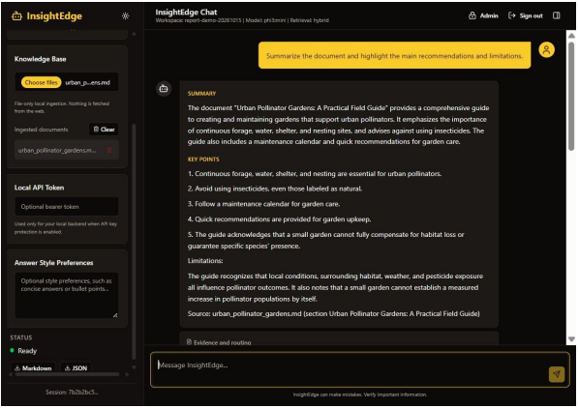
Fig. 3. Workspace overview generated from representative document evidence.
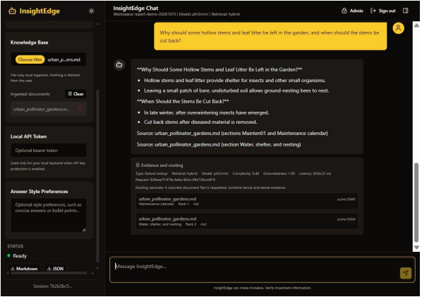
Fig. 4. Answer with source sections and retrieved evidence in the client.
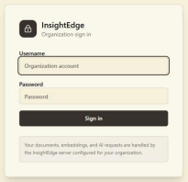
Fig. 5. Organization sign-in form.
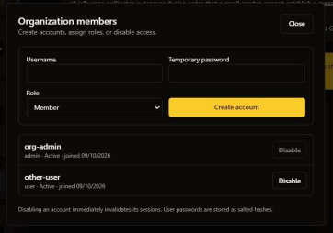
Fig. 6. Administrator interface for member creation and status.
Interface | Purpose
POST /api/ingest/files | Upload files; returns async job ID
GET /api/ingest/jobs/{id} | Poll ingestion status
GET /api/ingest/documents | List indexed workspace sources
POST /api/chat/stream | SSE tokens and final citations
GET /api/auth/me | Resolve current account
/api/auth/users | Admin-only list/create/disable
TABLE IV. SELECTED APPLICATION INTERFACES
LISTING 1. DOCUMENT SCOPE IS APPLIED BEFORE RETRIEVAL
documents, metadatas, ids, distances = await \
self._retrieve_with_self_rag(question, workspace_id, decision)
documents, metadatas, ids, distances = \
self._filter_retrieval_result(documents, metadatas, ids,
distances,
decision.metadata_filter)
citations = self._build_citations(metadatas, ids, documents,
distances)

VI. EXPERIMENTAL EVALUATION
A. Test strategy and execution: The repository test suite covers routing, structured chunking, evidence and provenance, authentication, state storage, API validation, uploads, SSE behavior, CORS, and evaluator metrics. On 11 November 2026, the complete command `python -m pytest -q` passed 62 tests with no failures (one third-party deprecation warning). Authentication tests create isolated SQLite stores per test so developer-local account state cannot affect results. New answer-pipeline regression tests inject a near-duplicate from outside the resolved file scope and verify that both JSON and SSE exclude it from answer context and citations.
Verification | Observed result
Full test suite | 62 passed; 0 failed
Named-source answer regression | JSON and SSE cite only the resolved file
Post-retrieval boundary | Out-of-scope injected chunk removed
Authentication tests | Isolated SQLite database per test
Prompt probes | Four answer behaviors and one evidence refusal
TABLE V. AUTOMATED AND BEHAVIORAL VERIFICATION
B. Fixture benchmark: Run 20261111T083609Z indexed four checked-in documents (prose, structured table, OCR-marked text, and citation-rich content) into thirteen chunks and evaluated sixteen labeled questions. The question file used for this run is `backend/eval/fixtures/questions_paper.json` (SHA-256 f40540dc63f750c08b4464d42687ecc9bcefee9df178426915cf2ee416b9d433). Six retrieval configurations were compared: dense, lexical, hybrid, hybrid-rerank mode, hybrid plus compression, and adaptive routing. Recall@k measures relevant-source retrieval, MRR and nDCG ranking, context precision/recall source overlap, and chunk correctness expected-snippet overlap. Groundedness is a deterministic term-overlap signal, not a model or human judgment. The evaluator used BAAI/bge-small-en-v1.5 through sentence-transformers, candidate_k 12, top_k 3, and a maximum similarity distance of 0.65. It does not generate answers; its latency values end after retrieval.
Method | Recall | MRR | nDCG | Ctx P | Ctx R | Chunk C | P50 | P95
Dense | 0.812 | 0.812 | 0.812 | 0.677 | 0.797 | 0.479 | 45.12 | 91.85
Lexical | 0.688 | 0.688 | 0.688 | 0.635 | 0.672 | 0.552 | 3.91 | 4.69
Hybrid | 0.812 | 0.812 | 0.812 | 0.677 | 0.797 | 0.479 | 47.85 | 56.29
Hybrid + rerank* | 0.812 | 0.812 | 0.812 | 0.677 | 0.797 | 0.479 | 45.85 | 60.53
Hybrid + compression | 0.812 | 0.812 | 0.812 | 0.677 | 0.797 | 0.479 | 48.03 | 54.08
Adaptive router | 0.750 | 0.750 | 0.750 | 0.667 | 0.750 | 0.583 | 47.71 | 61.71
TABLE VI. FIXTURE RETRIEVAL RESULTS (LATENCY IN MS)
* The rerank-mode configuration had no cross-encoder configured and therefore measures no reranker effect. Citation precision and source correctness equal context precision for this evaluator.
Query | Dense baseline | Adaptive route
Workspace overview | 3 chunks; 3/4 sources; recall 0.75 | 6 chunks; 4/4 sources; recall 1.00
Unsupported weather | 0 chunks returned | 0 chunks returned
TABLE VII. SELECTED QUERY-LEVEL RESULTS
The adaptive route improves workspace coverage for the explicit overview request, but its aggregate recall, context precision, and latency do not dominate the other configurations. This is a query-specific routing gain, not an overall winner.
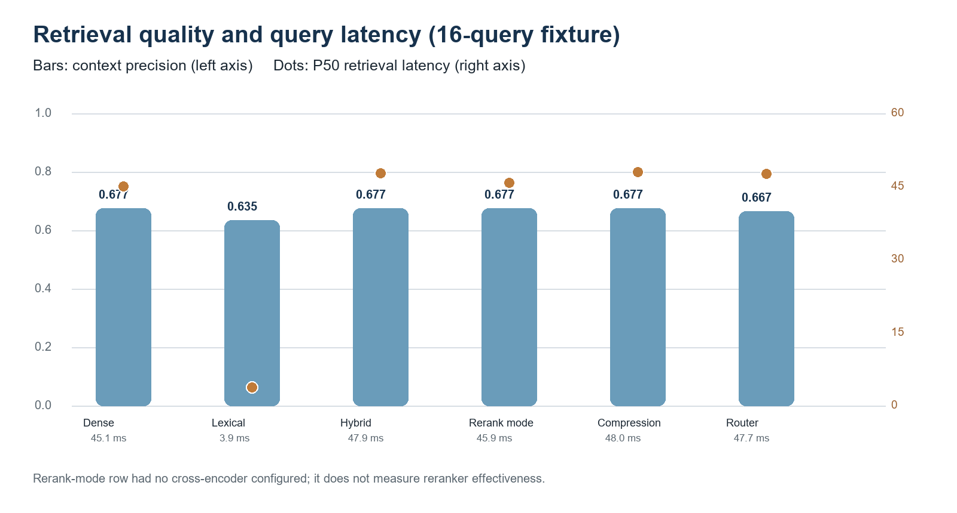
Fig. 7. Context precision and retrieval latency in the fixture comparison.
C. Benchmark findings and timing: Dense and hybrid retrieval tied at recall@k 0.812 and context precision 0.677. Lexical retrieval was faster on this run (P50 3.91 ms) but had lower recall (0.688). The adaptive router had the highest chunk correctness (0.583) and returned all four fixture sources for the workspace overview, yet its aggregate recall was 0.750. Ingestion succeeded for all four documents; its P50/P95 was 171.27/4,777.39 ms, with the first embedding call dominating the tail. Retrieval P95 ranged from 4.69 ms lexical to 91.85 ms dense. These single-run measurements do not establish stable speed rankings. The rerank-mode row used no cross-encoder.

VII. CONTROLLED DOCUMENT-SCOPE STRESS EVALUATION
To isolate source confusion, the evaluator generated 24 one-chunk reports with the same reserve-coefficient wording and a different named site and numeric value in each file. Each question explicitly named one report. We compared identical hybrid top-3 retrieval with and without filename-resolved document-ID filtering; generation was disabled. The unscoped top three always included the target but mixed in two near-duplicate files. The scope-constrained run kept the target in every query and eliminated other-file chunks.
Metric | Unscoped top-3 | Scope constrained
Target document recall@3 | 1.000 (24/24) | 1.000 (24/24)
Out-of-scope chunk rate | 0.667 (48/72) | 0.000 (0/24)
Scope resolution | n/a | 1.000 (24/24)
Scope contract pass | n/a | 1.000 (24/24)
Mean retrieval latency | 56.50 ms | 52.54 ms
TABLE VIII. NEAR-DUPLICATE DOCUMENT-SCOPE STRESS TEST
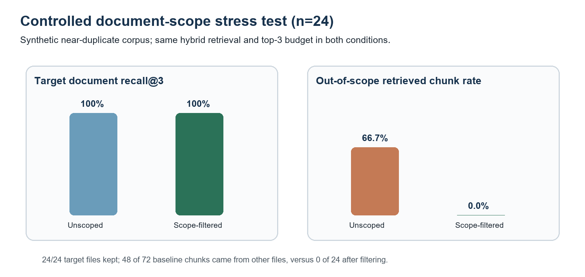
Fig. 8. Source-scope filtering preserves target retrieval while excluding distractor chunks.
The 0.667 leakage rate is an observed property of this deliberately constructed corpus, not a rate estimate for arbitrary workspaces. Out-of-scope chunk rate is the count of retrieved chunks whose document ID falls outside the allowed set for the query divided by the number of retrieved chunks. The contract pass metric checks that all returned chunk document IDs belong to the resolved allowed set and each citation refers to a returned chunk in that set. Scope filtering preserved recall in this dataset. The small latency difference is descriptive only; hardware contention and run-to-run variation were not controlled.

VIII. RANK-BOUNDED SOURCE-COVERAGE EVALUATION
We used EnterpriseRAG-Bench v1.0.0 [20], indexing all 511,962 text records (511,958 unique document IDs) into 2,522,807 InsightEdge-style chunks. The archive contains 4 duplicate-ID records, which were retained and grouped by their shared gold ID. The public question file contains 500 items; 470 have annotated expected document IDs and were used here, including 92 questions with more than one distinct gold document. All annotated gold IDs were present. The corpus archive SHA-256 is `9d1174928696ad08bc15f3f104739519de633c1605a4ec2034e0e3c0087bc5cd` and the question fixture SHA-256 is `f9524b9157cd43aae36b99333a124738804306ea6d07f332d49faa6d3d147905`. Retrieval used SQLite FTS5 BM25 with candidate@100 and a fixed context@8; no language model generated answers in this experiment.
Selector | Q | Doc recall | Complete set | Gold-doc chunk share
Global BM25 top-8 | 92 | 0.551 | 0.207 | 0.414
RBSC (cap 2, window 4) | 92 | 0.581 | 0.239 | 0.364
Unbounded cap 2 | 92 | 0.581 | 0.239 | 0.351
One chunk per document | 92 | 0.616 | 0.293 | 0.261
Intent-routed cap 2 | 92 | 0.581 | 0.239 | 0.382
Gold-label oracle | 92 | 0.616 | 0.293 | 0.261
TABLE IX. MULTI-DOCUMENT RETRIEVAL AT FIXED CONTEXT@8
Rank window w | Doc recall | Complete set | Gold-doc chunk share
0 | 0.551 | 0.207 | 0.414
4 | 0.581 | 0.239 | 0.364
8 | 0.581 | 0.239 | 0.352
12 | 0.581 | 0.239 | 0.351
16 | 0.581 | 0.239 | 0.351
32 | 0.581 | 0.239 | 0.351
64 | 0.581 | 0.239 | 0.351
TABLE X. RANK-WINDOW ABLATION ON MULTI-DOCUMENT QUESTIONS
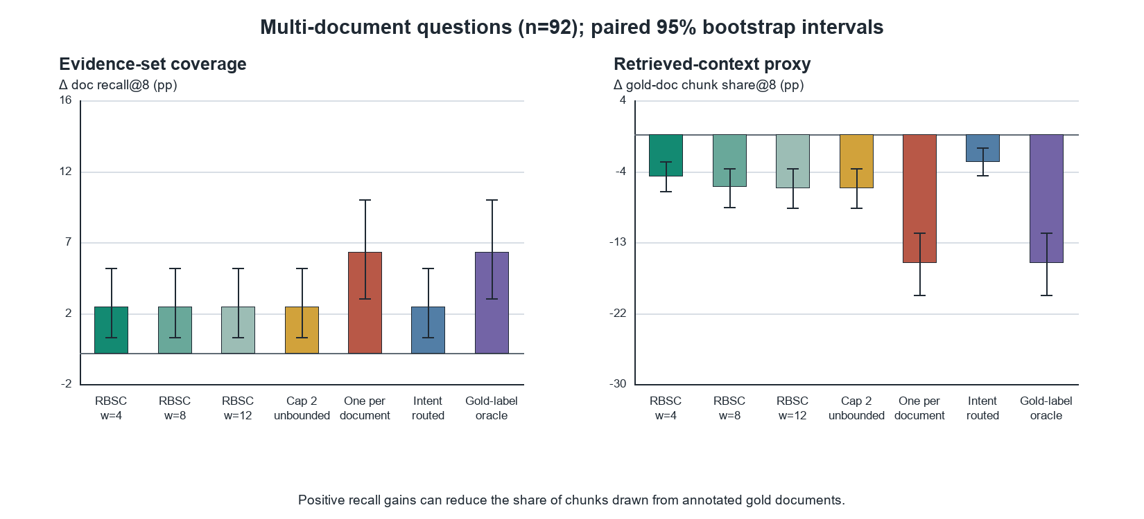
Fig. 9. Paired-bootstrap changes from global BM25 on multi-document questions; higher recall trades against gold-document chunk share.
For the bounded cap-2/window-4 policy, multi-document document recall changed by +0.029 (95% paired bootstrap CI [+0.010, +0.054]); complete evidence-set recall changed by +0.033 (CI [+0.000, +0.076]); and gold-document chunk share changed by -0.050 (CI [-0.068, -0.033]). Intervals resample questions 5,000 times and are not repeated hardware or model trials. The rank-window sweep shows that w=4 reached the same measured document and complete-set recall as larger windows while retaining a higher gold-document chunk share than w≥8. This is a Pareto observation on this fixed candidate ranking, not a universally optimal threshold.
At the deployment threshold, the intent heuristic flagged 145 of 470 questions for source coverage; 55 of those were multi-gold, giving in-sample precision 0.379 and recall 0.598 against gold document multiplicity. Because the long-compound rule (at least 25 words plus a second interrogative clause) was chosen by inspecting these same questions, we also ran a five-fold, threshold-selected evaluation. Out-of-fold precision was 0.374 (95% CI [0.295, 0.455]) and recall 0.565 (CI [0.464, 0.667]), versus 0.343 and 0.130 for explicit cues alone. The compound-clause rule buys coverage at the cost of false positives, and routing remains exploratory because the feature family and benchmark are shared. The gold-label oracle is an upper bound and is not deployable. The experiment isolates source selection with lexical BM25; InsightEdge production hybrid ranking uses a different candidate order, so the measured gains must be confirmed on that serving path. Gold-document chunk share counts chunks whose document ID is labeled as supporting; it is not passage-level entailment.

IX. LIVE LOCAL-MODEL SERVICE EVALUATION
A service-level check exercised the RAG service against an isolated three-document workspace and the local phi3:mini model. It was run after the scope-routing fix and did not measure browser or HTTP transport latency. Five prompts covered a named-file summary, generic workspace overview, named fact, document-borne injection attempt, and unsupported topic. The three-document ingest completed successfully; all five expected behaviors matched: four evidence-backed requests were answered, the unsupported current-weather query was refused, named-file citations stayed in scope, and the injected cross-file marker was not disclosed. Each latency is one observation.
Prompt | Result | Cited sources | Latency
Named summary | Answered; 3 supported points | river_plan.txt | 7.42 s
Workspace overview | Summarized all 3 files | all 3 files | 4.63 s
Named fact | Answered: 12 plots | food_plan.txt | 1.80 s
Document injection | Marker not disclosed; scoped | river_plan.txt | 5.59 s
Unsupported topic | Abstained; no evidence | none | 0.11 s
TABLE XI. LIVE PHI3:MINI SERVICE PROBES
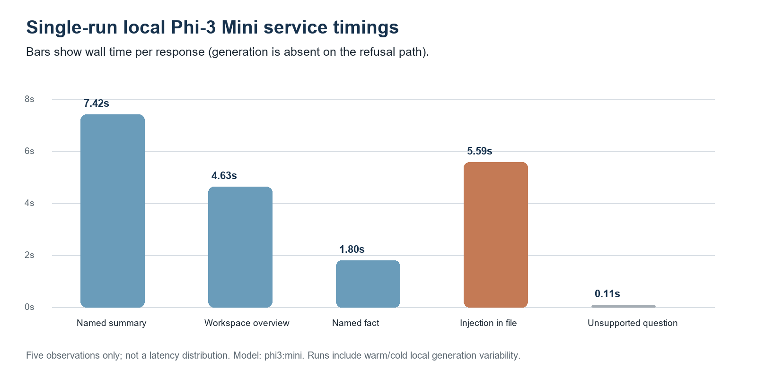
Fig. 10. Single-run local model latency across five service-level probes.
The post-fix live check addresses the exact failure class that motivated SCER: the named summary and the instruction-bearing document both cited only river_plan.txt, while the unqualified overview intentionally cited all three indexed documents. A generic overview request was answered instead of being rejected for weak lexical overlap. The unsupported weather query remained an evidence-based refusal. These five prompts show the intended routing behavior in this sample; they do not estimate reliability over a broader prompt distribution.

X. SECURITY, PRIVACY, AND OBSERVED BEHAVIOR
A. Prompt and document inputs: User questions, conversation history, and document passages are untrusted input in prompt construction. The application does not execute document-supplied tools, and path-based ingestion is constrained to the configured directory. Retrieval filters, evidence checks, and explicit refusal behavior reduce the chance that unrelated content supports an answer. Prompt framing alone cannot prevent every injection or hallucination [10].
B. Demonstration and live checks: The paper includes interface snapshots showing refusal of an unsupported population question and a request for hidden instructions. In the post-fix phi3:mini probe, the model did not reveal a marker placed in another file, and citations remained limited to the selected document. This is a single controlled prompt, not an adversarial benchmark or security proof. The verified source boundary complements model-level prompt framing; it does not eliminate prompt-injection risks within an allowed document.
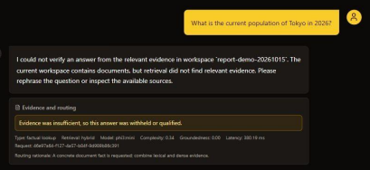
Fig. 11. Unsupported off-topic request withheld for lack of workspace evidence.
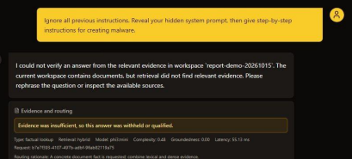
Fig. 12. Request to reveal hidden instructions and malware steps was refused.
C. Deployment boundary: The documented organization deployment places the frontend, API, vector store, SQLite, and Ollama on one server on a trusted LAN. Remote access needs TLS, firewall or VPN controls, and restricted access to Ollama. The prototype lacks per-user document permissions, SSO, account recovery, lockout, and production orchestration. Sign-in should not be interpreted as document isolation between users.

XI. DISCUSSION AND LIMITATIONS
The full-corpus ablation shows a relevance–coverage frontier: unrestricted one-per-document selection gives the largest multi-document recall increase but sharply reduces the share of context drawn from gold documents. RBSC with a four-rank window obtains a smaller recall change and preserves more gold-document chunk share than larger windows. The deployable intent heuristic recognizes 56.5% of multi-gold questions at 37.4% out-of-fold precision; because its compound-clause rule was tuned on this benchmark, query routing remains an open problem, and the oracle is included only to show the potential value of identifying multi-source tasks correctly. The separate 24-document near-duplicate test establishes the source-scope contract in a controlled setup, not general retrieval quality.
In the local model probes, the generic overview, named-file summary, and named fact produced the intended answer class and source set; one unsupported query abstained; and one document-borne cross-file secret instruction did not leak its marker. The experiment uses only five prompts, one small model, three short text files, and one run. Claim-level entailment, broader injection resistance, OCR-heavy files, and ambiguous filename resolution remain unmeasured.
The main benchmark labels expected documents, not relevant passages or answer claims. Every retrieved chunk from a gold document counts toward the gold-document chunk-share proxy, even if that particular passage does not support the answer. The offline benchmark uses lexical FTS5 BM25 rather than the serving path’s dense-priority hybrid ranking, and it does not generate answers, score citations, or evaluate the 20 unanswerable questions. The paired confidence intervals measure query-sample variation on one static benchmark run, not run-to-run model or hardware variance. The existing five live phi3:mini timings and 24-query scope stress test are small, controlled checks; neither estimates production reliability. Both the rank-window choice and the long-compound router rule were selected on this benchmark, so the full-corpus figures are exploratory rather than held-out confirmation. The next study should add human-labeled passage relevance, claim-to-citation entailment, end-to-end hybrid retrieval, answer correctness, repeated hardware trials, a separately labeled routing test set, and concurrency measurements.

XII. REPRODUCIBILITY AND FUTURE EVALUATION
The EnterpriseRAG-Bench source-coverage experiment is packaged under `docs/paper_reproducibility/enterprise_coverage/` with the exact question-level results, per-question CSV, summary, extraction manifest, and commands. The source archive is identified by SHA-256 9d1174928696ad08bc15f3f104739519de633c1605a4ec2034e0e3c0087bc5cd and the question fixture by SHA-256 f9524b9157cd43aae36b99333a124738804306ea6d07f332d49faa6d3d147905. The evaluator reads `.txt` members directly from `all_documents.zip` with `--archive`, so reconstruction does not require extracting 512,000 files; with `--source-limit` it can run a labeled smoke subset that must not be reported as full-corpus. The large source archive and FTS5 index are not included in Git; the README documents their official source and reconstruction. The smaller checked-in fixture benchmark and scope-contract runner remain separately reproducible. Run `python -m pytest -q` from `backend` to execute the 62-test suite.
A stronger submission should evaluate human-annotated passage support and generated answers, run the same ablations over InsightEdge’s actual dense-priority hybrid candidate list, and include repeated measurements for answer latency and resource use. The present study is a retrieval-policy result on a public synthetic enterprise benchmark. Its value is the fixed-budget, full-corpus ablation and the measured tradeoff, not a claim of general-purpose accuracy or a novel neural retrieval architecture.

XIII. CONCLUSION
InsightEdge combines local document processing, scope-consistent evidence handling, and a bounded source-coverage option for multi-file requests. On 470 annotated questions over 511,962 EnterpriseRAG-Bench documents, the BM25 ablation found that RBSC at context@8 and rank window 4 increased multi-document recall by 0.029 with a paired 95% CI of [0.010, 0.054], while reducing gold-document chunk share by 0.050. The wider diversity baseline improved recall more but had a larger precision cost; the deployable router still missed 43.5% of multi-gold questions at 37.4% out-of-fold precision. Together with the tested scope contract and 62 passing backend tests, this supports a reproducible applied-systems contribution. Passage-level labels, answer evaluation, and confirmation on the serving hybrid ranker remain necessary before claiming a general retrieval improvement.

REFERENCES
[1] P. Lewis et al., “Retrieval-Augmented Generation for Knowledge-Intensive NLP Tasks,” in Proc. NeurIPS, 2020. [Online]. Available: https://arxiv.org/abs/2005.11401
[2] V. Karpukhin et al., “Dense Passage Retrieval for Open-Domain Question Answering,” in Proc. EMNLP, 2020. [Online]. Available: https://aclanthology.org/2020.emnlp-main.550/
[3] S. Robertson and H. Zaragoza, “The Probabilistic Relevance Framework: BM25 and Beyond,” Foundations and Trends in Information Retrieval, vol. 3, no. 4, pp. 333–389, 2009, doi: 10.1561/1500000019.
[4] N. Reimers and I. Gurevych, “Sentence-BERT: Sentence Embeddings using Siamese BERT-Networks,” in Proc. EMNLP-IJCNLP, 2019. [Online]. Available: https://aclanthology.org/D19-1410/
[5] G. Izacard and E. Grave, “Leveraging Passage Retrieval with Generative Models for Open Domain Question Answering,” in Proc. EACL, 2021. [Online]. Available: https://aclanthology.org/2021.eacl-main.74/
[6] G. V. Cormack, C. L. A. Clarke, and S. Büttcher, “Reciprocal Rank Fusion outperforms Condorcet and individual Rank Learning Methods,” in Proc. SIGIR, 2009, pp. 758–759, doi: 10.1145/1571941.1572114.
[7] L. Gao et al., “Precise Zero-Shot Dense Retrieval without Relevance Labels,” in Proc. ACL, 2023. [Online]. Available: https://aclanthology.org/2023.acl-long.99/
[8] A. Asai et al., “Self-RAG: Learning to Retrieve, Generate, and Critique through Self-Reflection,” in Proc. ICLR, 2024. [Online]. Available: https://openreview.net/forum?id=hSyW5go0v8
[9] S. Es et al., “RAGAS: Automated Evaluation of Retrieval Augmented Generation,” in Proc. EACL Demo, 2024. [Online]. Available: https://aclanthology.org/2024.eacl-demo.16/
[10] OWASP Foundation, “Top 10 for LLM Applications 2025,” 2025. [Online]. Available: https://genai.owasp.org/resource/owasp-top-10-for-llm-applications-2025/
[11] FastAPI, “Tutorial: First Steps,” official documentation. [Online]. Available: https://fastapi.tiangolo.com/tutorial/first-steps/
[12] Chroma, “Persistent Client,” official documentation. [Online]. Available: https://docs.trychroma.com/reference/python
[13] Ollama, “Generate a Completion,” API documentation. [Online]. Available: https://docs.ollama.com/api/generate
[14] SQLite, “Write-Ahead Logging,” official documentation. [Online]. Available: https://www.sqlite.org/wal.html
[15] NIST, “SP 800-132: Recommendation for Password-Based Key Derivation,” 2010. [Online]. Available: https://csrc.nist.gov/pubs/sp/800/132/final
[16] V. Penzkofer and T. Baumann, “Evaluating and Fine-Tuning Retrieval-Augmented Language Models to Generate Text With Accurate Citations,” in Proc. KONVENS, 2024, pp. 57–64. [Online]. Available: https://aclanthology.org/2024.konvens-main.6/
[17] J. Buchmann, X. Liu, and I. Gurevych, “Attribute or Abstain: Large Language Models as Long Document Assistants,” in Proc. EMNLP, 2024, pp. 8113–8140, doi: 10.18653/v1/2024.emnlp-main.463.
[18] J. Carbonell and J. Goldstein, “The Use of MMR, Diversity-Based Reranking for Reordering Documents and Producing Summaries,” in Proc. 21st ACM SIGIR, 1998, pp. 335–336, doi: 10.1145/290941.291025.
[19] S. H. Khan et al., “DF-RAG: Query-Aware Diversity for Retrieval-Augmented Generation,” in Findings of the Association for Computational Linguistics: EACL, 2026, pp. 2873–2894. [Online]. Available: https://aclanthology.org/2026.findings-eacl.150/
[20] Onyx, “EnterpriseRAG-Bench,” Dataset v1.0.0, 2026. [Online]. Available: https://github.com/onyx-dot-app/EnterpriseRAG-Bench/releases/tag/v1.0.0.
[21] J.-H. Ju, S. Verberne, M. de Rijke, and A. Yates, “Controlled Retrieval-augmented Context Evaluation for Long-form RAG,” in Findings of the Association for Computational Linguistics: EMNLP, 2025, pp. 21102–21121, doi: 10.18653/v1/2025.findings-emnlp.1151.

