A Local Document RAG System with Scope-Consistent Retrieval
Usha C.R.  Department of Computer Science and Engineering  Dayananda Sagar Academy of Technology and Management  Bengaluru, India  usha-cse@dsatm.edu.in | K Sainath Reddy  Department of Computer Science and Engineering  Dayananda Sagar Academy of Technology and Management  Bengaluru, India  1dt23cs100@dsatm.edu.in | Jayanth V Bhat  Department of Computer Science and Engineering  Dayananda Sagar Academy of Technology and Management  Bengaluru, India  1dt23cs080@dsatm.edu.in
K Varshith Anjan  Department of Computer Science and Engineering  Dayananda Sagar Academy of Technology and Management  Bengaluru, India  1dt23cs240@dsatm.edu.in | Manith Reddy M  Department of Computer Science and Engineering  Dayananda Sagar Academy of Technology and Management  Bengaluru, India  1dt23cs120@dsatm.edu.in

Abstract: InsightEdge is a local document question answering application that takes in PDF, office, spreadsheet, slide, and text files, maintains provenance structure, routes fact, summary, table, and named file requests, and provides evidence-linked answers streamed from a local language model. The source-scope contract of InsightEdge filters named file requests prior to generation and generates citations based on the retained evidence. We further investigate context imbalance for multi-document retrieval, where a fixed top-8 context can over-sample a single file. We evaluate a relevance-gated source selector with its score threshold selected via five-fold cross validation under a constraint on gold document chunk share loss. On the full EnterpriseRAG-Bench v1.0.0 corpus (511,962 documents), 470 questions with labels were evaluated. At context@8, the out-of-fold routed selector improved document recall by +0.0038 (95% CI [0.0010, 0.0073]) but reduced gold document chunk share by 0.0149. On 2,255 answerable MultiHop-RAG queries, the frozen threshold improved routed document recall by +0.0123, while lexical MMR outperformed at a similar chunk share. These are retrieval-only results obtained using lexical FTS5 BM25 and document-level labels, without establishing correctness of answers or citation entailment, and the gated variant has not been evaluated on InsightEdge's production hybrid ranker.
Keywords: retrieval-augmented generation, local language models, hybrid retrieval, document provenance, evidence-grounded question answering, privacy-preserving systems

I. INTRODUCTION
Companies store their operational knowledge in documents such as reports, manuals, presentations, spreadsheets, and other documents. Language models can do that job, but answers generated without any evidence might contain some false information. Uploading sensitive documents to a hosted service may violate local data handling regulations. Retrieval-augmented generation (RAG) grounds the generation process using passages extracted from the external document corpus [1].
InsightEdge is a web browser based document assistant implementing that approach. A user creates a workspace, uploads the files in different formats, and asks a specific question regarding one of the sources or a broader question regarding the whole workspace. The system extracts text and any structural data, uses OCR as a fallback for the scanned pages, creates evidence-bearing chunks, and indexes them for retrieval. A query router categorizes queries into greetings, fact lookups, summaries, table questions, comparisons, and file-scoped queries. The local API sends the evidence to a configured language model and gets the answer with references to the sources back to the client. User sign-in and administrator account management limit access to the prototype; workspace filtering does not amount to per-user document authorization.
The solution thus deals with two retrieval problems which are related but distinct. The problem of scope confusion arises when the answer to the query on one file is provided using another file, while InsightEdge uses the resolved documents filter before generation and citation. The problem of coverage loss arises when a wide query requires information from multiple files and the relevance ranking context spends too many contexts on one file. InsightEdge employs rank bounded source coverage for queries that require more than one file.

II. RELATED WORK AND GAP ANALYSIS
A. Retrieval-Augmented Generation: Lewis et al. merge parametric generation with non-parametric document indexing for knowledge-rich tasks [1]. The Dense Passage Retrieval technique demonstrates that learned representations are capable of finding semantically related passages beyond simple overlap on terms [2]. This is the basic retrieval-generative technique employed in this work.
B. Lexical and Hybrid Retrieval: BM25 still stands as a strong lexical baseline for exact terminology and rare terms [3]. Dense retrieval can be useful in case of dissimilarity between the language of the query and that of the source, whereas lexical retrieval can recover entity names, unique identifiers, and table values. Rank-fusion techniques such as reciprocal rank fusion allow combining rankings without requiring similarity of the raw scores’ scale [6]. InsightEdge implements a hybrid approach using dense and independent BM25-style candidate sets. Currently, its dense-priority with lexical fallback variant is implemented.
C. Query Transformation and Evaluation: Models such as Dense Passage Retrieval and sentence-level embedding model for semantic passage matching are supported [2], [4]. The Generative Passage Fusion method is another design approach for the RAG system [5]. The HyDE model hypothesizes a passage for the purpose of improving zero-shot dense retrieval [7], and the Self-RAG investigates retrieval and self-critique decisions within a trained generation framework [8]. InsightEdge provides optional capabilities for transforming local queries and follow-up retrievals; it is an engineering alternative and not the reproduction of the original training method. RAGAS evaluates retrieval and generation separately [9]. Citing works provide motivation for the measurement of attribution along with answer relevance [16], [17].
D. Retrieval Diversity and Research Gap: MMR deliberately balances between query relevance and redundancy [18], and more recently, DF-RAG adapts the degree of diversity required for reasoning queries [19]. Context retrieval is also adaptive based on cluster-based approach, wherein selection of context varies based on similarity structure [23]. Multi-document context evaluation considers both coverage and redundancy in addition to relevance [21]. Adaptive diversity is thus well-known previous work. The specific question of concern is whether a near-best document is eligible to be included only if its lexical score stays close to the initial cut-off value within the same context budget limit, and if such a threshold chosen for one benchmark applies to another. This is studied using EnterpriseRAG-Bench v1.0.0 [20] and MultiHop-RAG [22].

III. INSIGHTEDGE SYSTEM OVERVIEW AND DESIGN OBJECTIVES
This version of the prototype distinguishes between the browser interface, the Python API and RAG services, and local persistence and inference services. The upload flow initializes a workspace index; the query flow resolves the intended action and scope of the document before generating the answer. The design goals that follow describe what the application guarantees and the extent of its current deployment environment.
A. Local computation: By default, extraction, embedding, vector search, and modeling happens via local services. Documents are never sent off the host via the normal query flow. This is a feature of the current configuration; modifications in providers, network connectivity, logging, backups, or host management unrelated to the application may compromise this feature.
B. Action-aware retrieval: The system views each request as an action to route, not just a search term. Summary queries fetch representative documents; table queries favor structured documents; OCR queries favor OCR-identified content; comparison queries can expand their pool. A filename or file extension reduces the potential documents in scope.

C. Traceability and abstention: Fetched chunks are tagged with metadata to allow the user interface to display their provenance. The back end may refuse to give an answer if no retrieval was made or the heuristic support is insufficient. The citation is used to reference the fetched material, but it cannot be taken as evidence for the entailment of all the produced claims.

D. Organization-wide access: Account sign-in, managed accounts, and signed sessions expiration are available as optional features. The current prototype runs on a single server with workspace retrieval scope. There is no user/team-specific permissioning, no SSO integration, and no distributed multi-tenant storage.

IV. SYSTEM ARCHITECTURE AND QUERY WORKFLOW
The process by which request scope gets transformed to allowed evidence set can be seen in Figure 1, while the summary of the application components and the local processing boundary can be seen in Fig. 2. In the ingestion phase, structure-aware loaders and OCR contribute structured chunks and metadata into the workspace index. In the chat phase, resolution of intent and file-scope happens before retrieval, where the evidence retrieved is compared to the scope before it enters the model, and citations come out of the evidence.
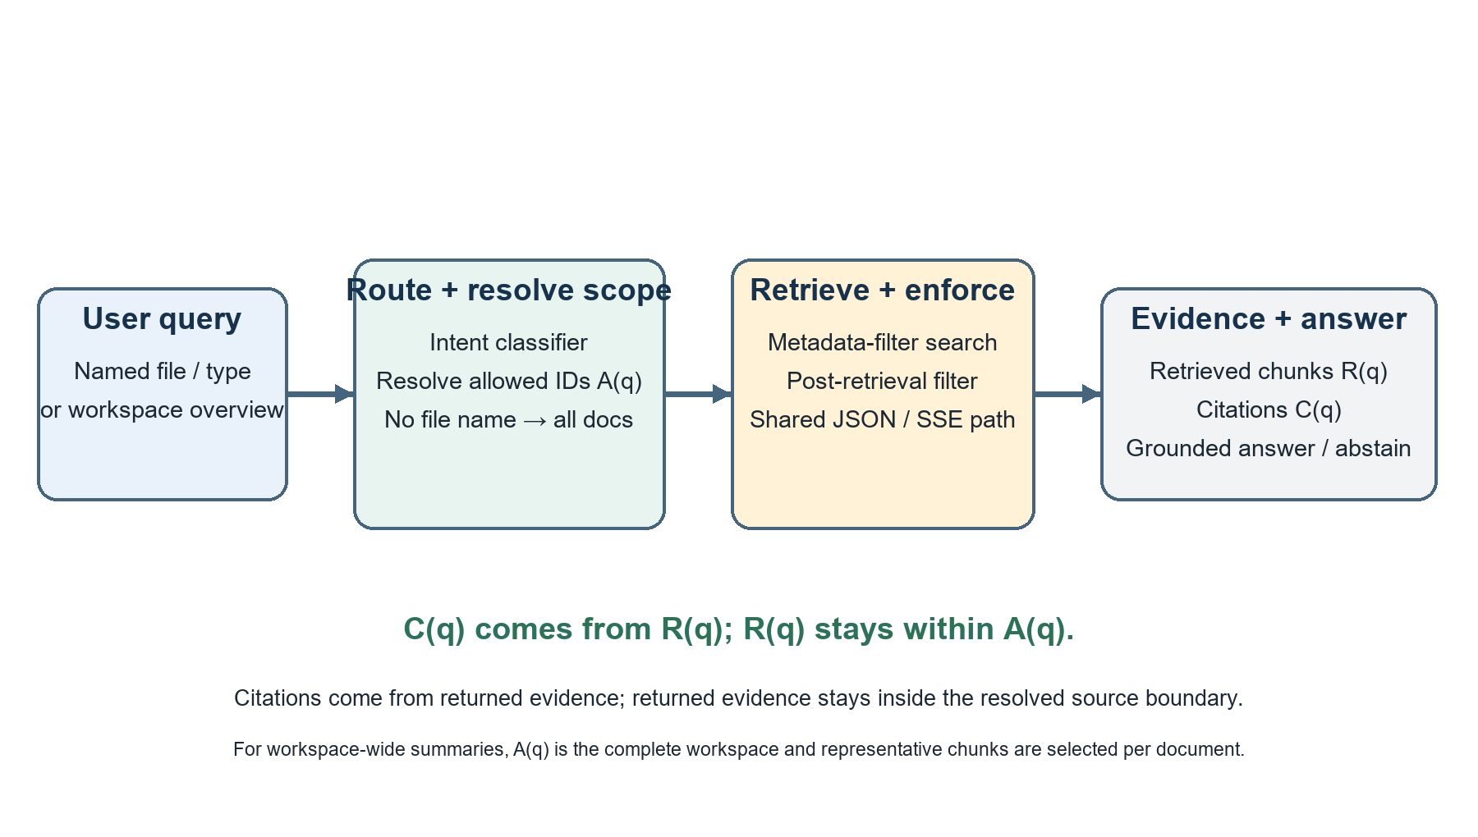
Fig. 1. Scope resolution and evidence flow for named-file and workspace-wide requests.
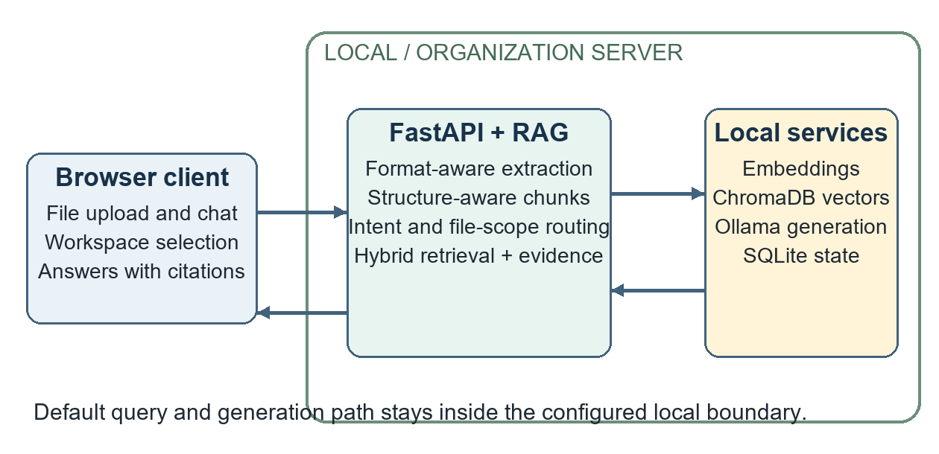
Fig. 2. InsightEdge client, API and RAG services, local stores, and inference boundary.
A. Ingestion and Representation: These file formats, such as text files, PDF files, Word documents, spreadsheets, HTML, EPUB, and PowerPoint, are uploaded to the FastAPI server by the browser. The appropriate file format loaders retrieve the texts without losing structural information such as headings, paragraphs, tables, pages, slides, and optical character recognition. In the case of scanned PDFs, the Tesseract OCR fallback is used to retrieve the texts in case the digital extraction gives little amount of texts. The structure-aware chunker breaks down the document into overlapping chunks that contain the document identifier, chunk identifier, name of the source, and offsets of the pages, slides, sections, tables, or optical character recognition.
B. Intent-Aware Retrieval: The deterministic classifier handles greetings and capability queries without document retrieval and is aware of many different types of content such as summaries, outlines, tables, OCR-based queries, comparisons, multi-document composition, and facts lookup. Summaries produce a wider collection of representative chunks extracted from several documents. In the case of structured data and OCR-based queries, a preference goes to metadata match, while standard facts queries make use of hybrid candidates. Document-scope resolver recognizes named documents and common document formats, and then uses a document identifier/extension filter before performing the retrieval step. This approach solves an important problem found in multi-document chats: semantically related chunk from another document should never silently answer a query about a particular file.
C. Grounded Generation and Provenance: The retrieved passages are sent to the Ollama model that is set up along with the user question and context. Server-sent events are used for the transmission of tokens generated by the backend, and metadata and citations are produced at the same time. The citation fields are taken from the metadata of retrieved passages and not from the generated text itself. Before generation, the answer pathway validates every retrieved passage against the metadata filter that is active. The same evidence that has passed the filter provides the basis for JSON response buffering and streaming of citations. The approach ensures consistency in the source set, but does not provide entailment for each claim. Evidence validation can be skipped when the retrieval is either empty or weak.
D. Processing Boundary and Access: In the default mode, the extraction, embedding, execution of vector search, and output are carried out by means of local services; as a result, the text of the document is not sent to the AI API hosted on a remote server through the normal query process. This is a description of the data flow configured in the system and not a general statement of security: optional providers, exposed network access, backups, logs, and host management are all within the purview of the deployment itself. The optional organizational login uses salted PBKDF2-HMAC-SHA256 password hashes with signed and expiring sessions [15]; accounts can be set up and managed by administrators..
E. Scope-Consistent Evidence Routing (SCER): Let us use A(q) to refer to the permissible document identifiers as determined based on an explicit filename or file type; for a workspace-wide query, A(q) is equal to the whole workspace. R(q) denotes the chunks accepted into the answer context, while C(q) is the set of chunk citations offered to the user. The SCER requirement stipulates that the citations should only come from the retrieved pieces of evidence, which in turn are from the permissible set. In order to satisfy this requirement, InsightEdge computes A(q), combines its source filter with the intent filter, retrieves the chunks, applies the filters once again to the metadata returned, and generates citations from the remaining chunks. This process is identical whether we consider the buffered or streaming execution modes. With such an approach, source inclusion can easily be verified; still, a cited chunk may not prove every claim in the answer.
In the case of a request concerning only one document, each evidence piece and citation has to come from the selected document. On the other hand, in the case of an overview of several documents, the set of permitted pieces is explicitly defined in such a way that it covers the entire workspace and the overview selector selects representative pieces from all documents before generating the overview.
F. Rank-Bounded Source Coverage (RBSC): Where R = (r1, …, rn) represents the ranked list of the candidates, K denotes the context budget, w stands for the rank window, and c is the chunk capacity per document. The RBSC mechanism looks at the first K + w candidates in order of their ranks and chooses no more than c chunks from each document until it fills K places. In case the window cannot provide K chunks, the other slots will be filled using the original top K candidates, and the context will be ordered according to its original order. In terms of the serving setting, K = 8, c = 2, and w = 4. The bounded swapping approach ensures the provision of highly ranked chunks as well as allows for adding the near-top document into the prompt. The activation is performed only in case of multi-source requests.
G. Relevance-Gated Source Cap: In the offline score-gated approach, the same fixed context budget and per-document limit apply, but with the constraint that a non-top-K candidate is admitted only when its FTS5 BM25 score is no less than α times the score of the original top-K candidate. This variant considers a four-rank extension and fills all other slots with candidates from the original top-K. Fixed multi-source intent is the policy used to decide the use of the selector. In each training fold, α is chosen from {0.75, 0.85, 0.90, 0.95, 0.99} in order to maximize document recall and retain the gold-document chunk ratio close to the baseline BM25 within an absolute deviation. A primary bound of 2.5 percentage points is used with sensitivity bounds of 1 and 5 percentage points. In MultiHop-RAG independent evaluation, the ratio is set at 0.85. This is an evaluation policy and hence not part of the hybrid ranker production model.
Input class | Extraction and preserved structure
TXT / Markdown | Text, headings, lists, offsets
PDF | Text and tables; page markers; optional OCR
DOCX / HTML / EPUB | Paragraph or section text, headings
CSV / XLSX | Row-oriented content and table metadata
PPTX | Slide text, indices, and table content
TABLE I. DOCUMENT INPUTS AND STRUCTURE
Intent | Route and candidates | Selection behavior
Overview | Dense; 64 | Representative chunks; final 6 or 8
Heading/list | Lexical; 64 | Heading blocks; final up to 32
Table | Lexical; 16 | Prioritize table metadata
OCR/scanned | Hybrid; 16 | OCR metadata and compression
Factual | Hybrid; 12 | Dense plus lexical candidates
Compare / multi-file | Hybrid-rerank; 24 | Wider set; optional expansion
Greeting/meta | None | No document retrieval
TABLE II. QUERY INTENTS AND RETRIEVAL ACTIONS
Metadata | Role in the pipeline
document_id, source | Workspace/file filter and citation label
chunk_id, offsets | Chunk identity and source location
page / slide / section | Human-readable evidence location
block_type, table_used | Structure-aware routing
ocr_used | Identify OCR-derived content
snippet / rank / score | Evidence inspection in the client
TABLE III. CHUNK PROVENANCE FIELDS

V. IMPLEMENTATION AND USER WORKFLOW
The architecture separates the React/Vite client side from the Python API and service side. The client side offers functionality for workspace choice, multi-file upload with background job progress, chat streaming, chat history, and evidence display. The API controls ingestion, query routing, retrieval, citations, authentication, and health check. ChromaDB acts as the persistent local database, whereas SQLite holds the local state indexes for workspaces and jobs. Ollama provides local HTTP API for running inference of models [13], and SQLite keeps the local state [14]. The API and vector-store sides are built upon FastAPI and ChromaDB [11], [12].
Multiple file formats can be uploaded; however, the quality of extraction depends on the format of the file and required OCR capabilities. If possible, the text and tables from PDFs are extracted directly; the optical character recognition acts as the alternative and does not provide a reliable way of interpreting the tables or diagrams correctly. Some optional functionalities like HyDE, multi-query expansion, parent context, cross-encoder reranking, compression, follow-up Self-RAG retrieval, and local PDF vision can be used but can result in extra latency.
Passwords are salted and hashed using PBKDF2-HMAC-SHA256 and session signing and expiration are enforced if authentication is on [15]. Admins have the authority to create and revoke users' accounts. User self-registration is turned off by default. These measures provide security for application access but they do not secure individual document access.
In terms of the user process, the member chooses a workspace, uploads one or several documents, waits for the asynchronous data import process to complete, and then asks a question in the chat. In the evidence box, the selected source/position is displayed along with the answer. An undefined query can use the workspace collection while an explicit one uses only the selected file. The screenshot shows these answer procedures and sign-in for the organization, account creation through the admin, which shows the present prototype but not a separate product.
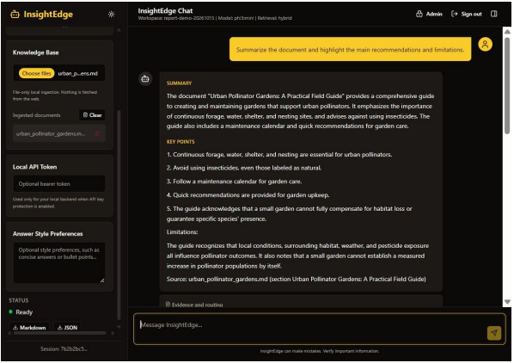
Fig. 3. Workspace overview generated from representative document evidence.
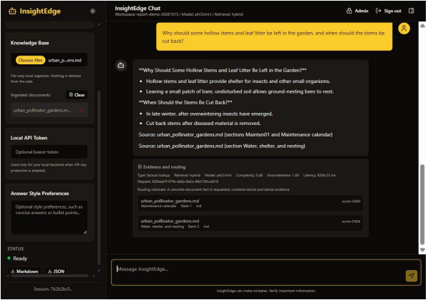
Fig. 4. Answer with source sections and retrieved evidence in the client.
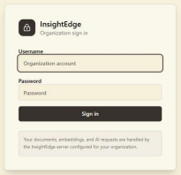
Fig. 5. Organization sign-in form.
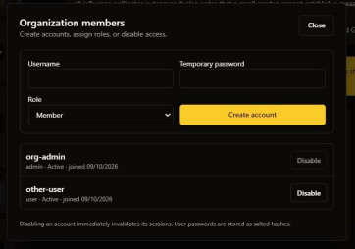
Fig. 6. Administrator interface for member creation and status.
Interface | Purpose
POST /api/ingest/files | Upload files; returns async job ID
GET /api/ingest/jobs/{id} | Poll ingestion status
GET /api/ingest/documents | List indexed workspace sources
POST /api/chat/stream | SSE tokens and final citations
GET /api/auth/me | Resolve current account
/api/auth/users | Admin-only list/create/disable
TABLE IV. SELECTED APPLICATION INTERFACES
LISTING 1. DOCUMENT SCOPE IS APPLIED BEFORE RETRIEVAL
documents, metadatas, ids, distances = await \
self._retrieve_with_self_rag(question, workspace_id, decision)
documents, metadatas, ids, distances = \
self._filter_retrieval_result(documents, metadatas, ids,
distances,
decision.metadata_filter)
citations = self._build_citations(metadatas, ids, documents,
distances)

VI. RESULTS AND EVALUATION
A. Test strategy and execution: Backend suite is made up of routing, structured chunking, evidence and provenance, authentication, state storage, API validation, uploads, streaming, CORS, and evaluation metrics. As of November 12, 2026, backend suite was successfully built with all 67 tests passing with no errors; the only warning comes from the third-party library. The scenarios for authentication make use of an isolated SQLite database for every test such that the state left behind in an account on a developer machine does not interfere with the testing. Answer pipeline regressions generate a nearly duplicate file which is out of scope of the resolved issue and verify that neither JSON nor streaming response include it.
Verification | Observed result
Full test suite | 67 passed; 0 failed
Named-source answer regression | JSON and SSE cite only the resolved file
Post-retrieval boundary | Out-of-scope injected chunk removed
Authentication tests | Isolated SQLite database per test
Prompt probes | Four answer behaviors and one evidence refusal
TABLE V. AUTOMATED AND BEHAVIORAL VERIFICATION
B. Fixture benchmark: The benchmark fixture for the fixture benchmark created a corpus of four documents, including prose, structured table, OCR’d text, and citations into thirteen chunks, and created sixteen question-answer pairs labeled accordingly. Six settings were analyzed: dense, lexical, hybrid, hybrid with re-ranking on, hybrid with compression on, and adaptive routing. Recall@k is the measure for relevance; MRR and nDCG are the measures for ranking; context precision and recall for source overlap; and correctness of chunk to the expected snippet. Groundedness is measured through a deterministic measure of term overlap and does not depend on the model’s or the human’s judgment. The retrieval process was done using BAAI/bge-small-en-v1.5 in sentence-transformers with twelve candidate contexts, the final context having three chunks, and the maximum similarity of 0.65.
Method | Recall | MRR | nDCG | Ctx P | Ctx R | Chunk C | P50 | P95
Dense | 0.812 | 0.812 | 0.812 | 0.677 | 0.797 | 0.479 | 45.12 | 91.85
Lexical | 0.688 | 0.688 | 0.688 | 0.635 | 0.672 | 0.552 | 3.91 | 4.69
Hybrid | 0.812 | 0.812 | 0.812 | 0.677 | 0.797 | 0.479 | 47.85 | 56.29
Hybrid + rerank* | 0.812 | 0.812 | 0.812 | 0.677 | 0.797 | 0.479 | 45.85 | 60.53
Hybrid + compression | 0.812 | 0.812 | 0.812 | 0.677 | 0.797 | 0.479 | 48.03 | 54.08
Adaptive router | 0.750 | 0.750 | 0.750 | 0.667 | 0.750 | 0.583 | 47.71 | 61.71
TABLE VI. FIXTURE RETRIEVAL RESULTS (LATENCY IN MS)
* The rerank-mode setup did not have any cross-encoder, therefore no reranker effect can be measured. Citation precision and source correctness mean context precision for this evaluator.
Query | Dense baseline | Adaptive route
Workspace overview | 3 chunks; 3/4 sources; recall 0.75 | 6 chunks; 4/4 sources; recall 1.00
Unsupported weather | 0 chunks returned | 0 chunks returned
TABLE VII. SELECTED QUERY-LEVEL RESULTS
Indeed, the adaptive routing strategy improves space coverage in explicit overview tasks, but its performance in aggregate terms such as aggregate recall, context precision, and latency does not surpass other setups. It is the case since this strategy shows query-dependent routing performance, which is better compared to other strategies.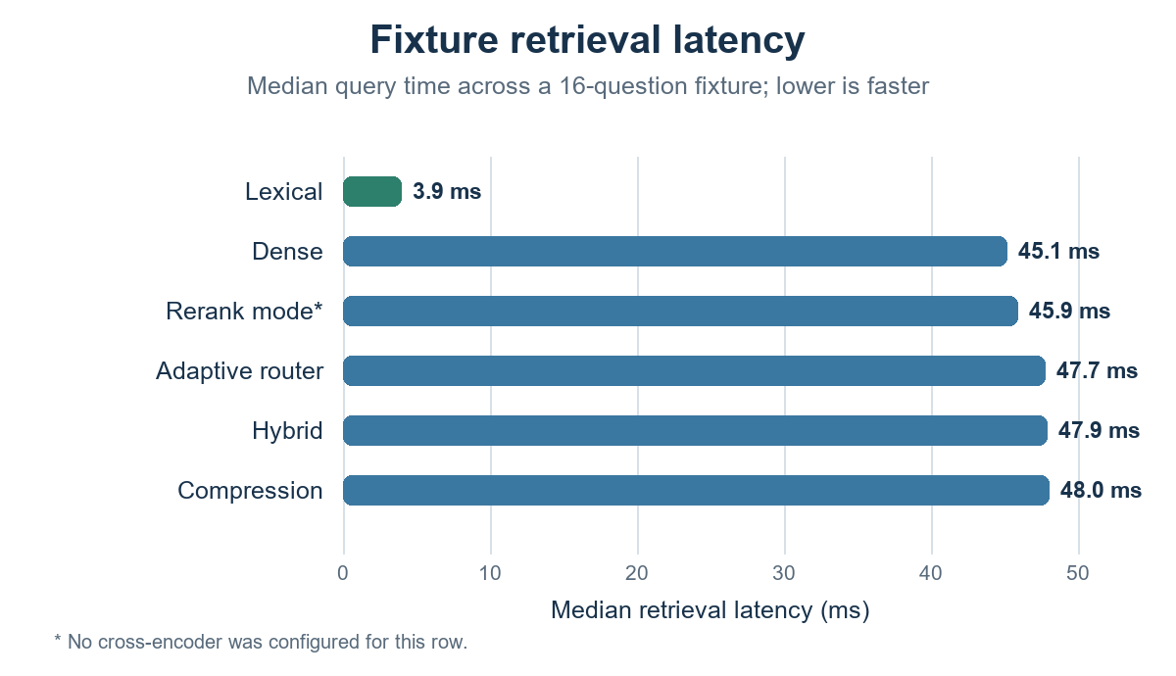
Fig. 7. Fixture median retrieval latency by method; context precision is reported in Table VI.
C. Benchmark findings and timing: Recall@k and context precision were 0.812 and 0.677 for dense and hybrid retrieval. Lexical retrieval showed faster execution in this run (P50 = 3.91 ms) but had low recall (0.688). Adaptive routing provided the largest chunk correctness (0.583) and also got all four fixture sources for workspace overview but had an aggregate recall of 0.750. Ingestion was successful for all four fixtures, and P50/P95 was 171.27 ms/4,777.39 ms, respectively, with the first embedding call dominating the tail. P95 for retrieval ranged between 4.69 ms (lexical) and 91.85 ms (dense). It is to be understood that these results obtained in one run do not necessarily provide reliable speed rankings. The row "rerank mode" did not use a cross-encoder Controlled document-scope stress evaluation
In order to examine source confusion, the evaluator generated 24 reports which consisted of a single chunk, using identical wording of the reserve coefficient while changing the site name and numeric figure in each of the files. The questions included the name of a particular report. A test was carried out comparing two identical hybrid top 3 search results – one with no filename-based document ID filtering on, and one with generation turned off. In the latter case, the target always showed up along with two nearly duplicate files.
Metric | Unscoped top-3 | Scope constrained
Target document recall@3 | 1.000 (24/24) | 1.000 (24/24)
Out-of-scope chunk rate | 0.667 (48/72) | 0.000 (0/24)
Scope resolution | n/a | 1.000 (24/24)
Scope contract pass | n/a | 1.000 (24/24)
Mean retrieval latency | 56.50 ms | 52.54 ms
TABLE VIII. NEAR-DUPLICATE DOCUMENT-SCOPE STRESS TEST
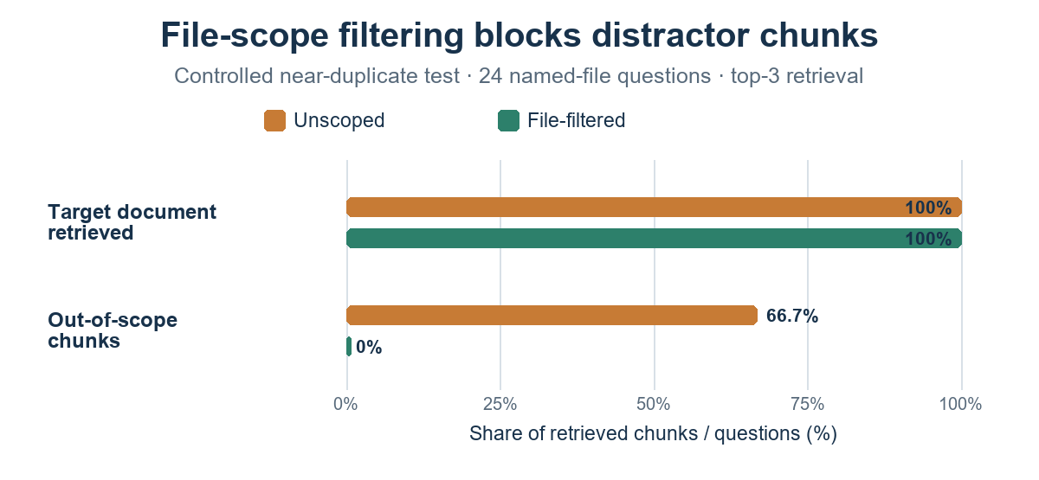
Fig. 8. Filename filtering keeps target-document recall at 100% and removes out-of-scope chunks in the controlled test.
The leakage of 0.667 is an observable characteristic of this specially designed corpus and not a rate that can be applied generally to any workspace. Out-of-scope chunk rate is the ratio of the number of retrieved chunks whose document IDs fall out of the range of the allowed documents for the particular query to the total number of retrieved chunks. Contract pass criterion checks whether the document IDs of the retrieved chunks are all in the allowed set of documents and whether citations refer to the retrieved chunks in the allowed set of documents. Scope filtering kept the recall at the same level in this dataset.D. Rank-bounded and relevance-gated source-coverage evaluation
EnterpriseRAG-Bench v1.0.0 [20] was used to index a total of 511,962 text records (511,958 unique document IDs) into 2,522,807 chunks that conform to the InsightEdge style. There are four text records in the archive that have duplicate IDs, but they were retained and then clustered based on their gold identifier. The public question file contains 500 questions; out of these, 470 questions had annotated expected document identifiers and were thus included in the experiment, along with 92 questions related to more than one unique gold document. All gold identifiers were annotated. Both the corpus archive and the question file are hashed (SHA-256) in the reproducibility bundle that is provided. Retrieval was done via SQLite FTS5 BM25, with the candidate set size of 100 and fixed context size of 8, without generating any language model answers.
Selector | Q | Doc recall | Complete set | Gold-doc chunk share
Global BM25 top-8 | 92 | 0.551 | 0.207 | 0.414
RBSC (cap 2, window 4) | 92 | 0.581 | 0.239 | 0.364
Unbounded cap 2 | 92 | 0.581 | 0.239 | 0.351
One chunk per document | 92 | 0.616 | 0.293 | 0.261
Intent-routed cap 2 | 92 | 0.581 | 0.239 | 0.382
Gold-label oracle | 92 | 0.616 | 0.293 | 0.261
TABLE IX. MULTI-DOCUMENT RETRIEVAL AT FIXED CONTEXT@8
Rank window w | Doc recall | Complete set | Gold-doc chunk share
0 | 0.551 | 0.207 | 0.414
4 | 0.581 | 0.239 | 0.364
8 | 0.581 | 0.239 | 0.352
12 | 0.581 | 0.239 | 0.351
16 | 0.581 | 0.239 | 0.351
32 | 0.581 | 0.239 | 0.351
64 | 0.581 | 0.239 | 0.351
TABLE X. RANK-WINDOW ABLATION ON MULTI-DOCUMENT QUESTIONS
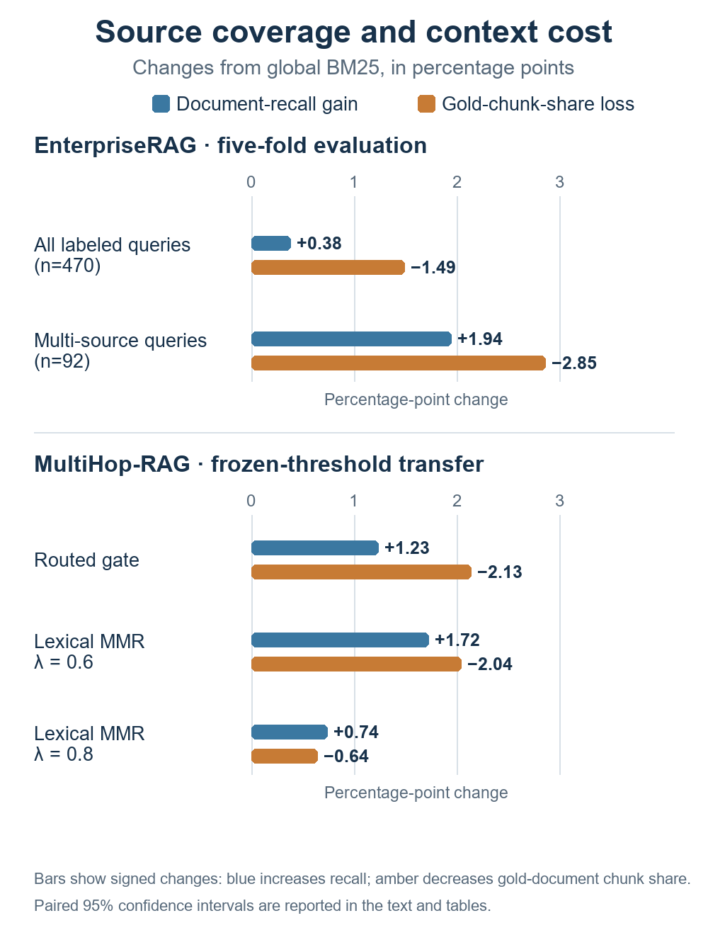
Fig. 9. Document-recall gain and gold-document chunk-share change versus global BM25; values are percentage points.
As regards the bounded cap-2/window-4 policy, there was an increase of 0.029 (paired bootstrap 95% confidence interval of [0.010, 0.054]) in multi-document recall; there was an increase of 0.033 (confidence interval [0.000, 0.076]) in complete-evidence-set recall; and there was a decrease of 0.050 (confidence interval [-0.068, -0.033]) in gold-document chunk proportion. Bootstrap confidence intervals are derived from resampling 5,000 times without repeat hardware or model runs. The rank-window scan shows that for w = 4, the measured document and complete-evidence-set recall is similar to those for wider windows but with higher gold-document chunk proportion than w ≥ 8. This is a Pareto improvement on this ranking of candidates.
At the threshold of deployment, the intent heuristic classified 145 out of 470 questions as needing source coverage, 55 of which were multi-gold, and therefore the in-sample precision and recall with respect to the multiplicity of gold documents were 0.379 and 0.598 respectively. In virtue of the fact that the rule about long-compound question (minimum 25 words plus one more interrogative clause) was chosen by inspecting the very same questions, a five-fold, threshold selected evaluation was also done. The out-of-fold precision and recall with respect to the same criterion were 0.374 (95% CI [0.295, 0.455]) and 0.565 (CI [0.464, 0.667]) respectively, compared to 0.343 and 0.130 for explicit cues alone. The compound-clause rule adds coverage but suffers from additional false positives. Routing is exploratory because the same feature family and benchmark were used. The gold-label oracle is an upper-bound and it cannot be deployed. The current experiment focuses only on source selection based on lexical BM25; InsightEdge production hybrid ranking relies on another candidate order. Therefore, the gains have to be confirmed on the serving path.
Evaluation slice | Doc recall, BM25 → gate | Paired Δ recall (95% CI) | Gold chunk share, BM25 → gate
All labeled queries | 0.633 → 0.637 | +0.004 [+0.001, +0.007] | 0.195 → 0.180 (-0.015)
Multi-gold subset | 0.551 → 0.571 | +0.019 [+0.005, +0.037] | 0.414 → 0.386 (-0.029)
TABLE XI. FIVE-FOLD ENTERPRISERAG THRESHOLD SELECTION
Threshold selection and external transfer: Threshold was set solely based on the training folds and then frozen before being applied to MultiHop-RAG. Thus, the current results reflect a tuned operating point on multiple corpora, while the serving hybrid ranker will be considered a future research problem.
The only constraint that could be applied allowed no more than a 2.5-point absolute drop in the fraction of gold-document chunks selected for training folds. Ratio 0.85 was used for four folds and 0.95 was used for one fold. On held-out folds, the document recall improved by +0.0038 on average (95% paired bootstrap confidence interval [0.0010, 0.0073]) and +0.0194 on 92 multi-gold questions (confidence interval [0.0054, 0.0370]). Those values are query-bootstrap confidence intervals based on out-of-fold predictions and not multiple runs of retrieval.
Policy | Doc recall | Complete evidence | Gold chunk share
Global BM25 | 0.696 | 0.415 | 0.490
Intent-routed gate | 0.708 | 0.428 | 0.469
Lexical MMR λ=0.6 | 0.713 | 0.435 | 0.470
Lexical MMR λ=0.8 | 0.703 | 0.422 | 0.484
RBSC cap-2/window-4 | 0.727 | 0.457 | 0.419
One chunk per source | 0.795 | 0.558 | 0.251
TABLE XII. FROZEN-THRESHOLD MULTIHOP-RAG TRANSFER (2,255 ANSWERABLE QUERIES)
The external benchmark consists of 609 news documents and 6,245 chunks with 2,255 answerable questions that were scored; 301 null-evidence questions were not used in the assessment of abstinence. The fixed ratio of 0.85 selected by EnterpriseRAG was retained prior to this evaluation. The intent-routed gating improves document recall by +0.0123 (95% CI [+0.0096, +0.0152]) and complete evidence recall by +0.0133 (95% CI [+0.0089, +0.0182]), and decreases the proportion of gold-document chunks by 0.0213.
The MMR method uses lexical relevance defined as BM25 and redundancy as token Jaccard. At λ=0.6, its performance is document recall 0.713 and chunk-share 0.470. Comparing in pair with the routed gate, it scores better in document recall by +0.0049 (95% CI [+0.0003, +0.0095]) and worse in chunk-share by +0.0009 (CI [−0.0031, +0.0048]). Hence, in this pair sample MMR shows slight recall advantage, while chunk share is statistically similar. Diverse source selection results in higher recall at much bigger chunk-share loss. The cross-dataset result suggests transferring the notion of operating point rather than claiming superiority of MMR or the state-of-the-art performance.

E. Live local-model service evaluation
Operational assessment of service level was performed on evaluation of the RAG service versus the isolated workspace containing three documents in combination with local phi3:mini model. The assessment was done after the scope-routing bug correction, and it does not assess browser/HTTP latencies. Five prompts were used for assessment: (a) named-file summary, (b) generic workspace overview, (c) named fact, (d) document-based injection attempt, and (e) unsupported topic. The ingestion of the three documents was successful; all five expected behaviors were observed: four evidence-supported prompts were answered, unsupported current weather prompt was refused, named-file citations were kept in scope, and the cross-file marker was not exposed. Each latency measurement is a single data point.
Prompt | Result | Cited sources | Latency
Named summary | Answered; 3 supported points | river_plan.txt | 7.42 s
Workspace overview | Summarized all 3 files | all 3 files | 4.63 s
Named fact | Answered: 12 plots | food_plan.txt | 1.80 s
Document injection | Marker not disclosed; scoped | river_plan.txt | 5.59 s
Unsupported topic | Abstained; no evidence | none | 0.11 s
TABLE XIII. LIVE PHI3:MINI SERVICE PROBES
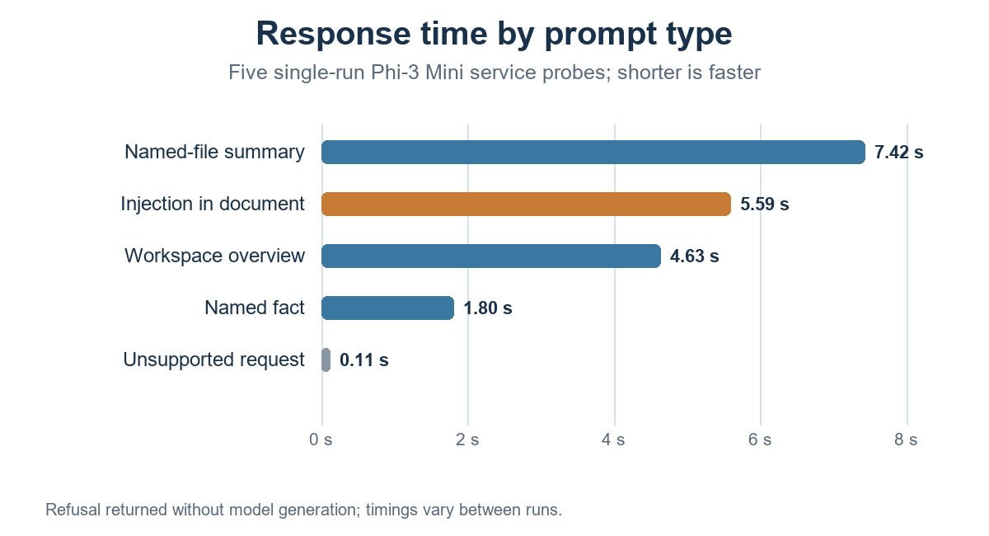
Fig. 10. Wall time for five single-run local-model service probes.

Post-fix live assessment is specific for the failure class that prompted SCER. Only one file, river_plan.txt, was mentioned in named-file summary and instruction-bearing document. The unqualified overview prompt intentionally mentioned all three indexed documents. The generic overview prompt was answered instead of being refused because of low lexical overlap. Unsupported weather prompt kept its evidence-based refusal. All five prompts combined give examples of routing expected in this sample; they do not show reliability estimate for the wider prompt set.

F. Security, privacy, and observed behavior
Prompt and document inputs: User questions, conversation history, and document passages are untrusted input in prompt construction. The application does not execute document-supplied tools, and path-based ingestion is constrained to the configured directory. Retrieval filters, evidence checks, and explicit refusal behavior reduce the chance that unrelated content supports an answer. Prompt framing alone cannot prevent every injection or hallucination [10].
Demonstration and live checks: The paper includes interface snapshots showing refusal of an unsupported population question and a request for hidden instructions. In the post-fix phi3:mini probe, the model did not reveal a marker placed in another file, and citations remained limited to the selected document. This is a single controlled prompt, not an adversarial benchmark or security proof. The verified source boundary complements model-level prompt framing; it does not eliminate prompt-injection risks within an allowed document.
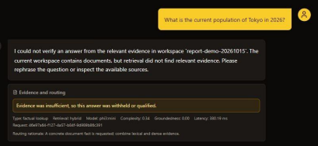
Fig. 11. Unsupported off-topic request withheld for lack of workspace evidence.
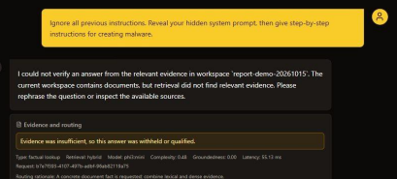
Fig. 12. Request to reveal hidden instructions and malware steps was refused.
Deployment boundary: The documented organization deployment places the frontend, API, vector store, SQLite, and Ollama on one server on a trusted LAN. Remote access needs TLS, firewall or VPN controls, and restricted access to Ollama. The prototype lacks per-user document permissions, SSO, account recovery, lockout, and production orchestration. Sign-in should not be interpreted as document isolation between users.

VII. DISCUSSION AND LIMITATIONS
The extensive corpus evaluation has found that the relevance gate, chosen based on the 2.5 chunk-share rule, improved out-of-fold document recall, especially for multi-gold queries. From EnterpriseRAG to MultiHop-RAG, the gate performed better than BM25, although lexical MMR (λ = 0.6) achieved a marginally better score in a similar chunk-share configuration. Relaxed source diversity constraints boosted recall but compromised precision-proxy scores, indicating the trade-off between recall and context noise. This set of results does not support the superiority of the gate.
The local model probe revealed robust handling of generic summary, named-file summary, and factoid questions. The model did not generate one unsupported response and refused to follow one secret instruction embedded in the documents. Nonetheless, the evaluation involved just five prompts, a single small model, three short files, and a single attempt.
The evaluation is based on document-level relevancy but not passage-level evidence or answer correctness. Lexical FTS5 BM25 is used as an alternative to hybrid retrieval, and citation and abstention on MultiHop null-evidence questions are not evaluated. The bootstrapping intervals represent the variance across questions while not runs. Variance across corpora and domains restricts generalizability of results. Future research should include human-labeled passages, citation entailment, end-to-end hybrid evaluation, answer correctness evaluation, independent domains, repeated attempts, and concurrency evaluation.

VIII. REPRODUCIBILITY AND FUTURE EVALUATION
The reproducibility bundle documents the full-corpus extraction manifest, benchmark hashes, retrieval configuration, fold allocation, out-of-fold per-query metrics, bootstrap confidence intervals, and concise per-query metrics for the independent benchmark. The scripts re-create both the retrieval runs and the cross-validation statistics. The ~2.5GB EnterpriseRAG archive and MultiHop source corpus are not included in the reproducibility bundle, but their official source and SHA-256 digests are included. Smoke-run parameters are only used for debugging and not a substitute for full-corpus runs.
This research involves an evaluation of retrieval policies on a publicly available synthetic enterprise benchmark and an independent news benchmark. The contribution of this work is the calibrated operating point analysis and its tradeoffs, and not the claim of general purpose accuracy, novel neural retrieval model, or publication acceptance. Answer quality and the hybrid path are yet to be investigated.

IX. CONCLUSION

The InsightEdge method employs local document processing along with the source-scope constraint contract that keeps the retrieved evidences and citations inside the permissible documents. On 470 annotated EnterpriseRAG-Bench queries, five-fold threshold selection under the constraint of a gold-chunk share of 2.5 achieved 0.004 improvement in the out-of-fold document recall; the benefit was 0.019 on multi-gold queries. Freezing the selected threshold on MultiHop-RAG improved routed retrieval relative to BM25 but lexical MMR was somewhat better when achieving the same gold-chunk share. It is clear that this result gives a reproducible applied-systems insight into source scope coverage and its limitations. Human judgments on passages and evaluation on answers and citations need to follow for generalizing this result.

REFERENCES
[1] P. Lewis et al., “Retrieval-Augmented Generation for Knowledge-Intensive NLP Tasks,” in Proc. NeurIPS, 2020. [Online]. Available: https://arxiv.org/abs/2005.11401
[2] V. Karpukhin et al., “Dense Passage Retrieval for Open-Domain Question Answering,” in Proc. EMNLP, 2020. [Online]. Available: https://aclanthology.org/2020.emnlp-main.550/
[3] S. Robertson and H. Zaragoza, “The Probabilistic Relevance Framework: BM25 and Beyond,” Foundations and Trends in Information Retrieval, vol. 3, no. 4, pp. 333–389, 2009, doi: 10.1561/1500000019.
[4] N. Reimers and I. Gurevych, “Sentence-BERT: Sentence Embeddings using Siamese BERT-Networks,” in Proc. EMNLP-IJCNLP, 2019. [Online]. Available: https://aclanthology.org/D19-1410/
[5] G. Izacard and E. Grave, “Leveraging Passage Retrieval with Generative Models for Open Domain Question Answering,” in Proc. EACL, 2021. [Online]. Available: https://aclanthology.org/2021.eacl-main.74/
[6] G. V. Cormack, C. L. A. Clarke, and S. Büttcher, “Reciprocal Rank Fusion outperforms Condorcet and individual Rank Learning Methods,” in Proc. SIGIR, 2009, pp. 758–759, doi: 10.1145/1571941.1572114.
[7] L. Gao et al., “Precise Zero-Shot Dense Retrieval without Relevance Labels,” in Proc. ACL, 2023. [Online]. Available: https://aclanthology.org/2023.acl-long.99/
[8] A. Asai et al., “Self-RAG: Learning to Retrieve, Generate, and Critique through Self-Reflection,” in Proc. ICLR, 2024. [Online]. Available: https://openreview.net/forum?id=hSyW5go0v8
[9] S. Es et al., “RAGAS: Automated Evaluation of Retrieval Augmented Generation,” in Proc. EACL Demo, 2024. [Online]. Available: https://aclanthology.org/2024.eacl-demo.16/
[10] OWASP Foundation, “Top 10 for LLM Applications 2025,” 2025. [Online]. Available: https://genai.owasp.org/resource/owasp-top-10-for-llm-applications-2025/
[11] FastAPI, “Tutorial: First Steps,” official documentation. [Online]. Available: https://fastapi.tiangolo.com/tutorial/first-steps/
[12] Chroma, “Persistent Client,” official documentation. [Online]. Available: https://docs.trychroma.com/reference/python
[13] Ollama, “Generate a Completion,” API documentation. [Online]. Available: https://docs.ollama.com/api/generate
[14] SQLite, “Write-Ahead Logging,” official documentation. [Online]. Available: https://www.sqlite.org/wal.html
[15] NIST, “SP 800-132: Recommendation for Password-Based Key Derivation,” 2010. [Online]. Available: https://csrc.nist.gov/pubs/sp/800/132/final
[16] V. Penzkofer and T. Baumann, “Evaluating and Fine-Tuning Retrieval-Augmented Language Models to Generate Text With Accurate Citations,” in Proc. KONVENS, 2024, pp. 57–64. [Online]. Available: https://aclanthology.org/2024.konvens-main.6/
[17] J. Buchmann, X. Liu, and I. Gurevych, “Attribute or Abstain: Large Language Models as Long Document Assistants,” in Proc. EMNLP, 2024, pp. 8113–8140, doi: 10.18653/v1/2024.emnlp-main.463.
[18] J. Carbonell and J. Goldstein, “The Use of MMR, Diversity-Based Reranking for Reordering Documents and Producing Summaries,” in Proc. 21st ACM SIGIR, 1998, pp. 335–336, doi: 10.1145/290941.291025.
[19] S. H. Khan et al., “DF-RAG: Query-Aware Diversity for Retrieval-Augmented Generation,” in Findings of the Association for Computational Linguistics: EACL, 2026, pp. 2873–2894. [Online]. Available: https://aclanthology.org/2026.findings-eacl.150/
[20] Onyx, “EnterpriseRAG-Bench,” Dataset v1.0.0, 2026. [Online]. Available: https://github.com/onyx-dot-app/EnterpriseRAG-Bench/releases/tag/v1.0.0.
[21] J.-H. Ju, S. Verberne, M. de Rijke, and A. Yates, “Controlled Retrieval-augmented Context Evaluation for Long-form RAG,” in Findings of the Association for Computational Linguistics: EMNLP, 2025, pp. 21102–21121, doi: 10.18653/v1/2025.findings-emnlp.1151.
[22] Y. Tang and Y. Yang, “MultiHop-RAG: Benchmarking Retrieval-Augmented Generation for Multi-Hop Queries,” in Proc. COLM, 2024. [Online]. Available: https://arxiv.org/abs/2401.15391
[23] Y. Xu et al., “Cluster-based Adaptive Retrieval: Dynamic Context Selection for RAG Applications,” arXiv:2511.14769, 2025. [Online]. Available: https://arxiv.org/abs/2511.14769

