Wi-Fi Security Assessment Report

Project Overview:
This report covers a comprehensive Wi-Fi security assessment of a mobile hotspot used on a personal Android device. The assessment includes network enumeration, vulnerability analysis, password strength evaluation, traffic sniffing, and an assessment of the device’s security posture.

Device Info:
Hotspot Device: Android Phone (Model: [Samsung A12])
IP Address of Laptop (Connected to Hotspot): 192.168.146.72
IP Address of Hotspot Device (Phone): 192.168.146.24

Nmap Network Scan:
Objective: Identify connected devices and exposed services using Nmap for network discovery.
Commands Used:
- Network Discovery: nmap -sn 192.168.146.0/24
Results: Two hosts found — your phone (gateway) and your laptop.
- Port Scan: nmap -sS 192.168.146.72
Open Ports Found:
- 135 (MSRPC)
- 139 (NetBIOS-SSN)
- 445 (Microsoft-DS)
Findings: Ports 135, 139, and 445 are open, which can be vulnerable to various attacks if exposed to the internet.

Wireshark Traffic Analysis:
Objective: Capture and analyze network traffic to identify unencrypted communication, potentially sensitive data leaks, or misconfigurations.
Traffic Captured:
Opened the website http://neverssl.com, which does not use HTTPS (no encryption).
Browsing HTTP sites can give attackers or hackers foothold to project some attacks. They can intercept and know the website you’re accessing and can inject a MITM attack to get some sensitive data from you.
A fake website was created, and the credentials of that website were exposed just because it was an HTTP website.
-Sensitive Data Exposure: Captured HTTP POST request contained plaintext credentials, highlighting the importance of using HTTPS for secure communication.
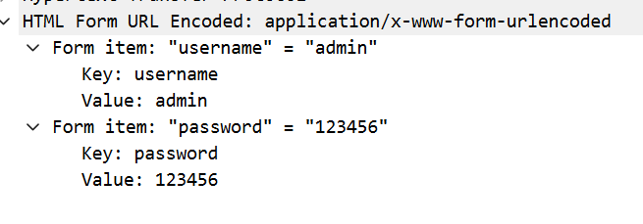

- Unencrypted Traffic: The website and traffic captured were unencrypted, making it vulnerable to man-in-the-middle (MITM) attacks if intercepted.

Hotspot Password Strength Evaluation:
Objective: Evaluate the strength and security of the hotspot's password.
Findings:
- Password Length: At least 12 characters
- Complexity: Mixed case, numbers, and symbols
- Uniqueness: Not reused from other accounts
Conclusion: The hotspot password is strong and follows good security practices. It is resistant to brute-force and dictionary attacks, and its uniqueness prevents credential stuffing.

Recommendations for Improving Security:
1. Block Unnecessary Ports:
- Action: Close ports 135, 139, and 445 using the Windows firewall or router settings.
- Why: These ports are commonly targeted in attacks like SMB exploits, lateral movement, and information leakage.
2. Disable NetBIOS:
- Action: Turn off NetBIOS over TCP/IP to reduce the attack surface.
- Why: NetBIOS is an older protocol that can be exploited in certain attacks.
3. Use a VPN:
- Action: Use a VPN when connected to public hotspots (including your own phone’s hotspot).
- Why: A VPN encrypts all traffic, preventing MITM attacks and hiding your real IP address.
4. Always Use HTTPS:
- Action: Ensure all websites you visit use HTTPS (and recommend this to others).
- Why: HTTPS encrypts traffic, protecting sensitive information from being exposed.
5. Regularly Change Wi-Fi Passwords:
- Action: Change your Wi-Fi password regularly (e.g., every 3-6 months).
- Why: This prevents long-term access by unauthorized users, ensuring your network remains secure.

Optional (If USB Wi-Fi Adapter was Available):
Cracking WPA2 Password: If a compatible USB Wi-Fi adapter were available, the WPA2 password could have been cracked using tools like Aircrack-ng by capturing a handshake and testing it against a wordlist.
Hardware: Alfa AWUS036NHA (or similar) would have been used to perform packet capture in monitor mode, then the password could be cracked using aircrack-ng.

Conclusion:
The Wi-Fi network on the Android device is reasonably secure with a strong, unique password. However, vulnerabilities such as open ports, unencrypted HTTP traffic, and potential exposure of sensitive data need to be addressed to further secure the network.
By implementing the recommendations outlined, security can be significantly improved, reducing the likelihood of unauthorized access and data leakage.

